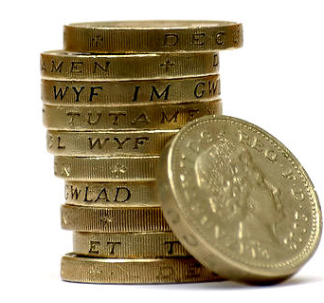
BTEC Business Unit 3 Handbook

Costs
Task One:
P1: Identify the difference between start up and operating costs, variable and fixed costs. M1: Explain the importance of costs, revenue and profit for a business organisation.
Define each of these terms and give examples.
Term | Definition | Examples.
Start Up Costs
Fixed Cost
Variable Cost
Contribution
Revenue
Gross Profit

Net Profit
Operating Costs

Revenue

Revenue refers to the money flowing into a business. It is also called income and is the opposite of costs.

Task Two:
P2: Identify the different types of revenue.

Identify the 3 sources of revenue:

Type | Definition | Examples.

Revenue calculations

To calculate total revenue you need to know the selling price of the item/unit and the number sold:

Total revenue = unit sales price x number of units sold

Calculate the total revenue for one week if Ford sells 2000 cars at £6000.00, 1500 cars at £12,500 and 1000 cars at £15.000?

Gross and Net Profit

Task Three:
P3: Outline the differences between gross and net profit.

Gross Profit definition:

Net Profit definition:

Calculating Gross and Net Profit:

You have set up a new bike shop in the hope valley. Your monthly operating costs are £1250.00. This is the combined cost of your rent, water and electricity bills, cleaning and staff salaries. You have sold 10 bikes for £800 each that cost you £450 each to buy. You have also sold 15 inner tubes for £3.50 that cost you £1.00 each to buy.

Question 1:
Calculate your Gross Profit, showing clearly how you worked this out:

Question 2:
Calculate your Net Profit, showing clearly how you worked this out:
Break Even

The break-even point is when the total costs of a company are exactly equal to its total revenue. If total costs are more than total revenue the company will make a loss. Conversely, if the total costs are less than the total revenue, the company will produce a profit.

Break-even is when: Total Cost=

To calculate Break Even you must know:
The Fixed Cost
The Variable Cost
The Selling Price

There is a quick way of calculating Break Even:

Fixed Cost
Selling Price-Variable Cost

The bottom part of that calculation (Selling Price-Variable Cost) is often called Contribution ... or more properly “Contribution to Fixed Costs and Profit”

Output | Fixed  Cost | Variable  Cost | Total  Cost | Total  Revenue | Profit |  | Variable Cost is calculated by multiplying output by Variable Cost for each item
0 | 200 | 0 | 200 | 0 | -200
10 | 200 | 30 | 230 | 70 | -160 |  | Total Cost is calculated by adding together
20 | 200 | 60 | 260 | 140 | -120 |  | Fixed plus Variable Cost
30 | 200 | 90 | 290 | 210 | -80
40 | 200 | 120 | 320 | 280 | -40 |  | Revenue is calculated by multiplying
50 | 200 | 150 | 350 | 350 | 0 |  | Output by Selling Price.
60 | 200 | 180 | 380 | 420 | 40
70 | 200 | 210 | 410 | 490 | 80 |  | Profit is calculated by taking Total Cost
80 | 200 | 240 | 440 | 560 | 120 |  | from Total Revenue
90 | 200 | 270 | 470 | 630 | 160
100 | 200 | 300 | 500 | 700 | 200

What is the selling price for this product? £

Task Four:
P4: Calculate breakeven using given data to show the level at which income equals expenditure.

Use the Break Even formula to give the break-even point for the following in terms of
A: Products B: Sales(£’s)
Fixed Cost per week = £5,000  Variable Cost each = £5  Selling Price each = £25  Contribution=£ | A: | B:
Fixed Cost per week = £250  Variable Cost each = £25  Selling Price each = £37.50  Contribution=£ | A: | B:
Fixed Cost per week = £10,000  Variable Cost each = £50  Selling Price each = £75  Contribution=£ | A: | B:
Fixed Cost per week = £20,000  Variable Cost each = £5  Selling Price each = £9  Contribution=£ | A: | B:
Fixed Cost per week = £100  Variable Cost each = £5  Selling Price each = £10  Contribution=£ | A: | B:
Fixed Cost per week = £200  Variable Cost each = £3  Selling Price each = £7  Contribution=£ | A: | B:

Break Even

Task Five:
P5: Present the break even as an annotated graph showing breakeven.

Peter sells DVDs, his Fixed Costs are £100 per week, Variable Costs are £3 and Selling Price is £5. Complete the table and draw a break-even graph for Peter.

Output | Fixed  Cost | Variable  Cost | Total  Cost | Total  Revenue | Profit
0 | 100 | 0 | 100 | 0 | (100)
10
20
30
40
50

Now plot the break even graph from the table.

Break-Even has its limitations.

It assumes that the firm can sell any quantity of the product at the current price. In practice the firm may need to reduce prices to sell at high levels of output.

It assumes fixed costs never change - but as output increases the firm may need to buy more machines, get bigger premises, take on extra sales and administration staff.

It assumes that all products are sold. This doesn’t always happen; some products may only be sold at lower prices or need to be thrown away.

Margin of Safety.

This is the difference between the actual level of production and the break-even point.

For example:
If the break-even point of product A is 400 units and the output is 700 units then the margin of safety is:
700 - 400 = 300 units.

Product | Actual Output | Break-Even Output | Margin of Safety
B | 1000 | 500
C | 5000 | 3000
D | 350 | 200
E | 150 | 80

Task Six:
An enterprise group is looking to sell teddy bears. They want to know how many they need to sell to break-even.

Information:
- Their fixed costs will be £200
- Their variable costs are £2 per bear
- They are going to produce 40 bears
- The selling price of a bear will be £8

Using the information above, complete table below.

No. sold | Sales Revenue | Fixed  Costs | Variable  Costs | Total  Costs | Profit/  Loss
0 | 0 |  |  |  | (200)
10 |  | 200 |  | 220
20 |  |  | 40
30 |  | 200 |  |  | (20)
40 | 320
50
60
70
80
90
100

How many bears do the group have to sell to break even? Write a sentence to explain: ________________________________________________________________________________________________________________________________________________________________

You are their business advisor. Would you recommend that they undertake this business or not?
______________________________________________________________________________________________________________________________________________________________________________________________________________________________________________________________

Draw break-even chart and ensure that you label each line and the axis.

Task Seven:
M2: Demonstrate the impact of changing cost and revenue data on the break even point of a selected business

Mel is a mobile hairdresser.

The fixed cost of running the business includes repayment of loans on the car and equipment she owns and administration costs. They are £400 a week.

The variable costs include petrol and they are calculated £20 per client.

She charges £30 for each client.

Based on this data, she has asked you to provide her with the following information:-

Complete the table attached, and state at what number of units break-even is reached.

Clients Per Week | Sales Revenue | Fixed Costs | Variable Costs | Total Costs | Profit/Loss
0
10
20
30
40
50
60
70
80
90
100

Now draw up a break-even graph from the information in the table. Indicate in the graph the break-even point.

Calculate how much profit or loss she would make if she treated:-

  - 50 clients
  - 20 clients
Mel is considering raising the price to £35. How will this affect her break-even point? Draw another table and illustrate this on a graph.

Clients Per Week | Sales Revenue | Fixed Costs | Variable Costs | Total Costs | Profit/Loss
0
10
20
30
40
50
60
70
80
90
100

Show her what would happen if at the original price of £30, costs increased to £25. What would the break even units be now?

Clients Per Week | Sales Revenue | Fixed Costs | Variable Costs | Total Costs | Profit/Loss
0
10
20
30
40
50
60
70
80
90
100

Cash Flow
Task Eight:
M3: Analyse the implications of regular and irregular cash inflows and outflows for a business organisation

Cash-flow is the movement of money in a business’ account at any one time.
These movements are dictated by the business’ Inflows and Outflows. List types of inflows and outflows below.

Inflows | Outflows

Outflows and inflows are further broken down into two-types. Both inflows and outflows can be regular and irregular.

Fill in the boxes below with types of inflows and outflows

Regular Inflows | Regular Outflows
Irregular Inflows | Irregular Outflows

How do regular and irregular flows affect a business?

Regular Inflows | Regular Outflows
Irregular Inflows | Irregular Outflows

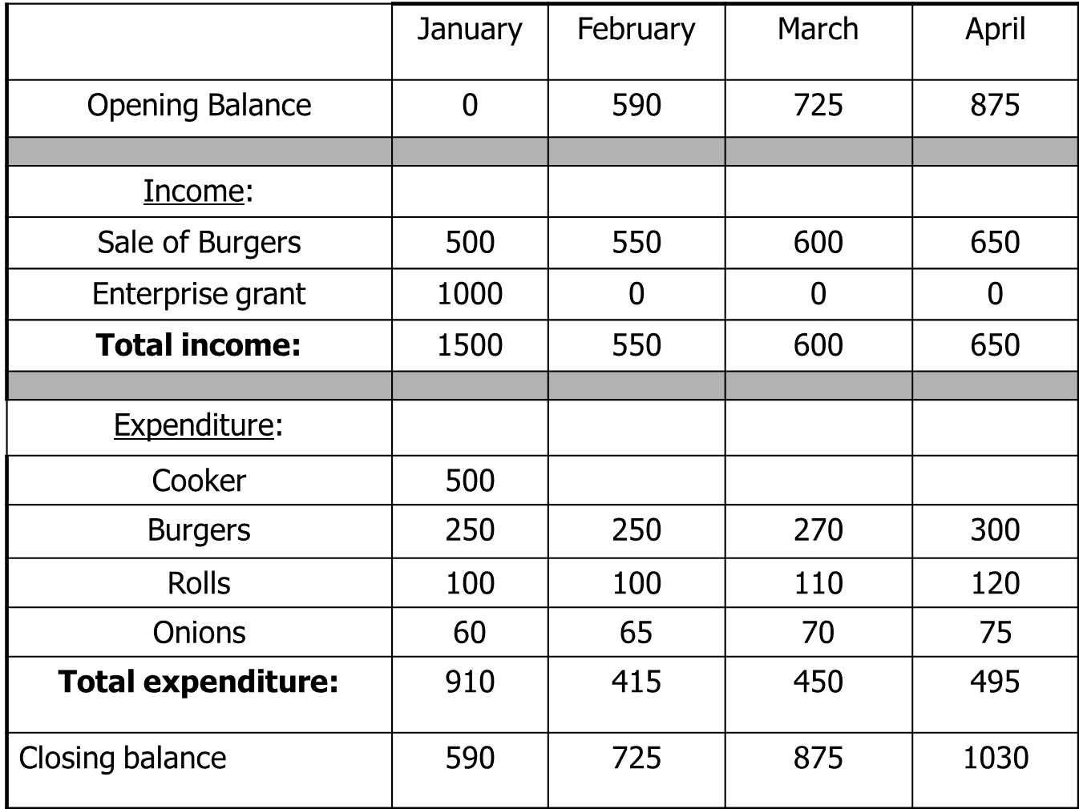

- What is the monthly income for February?

- What was the machinery expenditure? How much did it cost in total?

- During which month are revenue and expenditure the highest? Give a likely reason for this.

Task Nine
P6: Prepare an annual cash flow forecast using monthly data

An independent sole trader, I Scream, sells ice cream from their brother’s farm shop in the peak district. Write up the cash flow forecast for them. Use the following statements to fill in the cash flow forecast.

- Monthly sales income starts at £1000 in January and increases by £500 each month.

- An upgraded ice cream machine was purchased for £1500 in March.

- The proprietor will be on holiday during the whole of February and the farm shop will close completely.

- Opening balance for January was £1000.

- A grant of £3000 was received from the government in March.

- Rent paid at £500 a month.

- The proprietors wage is £300 per month.

- Loan of £1000 received in January. The monthly repayments of £150 start in February.

 | Jan | Feb | Mar | Apr | May | Jun | Jul | Aug
Opening Balance |  | £ | £ | £ | £ | £ | £ | £
Income
Sales
Sales (DD) | 20 | 20 | 20 | 20 | 20 | 20 | 20 | 20
Grants
Total
Expenditure
Machinery
Materials | 100 |  | 200 | 200 | 300 | 500 | 500 | 500
Rent
Wages
Total
Closing Balance | £ | £ | £ | £ | £ | £ | £ | £

1. When did revenue increase? Why?

2. Do the variable costs increase? Why?

3. Identify regular and irregular inflows.

Regular:

Irregular:

4. Identify regular and irregular outflows.

Regular:

Irregular:

5.Is this a good business?

6.Would you invest in this business?

Task Ten:
D1: Evaluate the importance of cash flow and break even for the effective management of business finance.

Jenny is an entrepreneur who began making greetings cards. Initially she made all the cards by hand, all by herself, and travelled around the country to sell them to newsagents and other outlets, which meant she had to work long hours. Larger outlets were given credit payment terms to purchase her cards.

As the business grew, Jenny had enough money in the bank to fund her lifestyle. In the last few months Jenny has come to realise that she is owed a lot of money but not entirely sure how much or when. She want to take on more staff, buy more printers and purchase a bigger premises.

Jenny wants your advice. Send her an e-mail stating how break even and cash flow work, and how they might benefit her situation.
