1. Properties
Wood | Classification | Properties
Oak | Deciduous | Heavy, hard, tough and polishes well.
Cedar | Coniferous | Lightweight, knot free, straight grained.
Beech | Deciduous | Very tough, hard, close grained.
Teak | Deciduous | Hard, durable, natural oils resist moisture and insects.
MDF | Man-made | No grain, smooth surface, saws well.
Scotts Pine | Coniferous | Straight grain, knotty, easy to work with.
Plywood | Man-made | Laminated layers at 90° to stop warping.

2. Forest Management stages
Stage | Explanations
Plantation | Planting the tree saplings.
Cultivation | Growing the tree, ensuring they are healthy.
Harvesting | Felling the trees into logs.
Transportation | Moving the trees to be process into timber.
Usage | Selling the wood to manufacture to make products.
Waste | Disposing of the products e.g. wood chip fuel.

3. Processes of timber
Processes | Description
Thinning | Forests need to be thinned so the trees do not need to compete for resources e.g. sun and water.
Felling | Trees are felled when they have reached maturity and turned into logs.
Timber conversion | 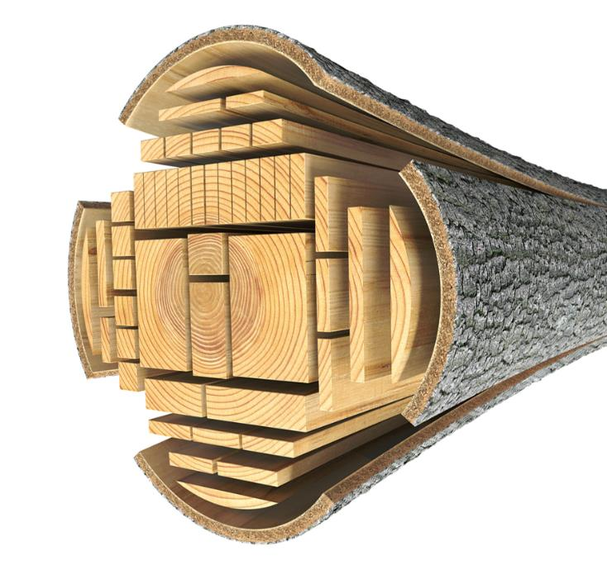  This is when a tree log is economically divided into a useful product e.g. planks of various sizes.
Green timber | Green timber is very wet, and difficult to work with. Timber for external use needs a moister content of 20% and 10% for internal use.
Seasoning | Seasoning timber reduces the moisture content, this is achieved by either air or kiln drying
Faults | Faults in wood include: bowing, splitting/cracking, crook/sprigging, cupping twisting.  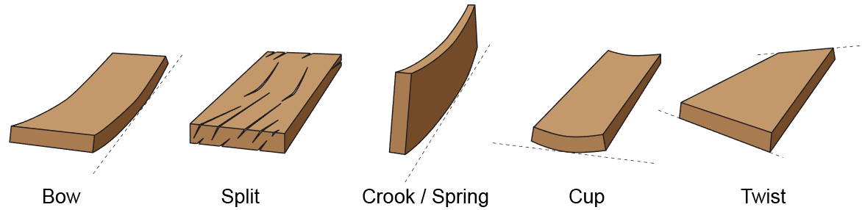

4. Sustainability
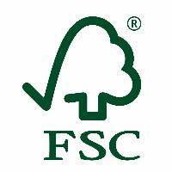 | Forestry Stewardship Council - This system allows consumers to identify, purchase and use wood, paper and other forest products produced from well-managed forests and/or recycled materials.
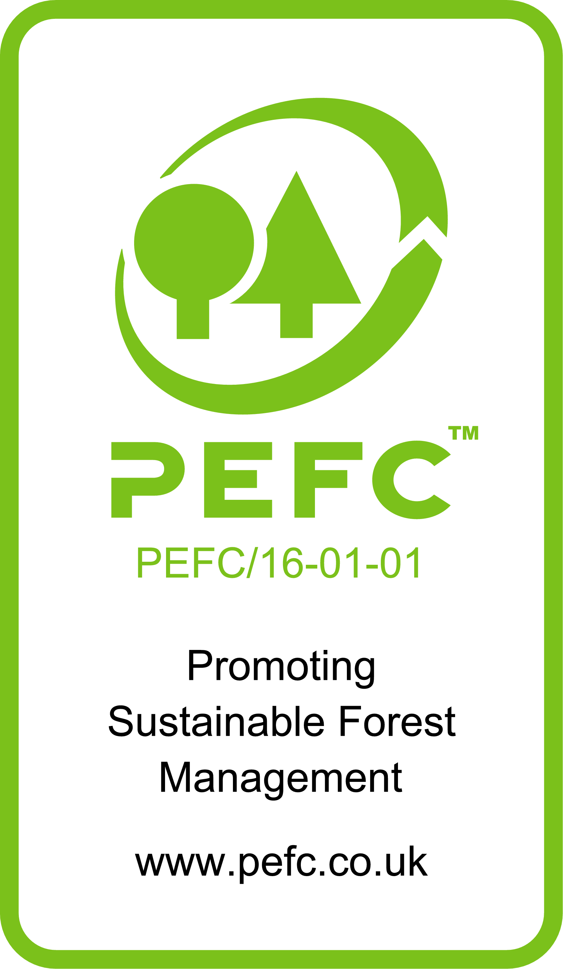 | Programme for the Endorsement of Forest Certification – An international non-profit, non-governmental organization dedicated to promoting sustainable forest management, the Programme for the Endorsement of Forest Certification is the certification system of choice for small forest owners.
Consequences of illegal forestry
Desertification – land turns to desert |  | Deforestation – no more tree to produce oxygen
Global warming – less oxygen production |  | Destruction of wildlife habitats – species could die out due to not having a home.

Task: 1-4 Learn/cover/write and self-check the properties of wood forest management, timber processes and sustainability.

1. PPE – Personal Protective equipment
Image | Name & use
 | Ear defender – to reduce noise when working with loud electric tools.
 | Overalls – These are used to protect your clothes from dust particles and liquids.
 | Safety glasses – Must be worn when cutting materials or working in an environment which
 | Face mask – To prevent people from breathing in tiny particles, which could affect your respiratory system.
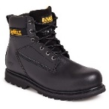 | Strong steel toe capped boots – These protect your feet e.g. treading on nails or dropping heavy items on to your toes.
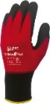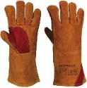 | Protective gloves – there are various types of protective glove, e.g. gloves with added grip to assist carrying materials and leather gloves for when hot objects need to be moved.
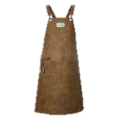 | Leather apron – this must be used when working with hot materials, as it takes a lot longer to burn/catch fir that a cloth apron.

2. Types of cut timber finishes
Processes | Description
Rough sawn | Wood which still has the rough surface from its first cut, it can be used in construction where it will be sealed behind other materials such as plasterboard.
PAR | Planed All Round – This is timber which has had the rough surfaced removed by planning.
Standard mouldings | This is wood which has been shaped to a particular profile, for example a door frame or skirting board.

3. Timbers and components – Stock forms
Commercial availability | Description
- Planks  - Boards  - Mouldings | Real wood is sold in planks of various lengths. Planks can only be the size width of the tree that they come from. Manufactured boards can come in large sheets and various thicknesses. These boards can then be cut down to the required size.
- Length  - Width  - Diameter  - Thickness | When purchasing wood, it will come in a variety of pre-manufactured sizes and shapes.
- Wood screws  - Hinges  - Knock down fittings  - Nails  - Brackets | These are pre-manufactured components made to be used with wood. They come in various lengths, materials, sizes and thicknesses.

4. Types of Knock Down Fittings
Image | Name
 | Connecting or block fitting
 | Cross dowel fitting
 | Cam lock fitting

Task: 1-4 Learn/cover/write and self-check the various PPE, timber cuts, timber/components and knock down fittings.

1. Components
Image | Description
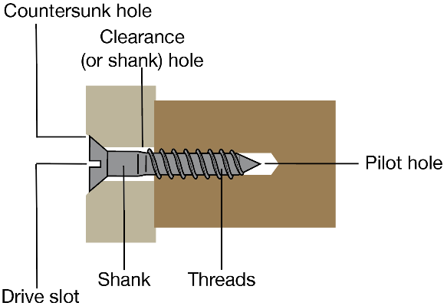  Wood screws | - Drill a pilot hole to guide the wood screw.  - Use a slightly larger drill bit to drill a clearance hole for the shank of the wood screw.  - Use a counter sink drill bit, so the head of the wood screw will fit into the wood without being above the surface (flush).
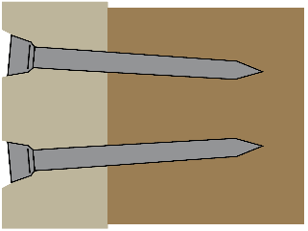  Nails | Nails are hammered into the wood at an angle to stop the join from coming apart easily.  There are many different types of nail for various purposes.

2. Laminating
- Laminating means layering. It is often used to create curved components.
- Strips of timber are glued and placed over a jig or former.
- Either clamps or a vacuum press are used to exert pressure on the lamination while the adhesive dries or cures.
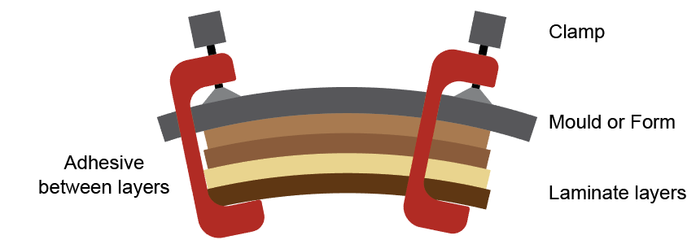

3. Wood joints
Joint | Uses
Butt joint | This joint needs to be reinforced with screws and glue to make it stronger. Used to make frames, cupboards and storage units.
Dowelled joint | Used to reinforce joints and support shelves and other components in cabinet making.
Mitre joint | Picture frames, door surrounds, cabinets and pattern making.
Housing joint | One of the most common uses of a housing joint is in the construction of shelving units, but they're also frequently used in the construction of cabinet carcasses.
Mortise and Tenon joint | Very strong wood joint used to make tables chairs and large structures e.g. timber framed building.

Task: 1-3 Learn/cover/write and self-check the various components, laminating and wood joints.

1. Manufacture Board
Image | Properties and uses
 | MDF(Medium Density Fibreboard) – Made by compressing and gluing tiny particles of wood fibres, has a smooth surface can be painted of veneered. Used for indoor furniture
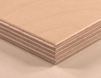 | Plywood – Made by laminating veneers at 90 degree angles so it doesn’t twist or warp. Used to make draw bottoms, doors and boats(marine ply).
 | Blockboard – Made by gluing strips of wood together and sandwiching them between to veneers. Used to make furniture such as table tops.
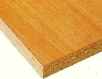 | Chipboard – Made by compressing and gluing chips of wood together. Used for flooring and veneered kitchen tops.
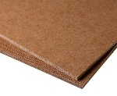 | Hardboard – Made by compressing and gluing small wood fibres together, one side of the board is smooth and the other has a rough texture. Used to line drawer bottoms backs of cabinets.

2. Engineered wood - Manufactured or engineered wood has many advantages over solid wood.
  - May be mixed with glues to give greater strength and stability.
  - Ideal for use in construction, industrial and domestic use.
  - Efficient in its use of mixed materials and utilising waste wood.
  - It can be made in a large sheets not limited
by the diameter of a tree trunk.

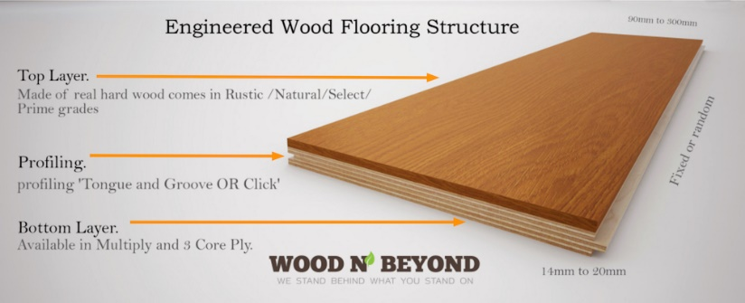

3. Flat pack furniture - Manufactured boards are well suited to
self-assembly products.
  - They are generally less expensive than hand-made items.
  - Arrives boxed making it easier to store and transport.
  - Relatively straightforward to assemble with a basic tool kit.

4. Commercial Manufacturing - Mass produced timber components are produced using CNC machinery.
- This enables large quantities of equal sized parts or
products to be produced.
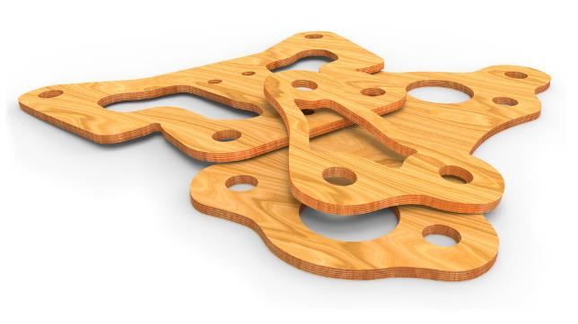
- Templates can be saved and reused to
help minimise waste.
- Screw holes, slots and patterns
can be cut in one process.

5. Commercial routing - CNC machinery can cut, drill, shape,
mill and profile manufactured or natural timbers.
  - Screw holes, slots and patterns can all be cut in one process.
  - Machines can accommodate big sheets of material.
  - Machines work quickly and efficiently
enabling a product to get to market swiftly.

6. Commercial turning - CNC wood lathes produce cylindrical components.
  - Once programmed they are very effective at producing complex shapes and spirals.
  - Ideal for repeat production.
  - Lathes can accept large and long pieces of material.

7. Mechanisation and automation - Automated machinery has changed the way industry manufactures timber based products.
  - Improvements in manufacturing methods have been embraced by designers.
  - Stringent quality control methods have increased consistency and accuracy.
  - Increased availability of manufactured boards means products can be batch and mass produced.
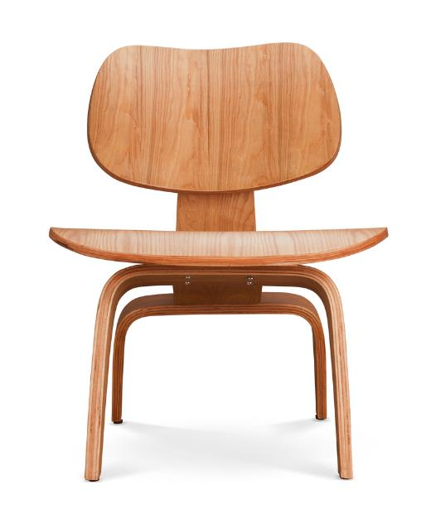

Task: 1-7 Learn/cover/write and self-check the manufacture boards, engineered wood, flat pack furniture, commercial manufacturing/routing/turning and mechanisms/automation.
1. Quality Control – ‘QC’ - The process where products are checked to ensure they meet the design specification.
They should also:
  - Function correctly.
  - Be free of defects.
  - Be consistent and accurate.
  - Meet set size tolerances.

2. Tolerance - The total amount a specific dimension or property is permitted to vary.
  - This can apply to hole depth, length, angle, thickness, weight and elasticity.
  - A gauge can be inserted into a gap or hole to check if the sizes fall within tolerance.
  - If parts do not fit within the specified tolerances they are discarded or recycled.

3. Surface treatments and finishes - Wood can be protected and visually enhanced using:
- Preservative  - Wax  - Oil |  | - Paint  - Stain  - Varnish
Finishes can be applied by brushing, rubbing or spraying.
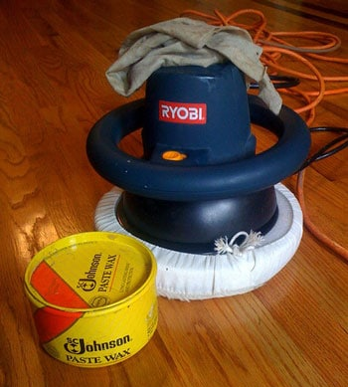 | 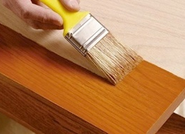
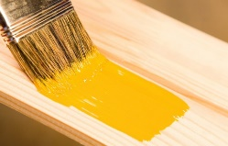

4. Wood preservation - Treating timber can help extend its life for decades.
Tanalising is the process in which timber is immersed in a preservative.
  - Hydraulic pressure forces the treatment deep into the timber.
  - Helps delay the rotting process.
  - Protects against insect and fungal attack.
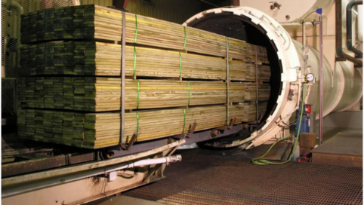

5. Commercial finishing - Modern finishes can extend the life of
timber based products.
  - Products can be sprayed by hand or machine.
  - Patterns, logos or wording can be printed onto the surface.
  - One of the fastest ways of painting is using a ‘curtain coater’ which gives a smooth and even coat.
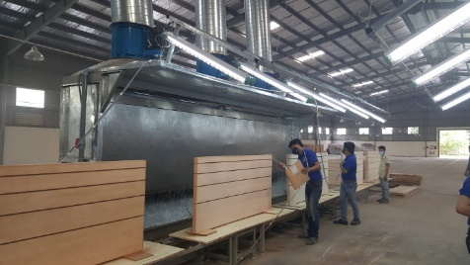

6. Environmental impacts - Traditional paints and finishes can have harmful effects on the environment.
  - Oil or solvent based products offer long lasting finishes, but contain high levels of VOCs – Volatile Organic Compounds.
  - Water based products are kinder to the environment.
  - Paint can be made from recycled latex and even milk.
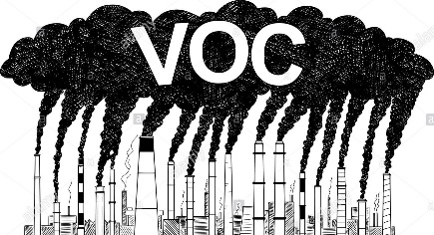

Task: 1-6 Learn/cover/write and self-check the QC, tolerance, wood finishes and VOC.

