Nose/  Mouth | Trachea | Bronchi | Bronchioles | Alveoli
Inspiration |  | Expiration
The intercostal muscles contract, lifting the ribs upwards and outwards causing the chest to expand |  | The intercostal muscles relax. The ribs move downwards and inwards under their own weight. The chest gets smaller.
The diaphragm contacts. It pulls down and flattens out the floor of the rib cage |  | The diaphragm relaxes. It is pushed back into a domed position by the organs underneath it.
The lung increases in size as the chest expands |  | The lungs decrease in size as the chest gets smaller. They are squeezed by the ribs and diaphragm.
The pressure inside our lungs falls as they expand. The higher pressure of air outside means air is now such into the lungs through the mouth and nose |  | The pressure inside the lungs increase as they get smaller. The air pressure is now lower than in our lungs. Air is forced out of the lungs though the nose and mouth.
Task4: To understand the process of gaseous exchange in the alveoli
Gaseous exchange takes place at the alveoli. These are tiny air sacs in the lungs. When you breathe in they fill with air. This is where oxygen is transferred into the blood stream and carbon dioxide is removed from the blood. To help this process the body has the following features
The alveoli are covered in capillaries. Gases pass through the thin walls and into the bloodstream
A large blood supply. Increased red blood cell increase the amount of oxygen supplied to the muscles and tissues
Capillaries are close to the alveoli to the diffusion distance in short
Alveoli have a large surface area to allow diffusion to take place
Thin walls (one cell thick) allows quick diffusion.
Gases move from areas of high concentration to areas of low concentration
Task5: To understand the difference between aerobic and anaerobic activity
Aerobic (with o2) | Glucose + oxygen >>> energy + Co2 + water |  | Marathon runner
Anaerobic (without o2) | Glucose >>> energy + lactic acid |  | Shot put
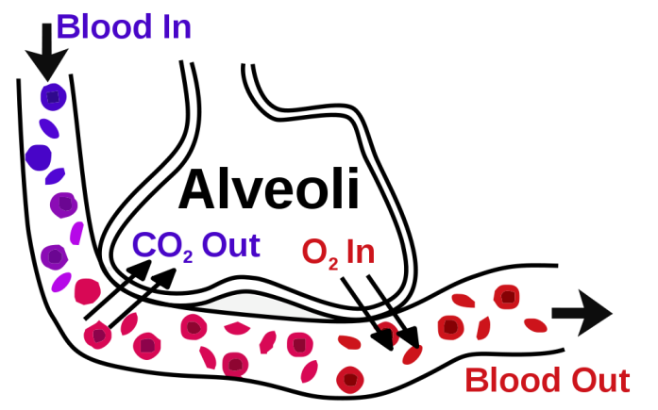
Breathing rate- The number of breaths per minute. This is typically 12-20 breaths per minute for a healthy adult at rest.

Tidal Volume-The volume of air inspired or expired per breath. This increases during exercise.

Minute Ventilation-The amount of air a person breathes out in a minute.
Breathing Rate x Tidal Volume = Minute Ventilation

Task2: To understand the key respiratory terms
Task2: To understand mechanics of breathing
Oxygen travels along the following pathway from the mouth and nose to the alveoli.

Task1: To understand the pathway of air
PHYSICAL EDUCATION – Respiratory system

