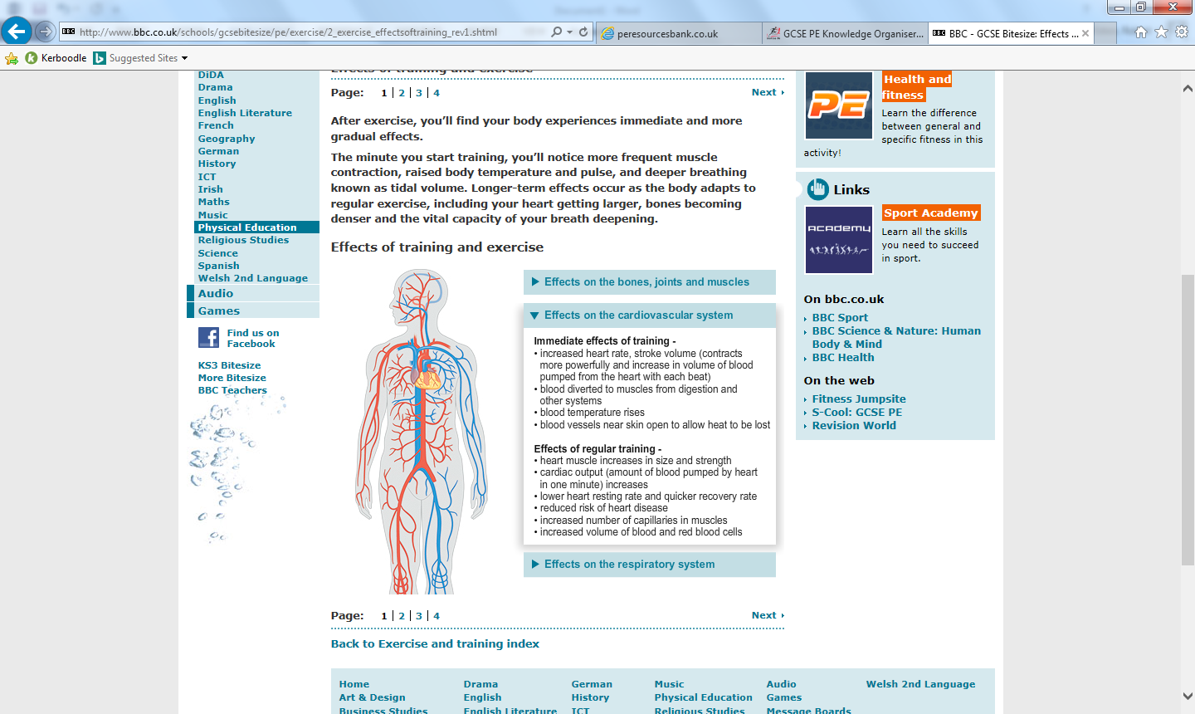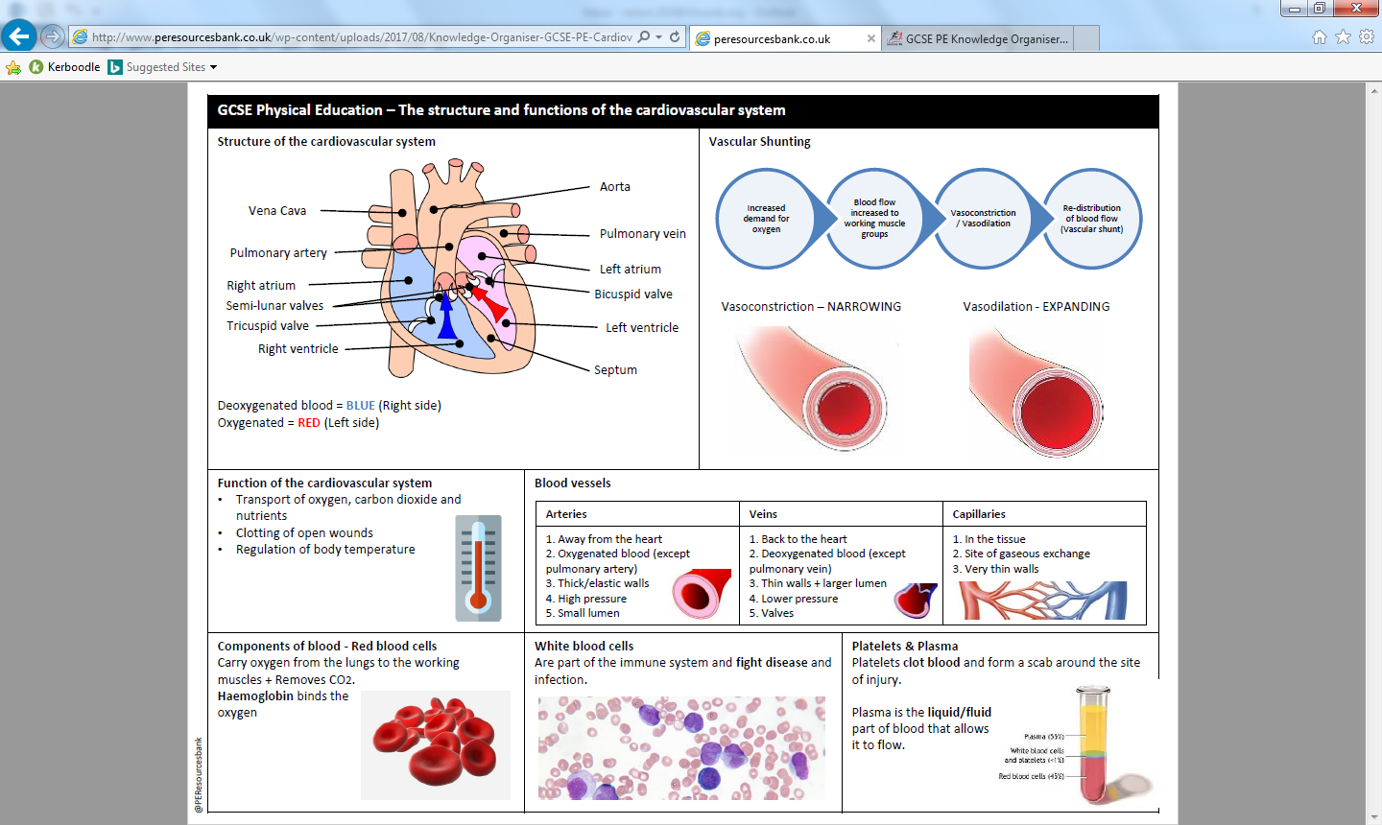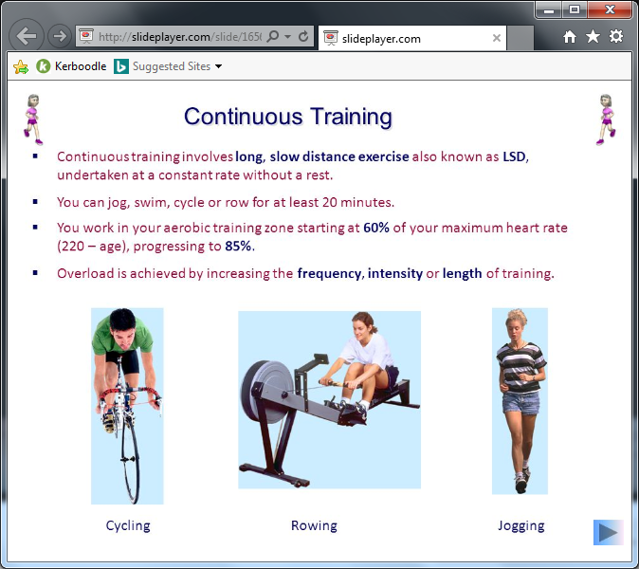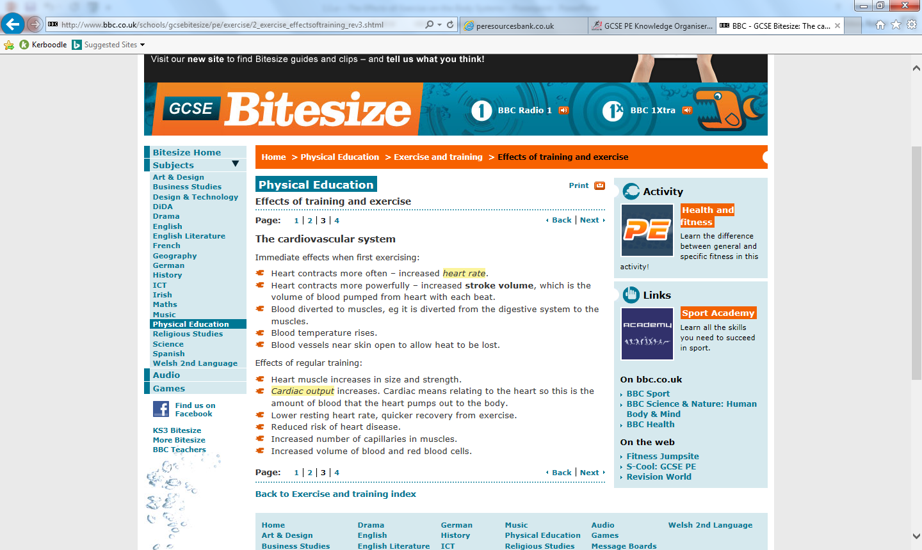

Homework 1: Know the different parts of the heart and the function of the cardiovascular system.

Homework 2: Understand the function of the different blood vessels

Homework 3: Remember the short term effects of exercise

Homework 4: Remember the long term effects of exercise

Long term effects on the CV system

Blood vessels

Function of the cardiovascular system

Short term effects of exercise on the CV system

PHYSICAL EDUCATION – The structure and function of the cardiovascular system in sport

The Heart