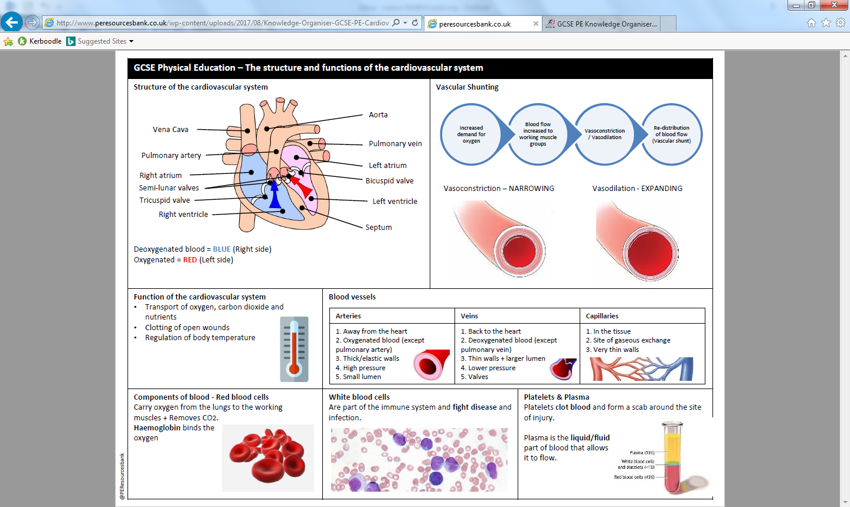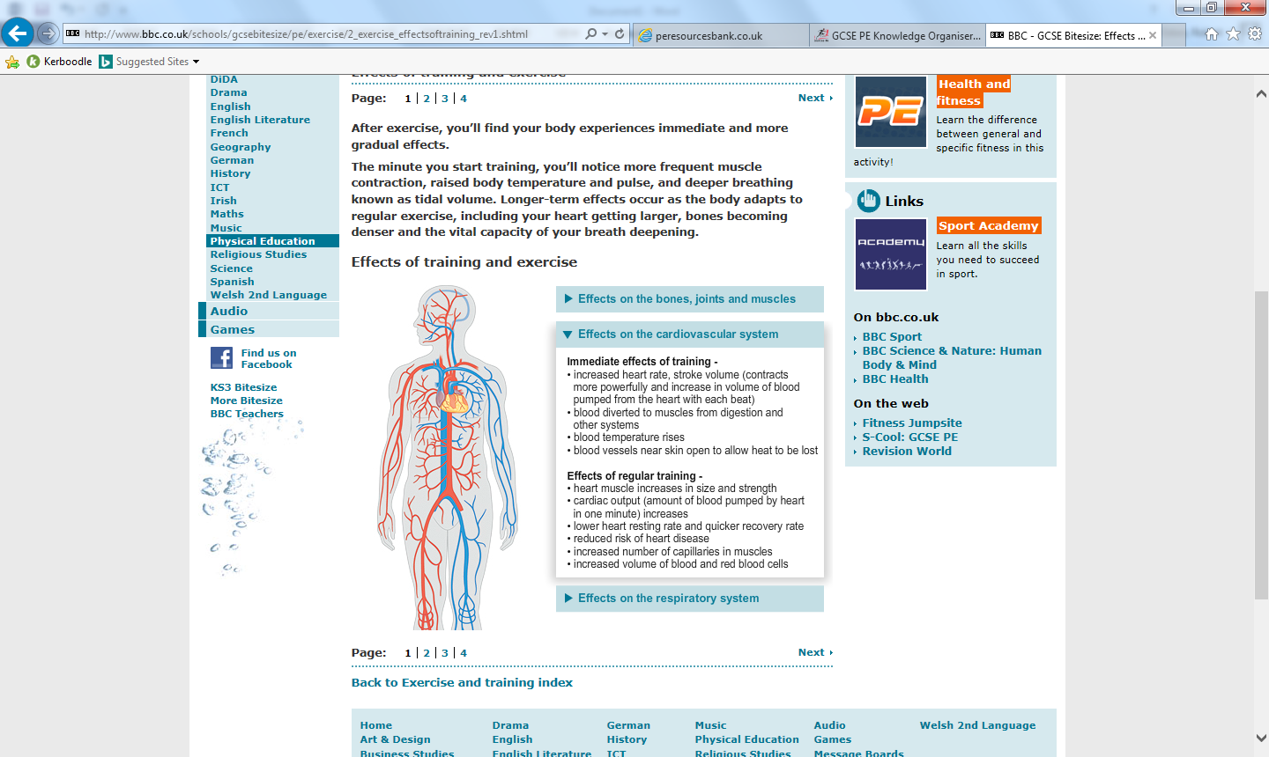

Task1: Label a diagram of the heart

Task5: State the function of the cardiovascular system

Task2: Describe and state the function of the blood vessels

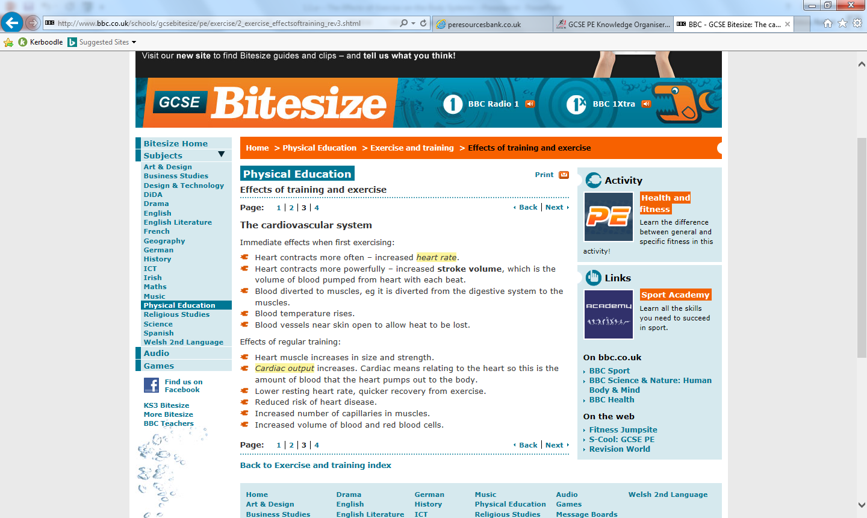

Task3: State the short term effects of exercise on the CV system

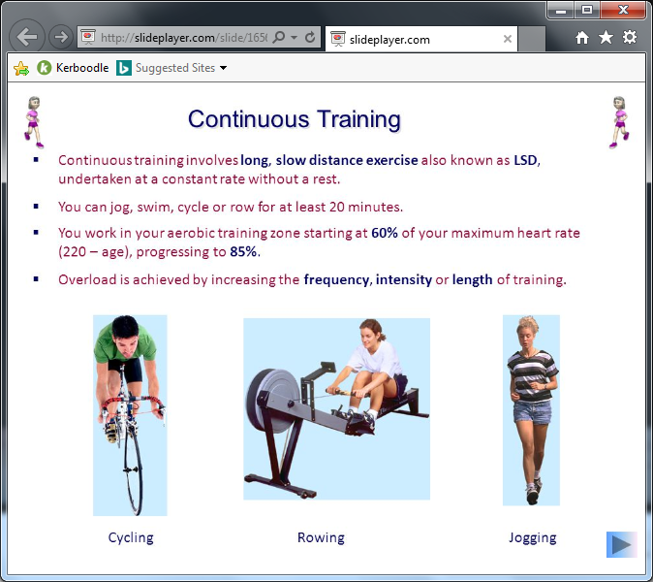

Task4:State the long term effects of exercise on the CV system

Task5: Know what types of training will cause these effects



PHYSICAL EDUCATION – The structure and function of the cardiovascular system in sport