Subject Content | What students need to learn?
1.3.2  Business revenues, costs  and profits | The concept and calculation of:  ● revenue  ● fixed and variable costs  ● total costs  ● profit and loss  ● interest
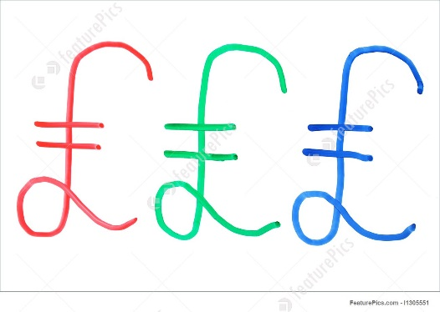
Before a business starts to sell their products and services, money needs to be spent setting up the business so it can run properly.
START – UP COSTS
__________________________________________________________________________________________________________
________________
A business will also have costs that they have got to pay regularly as a normal part of trading. These are usually paid monthly. These are known as ____________. Eg. Rent, raw materials, ___________.

COSTS ____________________________________________________________.

FIXED COSTS
Are costs that DON’T change when sales go up or down i.e. they DO NOT vary with output. E.g. Rent, salaries, insurance.

VARIABLE COSTS
Are costs that DO change when sales go up or down. i.e. they DO vary with output. E.g Raw materials, electricity, wages.
Variable Costs = ______________________________

TOTAL COSTS
All the costs a business must pay in a set period of time.
Total Costs = __________________________________

REVENUE
Revenue is the money generated from selling products/services. It is often referred to as sales revenue. ___________________________________
PROFIT
Profit is the amount of money the business has to keep once all costs have been covered.
Profit = ________________________
If the figure is ___________, the business has made a profit. If it is negative, the business has made a ___________.
INTEREST
Interest is the ______________________ money. When you take out a bank loan you must may back the amount with interest. E.g. a loan of £100 at a rate of 5% interest you pay back £105.
It is also the reward for saving. If you saved £100 in your bank account with an interest rate of 1%, by the end of the year you would have £101 in your account.

