Answer Key

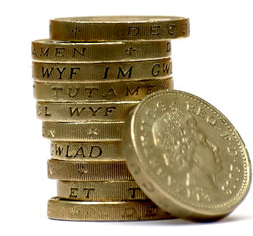
BTEC Business Unit 3: Financial Forecasting for Business

Learner Name: | Centre Number: | BTEC Business
Learner Name: | Learner No: | BTEC Business

UNIT NUMBER AND TITLE: | Unit 3: Financial Forecasting for Business
ISSUE DATE:
HAND IN DATE:
RESUBMISSION DATE:
ASSESSOR:

Aims
The aim of this unit is to enable you to understand the financial aspects of running a business. You will do this through looking at the key concepts used by businesses to manage their money, and forecast their finances for the future.

Money is at the heart of business. It is likely to be the main reason why a business was created and for it continuing to trade. This unit looks at the financial aspects of running a business.

Work covered
You will:
- Know about costs, revenue and profit in a business organisation
- Be able to prepare a break even analysis
- Be able to create a cash flow forecast

Know about costs, revenue and profit in a business organisation
Business costs: costs incurred at start up; operating costs (fixed, indirect, variable, direct costs, total costs)
Revenue: sources of revenue e.g. sales, leasing interest; calculating total revenue (unit sales price x number of units sold)
Calculating gross and net profit: revenue (income) minus costs (expenditure), cost of sales, expenses (operating costs); maximising profits (increasing revenue

Be able to prepare a break-even analysis
Break even: balancing costs or expenditure with revenues or income; areas of profit and loss; margin of safety; methods of presenting graphically

Be able to create a cash flow forecast
Cash inflow: capital; sales; loans; regular and irregular inflows; timing of inflows
Cash outflows: purchases; loan repayments; wages; regular and irregular outflows; timing of outflows
Cash balances: opening balance; closing balance; income per period; expenditure per period

Assessment
Everyone will be completing the PASS criteria work that is set. These activities will be the main focus of the preparation work needed for the task. You will also have the opportunity to do MERIT and DISTINCTION work which will be extension tasks. There are other tasks included to extend your depth of knowledge and understanding.

PASS | MERIT | DISTINCTION
P1: Identify the difference between start up and operating costs, variable and fixed costs | M1: Explain the importance of costs, revenue and profit for a business organisation | D1: Evaluate the importance of cash flow and break even for the effective management of business finance
P2: Identify the different types of revenue
P3: Outline the differences between gross and net profit
P4: Calculate break even using given data to show the level at which income equals expenditure
P5: Present the break even as an annotated graph showing breakeven | M2: Demonstrate the impact of changing cost and revenue data on the break even point of a selected business
P6: Prepare an annual cash flow forecast using monthly data | M3: Analyse the implications of regular and irregular cash inflows and outflows for a business organisation

Learner Declaration: I certify that all work submitted is my own
Signed: | Date:
To be completed by the assessor | Achieved
P1: Identify the difference between start up and operating costs, variable and fixed costs
M1: explain the importance of costs, revenue and profit for a business organisation
P2: Identify the different types of revenue
P3: Outline the differences between gross and net profit
P4: calculate break even using given data to show the level at which income equals expenditure
P5: Present the break even as an annotated graph showing breakeven
M2: Demonstrate the impact of changing cost and revenue data on the break even point of a selected business
P6: Prepare an annual cash flow forecast using monthly data
M3: Analyse the implications of regular and irregular cash inflows and outflows for a business organisation
D1: Evaluate the importance of cash flow and break even for the effective management of business finance
Assessor signature: | Date:
Lead IV signature: | Date:

Costs
Task One:
P1: Identify the difference between start up and operating costs, variable and fixed costs. M1: Explain the importance of costs, revenue and profit for a business organisation.
Define each of these terms and give examples.
Term | Definition | Examples.
Start Up Costs | Costs of setting up a business. | Capital purchases, Staffing, Licenses etc.
Fixed Cost | Costs to a business which are not output sensitive within certain parameters. | Rents, Water Rates, salaries etc.
Variable Cost | Output sensitive costs, which consist of direct costs for making a product/providing a service or experience. | Materials, Bonuses/Commissions, Water Meter, Wages (hourly).
Contribution | Difference between the selling price and the variable cost. It is the contribution to the fixed costs from each sale. | Item sells for £10 but costs £3 to make. There will be a £7 contribution to the fixed costs from each item.
Revenue | Income generated from business activities. | Interest, Sales etc.
Gross Profit | Sales revenue generated less the direct costs or costs of sales. | 10 bikes sell for £200 each (£2000) but cost £100 to buy (£1000). Gross profit of £1000
Net Profit | Gross profit less the overheads or indirect costs. | The £1000 gross profit less the overheads for the bike shop which are £200. Leaves £800 net profit.
Operating Costs | Cost from running the business, not asscotiated with production. | Sales, Administration etc.

Revenue

Revenue refers to the money flowing into a business. It is also called income and is the opposite of costs.

Task Two:
P2: Identify the different types of revenue.

Identify the 3 sources of revenue:

Type | Definition | Examples.
Loan | A sum of money lent by a lender, i.e. bank. To be repaid, with interest. | Business loan from NatWest to be paid back over 36 months at £150 per month including the 15% interest rate.
Interest | Money paid for use of money borrowed. | Interest received on a business account at NatWest.
Sales | Generated from selling a product, experience or service, to a customer. | Sale of the cars in the below example.

Revenue calculations

To calculate total revenue you need to know the selling price of the item/unit and the number sold:

Total revenue = unit sales price x number of units sold

Calculate the total revenue for one week if Ford sells 2000 cars at £6000.00, 1500 cars at £12,500 and 1000 cars at £15.000?

2,000 @ 6,000 = 12,000,000
1,500 @ 12,500 = 18,750,000
1,000 @ 15,000 = 15,000,000
£45,750,000

Gross and Net Profit

Task Three:
P3: Outline the differences between gross and net profit.

Gross Profit definition:

Sales Revenue less Cost of Sales= Gross Profit. Amount of money left after direct costs have been taken off the sale revenue.

Net Profit definition:

Gross Profit less Indirect Costs= Net Profit. Indirect Costs or Overheads are rents, bills etc.

Calculating Gross and Net Profit:

You have set up a new bike shop in the hope valley. Your monthly operating costs are £1250.00. This is the combined cost of your rent, water and electricity bills, cleaning and staff salaries. You have sold 10 bikes for £800 each that cost you £450 each to buy. You have also sold 15 inner tubes for £3.50 that cost you £1.00 each to buy.

Question 1:
Calculate your Gross Profit, showing clearly how you worked this out:
Bikes: (10x800)-(10x450)=3500

Tubes: (15x3.50)-(15)=37.50

3500+37.50= £3537.50 Gross Profit

Question 2:
Calculate your Net Profit, showing clearly how you worked this out:
Gross Profit £3537.50
-
Operating Costs £1250.00
£2287.50 = Net Profit

Break Even

The break-even point is when the total costs of a company are exactly equal to its total revenue. If total costs are more than total revenue the company will make a loss. Conversely, if the total costs are less than the total revenue, the company will produce a profit.

Break-even is when: Total Cost=Total Revenue

To calculate Break Even you must know:
The Fixed Cost
The Variable Cost
The Selling Price

There is a quick way of calculating Break Even:

Fixed Cost
Selling Price-Variable Cost

The bottom part of that calculation (Selling Price-Variable Cost) is often called Contribution ... or more properly “Contribution to Fixed Costs and Profit”

Output | Fixed  Cost | Variable  Cost | Total  Cost | Total  Revenue | Profit |  | Variable Cost is calculated by multiplying output by Variable Cost for each item
0 | 200 | 0 | 200 | 0 | -200
10 | 200 | 30 | 230 | 70 | -160 |  | Total Cost is calculated by adding together
20 | 200 | 60 | 260 | 140 | -120 |  | Fixed plus Variable Cost
30 | 200 | 90 | 290 | 210 | -80
40 | 200 | 120 | 320 | 280 | -40 |  | Revenue is calculated by multiplying
50 | 200 | 150 | 350 | 350 | 0 |  | Output by Selling Price.
60 | 200 | 180 | 380 | 420 | 40
70 | 200 | 210 | 410 | 490 | 80 |  | Profit is calculated by taking Total Cost
80 | 200 | 240 | 440 | 560 | 120 |  | from Total Revenue
90 | 200 | 270 | 470 | 630 | 160
100 | 200 | 300 | 500 | 700 | 200

What is the selling price for this product? £7

Task Four:
P4: Calculate breakeven using given data to show the level at which income equals expenditure.

Use the Break Even formula to give the break-even point for the following in terms of
A: Products B: Sales(£’s)
Fixed Cost per week = £5,000  Variable Cost each = £5  Selling Price each = £25  Contribution=£20 | A:  5000/20=250 | B:  250x£25=£6,250
Fixed Cost per week = £250  Variable Cost each = £25  Selling Price each = £37.50  Contribution=£12.5 | A:  250/12.50=20 | B:  20x£37.50=£750
Fixed Cost per week = £10,000  Variable Cost each = £50  Selling Price each = £75  Contribution=£25 | A:  10,000/25=400 | B:  400x£75=£30,000
Fixed Cost per week = £20,000  Variable Cost each = £5  Selling Price each = £9  Contribution=£4 | A:  20,000/4=5,000 | B:  5,000x£9=£45,000
Fixed Cost per week = £100  Variable Cost each = £5  Selling Price each = £10  Contribution=£5 | A:  100/5=20 | B:  20x£10=£200
Fixed Cost per week = £200  Variable Cost each = £3  Selling Price each = £7  Contribution=£4 | A:  200/4=50 | B:  50x£7=£350

Break Even

Task Five:
P5: Present the break even as an annotated graph showing breakeven.

Peter sells DVDs, his Fixed Costs are £100 per week, Variable Costs are £3 and Selling Price is £5. Complete the table and draw a break-even graph for Peter.

Output | Fixed  Cost | Variable  Cost | Total  Cost | Total  Revenue | Profit
0 | 100 | 0 | 100 | 0 | (100)
10 | 100 | 30 | 130 | 50 | (80)
20 | 100 | 60 | 160 | 100 | (60)
30 | 100 | 90 | 190 | 150 | (40)
40 | 100 | 120 | 220 | 200 | (20)
50 | 100 | 150 | 250 | 250 | 0
60 | 100 | 180 | 280 | 300 | 20

Now plot the break even graph from the table.

Break-Even has its limitations.

It assumes that the firm can sell any quantity of the product at the current price. In practice the firm may need to reduce prices to sell at high levels of output.

It assumes fixed costs never change - but as output increases the firm may need to buy more machines, get bigger premises, take on extra sales and administration staff.

It assumes that all products are sold. This doesn’t always happen; some products may only be sold at lower prices or need to be thrown away.

Margin of Safety.

This is the difference between the actual level of production and the break-even point.

For example:
If the break-even point of product A is 400 units and the output is 700 units then the margin of safety is:
700 - 400 = 300 units.

Product | Actual Output | Break-Even Output | Margin of Safety
B | 1000 | 500 | 500
C | 5000 | 3000 | 2000
D | 350 | 200 | 150
E | 150 | 80 | 70

Task Six:
An enterprise group is looking to sell teddy bears. They want to know how many they need to sell to break-even.

Information:
- Their fixed costs will be £200
- Their variable costs are £2 per bear
- They are going to produce 40 bears
- The selling price of a bear will be £8

Using the information above, complete table below.

Output | Total Revenue | Fixed Costs | Variable Costs | Total Costs | Profit/(Loss)
0 | £ - | £ 200 | £ - | £ 200 | -£ 200
10 | £ 80 | £ 200 | £ 20 | £ 220 | -£ 140
20 | £ 160 | £ 200 | £ 40 | £ 240 | -£ 80
30 | £ 240 | £ 200 | £ 60 | £ 260 | -£ 20
40 | £ 320 | £ 200 | £ 80 | £ 280 | £ 40
50 | £ 400 | £ 200 | £ 100 | £ 300 | £ 100
60 | £ 480 | £ 200 | £ 120 | £ 320 | £ 160
70 | £ 560 | £ 200 | £ 140 | £ 340 | £ 220
80 | £ 640 | £ 200 | £ 160 | £ 360 | £ 280
90 | £ 720 | £ 200 | £ 180 | £ 380 | £ 340
100 | £ 800 | £ 200 | £ 200 | £ 400 | £ 400

How many bears do the group have to sell to break even? Write a sentence to explain: 200/6=33.33. They have to be full bears (i.e. you can’t have .33 of a bear) so 34 bears

You are their business advisor. Would you recommend that they undertake this business or not?
Yes. Looking at the table, they break even quickly and realistically. It is realistic that they could make and sell 34 bears to break even and the table shows how much they could make if they made up to 100 bears, £400 which is very positive.

Draw break-even chart and ensure that you label each line and the axis.

Task Seven:
M2: Demonstrate the impact of changing cost and revenue data on the break even point of a selected business

Mel is a mobile hairdresser.

The fixed cost of running the business includes repayment of loans on the car and equipment she owns and administration costs. They are £400 a week.

The variable costs include petrol and they are calculated £20 per client.

She charges £30 for each client.

Based on this data, she has asked you to provide her with the following information:-

Complete the table attached, and state at what number of units break-even is reached.

Output | Total Revenue | Fixed Costs | Variable Costs | Total Costs | Profit/(Loss)
0 | £0 | £400 | £0 | £400 | -£400
10 | £300 | £400 | £200 | £600 | -£300
20 | £600 | £400 | £400 | £800 | -£200
30 | £900 | £400 | £600 | £1,000 | -£100
40 | £1,200 | £400 | £800 | £1,200 | £0
50 | £1,500 | £400 | £1,000 | £1,400 | £100
60 | £1,800 | £400 | £1,200 | £1,600 | £200
70 | £2,100 | £400 | £1,400 | £1,800 | £300
80 | £2,400 | £400 | £1,600 | £2,000 | £400
90 | £2,700 | £400 | £1,800 | £2,200 | £500
100 | £3,000 | £400 | £2,000 | £2,400 | £600

Now draw up a break-even graph from the information in the table. Indicate in the graph the break-even point.

Calculate how much profit or loss she would make if she treated:-

  - 50 clients
  - 20 clients
A: 50 Clients=£1,500(revenue)-(£1000(Variable)+£400(Fixed))=£100

B: 20 Clients=£600(revenue)-(£400(Variable)+£400(Fixed))=(£200)

Mel is considering raising the price to £35. How will this affect her break-even point? Draw another table and illustrate this on a graph.

Output | Total Revenue | Fixed Costs | Variable Costs | Total Costs | Profit/(Loss)
0 | £ - | £ 400 | £ - | £ 400 | -£ 400
10 | £ 350 | £ 400 | £ 200 | £ 600 | -£ 250
20 | £ 700 | £ 400 | £ 400 | £ 800 | -£ 100
30 | £ 1,050 | £ 400 | £ 600 | £ 1,000 | £ 50
40 | £ 1,400 | £ 400 | £ 800 | £ 1,200 | £ 200
50 | £ 1,750 | £ 400 | £ 1,000 | £ 1,400 | £ 350
60 | £ 2,100 | £ 400 | £ 1,200 | £ 1,600 | £ 500
70 | £ 2,450 | £ 400 | £ 1,400 | £ 1,800 | £ 650
80 | £ 2,800 | £ 400 | £ 1,600 | £ 2,000 | £ 800
90 | £ 3,150 | £ 400 | £ 1,800 | £ 2,200 | £ 950
100 | £ 3,500 | £ 400 | £ 2,000 | £ 2,400 | £ 1,100

Show her what would happen if at the original price of £30, costs increased to £25. What
would the break even units be now?
Output | Total Revenue | Fixed Costs | Variable Costs | Total Costs | Profit/(Loss)
0 | £ - | £ 400 | £ - | £ 400 | -£ 400
10 | £ 300 | £ 400 | £ 250 | £ 650 | -£ 350
20 | £ 600 | £ 400 | £ 500 | £ 900 | -£ 300
30 | £ 900 | £ 400 | £ 750 | £ 1,150 | -£ 250
40 | £ 1,200 | £ 400 | £ 1,000 | £ 1,400 | -£ 200
50 | £ 1,500 | £ 400 | £ 1,250 | £ 1,650 | -£ 150
60 | £ 1,800 | £ 400 | £ 1,500 | £ 1,900 | -£ 100
70 | £ 2,100 | £ 400 | £ 1,750 | £ 2,150 | -£ 50
80 | £ 2,400 | £ 400 | £ 2,000 | £ 2,400 | £ -
90 | £ 2,700 | £ 400 | £ 2,250 | £ 2,650 | £ 50
100 | £ 3,000 | £ 400 | £ 2,500 | £ 2,900 | £ 100

Cash Flow
Task Eight:
M3: Analyse the implications of regular and irregular cash inflows and outflows for a business organisation

Cash-flow is the movement of money in a business’ account at any one time.
These movements are dictated by the business’ Inflows and Outflows. List types of inflows and outflows below.

Inflows  - Sales(one off)  - Sales DD  - Interest  - Loans  - Grants  - Monthly Purchases | Outflows  - Rents  - Wages  - Travel Expenses  - Loan Repayments  - Interest  - Suppliers  - Capital Purchases

Outflows and inflows are further broken down into two-types. Both inflows and outflows can be regular and irregular.

Fill in the boxes below with types of inflows and outflows

Regular Inflows  - Sales DD  - Interest  - Monthly Purchases | Regular Outflows  - Rent  - Wages  - Loan Repayments  - Interest  - Suppliers
Irregular Inflows  - Loans  - Grants  - Sales | Irregular Outflows  - Travel Expenses  - Capital Purchases

How do regular and irregular flows affect a business?

Regular Inflows  - Allow business to know how much income they will be getting in the future. | Regular Outflows  - Allow the business to plan for the expenditure in the future.
Irregular Inflows  - Can give a boost to a business which may not be planned for. Or large injections such as loans and grants which can improve the business | Irregular Outflows  - Can damage a business if there is not enough working capital. Large unexpected events could be very detrimental if the company can then not meet other obligations.

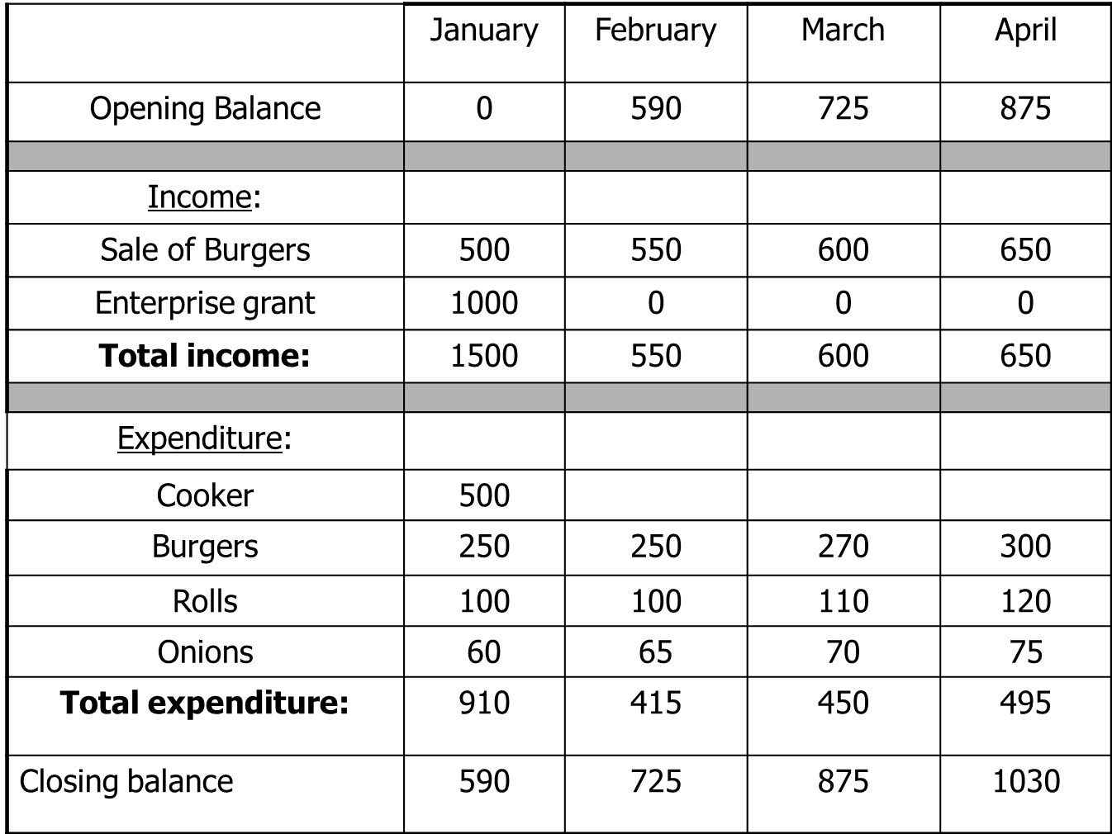

- What is the monthly income for February? £550

- What was the machinery expenditure? How much did it cost in total? Cooker £500

- During which month are revenue and expenditure the highest? Give a likely reason for this.
January. Start up costs, discounts and deals and grants.
Task Nine
P6: Prepare an annual cash flow forecast using monthly data

An independent sole trader, I Scream, sells ice cream from their brother’s farm shop in the peak district. Write up the cash flow forecast for them. Use the following statements to fill in the cash flow forecast.

- The proprietor will be on holiday during the whole of February and the farm shop will close completely.

- Sales income starts at £1000, January and increases by £500 each month after Feb(Closed).

- An upgraded ice cream machine was purchased for £1500 in March.

- Opening balance for January was £1000.

- A grant of £3000 was received from the government in March.

- Rent paid at £500 a month.

- The proprietors wage is £300 per month.

- Loan of £1000 received in January. The monthly repayments of £150 start in February.

 | Jan | Feb | Mar | Apr | May | Jun | Jul | Aug
Opening Balance | 1000 | 570 | -360 | 3210 | 4280 | 5850 | 7920 | 10490
Income
Sales | 1000 | 0 | 1500 | 2000 | 2500 | 3000 | 3500 | 4000
Sales (DD) | 20 | 20 | 20 | 20 | 20 | 20 | 20 | 20
Grants |  |  | 3000
Loan | 1000
Total | 2020 | 20 | 4520 | 2020 | 2520 | 3020 | 3520 | 4020
Expenditure
Machinery | 1500
Materials | 100 |  | 200 | 200 | 300 | 500 | 500 | 500
Rent | 500 | 500 | 500 | 500 | 500 | 500 | 500 | 500
Wages | 300 | 300 | 300 | 300 | 300 | 300 | 300 | 300
Loan | 150 | 150 | 150 | 150 | 150 | 150 | 150 | 150
Total | 2450 | 950 | 950 | 950 | 950 | 950 | 950 | 950
Closing Balance | £ 570 | -£ 360 | £ 3,210 | £ 4,280 | £ 5,850 | £ 7,920 | £ 10,490 | £ 13,560

1. When did revenue increase? Why?

March, the £3000 grant came in.

2. Do the variable costs increase? Why?

None in February, due to holiday. Increase in sales means more ice creams being sold, which means more are being made. This requires more materials so variable costs increase.
3. Identify regular and irregular inflows.

Regular: Sales by DD- Contract of purchase each month.

Irregular: Grants and loans are one of incomes.

4. Identify regular and irregular outflows.

Regular: Loan repayments, are taken at the same time each month.

Irregular: Capital purchases of machinery in January.

5. Is this a good business?
Yes, it is a small business which runs well. The only negative is that the size means that any holidays mean a complete stop in trade.

6. Would you invest in this business?
It is difficult to see where investment could be used. The business seems to be growing but it is impossible to know the market saturation etc. I think this business is working well but cannot grow much. This is not a good investment.

Task Ten:
D1: Evaluate the importance of cash flow and break even for the effective management of business finance.

Jenny is an entrepreneur who began making greetings cards. Initially she made all the cards by hand, all by herself, and travelled around the country to sell them to newsagents and other outlets, which meant she had to work long hours. Larger outlets were given credit payment terms to purchase her cards.

As the business grew, Jenny had enough money in the bank to fund her lifestyle. In the last few months Jenny has come to realise that she is owed a lot of money but not entirely sure how much or when. She wants to take on more staff, buy more printers and purchase bigger premises.

Jenny wants your advice. Send her an e-mail stating how break even and cash flow work, and how they might benefit her situation.

Email

Breakeven
This will show jenny exactly how much each card is costing her, and how many she needs to sell to break even. This will also allow Jenny to make informed decisions about expansion. If she can easily break even at the moment she could look at how many she could realistically make and still break even and or turn a profit. Similarly she could use this information so see if it would be practical to employ more staff and move to bigger premises. If she were to be making and selling 10 cards to break even at the moment then she decided that she could make 100 cards a week, more staff would need to be employed.

Cashflow
Using statements and forecasts Jenny could see what inflows and outflows she receives/ expects to receive. This would be split into months so she could see when she has enough working capital to make more cards, employ seasonal staff etc. If Jenny plans to move to bigger premises in February then she need to know that she can afford the mortgage payments or purchase of the items such as new bigger printers.

