1. Rice Key information
- Rice is the most widely consumed staple food for a large part of the world’s human population, especially in Asia.
- Rice grows well in hot and humid conditions in flooded fields called paddies.
- Rice is processed in a similar way to wheat. Rice is covered in a thick outer husk when the crop is harvested. This is removed during the processing stage.
- Rice types can vary in size, e.g. short and long grain, and colour: white, brown and red.
- Short grains can be very starchy. Rice pudding can be made using this type of rice.
- Long grain rice can have a frim, fluffy texture. Examples include Jasmine and Basmati rice.
- Rice can be cooked using various methods, e.g. baking, boiling, and steaming.
- Rice should be stored in a cool, dry cupboard.
- Cooked rice is a high-risk food. After cooking, rice should be cooled down very quickly and stored in the fridge. Rice must be heated thoroughly until piping hot.

2. Pasta Key information
- Pasta is made from a strong wheat called durum wheat.
- Pasta can be sold either fresh or dried. Types include lasagne sheets, filled tortellini, and cannelloni tubes.
- Pasta can be sold either fresh or dried. Types include lasagne sheets, filled tortellini, and cannelloni tubes.
- Pasta can be flavoured, e.g. with herbs and garlic. Coloured varieties include green, which is made using spinach, and red, which is made using tomato paste.
- Pasta provides the body with starchy carbohydrates, some protein and iron. Whole wheat pasta contains more dietary fibre (NSP).
- Fresh pasta must be stored in a fridge. It can also be stored in a freezer.
- Dried pasta (uncooked) should be stored in its packaging in a dry place.
- Cooked pasta should be cooled very quickly and stored in the fridge in an airtight container.

3. Potatoes Key information
- A potato has a skin on the outside, a fleshy section under the skin and a watery core in the centre called the pith.
- Potatoes are grown in the UK and are a staple food. They form a main part of many meals and can be cooked by roasting, baking, boiling and then mashing, or shallow and deep frying.
- Potatoes provide starchy carbohydrates, Vitamin C and some b group vitamins. The skin, if eaten provides dietary fibre (NSP).
- Potatoes should be sold in a dark, cool, airy place. If stored in a light environment they can turn green and become toxic.
- Potatoes can be stored in vegetable racks, paper or hessian bags. If stored in plastic bags they can sweat and eventually rot.
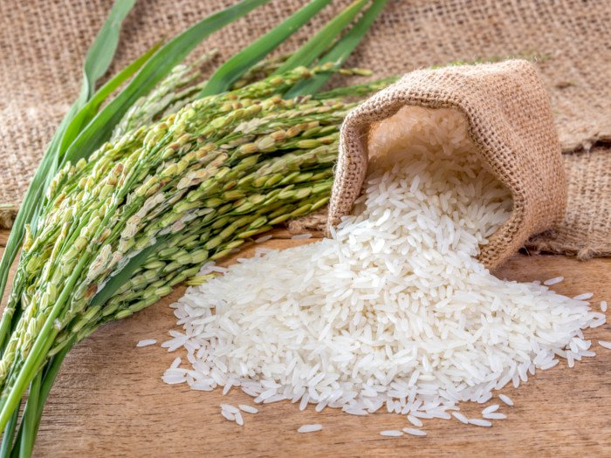
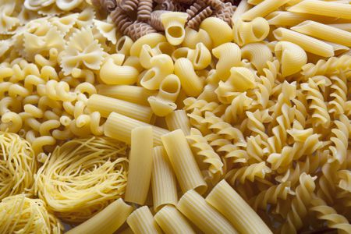
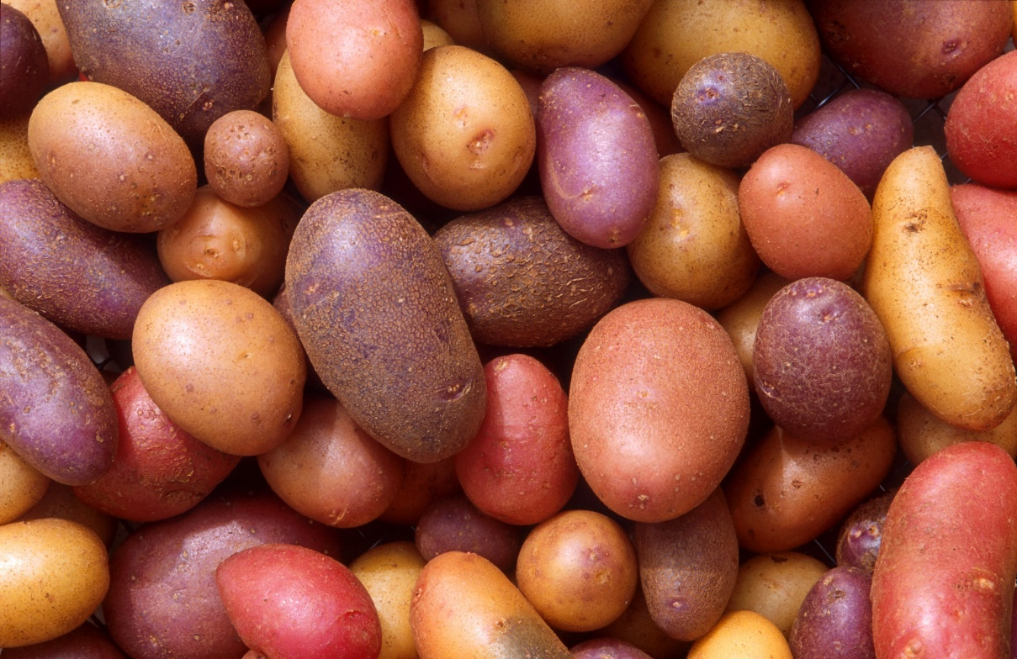

Task: 1- 4 Learn/cover/write and self-check; Rice, Pasta and potatoes.

