1. Milk & Yoghurt Key information
Milk comes from a variety of animals. In Britain we drink mainly cow’s milk.
Fresh milk has a layer of cream on top.
Homogenised milk is forced through tiny holes in a machine. This breaks up the fat and disperses it, so it doesn’t reform as a layer.
Lactose –intolerant people can substitute animal milk in their diet with milk made from soya, rice, coconut, almond or oats. These do not contain lactose. Milk goes through primary processing to produce a variety of different types:
- Pasteurised- this extends shelf life.
- Skimmed- this is pasteurised but has all or most fat removed.
- Semi-skimmed-this is pasteurised but has had some of the fat removed.
- Ultra-Heat Treated (UHT) - also known as ‘long life’. Has a shelf life of 6 months.
- Sterilised- has longer shelf life, is homogenised and has a slightly caramel flavour.
- Dried-does not need refrigeration until reconstituted.
- Canned-evaporated milk has had water evaporated off, its sweet and concentrated, homogenised and is sealed in cans and sterilised. Condensed milk has added sugar and is very thick.
Milk and yoghurt contain HBV protein, contain sugar (lactose), Vitamin A, B, and is fortified with Vitamin D.
Both milk and yoghurt must be stored in the fridge and used within the use-by-date.

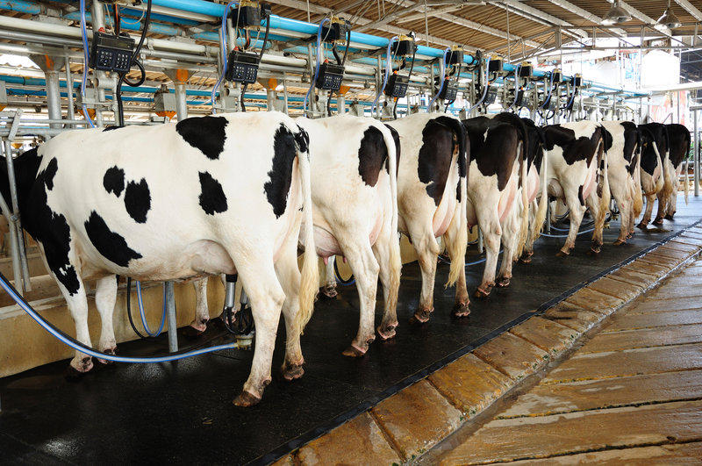
Task: 1- 2 Learn/cover/write and self-check; Milk, Yoghurt and cheese.

2. Cheese Key information
Task: 1- 2 Learn/cover/write and self-check; Milk, Yoghurt and Cheese.
Cheese is milk in its solid form.
There are many regional and international varieties of cheese, depending on the method and the milk used.
Different types of cheeses can be used to make both sweet and savoury dishes.
Cheese contains HBV protein, fat, calcium, Vitamin A and some B-group vitamins.
Cheese must be stored in a refrigerator between 0-5 .C.
Soft cheeses have a short shelf life so should be consumed quickly.



