1. Meat Key information
Meat is a muscle made of cells, which consist of fibres held together by connective tissue. The older an animal is the tougher the meat.
Muscles that work a lot, such as the thighs and shoulders of animals, provide tough meat. Small fibres are associated with tender cuts.
There are 4 main sources of meat:
- Animals –pork, beef, lamb.
- Poultry- chicken, turkey, duck, goose.
- Game-venison, rabbit, pheasant.
- Offal- liver, tongue, tripe, kidney, heart, brain, trotters.
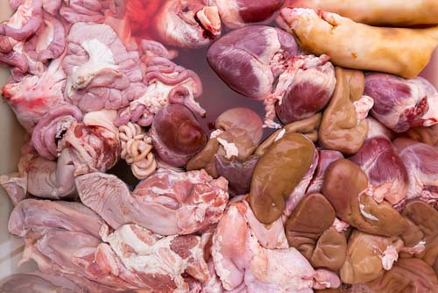
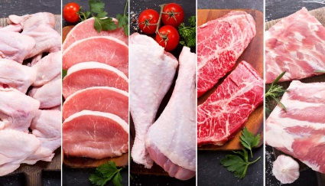

Cuts of Meat
- Cuts of meat from muscle areas that do a lot of work will need longer, slower cooking methods in wet heat e.g. stewing, braising, pot roasting and casseroling.
- Meat from tougher cuts can be ground or minced to break up the connective tissues so that it cooks more quickly.
- Cuts of meat from muscle areas not so heavily used by the animal e.g. the back and the rump, can be cooked much more quickly in dry heat, e.g. grilling, stir-frying.
Marinating and tenderising
- Marinades are added to meat before cooking to add flavour, and the acid content (e.g. lemon juice, yoghurt) breaks down the protein.
- Meat can also be tenderised by using a marinade, mincing or using a steak hammer.
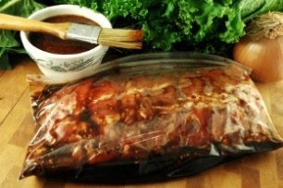
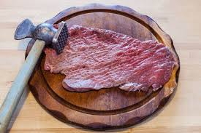

The effects of cooking meat
The browning of the meat is caused by a reaction with natural sugars and proteins to produce a dark colour. This is called the Maillard reaction or non-enzymic browning.
As meat cooks, the proteins coagulate due to heat. Collagen breaks down into gelatine, making the meat tender.
Meat contains protein, including collagen, elastin and myoglobin, which makes the meat red in colour. Meat also contains fat, Iron, calcium and phosphorus, Vitamins B6 and B12 and cholesterol.
Raw meat should be kept separate from cooked meat to avoid cross-contamination.
Raw meat should be stored covered at the bottom of the fridge so meat juices cannot drip onto other foods.
Cooked meat should be kept chilled and covered and treated as a high-risk food.
Key words
Word | Definition
Maillard reaction | A chemical reaction between a protein and a carbohydrate in the presence of dry heat.
Elastin | A highly elastic protein found in meat.
Collagen | Protein in the connective tissue that holds cells together.
Non-enzymic browning | Same as Maillard reaction.
Myoglobin | A protein that stores oxygen in the muscle cells of animals.
Muscle fibre | Very small tubes filled with water containing dissolved muscle proteins.
Gelatine | A natural protein substance present in the tendon, ligaments and tissues of animals. It is translucent and colourless.
Cross-contamination | The transfer of bacteria from one food to another, from humans, animals, other food or equipment.
Task: Learn/cover/write and self-check; all information on meat.

