1. Fruit & Veg
What are the benefits of…
…potatoes and pasta | …fruit and vegetables
- Cheap.  - Versatile - make plenty of dishes.  - Widely available in all shops.  - Suitable for a vegetarian.  - Long shelf life, easy to store.  - Easy to prepare.  - Naturally low in fat.  - Filling.  - Can be eaten hot or cold.  - A good source of carbohydrate. | - Cheap.  - Versatile - eaten in many ways  - Huge variety available  - Suitable for a vegetarian.  - A low risk foods.  - Many can be eaten raw.  - Naturally low in fat.  - Naturally sweet fruit (fructose).  - Full of vitamins A, C and E and minerals.  - High in fibre.
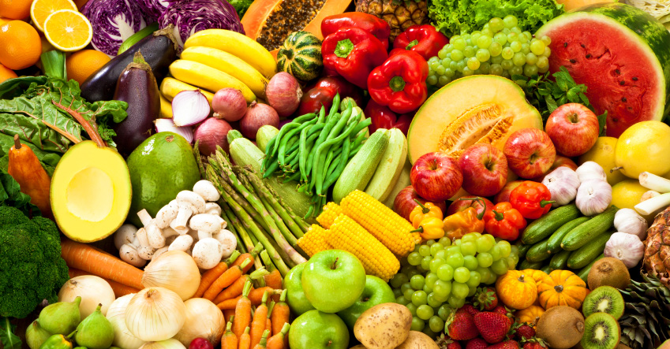

2. Dairy produce
Key information
Rich in vitamin A,D,B trace of C | Cream- single, double, whipping, clotted
High risk foods | Cheese- hard, soft, blue
Not suitable for lactose intolerant people | Parmesan, cheddar, soft- Brie, camembert and blue veined-stilton
Needs to be refrigerated at 5c or below | Uses of cheese
Widely available | Provides flavour
Milk can be consumed in many forms | Provides colour
Whole | Provides texture
Semi skimmed | Adds nutritional value
Skimmed | High biological value
Alternative milk –almond milk, soy milk

3. Carbohydrates
Carbohydrate Key information
Gluten | Protein found in flour which is responsible for the elasticity and stretchiness of the dough.
NSP | Non-starch polysaccharide (Dietary fibre).
Processed | When a raw material is changed to make it more edible.
Fortified | When nutrients are replaced in a food as they have been removed or lost during the processing stage.
Staple foods | A starchy food that is eaten frequently and makes a valuable energy contribution to the daily diet.
Contamination | Infected by bacteria which could lead to food poisoning.
Proving | Putting dough in a warm place for the yeast to become active

4. Technical Key words
Key word | Meaning
Commodity | Raw agricultural commodities which are either consumed raw or processed (wheat into flour).
Staple food | A food which is eaten regularly and makes a significant contribution to our diet like bread.
Unleavened bread | Bread which has no raising agent.
Cultivated | Grown on a farm under controlled conditions.
Processed | Changes made to a raw material to make it edible.
Fortified | When nutrients are replaced or added after processing.
Harvested | Gathering or picking of crops.
Durum wheat | Wheat which contains a high level of protein.
Seasonal | The time of year when food is at its peak in terms of harvest, flavour and at its cheapest.
High risk foods | Food which have ideal conditions for the growth of bacteria.

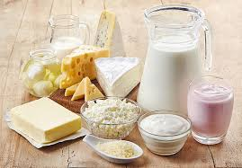
Task: 1- 4 Learn/cover/write and self-check Fruit & Veg, Dairy produce, carbohydrates and technical Key words.

