1. Fruit Key information
There are 4 main groups of fruits:
- hard fruits, e.g. apples
- soft/berry fruits, e.g. raspberries
- Citrus fruits, e.g. lemons
- Stone fruits, e.g. peaches.
Other fruits, often called exotic or tropical, can include papaya and mango.
Many fruits grown in the UK can be from a particular region of the country. Fruits that are not grown in the UK are imported from other countries.
Many types of fruits are seasonal, which means they are only grown at certain times of the year.
Fruits can be bought dried, fresh, canned, bottled and frozen.
Healthy diet guidelines recommend that 5-7 portions of fruit and vegetables are eaten every day.
Various nutrients can be supplied by eating a range of different fruits. These include key vitamins A, C and E, Carbohydrates and the minerals potassium and magnesium. Fruits provide dietary fibre (NSP).
Hard fruits should be stored in the fridge or kept at room temperature. Soft /berry fruits should be stored in the fridge. Same should be done for stone fruits and citrus fruits.

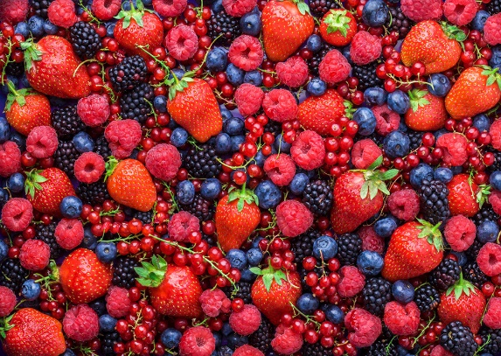
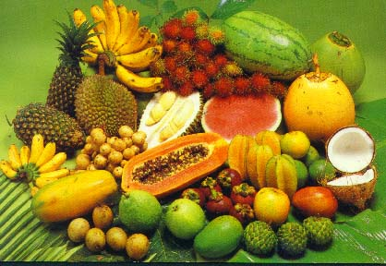

2. Vegetables Key information
Vegetables are grown above and below the ground depending on the type.
Vegetables are grouped according to the different part of the plant they come from:
- Fruits and seeds -peppers, sweetcorn, peas
- Flowers – broccoli, cauliflower
- Leaves – spinach , cabbage
- Stems – celery, asparagus
- Shoots – bamboo shoots, pea shoots
- Tubers – potatoes, sweet potatoes
- Roots – parsnips, swede, carrots
- Bulbs – Leeks, onions
Vegetables are very versatile; they can be eaten raw and juiced, and they can be cooked using various methods of cooking.
Eating a range of different vegetables on a daily basis will provide the body with nutrients such as carbohydrates, protein, vitamins A, C and E, dietary fibre (NSP), calcium and iron.
Fresh, raw, green vegetables can have a higher vitamin C value. Cooking them can reduce this.
Chilled storage for short term is best for many fresh, green types of vegetables to reduce the loss of nutrients. Nutritional value reduces with longer storage.
Root and bulb vegetables can be stored in dry, well-ventilated, cooler areas.

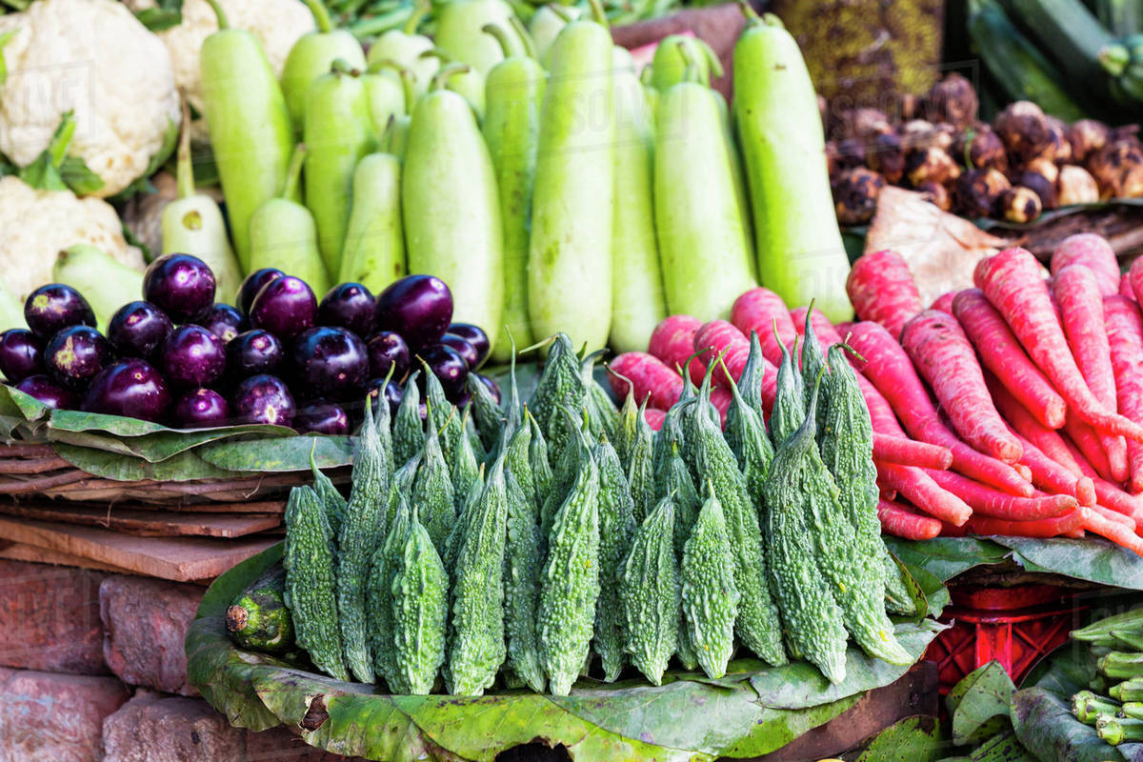
Task: 1- 2 Learn/cover/write and self-check; fruits and vegetables.

