1. Fish Key information
There are three main classifications of fish:
- White fish has white flesh and contains less fat. White fish can be round or flat, e.g. cod, haddock, plaice, sole.
- Oily fish has coloured flesh and contains more fat than white fish but this is healthy fat with fish oils. Examples include salmon, sardines, mackerel and tuna.
- Shellfish that usually has a hard backbone which must be removed during preparation. Examples include crabs, lobsters, shrimp and squid.
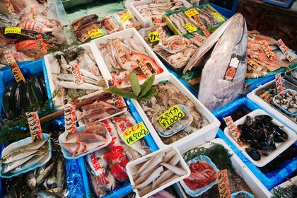
How to purchase fish safely
When buying fish check that the eyes are bright, not dull, scales are in place, gills are bright red, it has a fresh smell of the sea, and the flesh is firm.
Preserving fish
Fish can be preserved by canning, freezing, smoking, and salting.
Fish cooks quickly because the muscle is short and the connective tissue is thin. The connective tissue is made up of collagen and will change into gelatine and coagulate at 75.C.
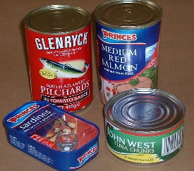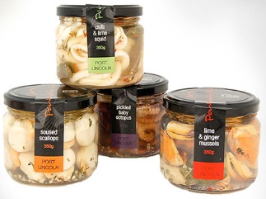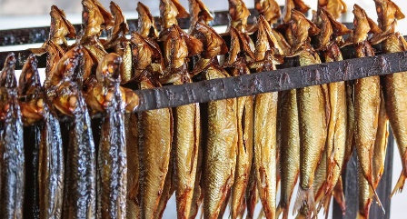
Cooking fish
Fish can be grilled, baked or fried. Fish is often enrobed in breadcrumbs/batter to protect it when using high heat.
Fish can also be cooked gently by steaming or poaching without coating the flesh.

Fish facts
Fish is high in protein, iron, zinc and iodine. It also contains Vitamins A and D.
Oily fish contains Omega-3 fatty acids for brain development, healthy bones and joints.
Fresh fish is best eaten on the day it has been bought.
Shellfish must be prepared and eaten within two days of purchase.
Fresh fish must be stored in the refrigerator.
Fresh fish can be frozen on the day it has been bought and stored for several months, it must be defrosted before use.

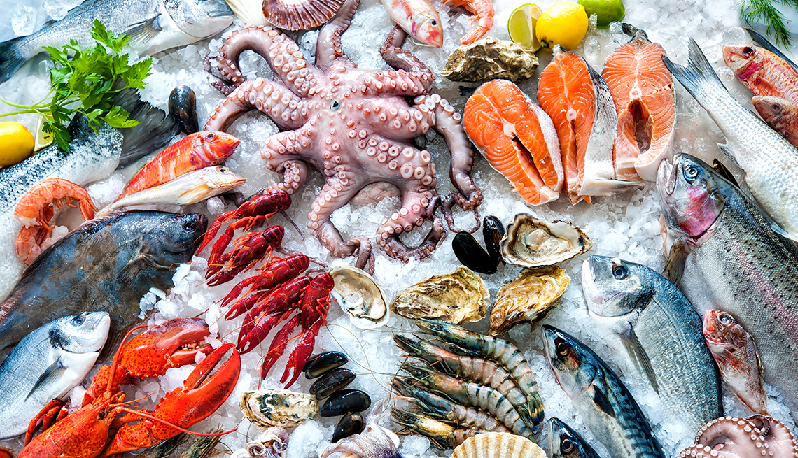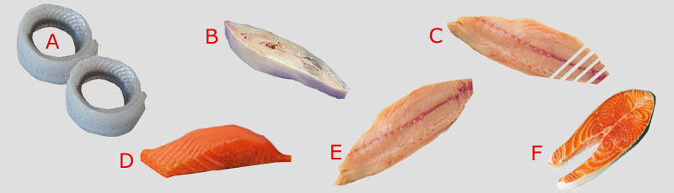
Task: Learn/cover/write and self-check; all information on fish.
Task: Learn/cover/write and self-check; all information on meat.

