- Testing the design AO3
When you have completed making your product you ned to test the prototype to ensure it works correctly.
Strength and stress loadings may need testing:
  - Is it safe?
  - Does it function at the appropriate temperature?
  - Does it work?
Physical testing | Target market opinion | Checklist
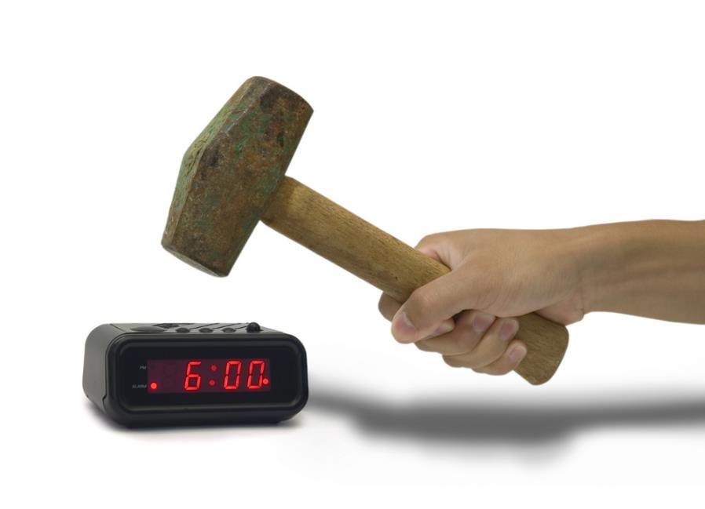 |  | 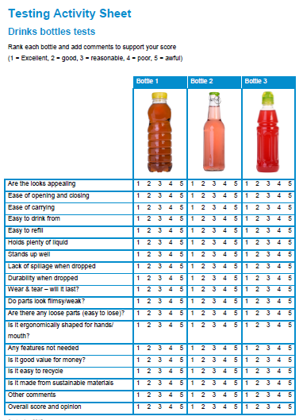

 | - Survey AO3
 | Complete a focus group/Survey with a compiled list of relevant questions.
 | Example Questions:
What are your two favourite colours generally?
How much would you pay for this product?
What did you like/dislike?
How long would you expect this product to last for?
What would you like this product to do better/improvements?
Would you generally buy a cheaper, less attractive product or a more expensive, more attractive product?

- Evaluate against original Specification AO3
Evaluated the prototype against the original specification points.  Underneath each spec point, discuss if the product has met the specification point. |  | 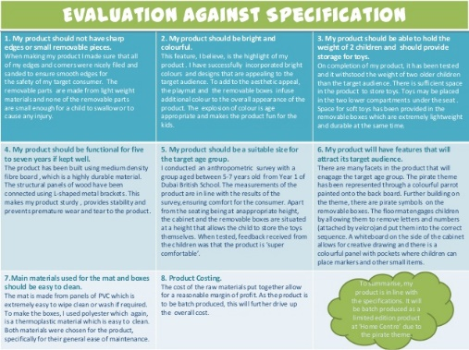

- Final evaluation AO3
Produce an in-depth essay on the success of your prototype.  You must discuss what went well or wrong. | 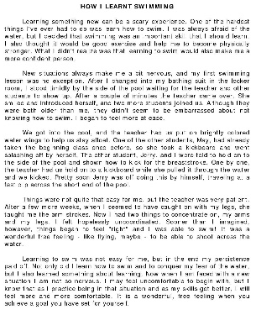

- Improvements AO3
Create a page to show and explain how the product could be improved.  Make a list of improvement and justify your reasons for the improvements, using notes and sketches. | 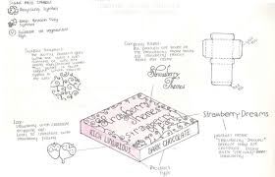

Task: 1-5 Learn/cover/write and self-check, testing, survey, evaluation against spec, final evaluation and improvements page.

