- Potential making processes A02
Create a selection of making processes and give reasons for your decision making.
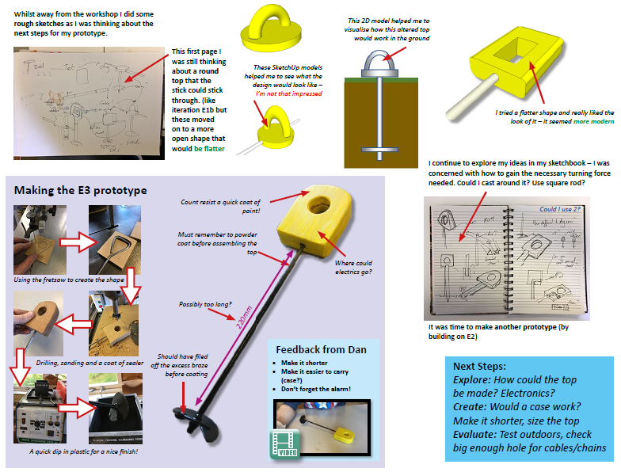 |  | This construction methods page is a mix of sketchup images, hand drawn sketches and model making photos. The designer has also annotated their decision making at each stage.
The designer has used a table to complete their construction method page. They have also used notes to explain their decision making.  This could also add images of various joining methods. | 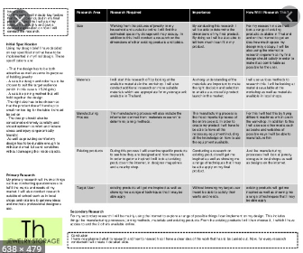
Tips:
-Use text books and past practical’s to consider how the product can be made.
-Use the internet and YouTube to gain construction ideas for how to make your product.

- Planning the making process A02
-Planning steps for making and finishing processes, with Quality Control checkpoints.
-Quality assurance is required to ensure the product is accurate as it I being manufactured.
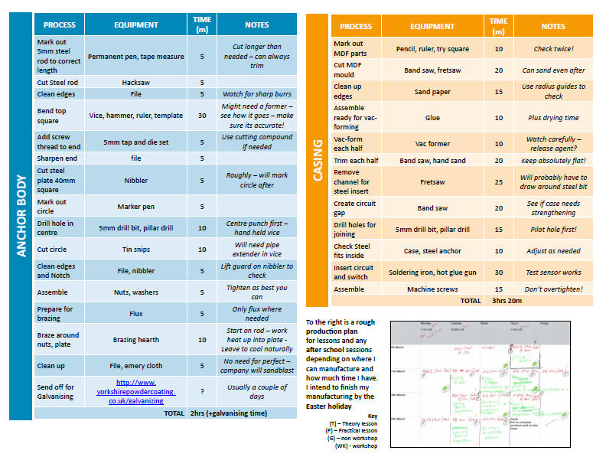

You will need to create a table with the following headings:
Task, Time, Tools, H&S and Quality Control questions.
You may have several tables for specific section of construction.

- Practical tips AO2
-Ensure the thickness of your materials are correct and are in line with your choices.

-Using the correct tools such as try square, steel rule, mitre square etc. to measure, mark out and cut joints, is essential to the whole making process.

-Having Quality control checkpoints throughout the making ensures less mistakes can be made.

Task: 1-3 Learn/cover/write and self-check, potential making processes, planning and practical tips.

