- Initial design ideas - A02
Methods:
-Sketches with various views
-Zoom in on details
-Modelling with graphic materials (print the images and use to add more detail).
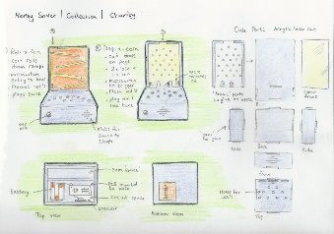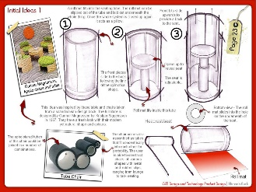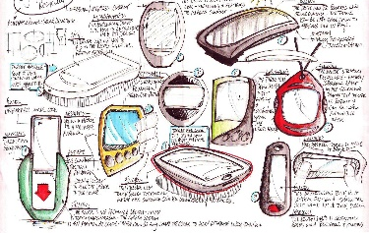

Notation:
-Use notes to explain how your ideas work. E.g. ergonomic consideration, colour choices, material consideration, potential construction methods etc.

- Further Research A02
Research must be undertaken to consider the best requirements for the product.
-This can be achieved using the internet, books, wall displays and varies basic construction methods | -Social, Moral and Economic issues require a deeper understanding and examples could be soured where applicable to the product.
You need to consider:  - A selection of materials and their properties.  - Product finishes  - Ergonomics  - Component choices  - Stock form selection | Consider how the above have an impact on your product:  Social – Is your chosen material acceptable to all society.  Moral - Low impact on the environment, material from living organism, was it killed humanely?  Economic –has the cost been affected by your choices
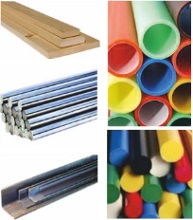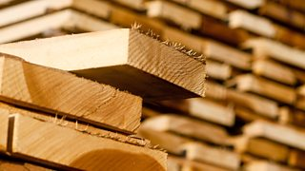 | 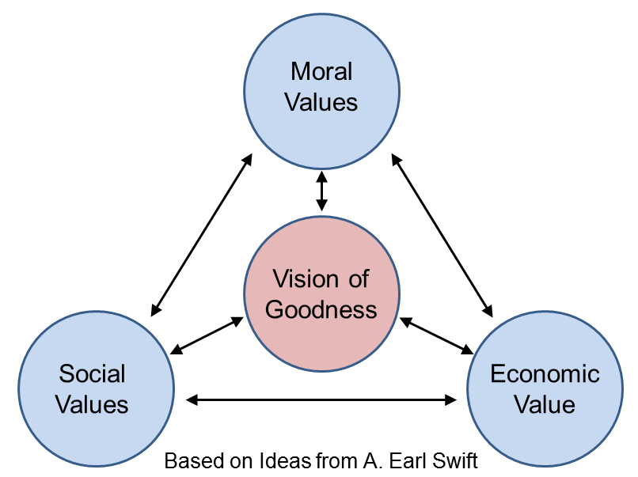

- Product elevations A02
You must produce various elevation of final design accurately:
a. Use of 1cm² graph paper.
b. Publisher
c. Sketch Up
d. Isometric exploded drawing
a.  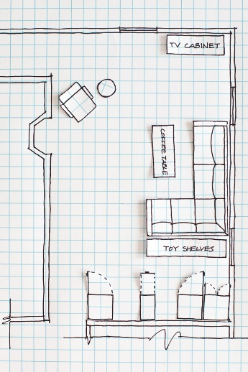 | b.  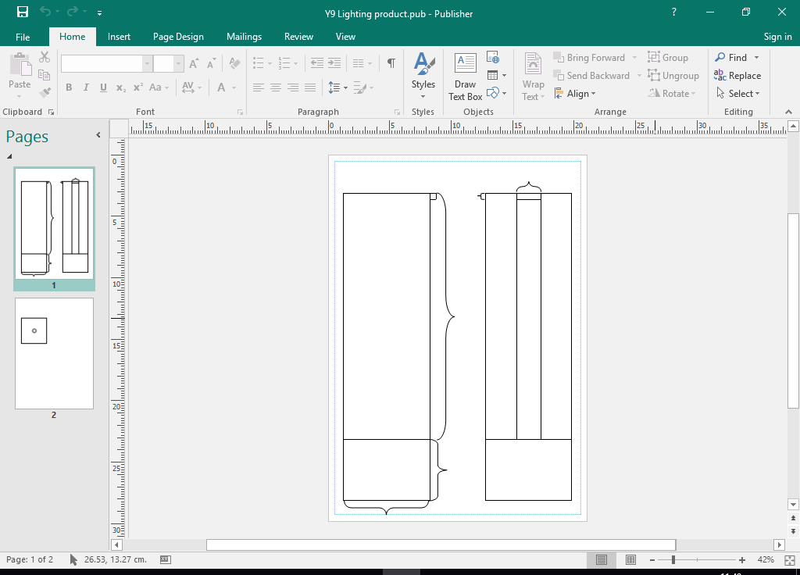
c.  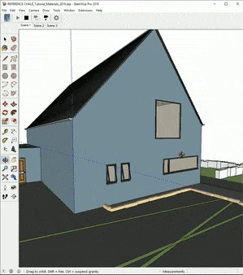 |  | d.  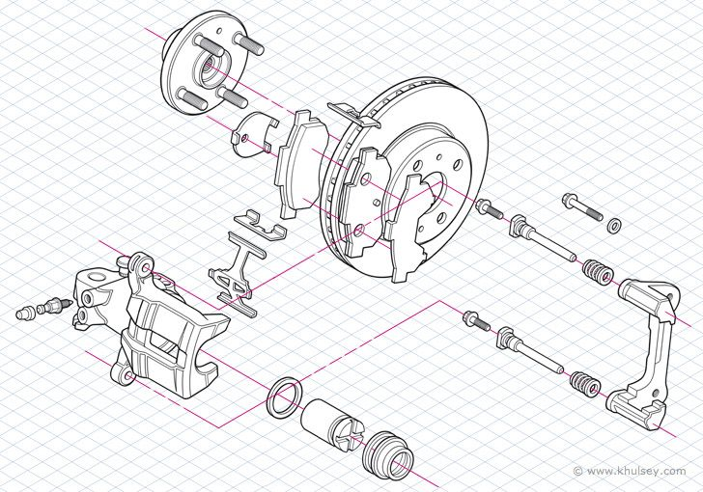

Task: 1-3 Learn/cover/write and self-check, initial design ideas, further research and product elevations.

