- Choosing a design brief A01
Before choosing a brief you need to create word storms for all of the briefs. In your word storm you need to consider the 5 W’s; Who, What, Where, Why, When
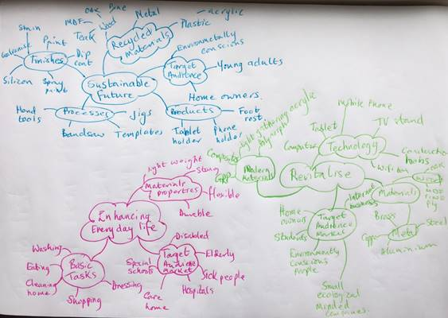 | Word storm heading:  Target Market  Target Audience  Materials  Products  Sustainability  Technology | Making processes  Ergonomics  Social, moral & economic issues  Modern materials
You know which brief you prefer as this will be the one you write about the most.

- Your chosen brief A01
Once you have chosen your brief you need to explain to the reader your reasons for choosing it.  -Think about the design brief and consider who the target audience/market is. See questions below:  Who is it for? Who will purchase it? Who will sell it? Where can it be purchased?  This can be achieved using lists, word storms or however you choose. | 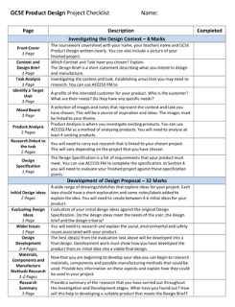

- Research A01
-Under take a variety of research using various source e.g. internet, surveys or government information.
-Find a selection of similar existing products and discuss them using heading from a design specification.
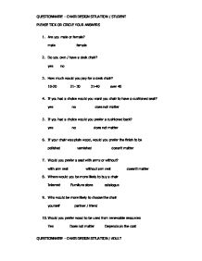

- Product Analysis A01
-Choose one existing product to complete an in-depth product analysis.  -Create potential market research questions.  -Summarise how the research has formed your ideas. | 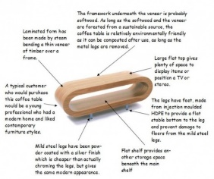

- Problems/Solution and Final design brief. A01
-Problems which could arise, could be relating to materials, H&S, ergonomics, aesthetics, anthropometric data etc. |  | 
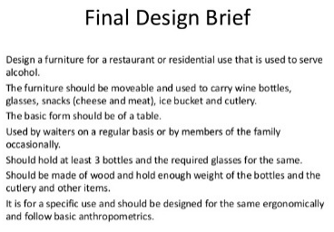 | -Final design brief should answer the 5 W’s; who, what, when, where and why.

- Design Specification A01
A design specification is a key document which essential for all products.
Design Specification Heading’s:
- Materials  - Function  - Ergonomic  - Anthropometric Data  - Manufacture | - H&S  - Target audience  - Target market  - Aesthetics  - Finish
You will need to select eight headings and write two specification points under each heading.

Task: 1- Learn/cover/write and self-check, choosing a design brief, your chosen brief, research, product analysis, problems & solution, final brief and final specification.

