
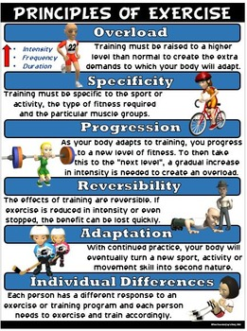
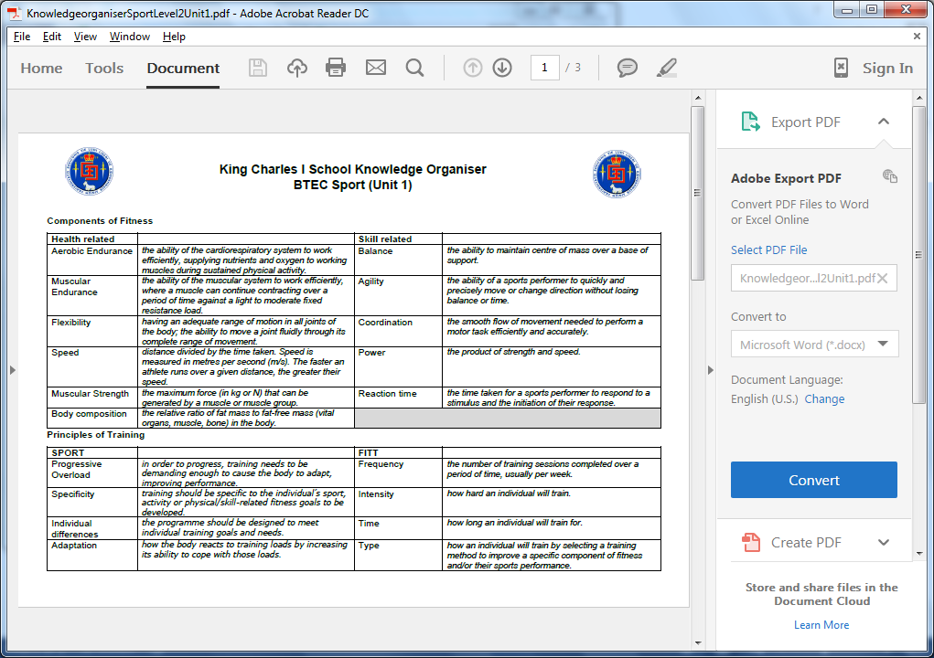
- Define the principle of training and apply them to a sport
- Describe the FITT principles and apply them to my sport
- Learn the methods of training and describe them
- Identify what components of fitness the method improves and what sport would use it
EXT. Look at the example below of a pre-season training regime for a rugby team. For your own sport can you think of your own training programme using the methods of training and one that encompasses the principles of training.
PHYSICAL EDUCATION – The Principles and Methods of Training


