Cardiovascular Fitness | Muscular Endurance | Muscular Strength | Flexibility | Power | Agility | Balance | Coordination | Speed | Reaction Time
12 Minute Cooper Run | 60 Second Sit-Ups | Hand Grip Dynamometer | Standing Stork Test | Sargent Jump | Illinois Agility Run | Standing Stork | Alternate Hand Wall Throw. | 30 Metre Sprint | Ruler Drop Test


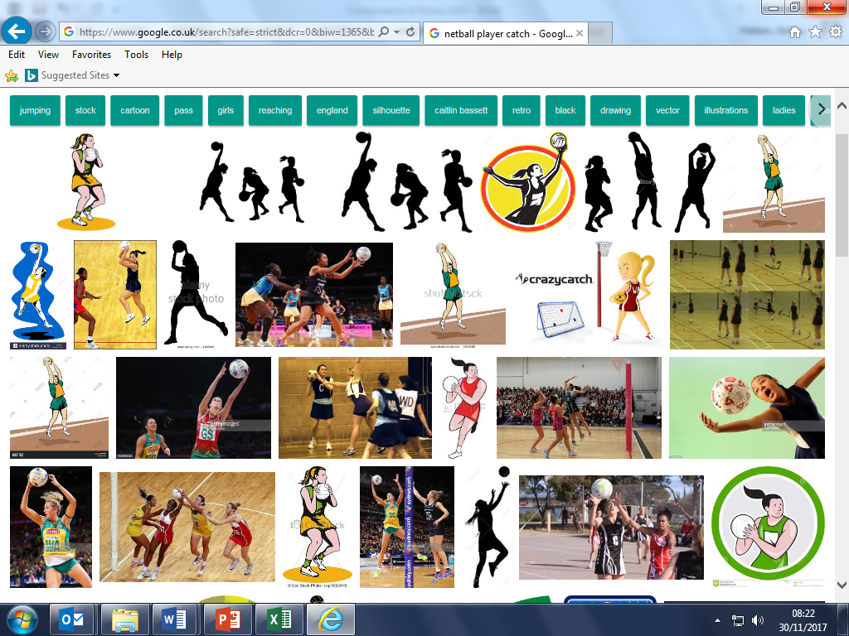



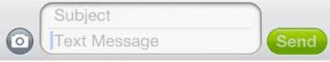
You should definitely work on Cardiovascular and Muscular Endurance, Mo.
Hi David, you should be focussing on Agility and Reaction time. Then Leicester might not beat you…
- Understand how to test a component of fitness.
- Be able to relate a Component of Fitness to a sportsmen.
Coordination, Speed, Balance, Reaction Time.
Muscular Strength and Endurance and Power.
Agility, Coordination, Speed and Power
- Remember all of the components of fitness and their definitions.
PHYSICAL EDUCATION – Components of Fitness
Cardiovascular Fitness- The ability to work the entire body for long periods of time without tiring.
Muscular Endurance- To work the same muscle over and over without tiring.
Muscular Strength- The maximum amount of force a muscle can exert in one movement.
Flexibility- The range of movement at a joint.
Power- The combination of strength and speed.
Agility- The ability to change direction at speed.
Balance- The ability of the performer to retain their centre of mass over their base of support without falling.
Coordination- The ability to move two or more body parts at the same time.
Reaction Time- The time between the presentation of a stimulus and movement.
Speed- The ability to cover a distance in the shortest time possible.
Body Composition- The % of fat, muscle and bone.

- Reply to the athlete’s concerns.

