
PHYSICAL EDUCATION – Effects of Exercise
- Name the four systems and give sporting examples where they are important
- List the long term effects on each system
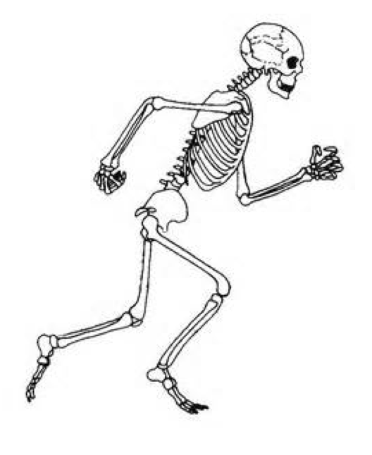 | SKELETAL SYSTEM:  - Bone density increases
 | MUSCULAR ENDURANCE:  - Muscle hypertrophy occurs.  - Muscular strength increases.  - Muscular endurance increases.  - Resistance to fatigue increases.
 | CARDIOVASCULAR ENDURANCE:  - Heart hypertrophy occurs.  - Resting heart rate decreases.  - Resting stroke volume increases.  - Cardiac output increases.  - Recovery rate increases.
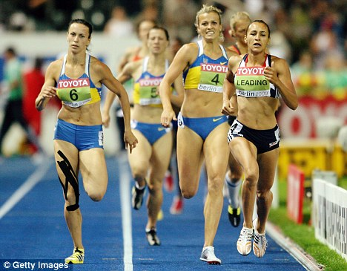 | RESPIRATORY SYSTEM:  - Aerobic capacity increases.  - Respiratory muscles become stronger.  - Tidal volume during exercise increases.  - Minute ventilation during exercise increases.

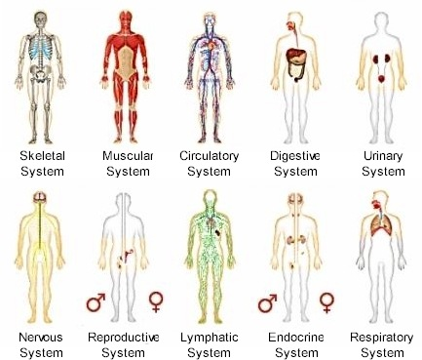
- Short term effects of exercise.Remember the short term effects of exercise on the different body systems

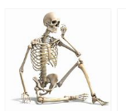 | SKELETAL SYSTEM:  There are no short term effect of exercise on the skeletal system!!!!!
 | MUSCULAR ENDURANCE:  When we exercise our muscle respond in a number of ways  - The temperature of our muscles increases.  - Build up of waste products like Lactic acid in the muscles.  - Blood is redistributed to the working muscles, known as the vascular. So there is an increased supply of oxygen to the muscles.
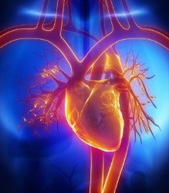 | CARDIOVASCULAR ENDURANCE:  - Heart rate increases. The heart beats faster to increase the flow of blood around the body especially to the working muscles.  - Stroke volume increases. More blood is pumped per beat as the heart expands to allow more blood in and out per beat.  - Cardiac Output increases (HR X SV = CO)  - Vascular Shunt occurs = Blood is redistributed to the working muscles.
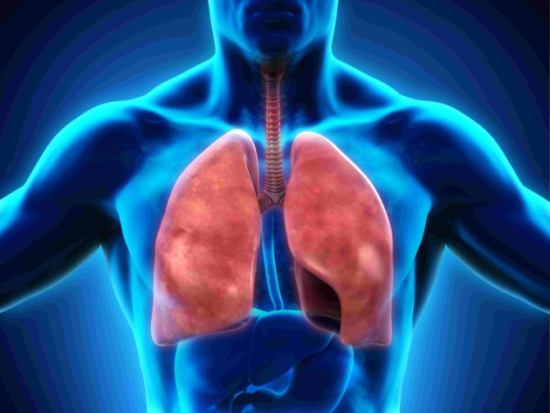 | RESPIRATORY SYSTEM:  - Respiratory rate increases.  - Minute ventilation increases.  - Tidal volume increases.

4. Analyse the benefits of long term exercise on the body compared to a sedentary lifestyle


