Plane of movement | Diagram | Sporting example
Saggital  Splits body left to right  Movement: Flexion & extension | 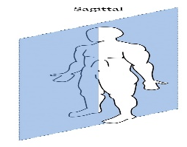 | 
Transverse  Splits body upper and lower  Movement: Rotation | 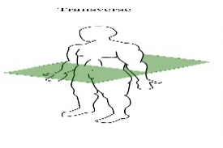 | 
Frontal  Splits body front to back  Movement: Abduction and Adduction | 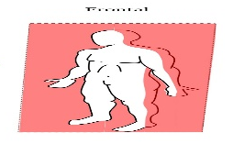 | 
Task4: Know the axes of the body and apply sporting examples
Longitudinal  Runs vertically from top to bottom | 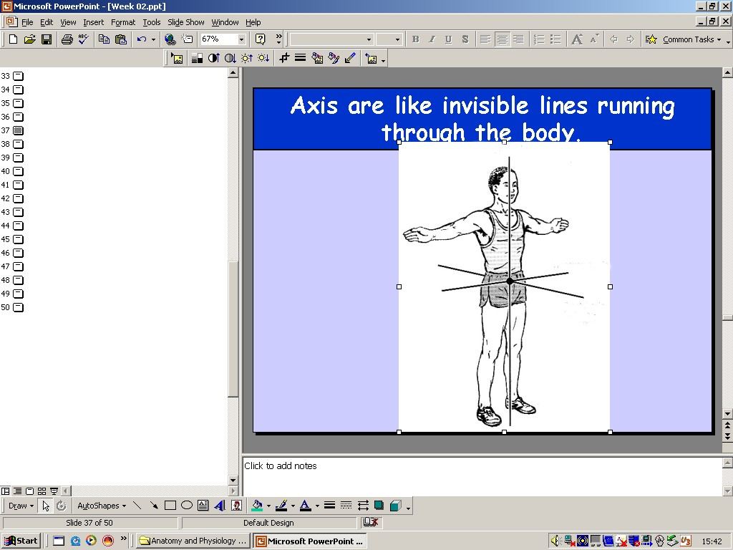 | 
Transverse  Runs horizontally from left to right | 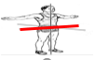 | 
Frontal  Runs horizontally from back to front | 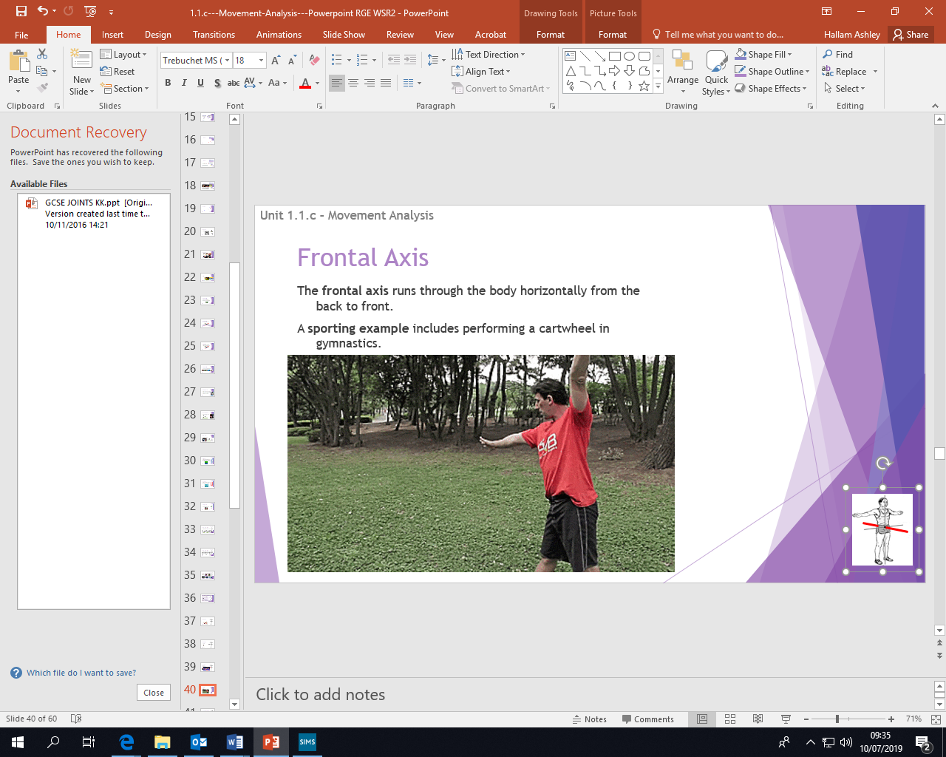 | 
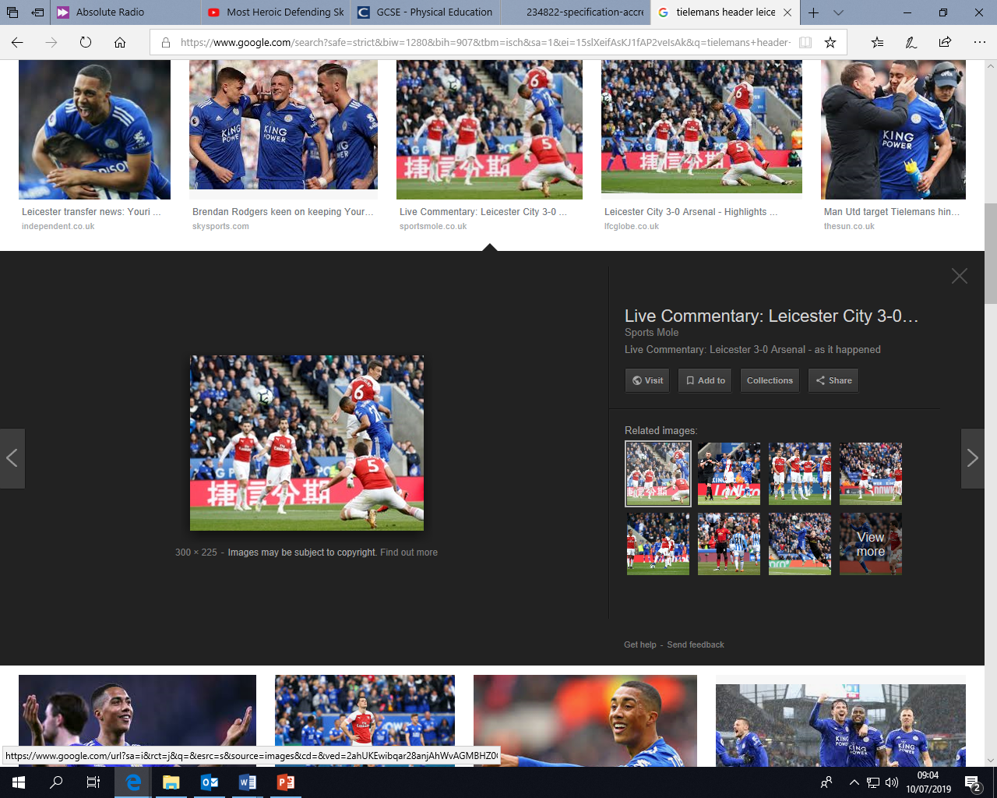
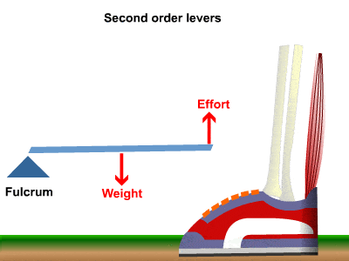
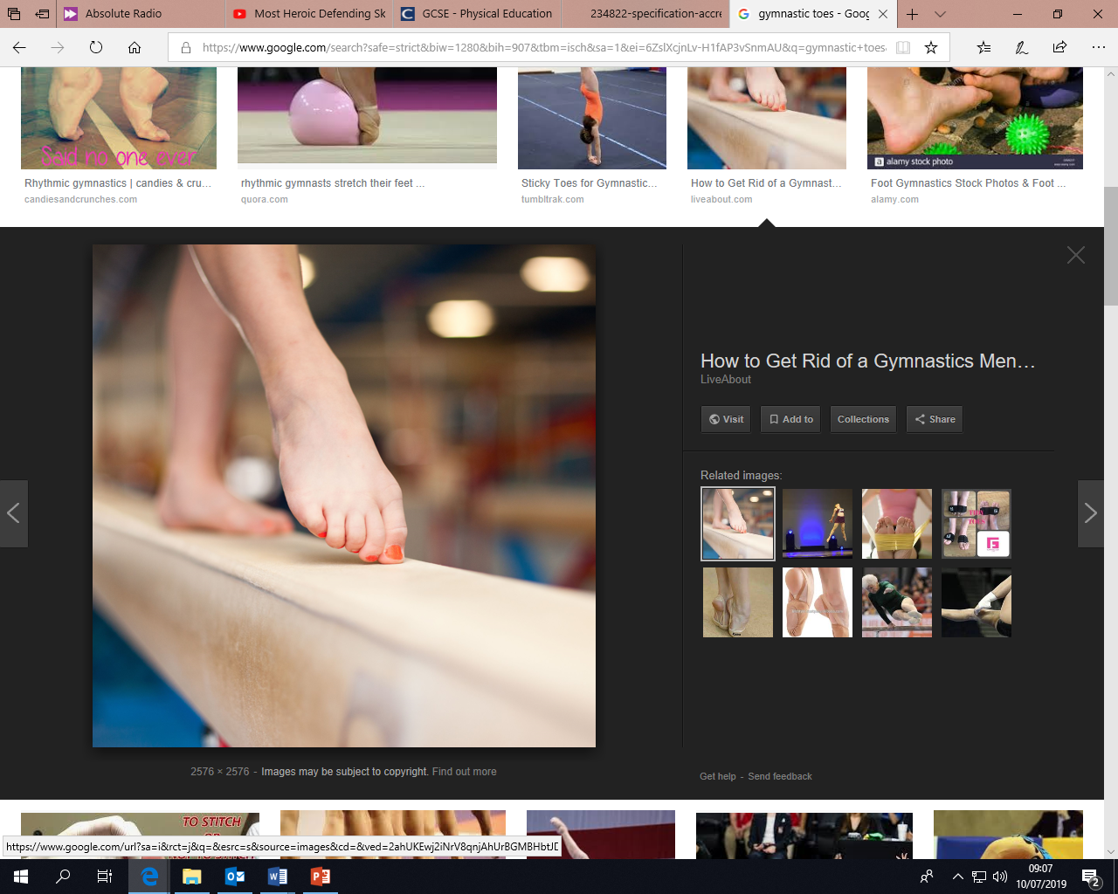
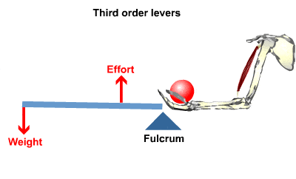

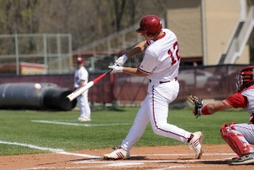


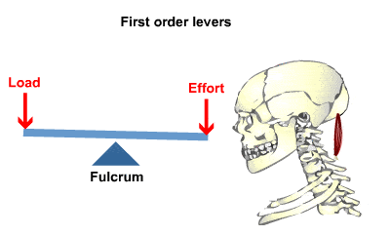
Task2: Understand what mechanical advantage is
Levers are used to make a small amount of force into a bigger amount of force. This is known as gaining a mechanical advantage.
A mechanical advantage is when a lever allows you to move a large load with a smaller effort.

PHYSICAL EDUCATION – Movement analysis
Task1: To know the levers of the body
1 2 3
F L E
Task3: Know the planes of the body and apply sporting examples
Sporting example

