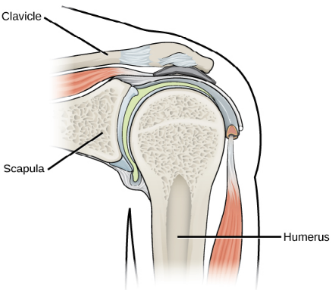
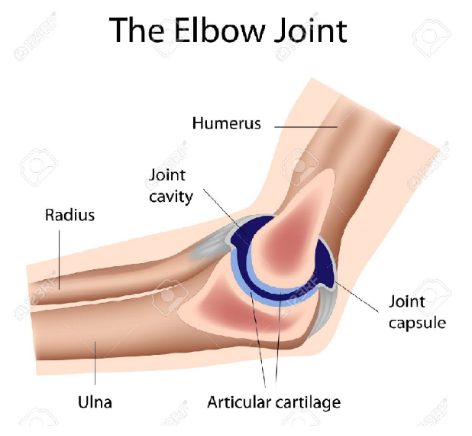
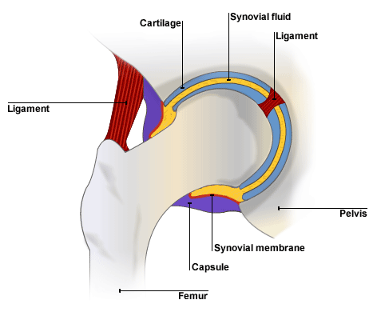
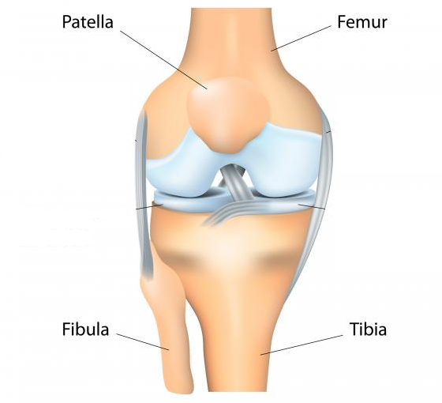
3. Types of Joints
The Skeletal System
- Location of Major Bones
- THE LOCATION OF MAJOR BONES

3. TYPES OF JOINTS

Type | Example | Bones | Possible movements
Ball and socket | Shoulder | Humerus and Scapula | - Flexion and Extension  - Adduction and Abduction  - Rotation  - Circumduction
Ball and socket | Hip | Femur and Pelvis
Hinge | Elbow | Humerus, Radius and Ulna | - Flexion and Extension
Hinge | Knee | Femur and Tibia | - Flexion and Extension

ELBOW
SHOULDER
HIP
KNEE


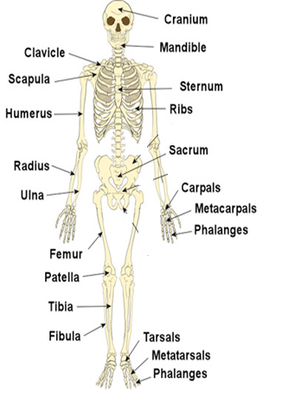

2. FUNCTIONS OF THE SKELETON

Function | Definition | How does it affect performance?
Shape and support | Bones give shape to our body and keeps vital organs in place | The spine holds the body upright
Movement | Allows movement of the body | Performers need to be able to move to “play the game”
Protection | Bones protect vital organs | Reduces the chances of injury. Rib cage protects heart and lungs when a rugby player is tackled.
Production of blood cells | Red blood cells are produced | The more red blood cells, the more oxygen can be carried to the working muscles.
Storage of minerals | Storage of calcium and iron | Essential for good health and growth.

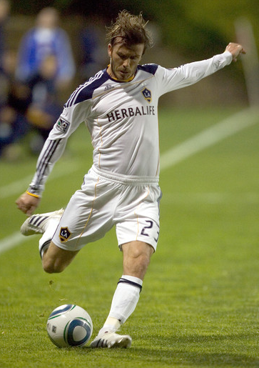
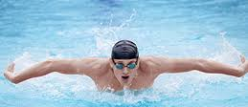
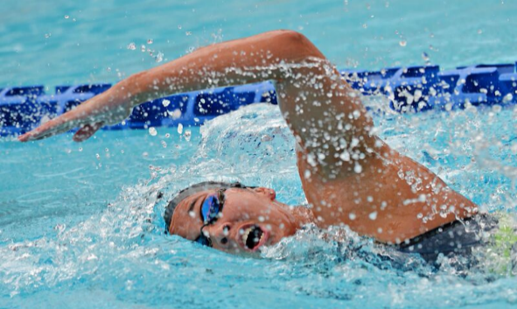
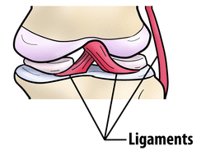
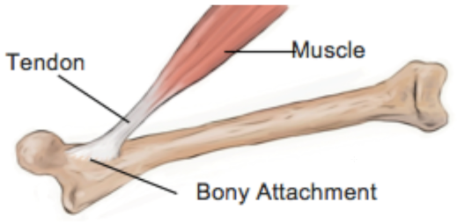
6. Homework Tasks
5. Components
4. Types of movement possible at a joint
4. TYPES OF MOVEMENT POSSIBLE AT JOINTS
Type of movement | Definition | Sporting example
FLEXION | Closing the angle at a joint | Holding the javelin before the throw
EXTENSION | Opening the angle at a joint | Basketball player’s elbow when shooting
ADDUCTION | Movement towards the centre of the line of the body | Preparation to throw the discus
ABDUCTION | Movement away from the centre line of the body | Shoulder action when throwing the discus
ROTATION | Joint moves in a circular way | Tennis player’s shoulder when serving
CIRCUMDUCTION | Continuous circular movement around a joint | Swimmer’s arm when performing front stroke

Adduction
Abduction
Extension
Flexion
Circumduction
Rotation
5. Other components:
Component | Function
Ligaments | - Attach bone to bone;  - Keep joint stable.
Tendons | - Attach muscle to bone;  - Transmits power to move bones.
Cartilage | - Reduces friction;  - Shock absorber for the joint.

Homework tasks:
- Learn the names and location of the bones in diagram 1.

- Understand the different functions of the skeleton in table 2 and how they impact / aid sports performance.

- Learn the different types of joints in table 3 and recognise what movements are possible at each of the joints.

- Define and demonstrate the different movements possible at a joints in table 4. Give examples of sporting actions.

- Learn different components that form a joint in table 5 and their functions.

