1. Stages of making paper
Stage | Explanations
Mixing | Natural cellulose fibres are mixed with water
Heating | The mixture is heated to break down the cellulose and create a liquid called pulp.
Drainage | The pulp is fed on a mesh conveyor to drain the surplus water.
Forming | The damp fibres are then passed through several rollers to press form and dry the pulp. This is then rolled onto big rollers in a continuous sheet.
Cutting | The rolled paper is then processed at a later date and cut to the size required.

 | 2. How paper is measured
 | Measurement |  | Description
 | GSM |  | Grams per Square Metre – this is the weight in grams of one metre square.
 | Microns |  | Board is measured in microns – this is the thickness of the materials. 1000 microns equal 1mm.
 | Quire |  | A quire is 25 sheets of paper.
 | Ream |  | A ream is 500 sheets of paper.
 | Bundle |  | A bundle is a 100 sheets of paper.
 | Bale |  | A bale is 5000 sheets of paper.
 | A0, A1, A2, A3, A4, A5, A6, A7, A8 |  | Paper is measured from A0 to A8. A8 is the smallest and as the numbers goes up the size of the paper doubles.
 | 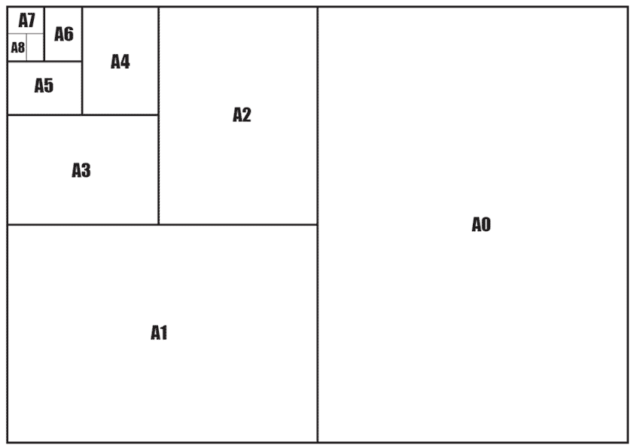
3. Types of paper based materials
Type |  | Description |  | Uses
Cartridge |  | Thick, quality paper with a slight texture |  | Pencil/ink drawings and painting
Bleed proof |  | Smooth with a special coating, so the ink sits on top and does not soak in. |  | Art work, resists bleeding and feathering.
Grid paper |  | Printed with feint lines to enable plotting graphs. |  | Mathematics, architectural and scientific use
Layout paper |  | Translucent to enable tracing. |  | Used for working on sketches designs.
Card board |  | Comes in a range of thicknesses and is versatile. |  | Make models and basic structures
Corrugated cardboard |  | Lightweight, can be printed on impact resistant. |  | Commonly used for packaging.
Foil lined board |  | Stiff card lined with foil. |  | Food packaging
Duplex board |  | Card with a wax coated layer. |  | Food containers, stationary folders.
Foam board |  | Thin layer of foam sandwiched between two layers of card. |  | Models and presentation boards.
Solid white board |  | High quality board with a white finish. |  | Hard book covers and product packaging.
Ink jet Card |  | The ink sits on the surface of the paper. Smooth and ensures ink coverage and absorbency. Comes in matt and gloss finish. |  | Inkjet printing.

Tasks 1-3 Learn/cover/write and self-check the paper based products stages of making, measuring and list of paper based materials.

1. Classifications of wood
Coniferous | Deciduous
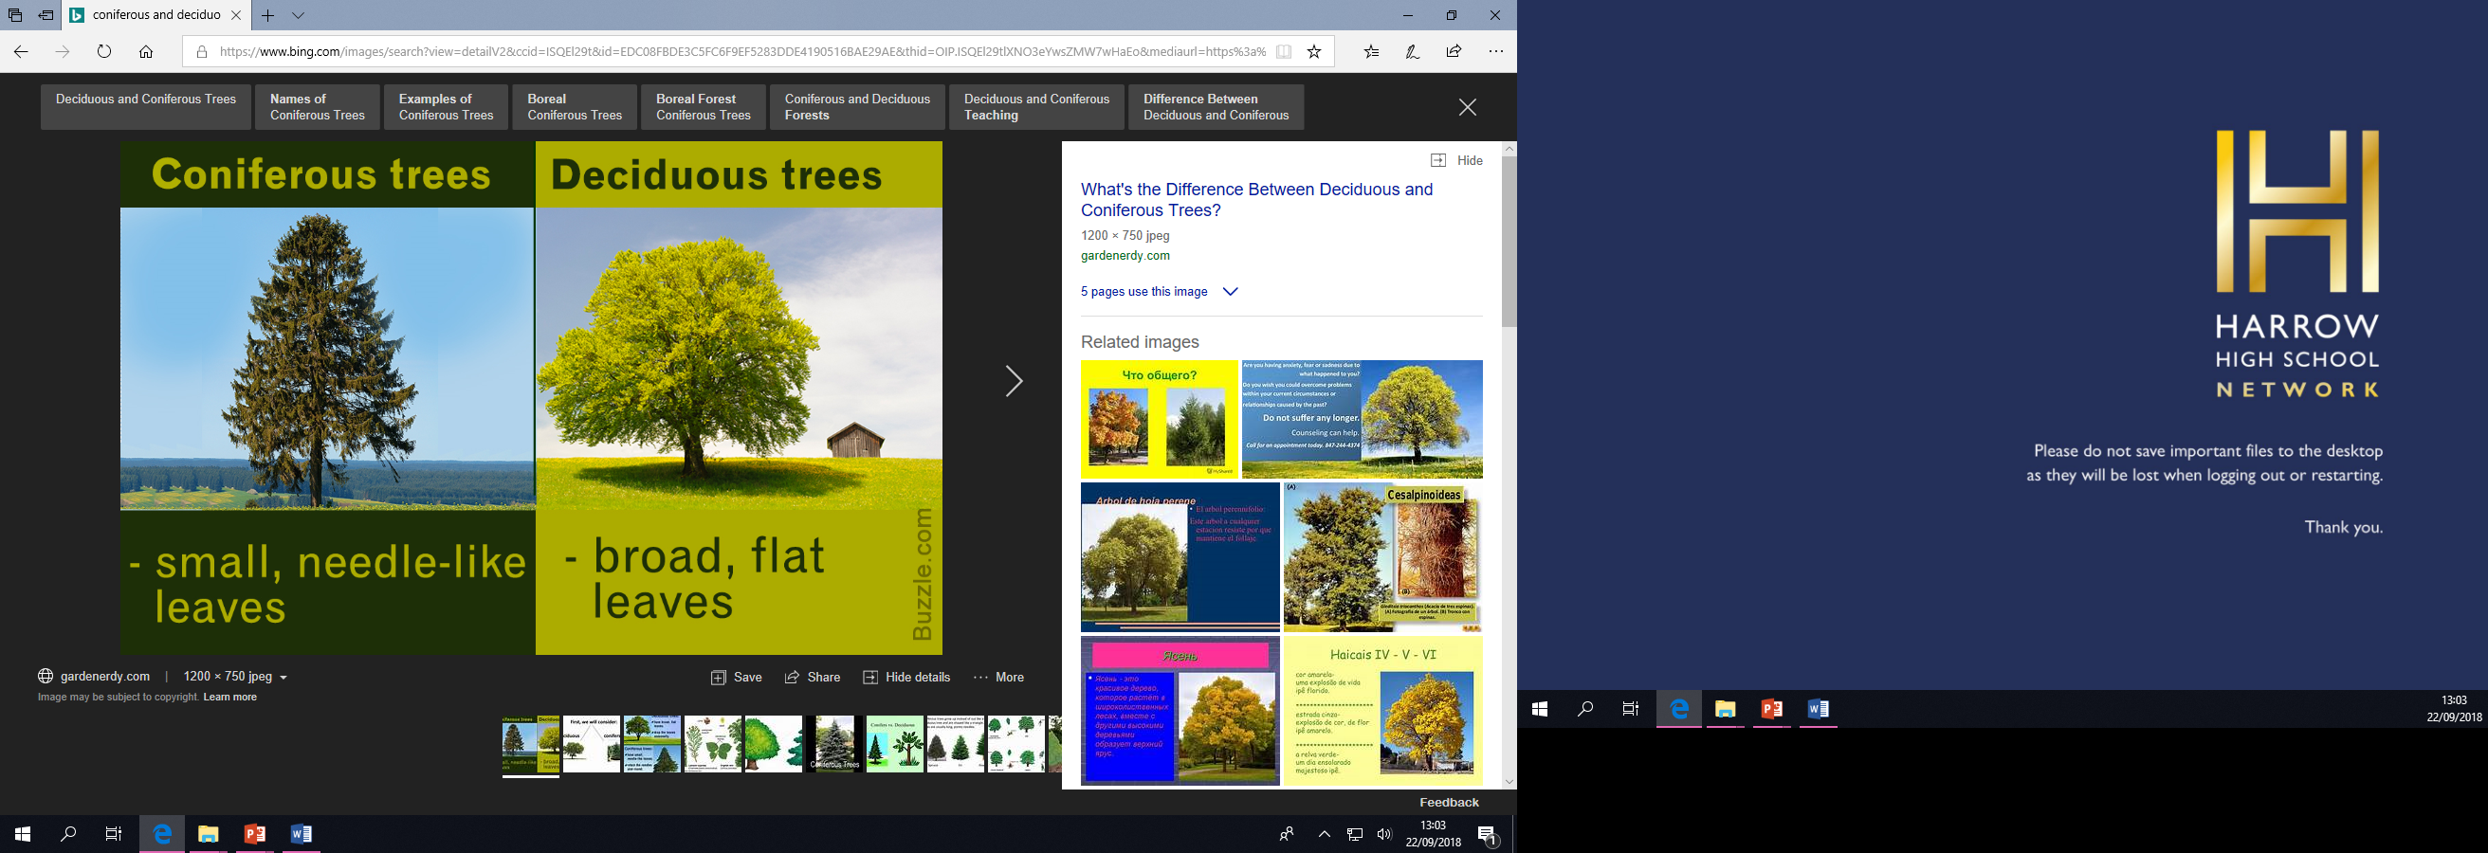 | 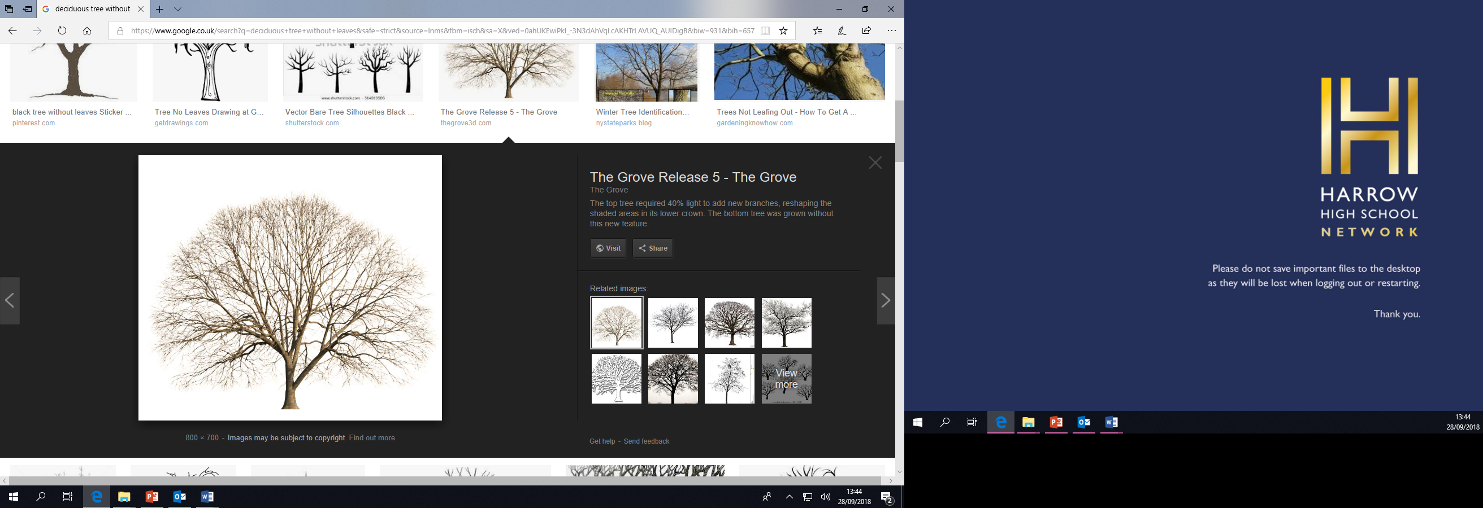
- Ever green all year round. | - Annually loses leafs.
- Needle-like leafs. | - Has broad leafs.
- Grows cones. | - Grows fruits and nuts.
- 30 years to reach maturity | - 100 years to reach maturity
- Grows in cooler climates. | - Grows in warmer climates.

 | 2. Manufactured boards (man-made)
 | Measurement |  | Description |  | Use
 | 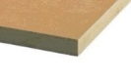  MDF |  | Made by compressing and gluing tiny particles together. |  | Indoor furniture.
 | 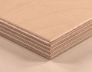  Plywood |  | Made by laminating a number of layers (known as veneers or plies) at 90 degree angles. |  | Doors and boats (marine ply).
 | 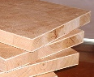  Blockboard |  | Made by first gluing strips of softwood side by side, and then sandwiching them between veneers or plies. |  | Table tops. Work benches
 | 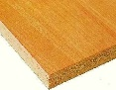  Chipboard |  | Made by compressing and gluing wood chips together. |  | Flooring and veneered kitchen tops.
 | 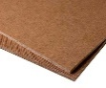  Hardboard |  | Made by compressing and gluing small wood fibres together. |  | Drawer bottoms backs of cabinets.
3. Wood and its uses in construction
Type |  | Classification/ properties |  | Uses
Pine |  | Coniferous - Pine is a soft, white or pale yellow wood which is light weight, straight grained and lacks figure. It resists shrinking and swelling. |  | External cladding, roof rafters, window frames/ sills and doors.
Chipboard |  | Man-made - This creates a rigid board with a relatively smooth surface. Chipboard is available in a number of densities: -normal, medium and high-density. |  | Internal cladding and veneered kitchen worktops.
Cedar |  | Coniferous – light weight, knot free, straight grained and contains natural oils resistant to weather and insects. |  | External cladding
Oak |  | Deciduous - strong, hard, tough, open-grained, corrodes steel screws and fittings |  | External cladding,  flooring, door, timber house frame etc.
Mahogany |  | Deciduous - fairly strong, durable, some interlocking grain |  | Front door internal furniture.
Plywood |  | Man-made - increased stability, high strength, flexibility, fire resistance |  | Internal cladding
Larch |  | Coniferous - Natural strength and durability Larch heartwood is strong and is durable outside without the use of preservatives |  | External/ internal cladding, fencing and boat building.
Beech |  | Deciduous - close-grained, hard, tough, strong, warps easily |  | Window frames/ sills, flooring. Tool handles.
Ash |  | Deciduous - strong, durable the grain is fairly straight, but the wood can be course. |  | Flooring and tool handles.
MDF |  | Man-made – Uniform in size and thickness, takes a good finish and is easy to work with. |  | Laminated flooring or kitchen cupboards.

Tasks 1-3 Learn/cover/write and self-check the wood, classifications and properties.

1. Improving the look of cheaper timber based materials.
Adding a layer of veneer can improve the look of a cheap piece of timber.
  - Veneers may be made from real wood, a man made finish or plastic.
  - Suggest another benefit of surface finishing a manufactured board.
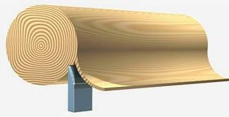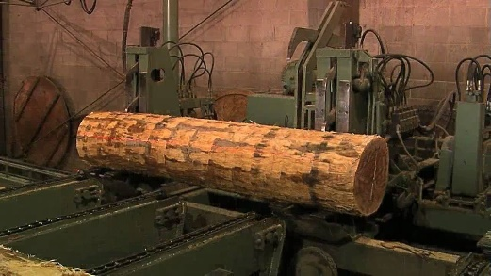

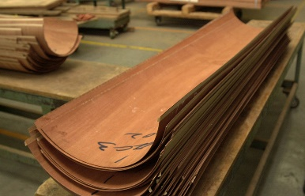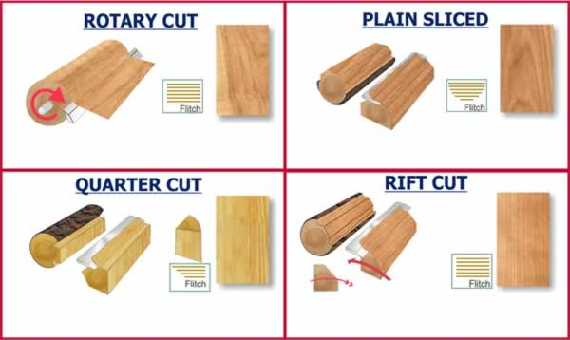

2. Knotty problems - Natural timbers can have natural defects.
  - The most common natural defect is a knot.
  - Softwoods such as pine, larch and cedar can also seep resin at the knot. A knot solution must be used to seal the knot so the oil does not affect the paint.

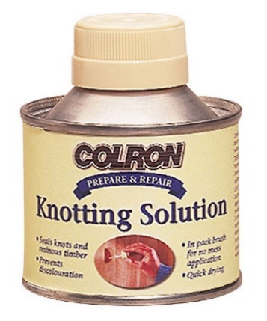

3. Common boards
Important information relating to common manufactured boards below:
Medium density fibreboard or MDF | Chipboard or particle board | Plywood
Very dense board which makes it tough | Good compressive strength | Made up of alternative rotated layers of glued wood veneers
Its smooth surface makes it suitable for veneers and finishes | Edges chip easily | Available in various forms including marine ply for greater water resistance

3. House construction and their material uses
Below is a diagram of what materials are used on various parts of a house.
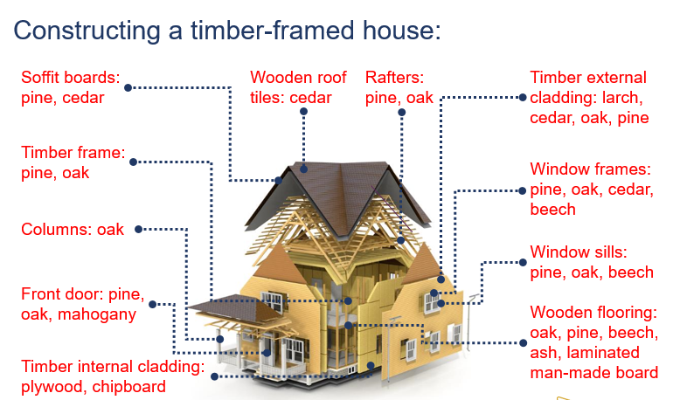

Tasks 1-3 Learn/cover/write and self-check the wood, classifications and properties.

1. Where metal comes from.
The word ‘metal’ comes from the ancient Greek word ‘metallon’ which means to mine, excavate or extract from the ground. The Earth’s crust contains many types of rock.
  - Metallic minerals are found naturally in rock or ore.
  - Ore is obtained by mining and the metals within it are extracted.
  - The method used for extraction depends on the metal’s reactivity with air, water or acids.
  - The more reactive the metal, the more expensive it is to extract.
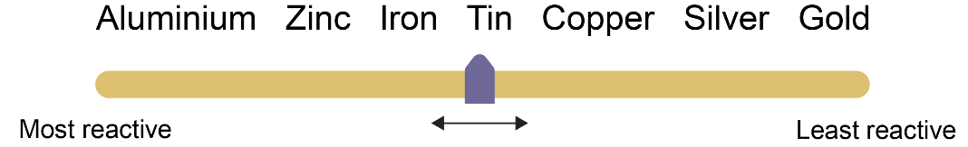

2. Extraction processes
Some metals exist as oxides.
  - Metals such as copper, iron and zinc are oxides. These are heated with carbon to extract the metal.
  - Electrolysis is used to extract metals such as aluminium.

3. Iron ore
Iron can be extracted from iron ore by using a blast furnace and the process of smelting.
  - Smelting extracts common industrial metals such as iron.
  - The extreme heat draws off the metals in a liquid state called ‘hot metal’.
  - The impurities are removed and the iron mixed or ‘alloyed’ with a small amount of carbon to create steel.
  - The amount of added carbon affects the strength of the steel.
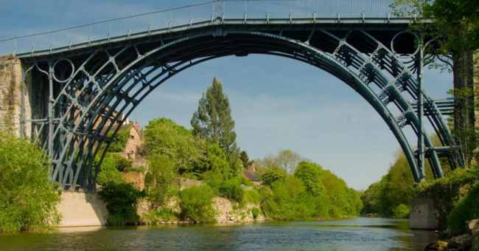

4. Ferrous metals
Ferrous metals contain iron and may rust.
  - Iron and steel can corrode – this is known as rust.
  - Rust is a compound called iron oxide and is formed when iron and oxygen react in the presence of moisture or water.
  - Most ferrous metals are magnetic.
  - Name two types of protective layer that could be added to metal to prevent rust.

5. Ductility and malleability
Ductile metals | Malleable metals
- Will stretch without being damaged.  - Can be drawn or stretched out into long wires.  - Copper is highly ductile and can be drawn into long, thin wires. | - Can be hammered into a shape  without breaking.  - Can be rolled or pressed into sheets.  - Will deform under compression.

6. Hard and tough
Hardness | Toughness
- A material’s ability to withstand abrasion.  - A very hard metal is likely to crack or shatter upon impact or force. Cast iron would be described as hard and brittle. |  | - Toughness – metal requires  strength and ductility.  - This is how well a metal can  absorb energy and resist  fracturing without deforming.

7. Tensile strength
Tensile strength is the amount of tensile stress (stretching) a material can withstand before breaking or failing.
- Testing for tensile strength is crucial in industry.  - Suggest two uses for metals with high tensile strength. | 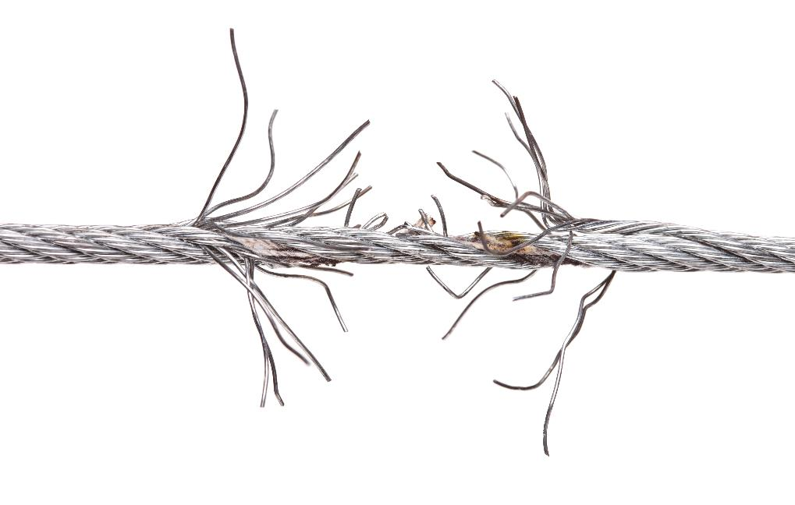

8. Steel
Steel is a ferrous metal available in different forms.
  - Steel has a high resistance to corrosion, staining and friction which makes it suitable for a wide range of uses.
  - These elements give steel its characteristic properties of hardness and toughness.
  - High speed steel is formed by alloying elements of carbon, tungsten, vanadium, cobalt, chromium or molybdenum.

8. Non-ferrous properties
Non-ferrous metals don’t contain iron. They are often more expensive than ferrous metals owing to their desirable properties which include:
- Lightweight  - Good conductivity  - Ductile and malleable  - Resistant to corrosion | The process of galvanising adds a protective coat of zinc to iron and steel to help prevent rusting.
Tasks 1-8 Learn/cover/write and self-check metals part 1.

1. Electrical conductivity
Conductivity is how easily an electrical current can flow through a metal.
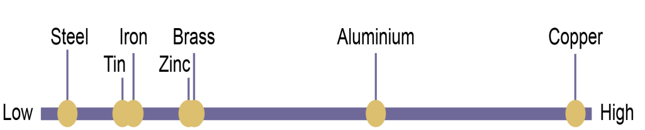
As copper is such an efficient conductor, it’s most common use is in electrical cabling.

2.Thermal conductivity
Thermal conductivity measures the ability of a metal to conduct heat.
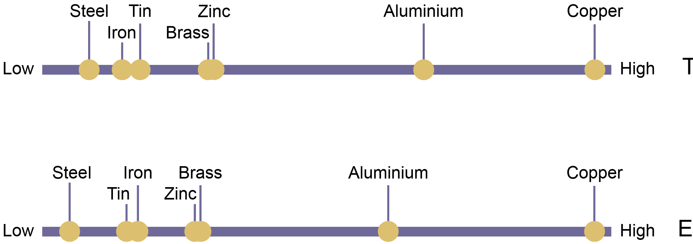
Copper is also an excellent conductor of heat and is commonly used in air conditioning, water tanks, saucepan bases and water heaters.

3. Alloys
Metals are rarely used in their pure form. Alloys are made by combining two or more elements.
- This helps improve the working properties and appearance.
- Brass and steel are common alloys.
- Stainless steel is made by combining iron, with a small amount of carbon and chromium; this protects the alloy from oxygen.
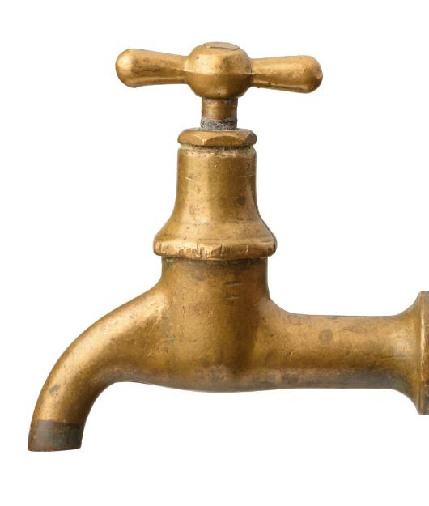

4. Uses of metals
A vast range of metals may be used to create a single product. The diagram below shows a variety of uses for metal.
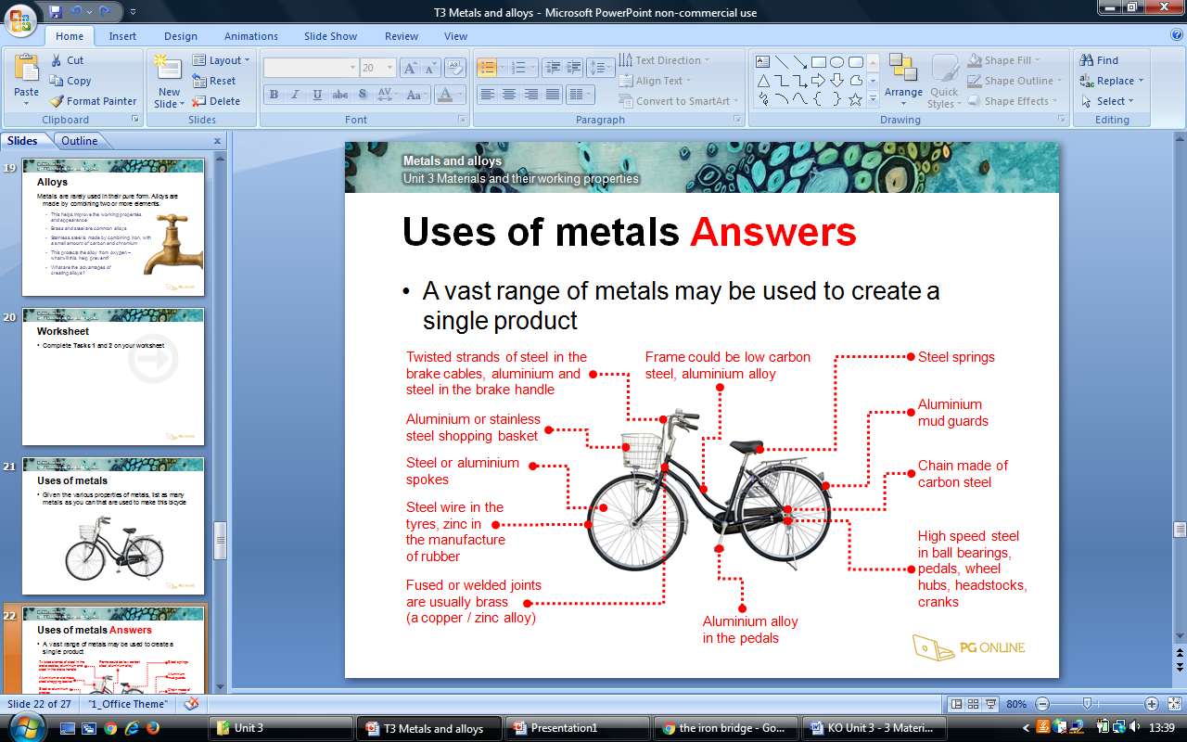

5. List of metals and their classifications
Ferrous metals |  | Non-Ferrous metals | Alloys
- Iron  - Steel  - Mild steel  - High speed steel  - Carbon steel  - Engineered steel |  | - Aluminium  - Aluminium Alloys  - Copper  - Brass  - Lead  - Zinc | - Duralumin  - Brass  - Bronze  - Titanium
Alloys
Alloying agent | Properties |  | Uses
Chromium | Resists wear and increases corrosion resistance. Increases hardness and toughness. |  | Stainless steel: Kitchen utensils, medical instruments.
Vanadium | Increases strength and toughness of steel, including wear resistance. |  | Crank shafts, some hand tools & surgical instruments.
Nickel | Increases strength and hardness, resistance to corrosion. |  | Engine parts, turbine blades, measuring tapes.

Tasks: 1-5 Learn/cover/write and self-check metals and alloys.

1. What are polymers?
Polymers are mostly synthetic materials.
- They are usually derived from finite resources such as coal, natural gas or crude oil.  - More renewable and sustainable materials such as vegetable starches are being used to make bio-plastics. | 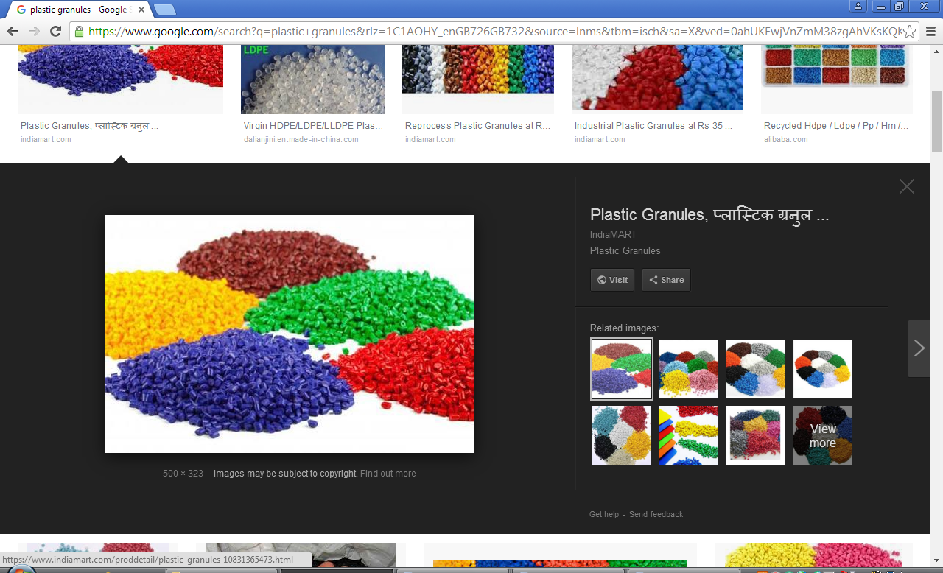

2. Classification of plastic
Plastics are categorised into two types.
Thermo plastic (thermoforming) |  | Thermosetting plastic
Also known as thermoplastics, when heated the plastic becomes soft and flexible. |  | Also known as thermosets, this plastic cannot be reformed once set in to shape.
Thermoplastics can be remoulded without affecting the material’s physical properties. |  | Thermosets have strong chemical bonds between the molecules, which do not separate on heating.
 |  | High heat resistance.
Molecular structure
Thermoforming plastics |  | Thermosetting plastics
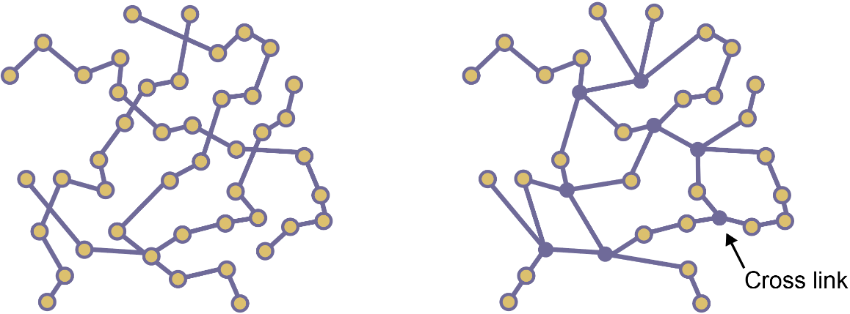
Long chains of loose molecules that have no fixed structure or pattern. |  | Individual monomers join to form a large polymer. These long chains of molecules are cross linked resulting in a rigid molecular structure.
3. Thermoplastic pros and cons
Thermoplastics can be repeatedly heated and moulded.
- Thermoplastics are not suitable for use in areas of heat or UV sensitivity.  - A good surface finish can be  achieved for superior aesthetics.  - They can be recycled.  - Each time the plastic is reheated  it will try to return to its original shape – this is known as plastic memory. | 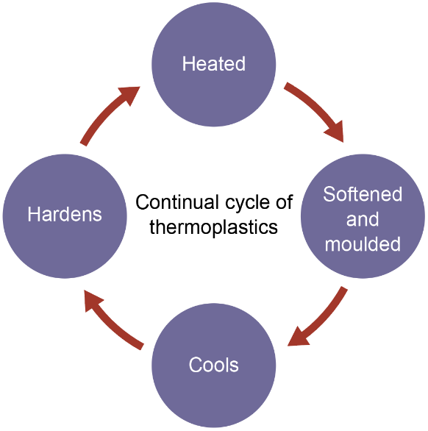

4. Thermosets pros and cons
Thermosets are hard and durable with good structural rigidity.
- Able to withstand higher  temperatures.  - Waterproof when solid, so ideal  for use in adhesives.  - A good electrical insulator.  - Cannot be remoulded. | 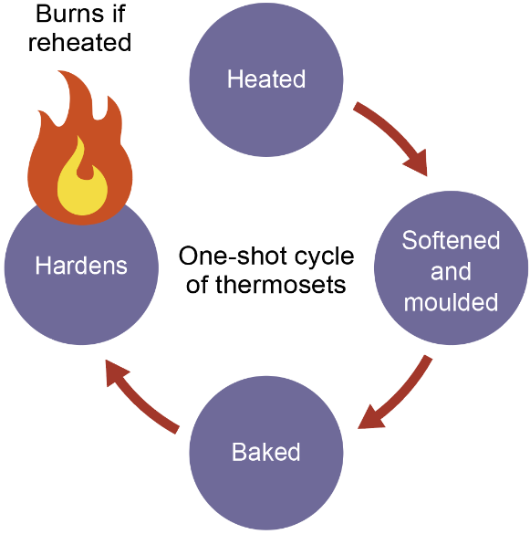

5. Moulding and forming
Plastics can be formed using a variety of processes
  - Blow moulding – forming hollow plastic items.
  - Extrusion – creating objects with a cross section profile.
  - Injection moulding – injecting softened plastic into a mould.
  - Vacuum forming - sheet of softened plastic forced onto a mould.

Tasks: 1-5 Learn/cover/write and self-check plastic classifications.

1. Polyethylene - This is the most common thermoplastic with over 80 million tonnes produced globally each year.
There are several types of polyethylene including:
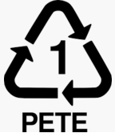
    - Polyethylene terephthalate (PETE)
    - High density polyethylene (HDPE)
    - Low density polyethylene (LDPE)

Polyethylene can be rigid with good strength to weight ratio. It has good ductility and impact strength. Its stability makes it a suitable plastic for blow-moulding.

2. Polyvinyl chloride - PVC is widely used for packaging, pipes, outerwear, electrical tapes and children’s toys.
  - PVC can be rigid and commonly used for making pipes.
  - It is tough and easily extruded.
  - With the addition of plasticisers, it becomes flexible.

3. Polypropylene - A very versatile polymer, polypropylene is used for solid plastics, films and fibres.
  - It has low density, making it lightweight.
  - It is ductile, enabling it to stretch for use in fibres and films.
  - It’s chemically resistant and easily cleaned which makes
it very suitable for food containers.

4. High Impact Polystyrene - HIPS is shatterproof and a good insulator.
  - It’s flexible and lightweight so ideal for vacuum forming.
  - Impact resistant, it is suitable for food containers
particularly yoghurt pots and fast food containers.
  - HIPS is easily mouldable and has a good gloss finish.

5. Acrylic Polymethyl-Methacrylate - This versatile and hard wearing plastic, comes in a variety of thicknesses and colours.
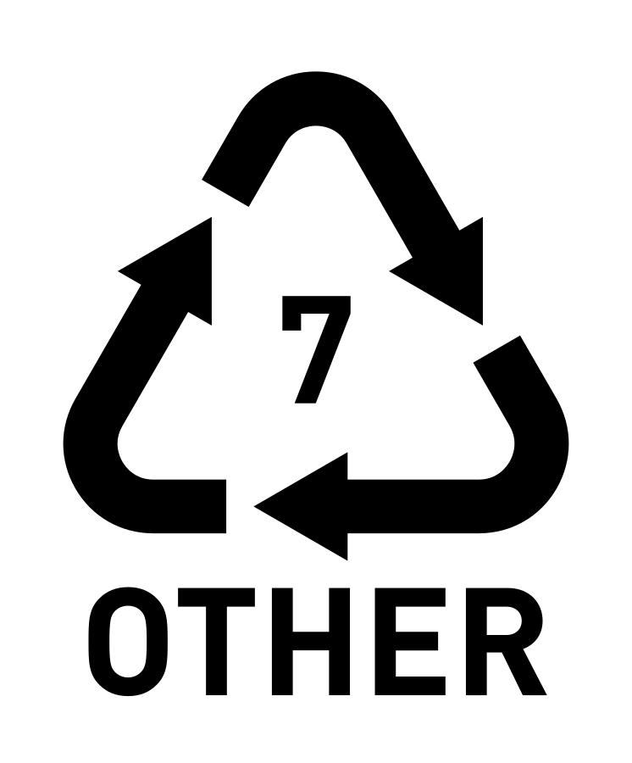
  - It’s a tough plastic, but becomes brittle if very thin.
  - It can also be spun into threads and woven.

6. Epoxy resin Epoxy resins are a class of reactive polymers.
  - Supplied as two liquids; a resin with a hardener which acts as a catalyst to set the resin.
  - Epoxy resins are used as adhesives, for example Araldite®.
  - With a good strength to weight ratio, epoxy adheres well to fibreglass and carbon fibre, reinforcing it.

7. Polyester resin - Polyester resin is a viscous, pale polyester solution and the addition of a catalyst, hardens the resin.
  - The hardened resin is tough with high abrasion resistance which makes a high-performance coating for areas of high wear, for example flooring.
  - Clear polyester resin is suitable for object embedding, clear sculpture casting and jewellery making.
  - Resin replicas e.g. anatomical models can also cast be cast and painted.

8. Composite adhesive - Polyester resin is commonly used with composite materials such as fibreglass.
  - Lightweight and weatherproof, it’s used to adhere layers of fibreglass
in the making of boat hulls, vehicle parts and panels for caravans.

9. Formaldehyde - An early compound, thermoset products made using formaldehyde include:
- Melamine formaldehyde  - Phenol formaldehyde  - Urea formaldehyde | Phenol formaldehyde (created in 1909) was known as Bakelite.  - Very rigid and hard, it was often used for electrical components and household items such as clocks, radios and telephones.

10. Melamine formaldehyde - Melamine is a hard thermoset.
- A heavy material, it has good resistance to heat, chemicals and moisture.  - It has good resistance to scratches,  but it is prone to chipping. | - Available in a range of colours and thicknesses, it is often used for picnic wear and as a laminate for  kitchen surfaces.

11. Urea formaldehyde - Urea formaldehyde is a good electrical insulator.
- With good heat resistance it is used for  manufacturing electrical fittings.  - The textiles industry treats some fabrics with UF resins to promote easy care properties such as anti-wrinkling. | - The paper industry uses UF to improve tear strength.  - The timber industry uses UF resin to bind particles in the making of manufactured boards such as MDF.

Tasks: 1-11 Learn/cover/write and self-check the various plastic types and uses.
1. Textile categories - Textiles can be manufactured to exhibit a variety of properties depending on the blend of fibres.
- Natural fibres  - Synthetic fibres  - Blended and mixed fibres | - Woven and non-woven fabrics  - Knitted textiles

2. Fabric types
Natural fabrics | Synthetic fabrics
- Wool, Cotton and Silk. | - Polyester, Elastane (Lycra)  - Nylon

3. Cotton - The fruit of a cotton plant is a capsule called a ‘boll’.
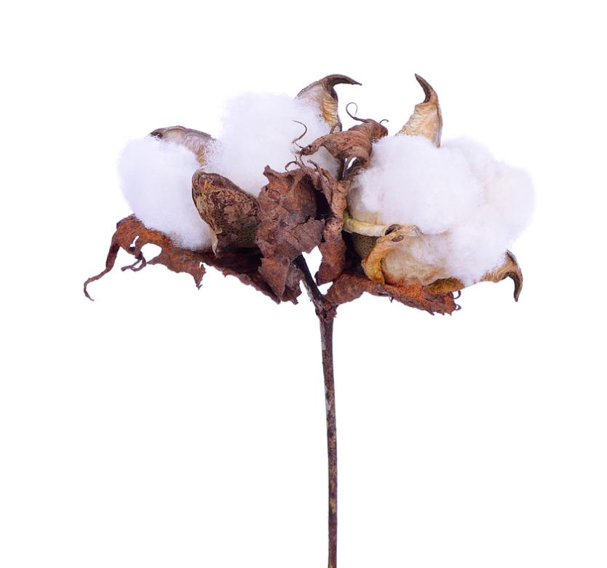
  - The mature seed splits open to reveal the fibres.
  - Once harvested, the fibres are spun into yarn.
  - Cotton is soft, strong and easily washable.

4. Silk - Silk is a natural, raw fibre sourced from the cocoon of the larvae of a silkworm.
- The shimmering appearance comes from the  fibres’ triangular like structure.  - A luxury material, its fine finish is soft and  gentle to the touch.  - Silk drapes beautifully & retains its shape well. | 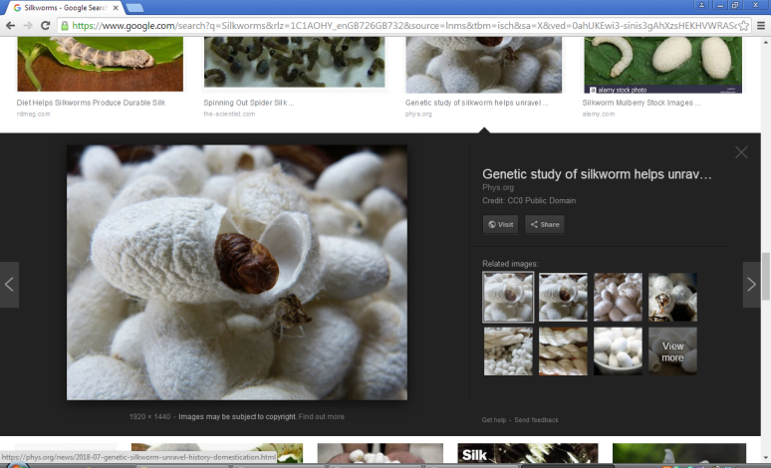

5. Wool - Wool fibre is commonly sourced from sheep fleece.
- Depending on the source of the wool, it can feel coarse or soft.  - It can be easily spun, woven or knitted.  - Wool is naturally crease resistant and absorbs dyes very successfully.  - Wool absorbs vapours and keeps a layer of dry air next to the skin, which helps retain body heat, keeping you warm. | 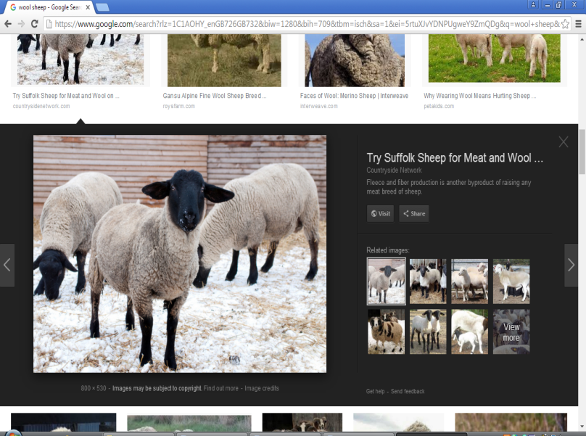

6. Synthetic fibres - Synthetic fabrics are made from different
types of polymer, derived from petrochemicals.
- Dyes are added at the manufacturing stage, so a wide range of colours can be easily produced. | Polyester & Polyamide (Nylon) are:  - Hardwearing, with good strength.  - Non-absorbent and wash well.  - Easily blended with other fibres.

7. Stretch - Elastane, Spandex or Lycra® is a synthetic fibre and used where elasticity is required.
  - It can be spun with other textiles to give form fitting properties which are ideal for under garments and swimwear.
8. Polycotton - A fabric made from a blend of polyester and cotton.
  - Lightweight, soft and moisture absorbing.
  - A durable fabric, it’s suitable for bed sheets, pillow cases and clothing.

9. Woven textiles - Yarns are woven together to form fabric.
- The commonly used types are plain weave and twill weave.  - A loom weaves two threads – the warp and the weft - at right angles to each other.  - The self-finished edge is known as the selvedge, which stops the fabric from fraying. | 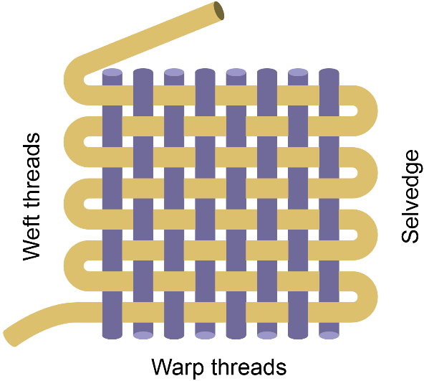

10. Plain woven textiles - Plain weave is straightforward to produce and stronger than more decorative weaves.
  - No matter what thickness yarn is used, plain weave forms a stable fabric construction.
  - This is commonly used with fabrics such as calico, muslin, gingham, taffeta and voile.
  - It’s typically used with home furnishings and tablecloths.

11. Non-woven textiles - A sheet or web of fibres are bonded thermally, chemically or mechanically.
  - Made directly from fibres, no weaving or knitting is required.
  - Non-woven fabrics have specific properties such as absorbency, sterility, stretch, softness, flame retardancy, cushioning and filtering.

12. Felted fabric - Felt is a dense, non-woven fabric.
  - Matted fibres are pressed together with heat, moisture and pressure.
  - Felt is usually made of wool, but when mixed with synthetics it becomes more resilient.
  - Using heat and moisture, it can be shaped and formed.

13. Knitting - A series of interlocking loops produces a knitted fabric.
- Weft knitting – the interlocking loops are formed horizontally, which enable it to stretch, but may lose shape.  - Warp knitting – the loops interlock vertically, so the knit keeps it shape and is less likely to unravel or ladder.  - Weft knits are suitable for close fitting garments as the stretch allows the wearer to move comfortably. | 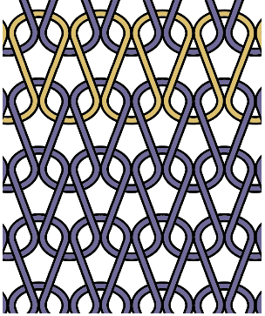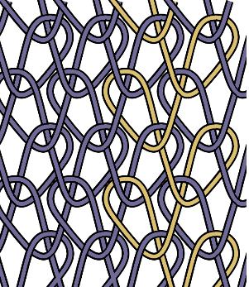  Weft  Warp

Tasks: 1-13 Learn/cover/write and self-check the variety of fabrics.

