1. Energy generation
Fossil fuels can be burned to superheat water under pressure, which in turn, drives turbines.
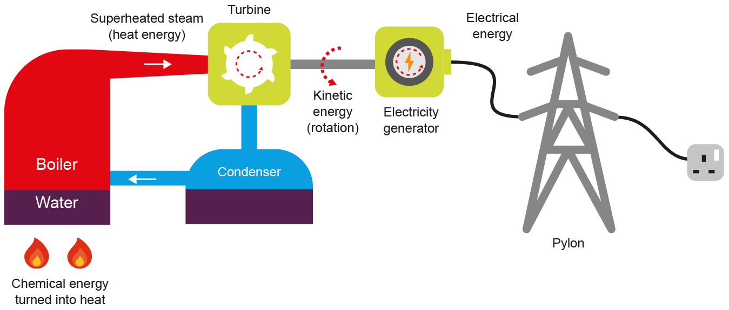
Fracking involves drilling into layers of shale rock deep in the earth to release pockets of gas.
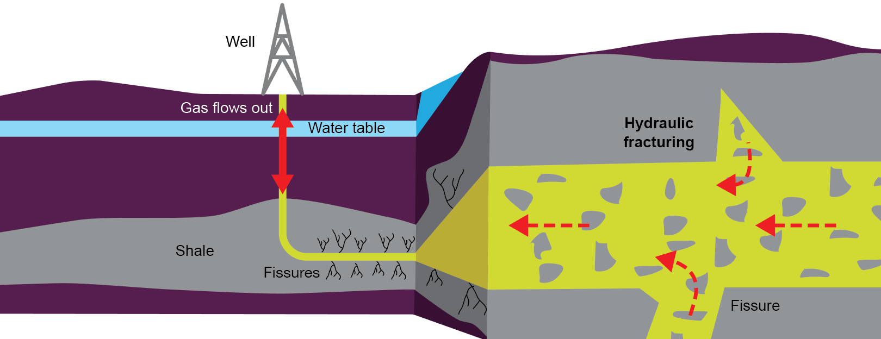
Wind turbines produce energy when the turbines are spun by the wind
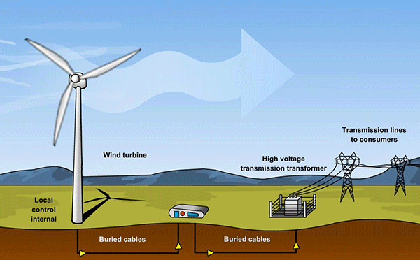
Solar power – Protons from the sun beam to earth. The Semi-conductive material silicon, collect the protons and stored.
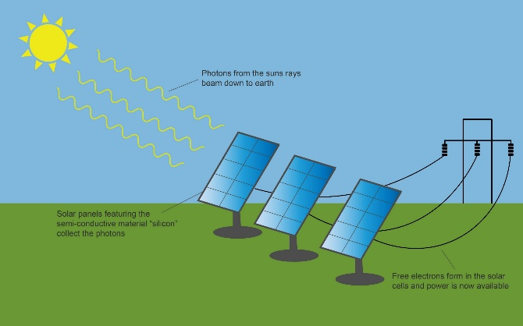
Tidal energy- The rise and fall of the tide forces water through turbines, which drive generators to produce electricity.
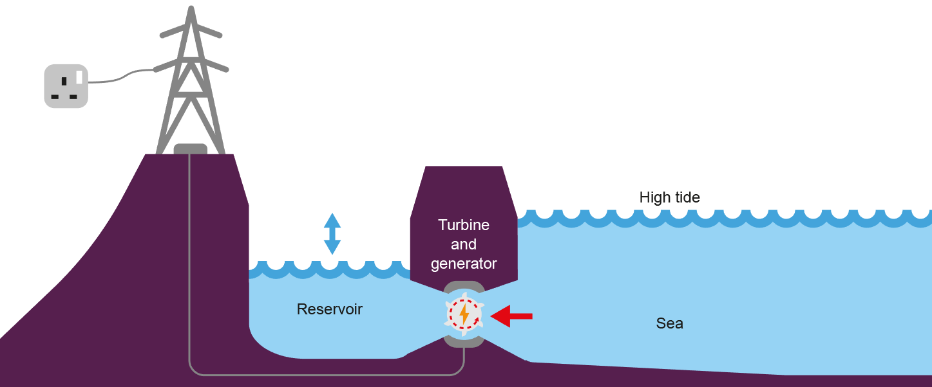
Nuclear power provides an abundant, reliable supply of clean energy, but produce deadly radiation waste.
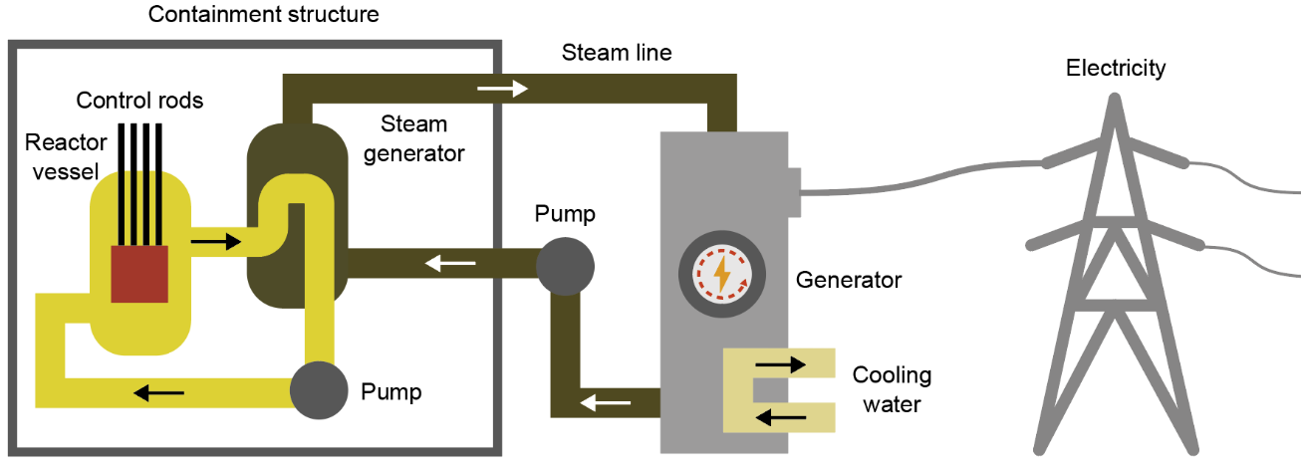
Task 1. Learn/cover/write and self-check the various ways energy can be produced.
1. Energy storage
What is energy?
Energy is the capacity to do work. Energy comes in different forms and can be stored. Examples of these are kinetic and Potential energy.

Potential energy is stored in objects not in motion, which will move once released. An example of this is: Pressure in a fire extinguisher and water in a reservoir ready to turn a turbine for Hydro Electric Power.

Kinetic energy involves motion and movement, for example: Electricity when travelling throughout a circuit, heat radiating from a fire, sound coming from a speaker, projected light and atoms vibrating.

How energy is it stored?
Mechanical storage  - Compression  - Tension  - Motion | Chemical storage  - Batteries  - Gases  - Solid fuel  - Food  The energy store associated with chemical bonds, such as those between molecules.
Pneumatics– A compressor is used to compressed air or gas. Pneumatic systems are very accurate and low maintenance.
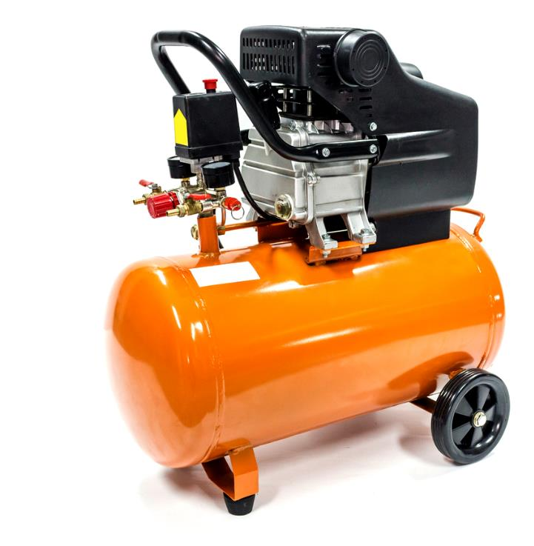
Pneumatics are commonly used in industry, for example with mechanical drills and on automated production lines.

Hydraulics Pumps and compressed liquid instead of air, which creates a powerful system.
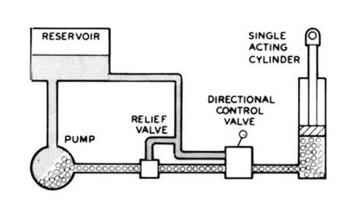
Hydraulics are used in:
  - Lifting equipment.
  - Car braking systems.
  - Fire fighter
cutting equipment.

Kinetic pumped storage
Hydroelectric power provides a very controllable supply of power.
  - When there is a surplus supply of electricity, water is pumped back up to the high-level reservoir.
  - Potential energy is stored in the water at the higher level and
used when demand is high.

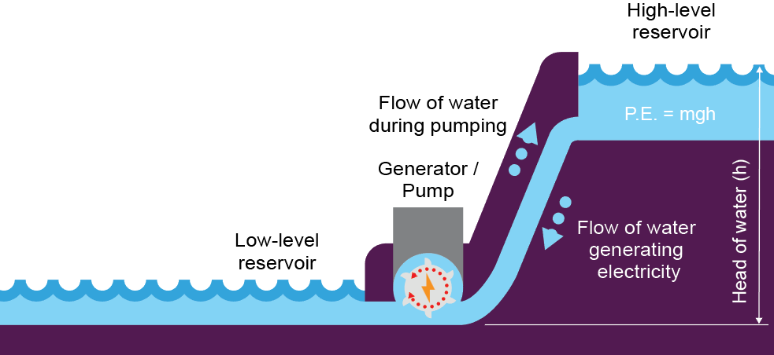

Fly wheel Energy Storage
Flywheels rotate in a near frictionless environment.
  - They use surplus energy to reach optimum speed.
  - Momentum is stored until it is required.
  - The motor used to power them, in turn, becomes a generator, which returns electrical energy when needed.
Kinetic Energy Recovery Systems (KERS) are used on vehicles to save fuel.
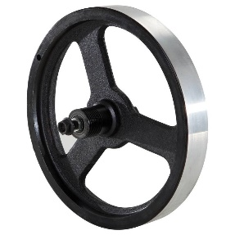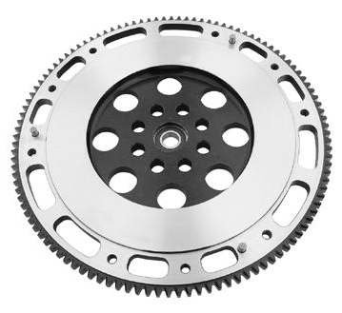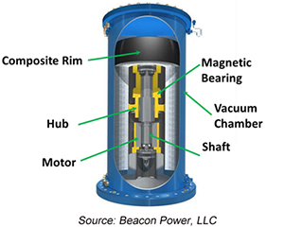

Task
Learn/cover/write and self-check the each section of the how energy is stored.
1. Modern Materials
New and improved materials are constantly being discovered and developed. Modern materials can help to solve, design issues, technical constraints and environmental issues.
Biodegradable polymers are made from vegetable starches, often corn-starch.
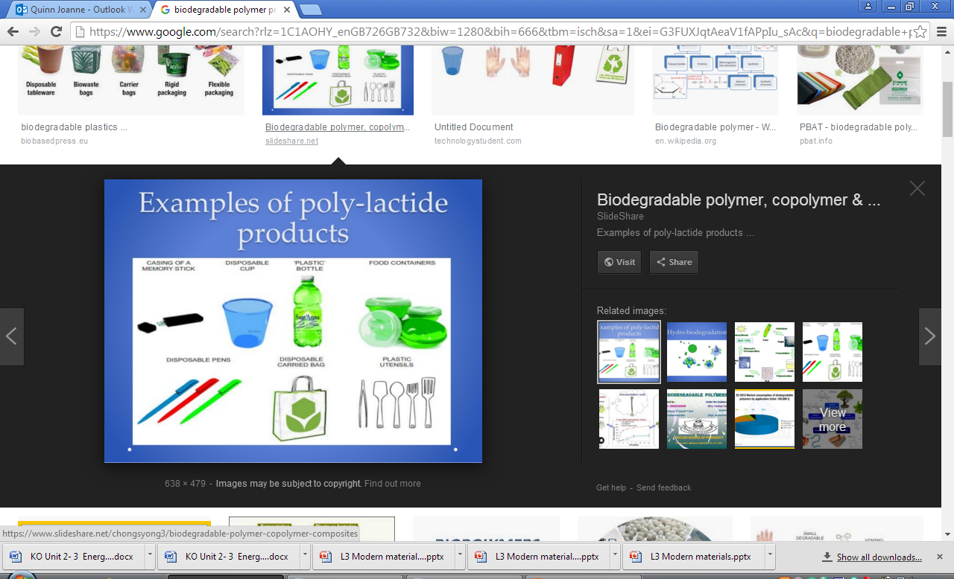
Common varieties include:
  - Polylactic acid (PLA) commonly used in
3D printing filament.
  - Polyhydroxybutyrate (PHB) trade name Biopol^{TM.}
  - Polycaprolactone (PCL) known as Polymorph.
Polycaprolactone (PCL) is a low temperature, hand-mouldable polymer. Polymorph fuses at 62°C, although CoolmorphTM bonds together at just 42°C making it easier to use.
  - They are both biodegradable, non-toxic and can be coloured.
  - They are ideal for modelling as they can be shaped using only hand pressure.
  - They can be reused and remoulded multiple times.
Flexible MDF allows for the creation of natural curves It is commonly used in the design of shop fittings and bespoke commercial projects.
  - Routed or machined grooves enable the material to bend.
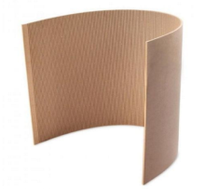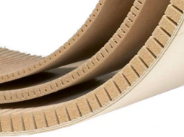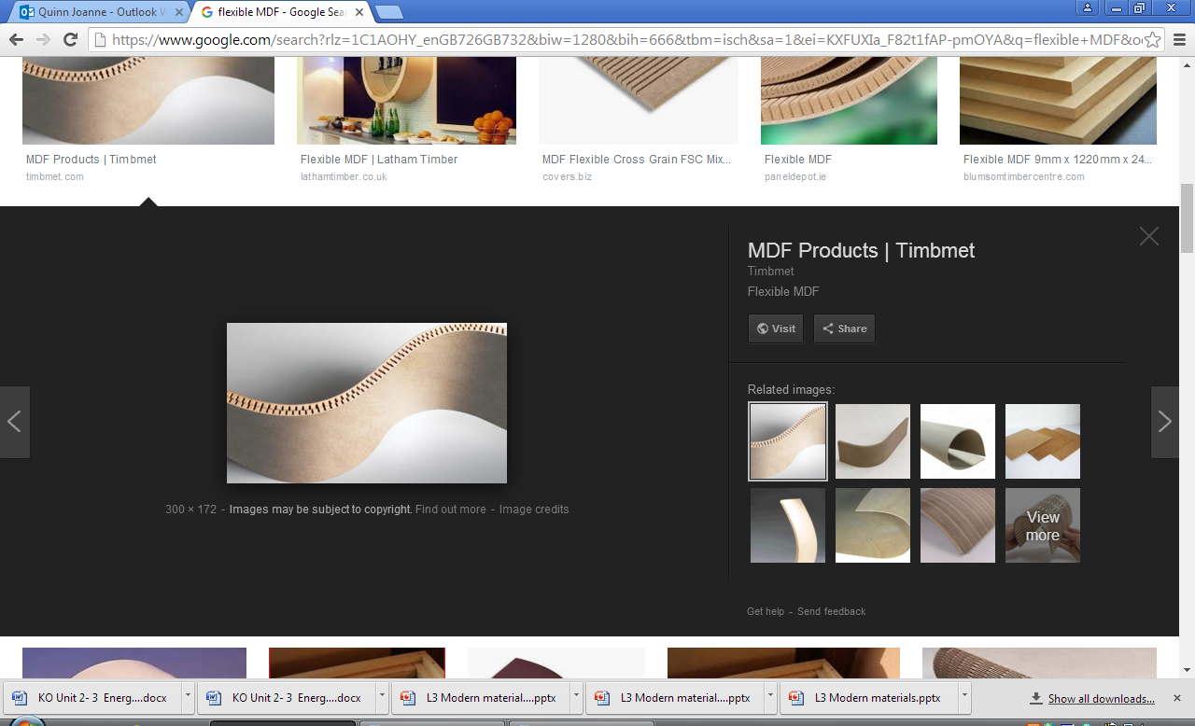
Titanium - Although a chemical element, titanium is commonly alloyed with other metals.
  - It is relatively lightweight, tough and stiff with low density.
  - It has excellent corrosion resistance making it very versatile.
  - Titanium does not react with the human body, making it ideal for
medical applications.
Fibre optic cables carry light down a thin glass core. Uses include:
  - Cable TV and broadband infrastructure.
  - Medical applications using endoscopes to allow doctors to see into the body.
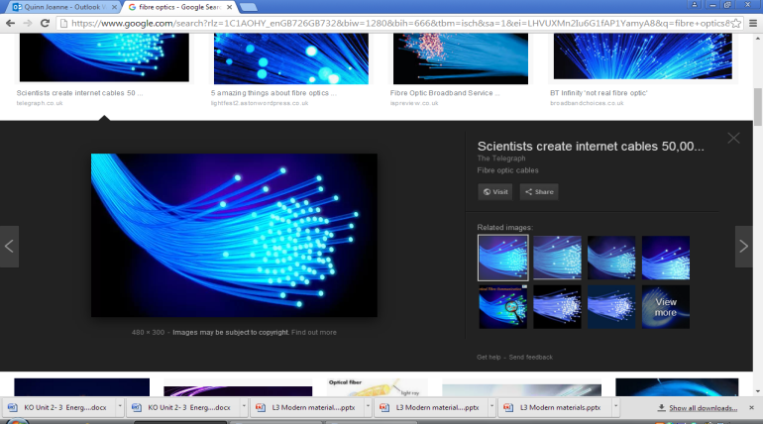
  - Fun optoelectronics and novelty goods.

Graphene was accidentally discovered in 2004. It is made from atom thick graphite and has the same atomic structure as diamond.
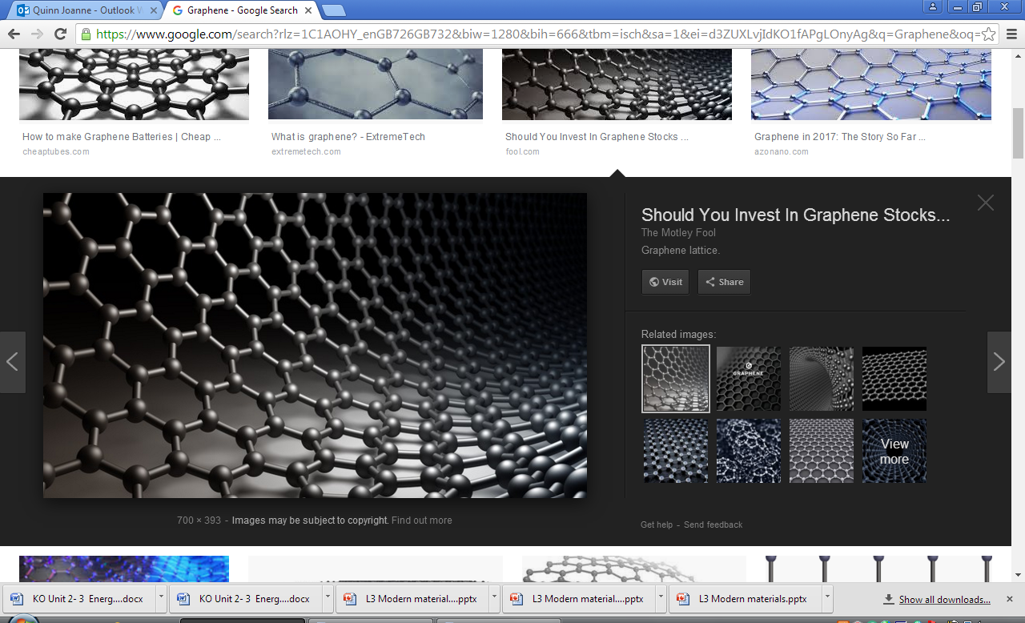
  - 200 x tougher than steel.
  - Stretchable and flexible.
  - Transparent yet impermeable.
  - Highly electrically conductive.
Research into the uses of graphene is currently active in many areas including: flexible electronics, biomedicine, energy storage and composite materials. Scientists are very optimistic about its future applications.
Liquid Crystal Display (LCD) - LCDs come in monochrome and full colour versions.
  - Screens can be very small and lightweight.
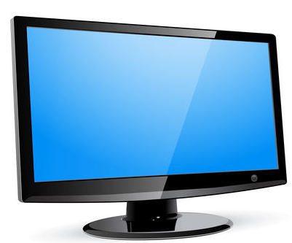
  - Bespoke monochrome layouts can be achieved.
  - They have very low power consumption.
  - LCDs do not emit light, so they require back lighting.
  - Colour versions use pixels.
Nanomaterials have one dimension that measures 100 nm or less.
Applications:
- Nanoscale additives to or surface treatments of fabrics can provide lightweight ballistic energy deflection in personal body armour.
- Clear nanoscale films on eyeglasses, computer and camera displays, windows, and other surfaces can make them water- and residue-repellent, antireflective, self-cleaning, resistant to ultraviolet or infrared light, anti-fog, antimicrobial, scratch-resistant, or electrically conductive.
Metal foams are very lightweight compared to solid metals.
  - As little as 25% of the mass of the solid metal is used.
  - The air pockets are made by injecting gas into liquid aluminium or titanium.
  - They are 100% recyclable.
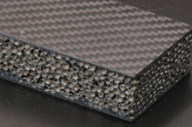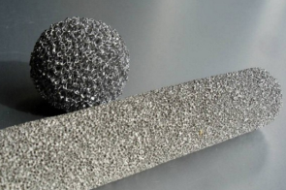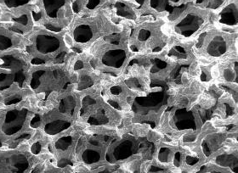

Tasks
- Learn/cover/write and self-check the various modern materials.

1. Self-healing polymer
Self-healing polymers react to stress fractures by releasing a resin into the new crack.
  - Microcapsules of liquid resin are ruptured to bond the polymer back together again.
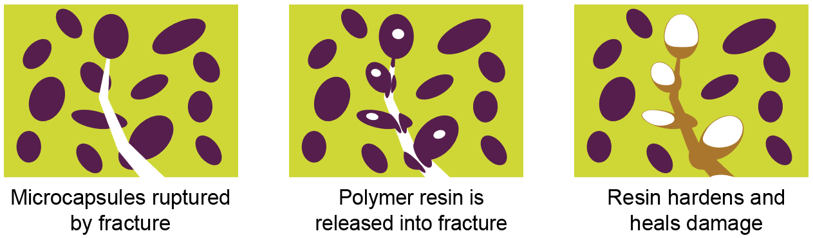
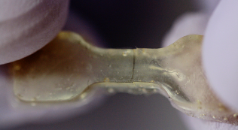

2. Self-healing concrete
Designed to avoid stress cracks filling with water.
  - Cracks enlarge over time and water can cause the steel reinforcements to rust and weaken the structure.
  - Self-healing concrete has spheres of bacteria added to the mixture, which contain their own food.
  - When a crack forms and water seeps in, the bacteria start to feed, producing calcium carbonate, which fills the crack.
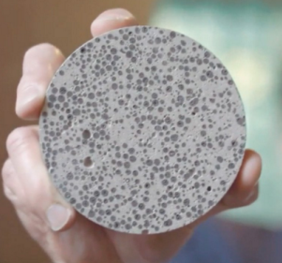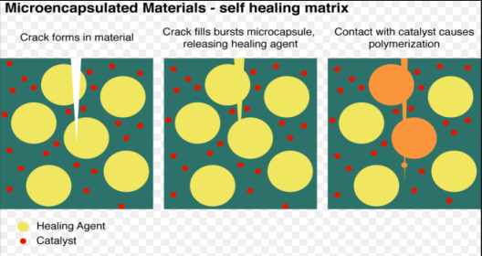

3. Thermo chromic pigments
Hot and cold temperatures trigger a change of colour in special thermo chromic dyes.
Applications include:
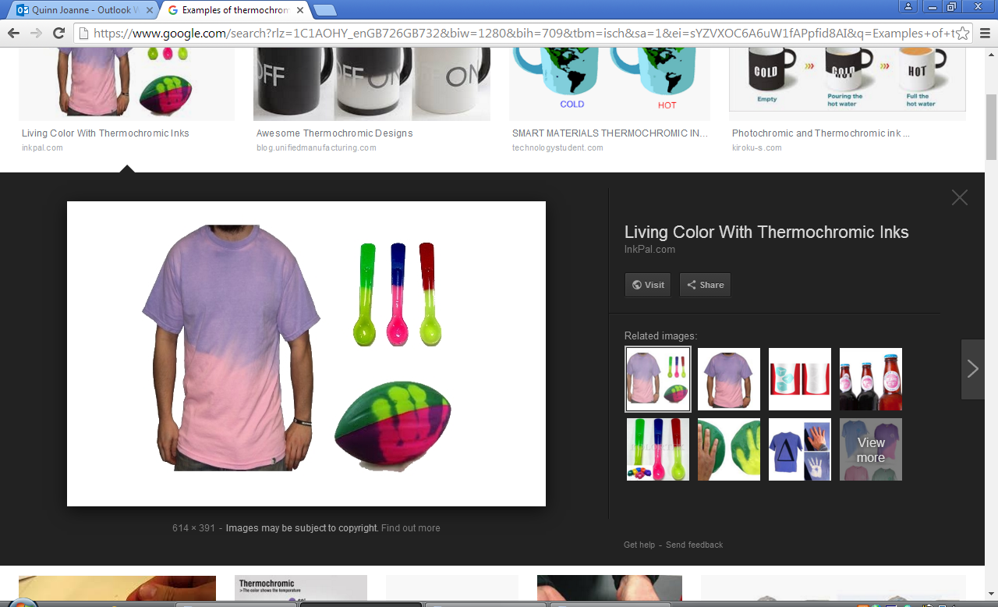
  - Fever scan strips used on infants.
  - Room thermometers.
  - Children's cutlery and crockery.
  - Novelty goods and colour changing clothing.
  - Some pigments have a permanent change.

4. Photo-chromic particles
Ultraviolet light reacts with photosensitive silver halide particles within the lenses.
  - This reaction is commonly seen in prescription sunglass lenses that darken .in bright sunlight and return to clear indoors.
  - The reaction can take up to two minutes to complete.
  - Over time the particles can lose their ability to revert to clear.
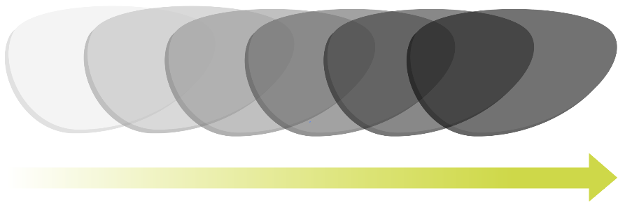
UV Light levels

5. Photo-chromic pigments
Photo-chromic pigments change colour when exposed to ultraviolet light usually from the sun. The inks are effectively colourless indoor and turn vibrant colours outdoors.
- These pigments are mainly used for novelty goods and colour changing paints
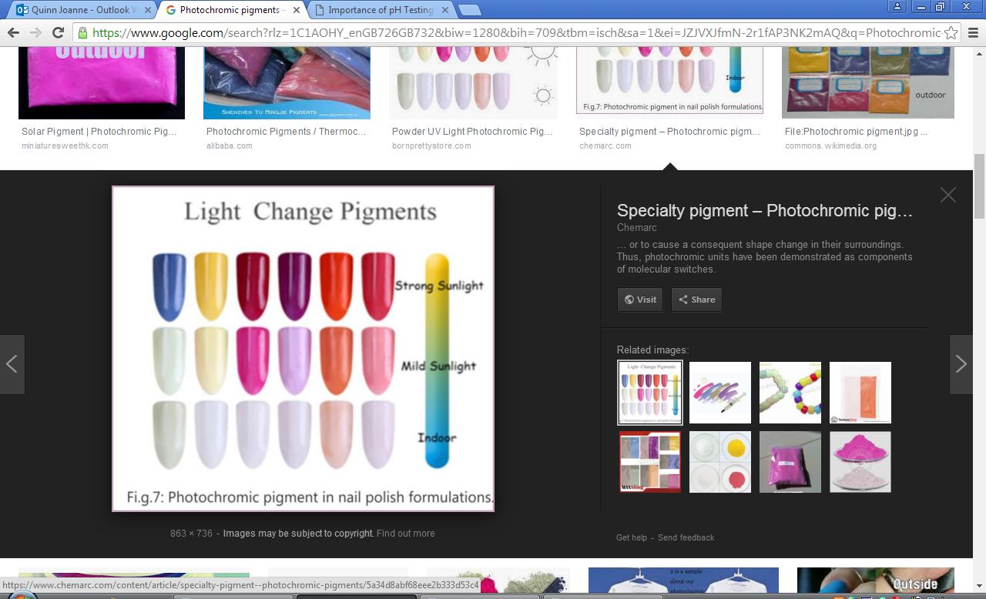
- UV light stimulates particles in a special pigment.
- The effect only lasts as long as strong UV light is present.
.

6. Shape memory alloy (SMA)
Nitinol is an SMA of nickel and titanium.
  - Nitinol needs to be ‘set’ into a shape, which needs a temperature of 540°C.
  - Once set, the alloy can be deformed into a different shape.
  - Heat or electricity is used to trigger a response in its shape.
  - When reheated to around 70°C it will go back to its pre-set shape.
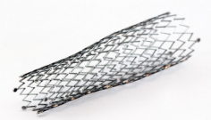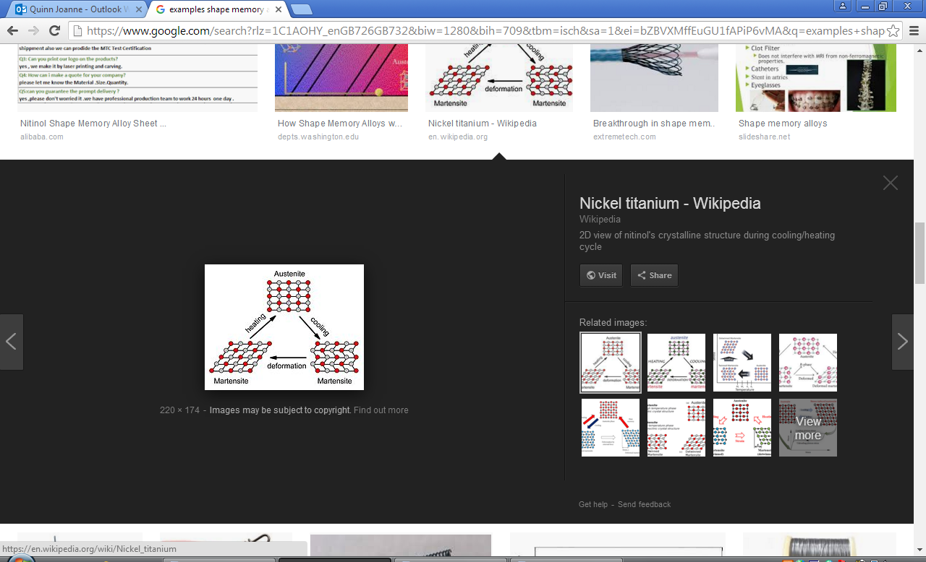

7. Acid/Alkali testing
PH levels can be detected using litmus paper.
  - It uses compounds found in different varieties of lichen.
  - Different colours and shades appear depending on the PH.
  - Common uses include garden soil testing / pool water testing / skincare products – (dermatological testing).
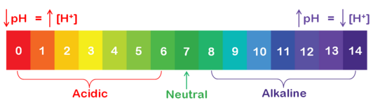

Tasks: 1-7 Learn/cover/write and self-check the various smart materials.

1. GRP (CRP) process Carbon fibre reinforced plastic (CRP)
Step by step process to construct a GRP (CRP) part.
  - Prepare the mould or former.
  - Apply a release agent to the mould.
  - Apply a gel coat for GRP (or first resin coat for CRP).
  - Apply the glass fibre matting (or woven carbon fibre).
  - Work a second coat of resin into the material.
  - Repeat layers of matting and resin coats to achieve correct thickness for the specific application.
  - Clamp and leave a GRP work piece to cure (Seal a CRP work piece in a vacuum bag and heat in an oven to cure).
  - Release from the mould, trim and finish work piece.

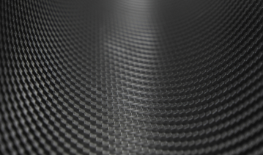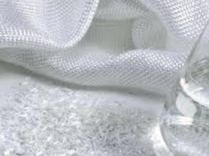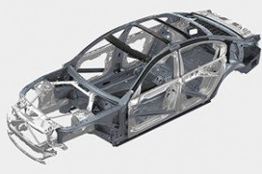

2. Gore-Tex®
Gore-Tex® is a special fabric membrane that is waterproof yet breathable.
The membrane has 150 million holes per cm².
  - This means water droplets are too big to pass through.
  - Perspiration can still escape as water vapour.
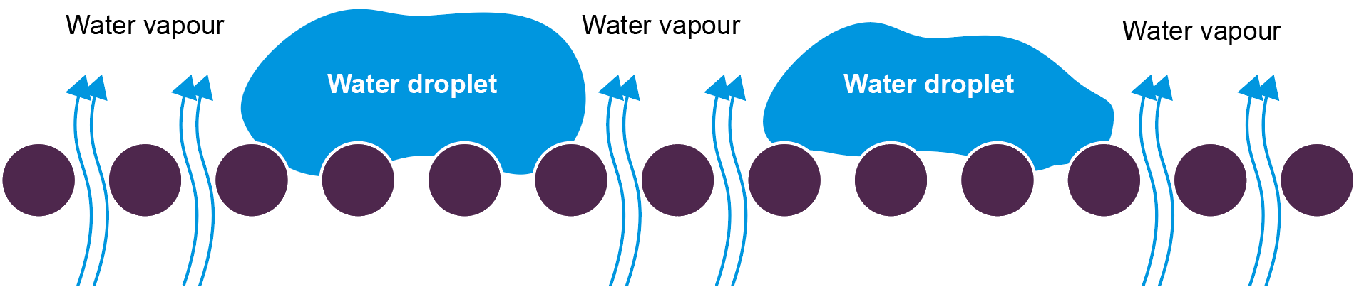

3. Conductive fabrics and threads
E-textiles allow electricity to travel along special threads which are either woven or sewn into fabrics.
  - Stainless steel or other conductive strands are mixed with other fibres
providing flexibility.
  - The thread can be soldered onto special sew-on components.
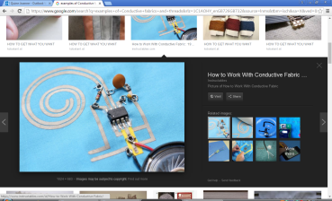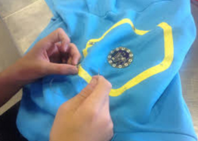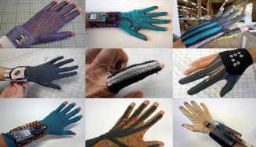

4. Microfibres
Microfibers are less than one denier thick - that’s one fifth the width of a human hair.
  - They create an electrostatic charge that attracts particles of dust.
  - Usually made from polyester and polyamide.
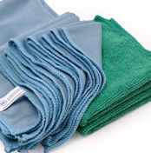
Issues: Can be flammable unless treated, synthetic, not renewable and takes years to decompose. There is evidence that microfibres are causing oceanic pollution and entering our food chain.

5. Microencapsulation
Solids, liquids or gasses are sealed in tiny capsules. These active ingredients can be released at controlled rates and under controlled conditions.
Active ingredients include:
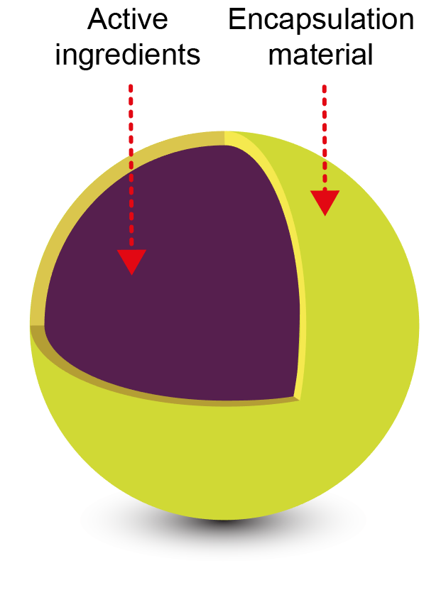
  - Thermo-chromic dyes, antibacterial material, Pesticides,
Perfumes and Pharmaceuticals.
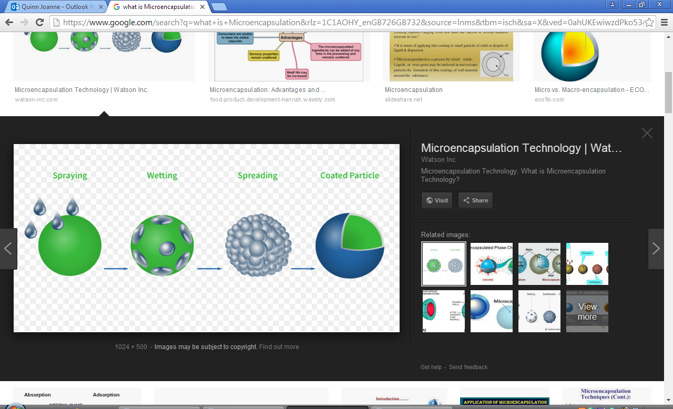

6. Flame resistant and flame retardant.
Flame resistant fabrics | Flame retardant fabrics
Flame resistant fabrics are made from materials that are inherently non-flammable - the materials have flame resistance built into their chemical structures.  Fabrics made with these types of materials are designed to prevent the spread of fire and will not melt or drip when in close proximity to a flame. Because flame resistant fabrics are not usually made from 100% flame resistant materials, they will burn, but will do so very, very slowly and are often self-extinguishing. | Flame retardant fabrics are chemically treated to be slow-burning or self-extinguishing when exposed to an open flame. These fabrics can be made from any material, but they must be treated with special chemicals to qualify as flame retardant.

Tasks: 1-6 Learn/cover/write and self-check the various composite materials.

1. Electronic Systems
What is an electronic system?
An electronic system is a series of parts or components that control a task or activity. Many products contain electronic systems.
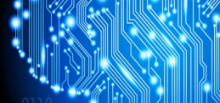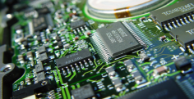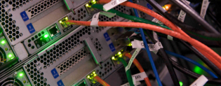

2. Subsystems
Subsystems or subtasks are events or tasks that happen within a system.
A car’s systems include:
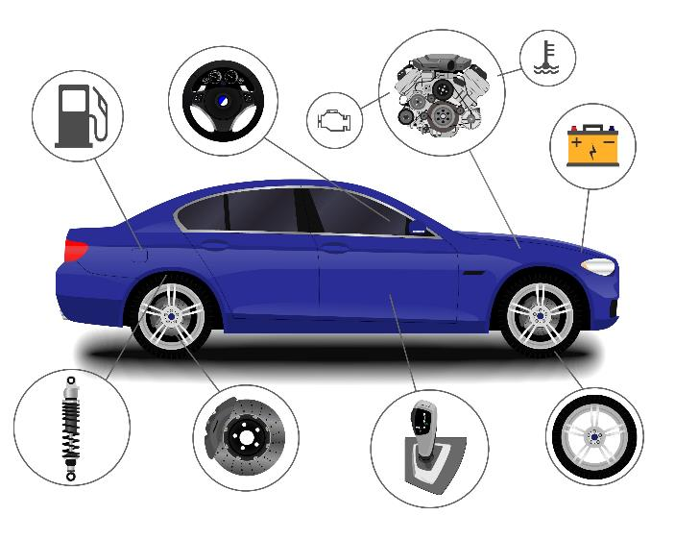
  - Steering
  - Braking
  - Electrical
  - Power and drive
  - Entertainment
  - Navigation

3. Systems diagram
Explaining how a system works can be confusing so a simple block diagram is used.
  - Separate inputs, processes, decisions and outputs are placed in individual boxes.
  - They are linked with arrows to create a system or subsystem.
  - The arrows show the direction (flow) within the system.
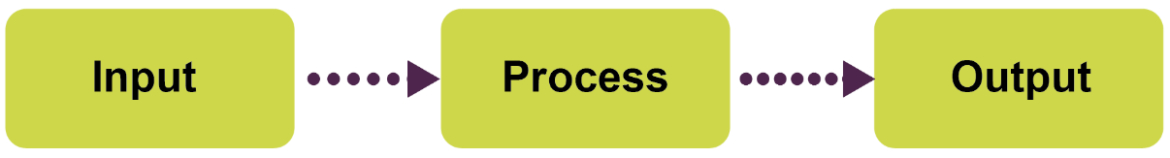

4. Closed loop systems
Feedback is used to make a decision.
- Diamond boxes represent decisions.
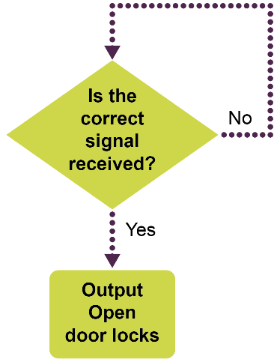

5.Flowcharts
Flowcharts are a more detailed way to graphically represent systems.
  - They can also be used when programming microcontrollers.
The common symbols include:
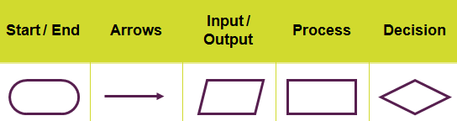

6.Circuits and symbols
Specific symbols are used to represent components in an electronic circuit.
  - Circuit symbols are connected in a particular way to assist understanding in a clear layout.
  - It is known as a schematic diagram and is a visual representation of the circuit but not a real-life diagram.
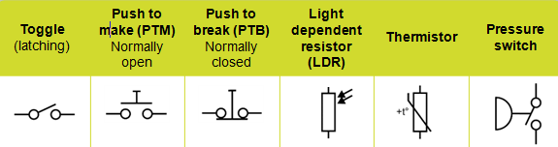

7. Connecting inputs
Most input components, especially sensors, work best in a potential divider.
  - The input is connected to both the positive and negative of the power supply through appropriate components.
  - It helps to provide a consistent signal to an input pin.
  - A resistor is used to pull-up or pull-down an input pin to avoid it floating, which can cause erratic errors.
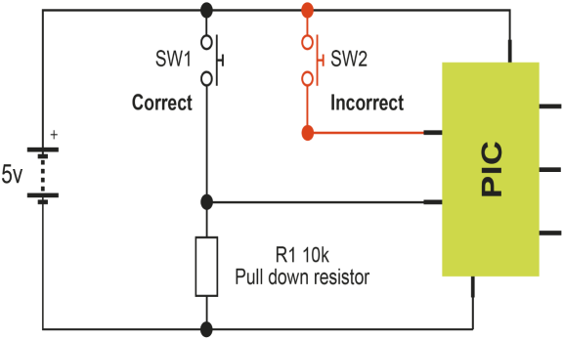

Tasks: 1-7 Learn/cover/write and self-check the various aspects of electronic systems.
1. Digital Vs Analogue
There are two types of signal in electronic systems:
  - Analogue signals have an infinite range of values between the minimum and maximum points.
  - Digital signals are either on or off, and are usually represented by a 0 for off and a 1 for on.
Analogue | Digital
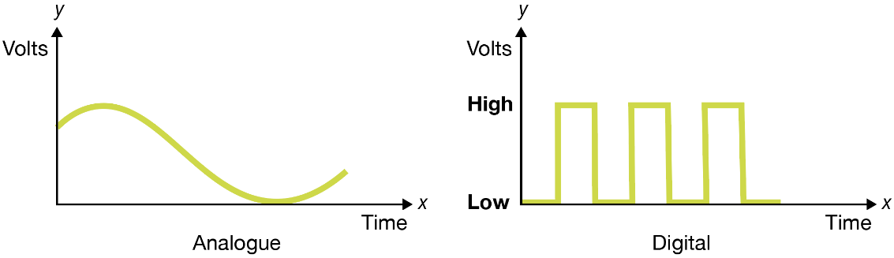

2. Integrated Circuit (IC)
Also known as microchips, ICs are capable of performing specific tasks.
  - There are many different types of IC.
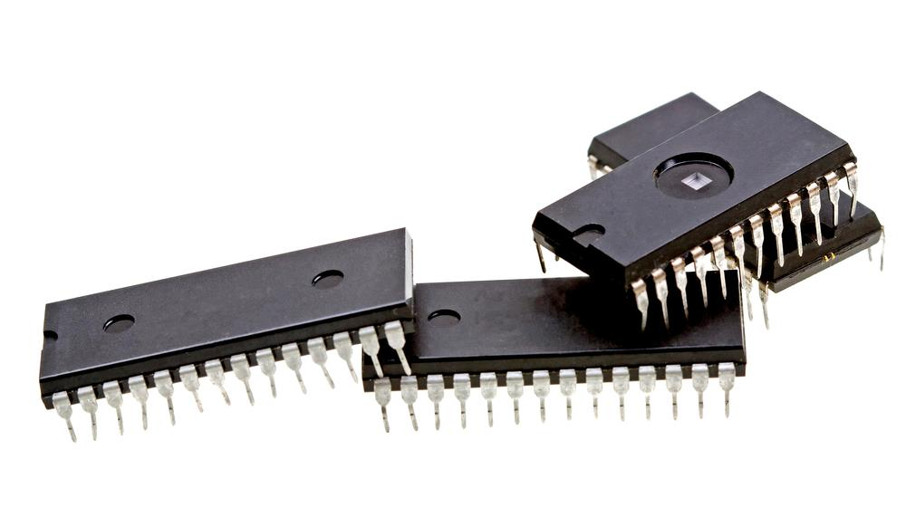
  - A programmable IC is called a microcontroller.
  - ICs come in all different shapes and sizes.
  - Most come in a dual in line (DIL) package.

3. Microcontroller IC
A microcontroller IC is known as a peripheral interface controller (PIC).
  - This reduces the amount of components needed to perform a task (component redundancy).
  - They can be programmed to perform multiple processes.
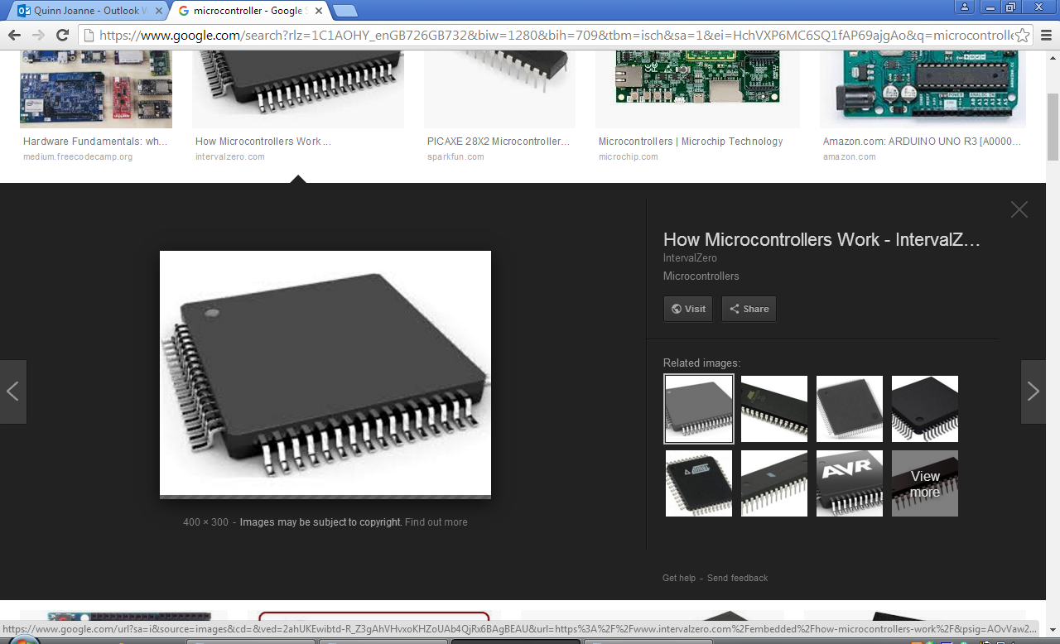
  - These programmable ICs are very adaptable.

4. Programming a PIC
A PIC’s functions are controlled by a program or code that is received via a download cable.
  - Specialist software enables the program to be drawn graphically as a flowchart.
  - It can also be written in a coding language, such as BASIC.
  - Most PICs can be reprogrammed multiple times, allowing for corrections and updates.

5. Output components
Buzzers and speakers produce sound
  - Buzzers normally give out a set frequency meaning they are good for system alerts.
  - Speakers have a broader frequency range and are used for speech
and audio.
  - Suggest one instance where a buzzer would be more appropriate than a speaker.

6. Monostable device
The single pulse produced is usually triggered by a switch or sensor.
  - The length of the pulse can be varied by changing the delay time.
  - Monostable devices are used for timing how long events occur such as an
automatic door opening and shutting.
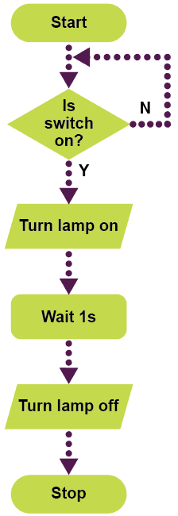
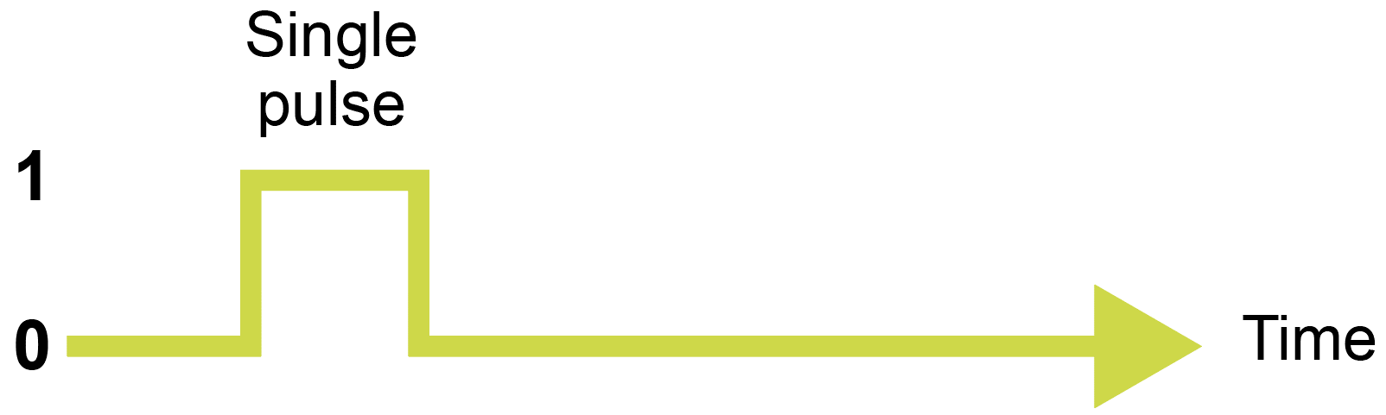

7. Astable device
The stream of pulses produced are oscillating and constant.
  - One cycle is the time (t) a single pulse takes to go from 0 (off) to 1 (on) and back to 0.
  - The speed of the pulses is known as the frequency and is measured in hertz (Hz).
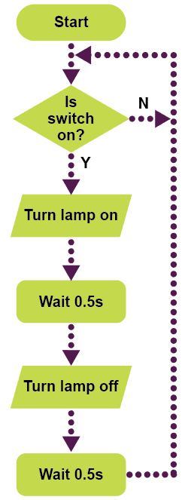
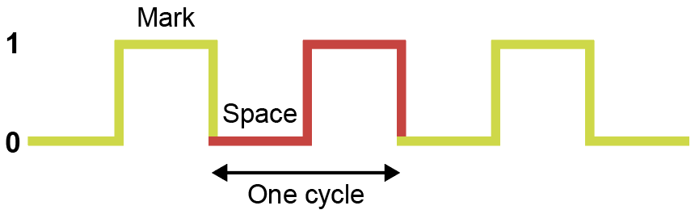

Tasks: 1-7 Learn/cover/write and self-check the various aspects of electronic processes.
1. Movement and motion
Motion is the action of something being moved.
  - Motionless is something at rest. There are different types of motion which can be added together and even changed from one to another.
Linear motion | Reciprocating motion
Movement in one direction along a straight line.   | A repetitive back-and-forth or up-and-down linear action.  
Oscillating motion | Rotary motion
A repetitive back-and-forth motion  along a curved path.   | Objects moving in a circular motion usually around a fixed axis.  

2. Levers
Levers help provide mechanical advantage (MA).
  - They have two parts – a bar and a pivot also known as the fulcrum.
  - Identify the three elements at work: the effort, the load and the position of the fulcrum.
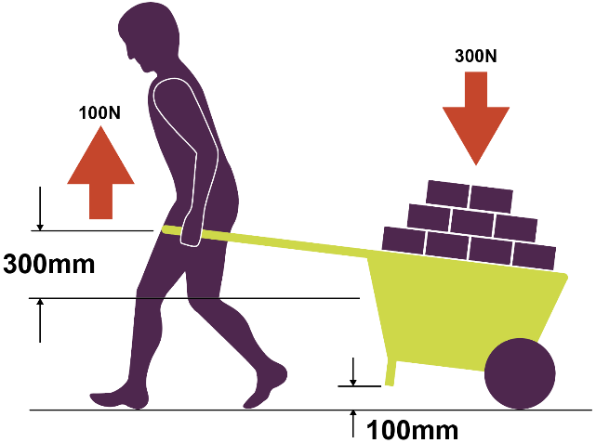
  - To calculate the MA, use
the formula:

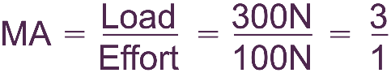

  - Also written as 3:1 or MA of 3

3. First order lever (Class 1)
Class 1 levers act in a seesaw or scissor action.
  - The load and effort are at
opposite sides with the fulcrum
positioned at any point between.
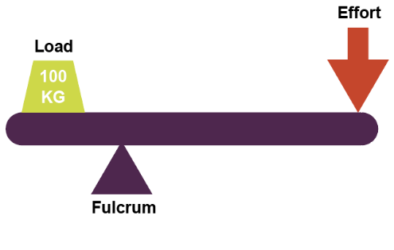

4. Second order lever (Class 2)
Class 2 levers act in a wheelbarrow action or that similar to a nutcracker.
  - The effort is at the opposite end
to the fulcrum, with the load
positioned between.
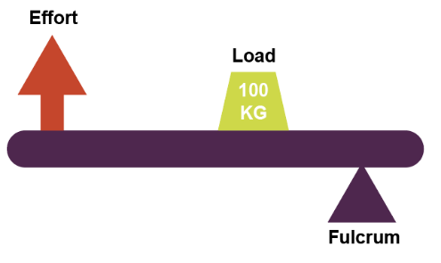
  - Identify the effort, load and
fulcrum on the nutcrackers.

5. Third order lever (Class 3)
Class 3 levers have a pincer-like action seen with tweezers and tongs.
  - The load is at the opposite end to
the fulcrum, with the effort
positioned between.
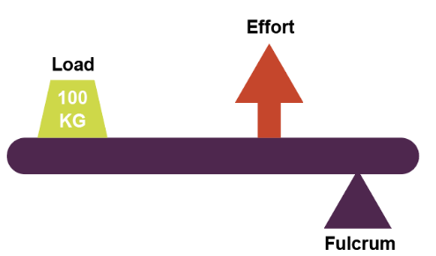
  - Explain how the acts of fishing or
sweeping the floor could be class
3 levers.

6. Equilibrium
When the effort and the load are equal, equilibrium can be created in a mechanism.
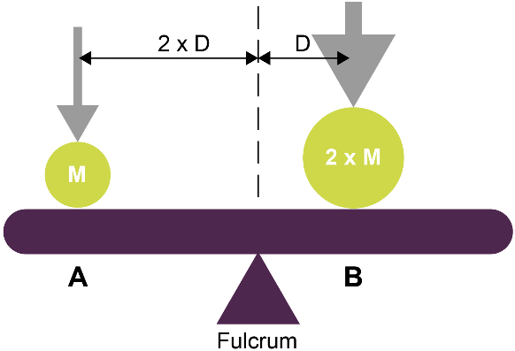

7. Linkages
Linkages are mechanisms that use rigid parts to:
  - Change the magnitude of a force.
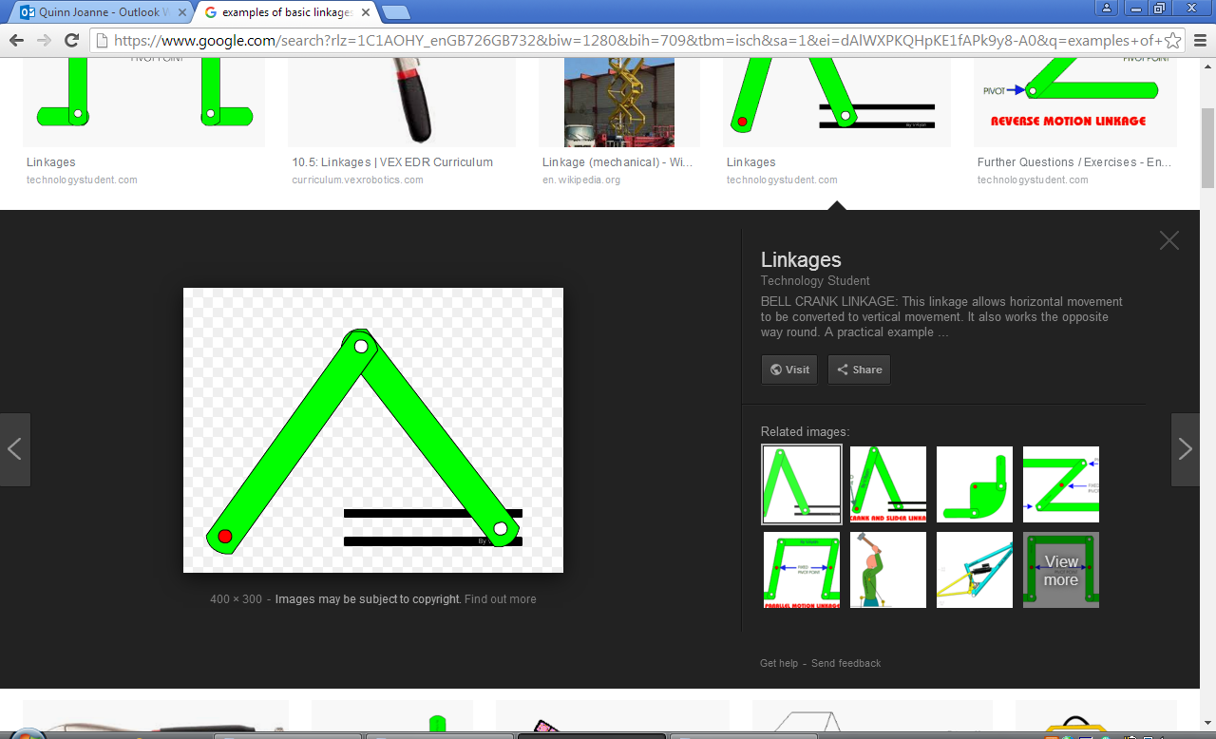
  - Change the direction of a force,
or transform it into a different motion.

Tasks: 1-7 Learn/cover/write and self-check the various aspects of mechanical devices.

1. Reverse motion linkage
This changes the direction of the input motion.
  - If the input is pulled, the output will push.
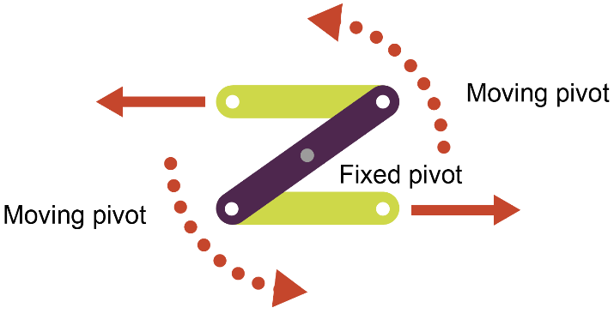
  - The linkage uses a fixed central pivot.

2. Parallel motion linkage
Also known as push / pull linkage as it keeps the direction of the output the same as the input.
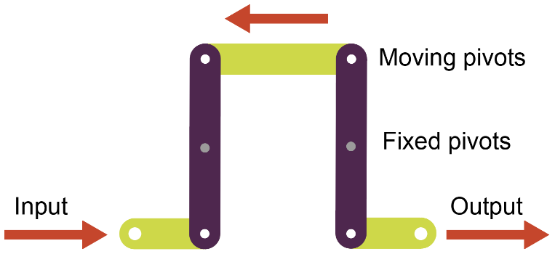

3. Bell crank linkage
Input direction is converted through 90 degrees.
  - It changes horizontal motion to vertical and vice versa.
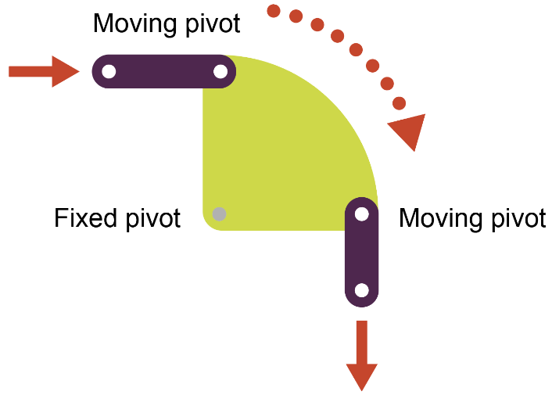
  - Often found in steering and throttle
mechanisms on vehicles.

4. Crank and slider
Crank and sliders convert rotary motion into reciprocating motion and vice versa.
  - A linkage commonly found in engines
to transfer the energy from pistons.
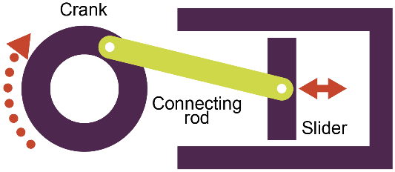
  - The slider is guided along a set path.

5. Rotary systems
Rotary systems drive mechanisms in machinery and equipment.
  - A rotating axle called a camshaft
is used to drive, or is driven by,
other mechanical components.
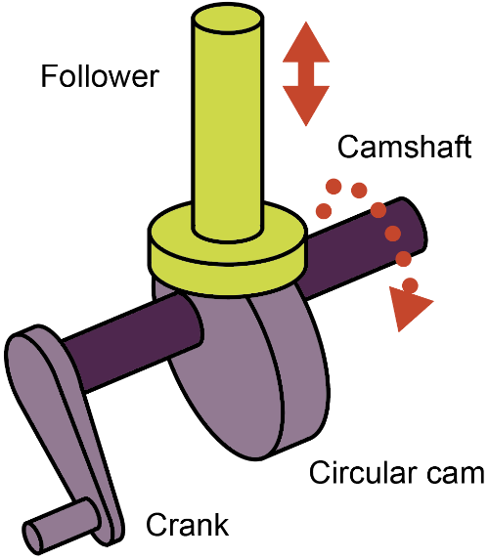
  - Cams are shaped pieces of
material that are attached
to the camshaft.
  - Cams change rotary motion
into reciprocating motion
through a follower.

6. Types of cams
Different shaped cams are used for different tasks:
Heart
Snail
Eccentric
Pear

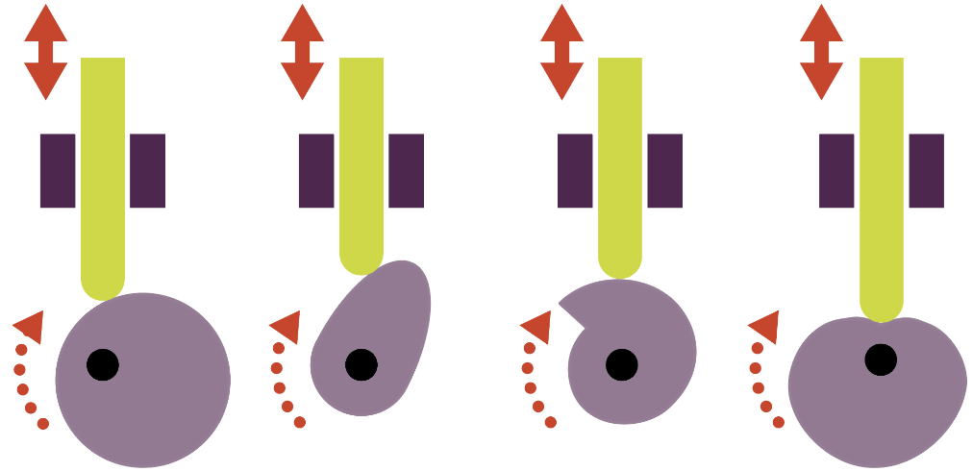

7. Types of followers
Followers rest on a cam and track its rise and fall.
Roller
follower

Knife-edged
follower

Flat
follower

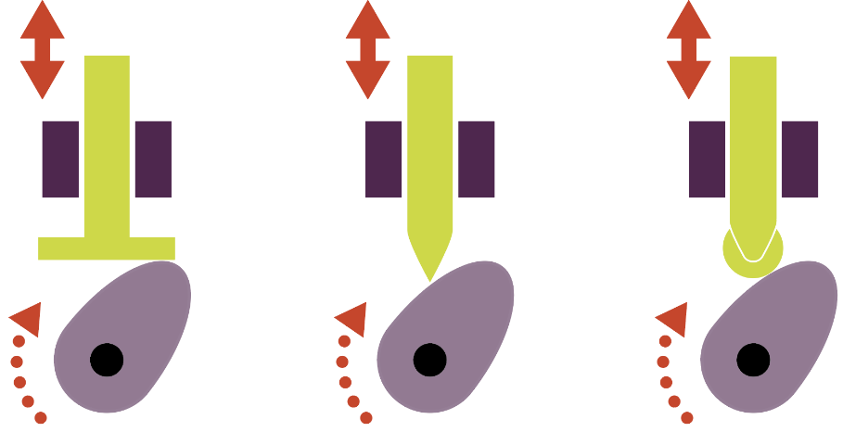

Tasks: 1-7 Learn/cover/write and self-check the various aspects of Mechanical processes.

1. Idler gear
An idler gear ensures that the direction of the drive gear and the driven gear are the same.
  - The idler gear sits between the two gears and directly transfers the drive.

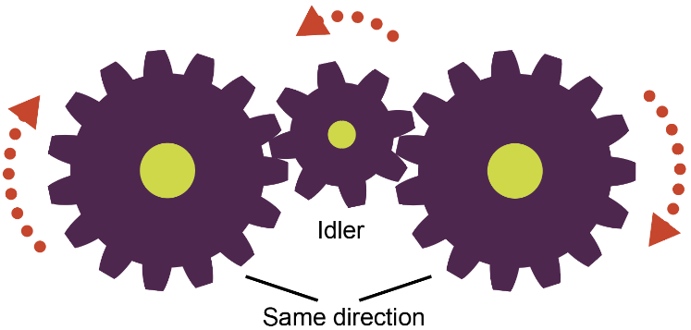

2. Pulleys and belts
Drive belts are used to transfer drive from one pulley to another.
  - Belts rely on friction to grip
the pulley and are often made
from rubber, but also many
other materials.
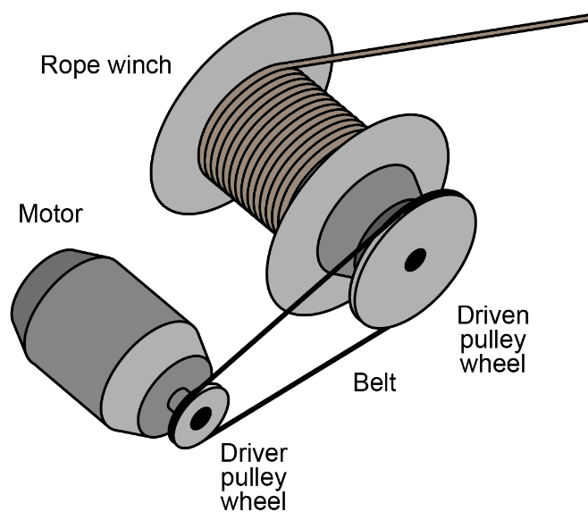
  - A pulley is often grooved
to help increase the friction
on the belt.

3. Block and tackle
Block and tackle systems combine pulleys to lift heavy weights.
  - A rope is looped around pulleys in a block to form a tackle, to reduce the effort needed to lift.
  - As more pulleys are added, the lighter it becomes, although more rope needs to be pulled through.
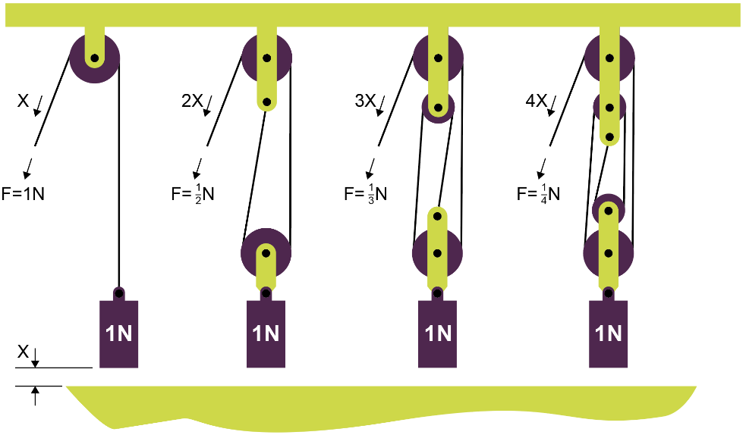

4. Gear trains
Cogwheels are meshed to create gear trains.
  - A simple gear train has a drive cog or ‘gear’, which rotates the ‘driven gear’.
  - Gear ratios can be worked out by comparing the number of teeth on each gear.
  - If the drive gear has 20 teeth and the driven gear has 10, then the driven gear will rotate twice for each turn of the drive gear.
  - This is a gear ratio of 0.5 and is called ‘gearing up’.
  - Gearing down uses a smaller drive gear than the driven gear
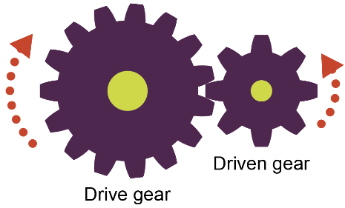

Tasks: 1-4 Learn/cover/write and self-check the various mechanical devices.

