1. Automation
What is automation?
Robotic automation of manufacturing processes offers significantly greater consistency, accuracy, reliability and productivity than human workers. |  | 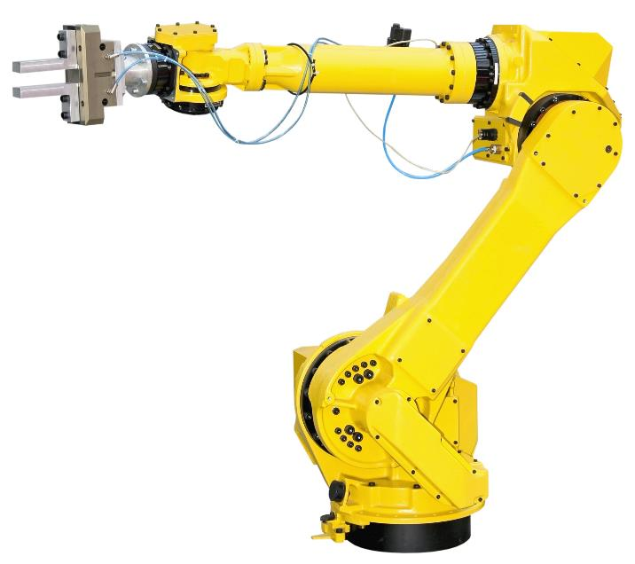
Automation appears in most factory environments. Industries such as cars, food, clothing and electronics.
Advantages | Disadvantages
- Robots don’t get tired  - Speed  - Accuracy  - Consistent  - Reprogrammable | - People lose their jobs  - Expensive to repair, as they tend to need a specialist.  - Initial high investment costs.  - Machines and parts are expensive.

 | 2. Barcodes
 | Why are barcodes important?
 | All products have barcodes, a barcode is a specific number allocated to individual products. | 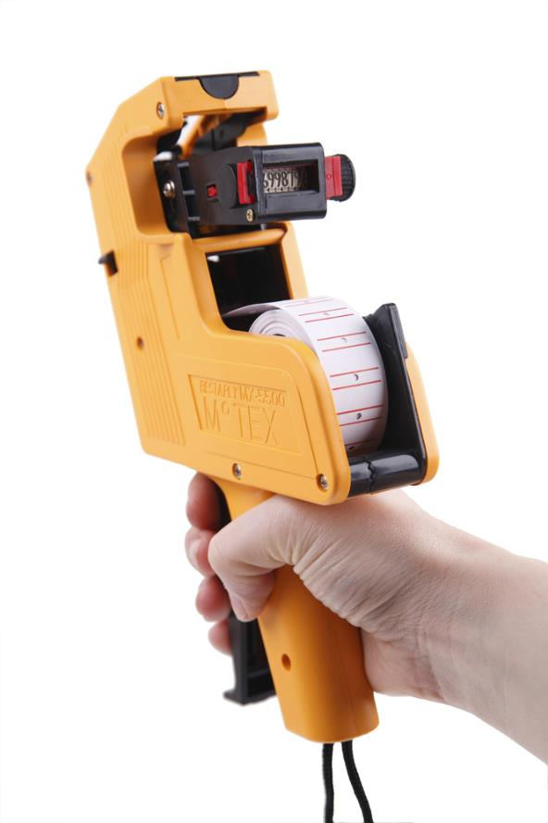
Two common types of barcode system:


  - Universal Product Code version ‘A’
(UPC-A).
  - Used in EPOS systems
and warehousing.

  - Code 128
  - Used in transport and
shipment tracking.

Code 128 can represent letters and numbers whilst UPC-A can only represent numeric digits.

3. Design of the workplace
Workflow is essential to health, safety and efficiency.
  - A production line must flow logically from one stage to the next.
  - Automation and new technologies may require change to production flow.
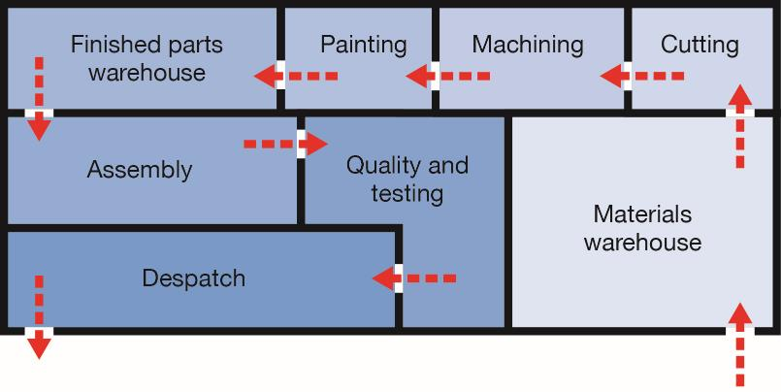

4. Low oil supplies
The depletion of oil reserves is hastening change and development of replacement technologies to fuel our industries, homes and transport.
New technologies include:
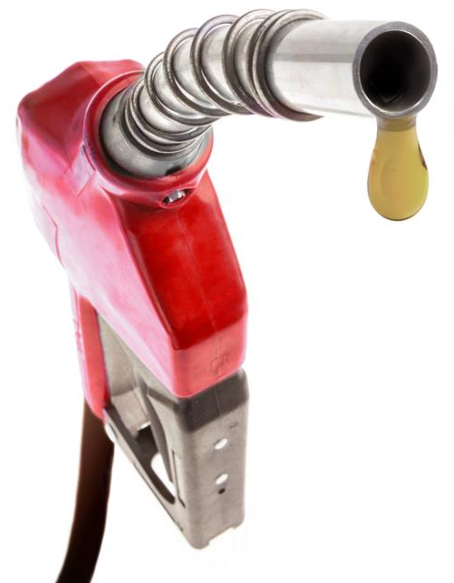
  - Harnessing natural resources
  - Hydrogen power
  - Battery technology

5. Electric vehicles
The EV market is expanding rapidly.
Success is dependent on:
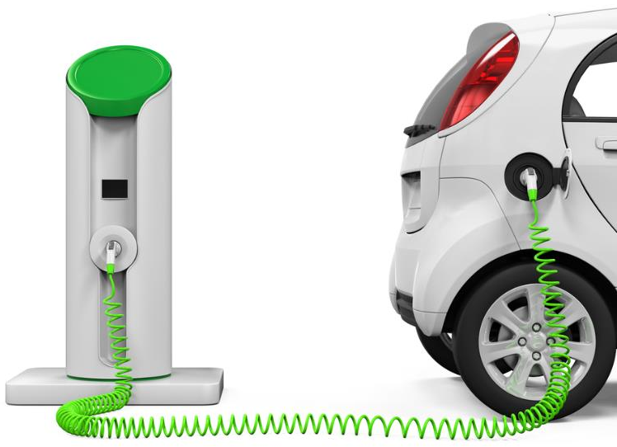
  - National and international charging networks.
  - Battery technology.
  - A change in driver mind-set.

Task: 1-5 Learn/cover/write and self-check Automation, Bar codes, Design of the workplace, Low oil supplies and Electric vehicles.

1. Product innovation
A new invention or idea requires a considerable investment to make it a commercial success. No matter how good an idea is, it can still fail if its development and execution is not right.
  - A huge industry exists to support fledgling ideas and research using new and emerging technology.

2. New materials and technology
Graphene was discovered in Manchester University, it is an atom thick sheet of graphite (which has the same atomic structure as diamond) layered onto a piece of plastic.
- Graphene is a honeycomb lattice carbon structure only one atom thick.
- It is 200 times stronger than steel, very flexible, conducts
heat and electricity, and is almost transparent.
- Electronics and energy storage could be revolutionised.
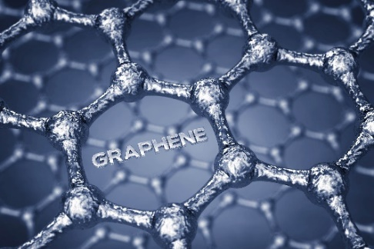

3. Developing ideas
Innovation such as 3D printing has the potential to change product development everywhere. This fuels a cycle of new ideas, new businesses, new jobs and newer ideas.
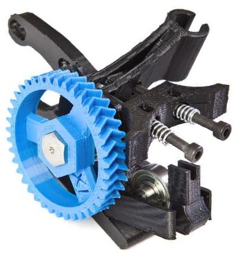
  - 3D printers can produce solid
objects, intricate hollow artefacts
and moving parts that
actually work.
- Printing body parts -3D bio printing is being used to create new, living organs. Skin tissue, livers, and joint cartilage have already been ‘printed’ and successfully transplanted.
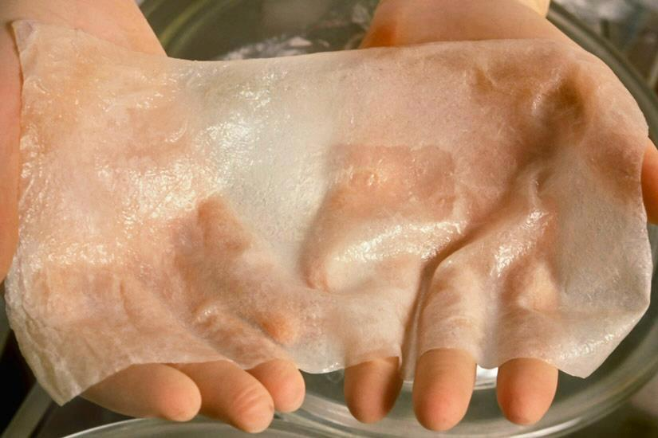
A solution for more complex organs is probably
only a couple of decades away

4. Dangers of 3D printing
In 2013, the 3D print file required for all the parts of a working gun was created and distributed online.


5. Small enterprises Inc.
Small businesses can use new technology to compete with their larger competitors.
  - Computer technology has enabled individual designers to access the leading industry design tools.
  - Production technology has meant that widgets can be made on demand, avoiding the costs of holding stock.
  - Communications technology has enabled remote working so small teams can be formed across the globe.
  - Social media has provided access to vast audiences on minimal marketing budgets.
  - Crowdfunding provides opportunity for significant start-up investment capital.

Task: 1-5 Learn/cover/write and self-check

1. Crowd funding at 
Crowd funding enables organisations to raise investment from individuals who believe in their idea.
  - POD Point supply electric vehicle
charging solutions to individuals
and organisations across the UK.
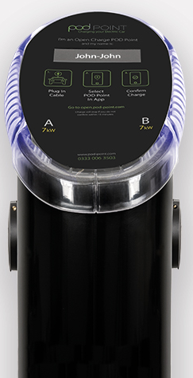
  - In 2015, they launched an online
crowd funding campaign.
  - This raised over £1.8m in investment from 618 individuals.

2. Virtual marketing
Virtual marketing includes:
  - Search Engine Optimisation to increase page ranking.
  - Email marketing.
  - Social media.
  - Viral campaigns.

3. Virtual and augmented retail
Augmented reality and virtual reality will play an increasing role in online retail
  - Placing virtual goods (e.g. furniture) in a person’s home to check physical and aesthetic fit.
  - Using VR headsets to try on clothes at home.


4. Co-operatives
Co-operatives are organisations or businesses that are owned and run by its members.
- Members will also share profits.
- Examples are often local, but can be national businesses.
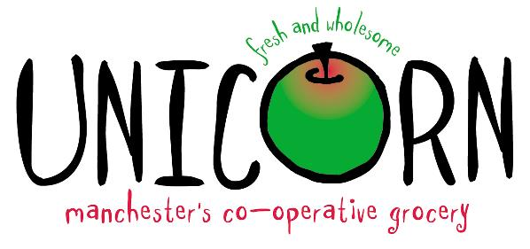

5. Fairtrade
Fairtrade is about better prices, decent working conditions and fair terms of trade for farmers and workers in less economically developed countries.
  - Farmers also receive a Fairtrade Premium to invest in
their communities.


Task: 1-5 Learn/cover/write and self-check crowd funding, virtual marketing, virtual/augmented retail, co-operatives and fairtrade.

1. Finite resources
What are finite resources?
Finite resources are being used faster than they are naturally replaced.
These cannot be produced synthetically reproduced. Finite resources includes coal, gas, oil, metal and precious jewels/stones.

Advantages | Disadvantages
- Produce energy to power products, homes and streets.  - Extremely efficient.  - Very stable.  - Easy to find.  - Generates employment.  - More reliable that natural forms of wind and solar power. | - Product green house and other poisonous gases which contributes to the greenhouse effect which warms up the planet.  - To obtain these resources the environment is damaged, sometimes permanently.  - Oils spills  - Rising costs.  - Public health hazard.

2. Non- finite resources
What are non-finite resources?
Non-finite resources can be grown, bread or harnessed.
Examples of these are:
- Timber  - Wool  - Leather  - Cotton  - Hemp | - Solar power  - Wind power  - Hydro power  - Wave power  - Geothermal  - Biomass
Advantages | Disadvantages
- Less harm on the environment.  - No pollution  - Renewable energy won’t run out.  - Less health issues to people/animals.  - Economically challenged countries will have less reliance of on wealthier countries. | - Some animals/people could lose their environments (dams)  - Over breeding of animals  - More expensive up-front costs (over the last 150 years money has been invested in the fossil fuel industry) and renewable energy is innovative.

3. Responsible design
What is responsible design?
Considerations includes:
  - Using production techniques that may use non-renewable energy.
  - Toxic by-products created in manufacture.
  - Environmental impact of mining or harvesting.
  - The product itself or production processes may emit CO_{2.}
  - Powering a product may require non-renewable energy.
  - Transportation and distribution distance.
  - Maintenance and repair costs.
  - Welfare of workers in the material supply chain.
  - Recyclability at the end of a product’s lifetime.

4. Waste disposal and product life cycle
How we treat and dispose of this waste can dramatically improve its impact on the planet. What impact might the following methods have?
- Incineration / burning.  - Landfill / burial.  - Dumping at sea.  - Recycling. | -toxic fumes released into the atmosphere.  -build-up of toxic gas/liquids whilst material is degrading.  -harmful to marine life and the ocean.  -toxic fumes in recycling process.  Life Cycle Assessment / Analysis  LCA is a technique to assess environmental impacts associated with all the stages of a product's life from raw material extraction through materials processing, manufacture, distribution, use, repair and maintenance, and disposal or recycling. Designers use this process to help critique their products.
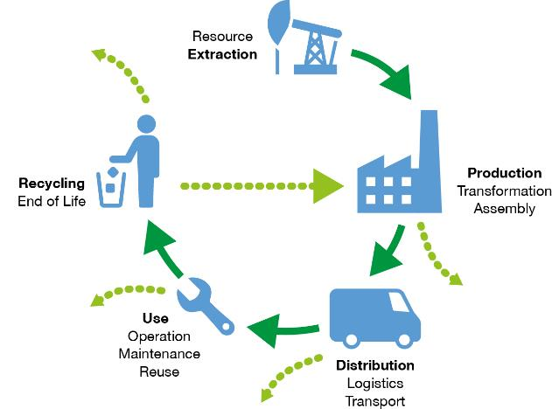

Task: 1-4 Learn/cover/write and self-check, finite resources, non-finite resources, responsible design, waste disposal and LCA.

1. Technology Push and Market pull
Technology push
New technology is often pushed onto the market, driven by research.
Often consumers are not aware of the new technology or the advantages it may bring. Some products might not be very useful or necessary, others may do the job perfectly and not change for decades.
Market Pull
Consumer driven pressure causes manufacturers to continuously develop new products or add functionality to existing products. For instance, currently consumers have concerns regarding the amount of plastic/packaging used by manufacturers and the impact this is having on the environment.

2. Fashions and trends
How does Technology influence fashion?
Evolution in the development of materials, technology and fashion has driven design trends, such as the Compact Disc and iPhone.
Compact Disc  These replaced vinyl records, which were prone to damage and easily scratched. CDs failed to replace the tape cassette or Sony Walkman’s, as the technology for personal CD players was not good enough at the time. | iPhone  This product has taken over in terms of technology and becoming market leaders.  They managed to replace person stereos and beat ‘Nokia’ which was a leading phone company at the time. IPhone succeeded to incorporate several technologies in one device. This saw apple become one of the biggest mobile phone suppliers in the world.

3. Cobots
What are cobots?
Collaborative robots, or ‘cobots’, are being developed to allow greater human-robot interaction. Most industrial robots work separately from humans.
  - Cobots can adapt to human operation and vice-versa.
  - They will work with humans rather than for them.
  - This is expected to significantly improve productivity.

4. Culture & Society
How does culture play a part in design?
Colour – Some colours are lucky or unlucky in various countries. Red is a colour used to alert people of danger, whereas in china this is a very lucky colour.

Icons – need to be universal for instance the icon for ‘fragile’ should be understood around the globe.


Culture – Culture is the characteristics and knowledge of a particular group of people, encompassing language, religion, cuisine, social habits, music and arts.
For example: Japanese culture is to sit on the floor at mealtimes. Design of tables and chairs in Japan is therefore very different from those in the rest of the world.

Language – Particular words could have different meanings in other languages, so companies must be careful with the words they use for their products.
Not all cultures read from left to right along horizontal lines of text. Arabic and Hebrew are read from right to left; some older forms of Chinese are read vertically.

Inclusive design - Designs may be developed to be easily used by the elderly or disabled.

Design for various religious groups - Textile and fashion design may be judged very differently by those of different religions.
Some religions require fuller coverage of skin and hair than others. Some have particular grooming requirements. Some require that certain materials must not be blended.

Task: 1-4 Learn/cover/write and self-check technology push/pull, fashion/trends, cobots and culture/society.

1. Automation
Automatic control is often used in production lines, communications networks and guidance systems.
Robots and automated systems often replace manual jobs, and can therefore save labour costs
Automated guidance systems - Some companies including Google are developing autonomous self-driving vehicles.

2. Computer Aided Design
CAD software is used to create precision 2D or 3D drawings, models or technical illustrations. It is commonly used by designers, architects, engineers and artists.
Advantages | Disadvantages
Designs can be created, saved and edited easily, saving time. | CAD software is complex to learn.
Designs or parts of designs can be easily copied or repeated. | Software can be very expensive.
Designs can be worked on by remote teams simultaneously. | Compatibility issues with software.
Designs can be rendered to look photo-realistic to gather public opinion in a range of finishes. | Security issues - Risk of data being corrupted or hacked.
CAD is very accurate.
CAD software can process complex stress testing.

3. Computer Aided Manufacture
Automated machinery is controlled by software to manufacture physical parts.
- CAM uses Computer Numerical Control (CNC) and CAD files to generate 3D tool paths for the machinery to follow.
- CAM machinery includes laser cutters, embroidery machines, CNC milling machines, routers and lathes.
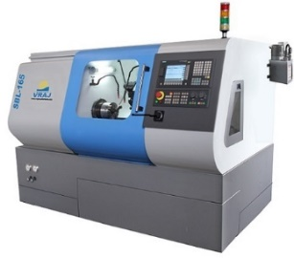 | 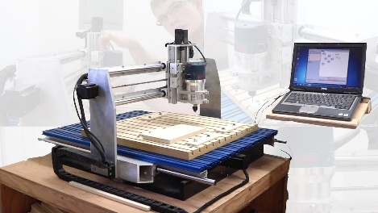

4. CNC Milling machine
CNC milling machines work in three dimensions to produce intricately and accurately machined objects such as this jet engine turbine wheel.
  - Digital designs are converted into a series of x, y, z coordinates for the machine to follow.

CNC laser cutting machines
By cutting at different speed rates, laser cutters can burn through or etch the surface of a material. They can cut complex shapes in a wide range of materials including:
  - Paper, Polymers, Timber, Metals and Textile based materials.

5. Flexible Manufacturing Systems (FMS)
FMS involve an assembly of automated machines commonly used on short-run batch production lines where the products frequently change.
They can be easily:
  - Recalibrated, Reprogrammed and Retooled.

6. Lean Manufacturing
‘Lean’ is a Japanese philosophy created by Toyota.
It aims to manufacture products just before they are required to eliminate areas of waste including:
  - Overproduction, Waiting, Transportation, Inappropriate processing
Excessive inventory, Unnecessary motion and Defects.

7. Just In Time (JIT) production
Items are created as they are demanded.
No surplus stock of raw material, component or finished parts are kept.
Advantages of JIT | Disadvantages of JIT
No warehousing costs | Reliant on a high quality supply chain
Ordered secured before outlay on parts is required | Stock is not available immediately off-the-shelf
Stock does not become obsolete, damaged or deteriorated | Fewer benefits from bulk purchasing

Tasks
  - Learn/cover/write and self-check the various types of product manufacturing.

1. Informing Design Decisions
If you are designing a new product, you will need to gather opinion and facts in relation to:
  - Successes and shortfalls of similar available products.
  - Available technology.
  - The size of the market.
  - The market need.

2. Planned obsolescence
Planned obsolescence is when a product, is deliberately designed to have a specific life span.
A product is designed to last long enough to develop a customer’s lasting need. The product is also designed to convince the customer that it is a quality product, even though it will eventually need replacing. In this way, when the product fails, the customer will want to buy another, an up-dated version.
How is the life span of a product determined?
  - Fashion and trends
  - The requirements to maintain market share
  - New technologies
  - Upgradeability and function

Once the expected lifespan of a product is determined, manufactures need to appropriately engineer the product, in order for it to last as long as expected.

 | 3. Disposability
 | Some products are planned with deliberately short lifespans.
 | What are the advantages and disadvantages of disposable products?
 | Advantages | Disadvantages
 | - Companies do not need to change their machine tooling often.  - Products can be packed/bundled in large quantities. | - Creates substantial waste.  - Products may not be biodegradable.  - Harmful to the environment.  - Disposable medical products need to be highly sterilised which is an extra stage in the manufacturing process.
4. Design for maintenance and Specialist repairs
Should all products be repairable?
We are seeing an increase in sealed units in some electrical products, such as televisions.
Some products are manufactured to be too complex to be repaired at home.
  - Knowledge is required to fix electronics or mechanical parts.
  - Specialist tools are required.
  - Specialist replacement parts may be required.
An example of this is the Apple company who created their own components for the outer casing of their iPhone, so people would not be able to open and fix them. Inside, the units are built with standardised components.
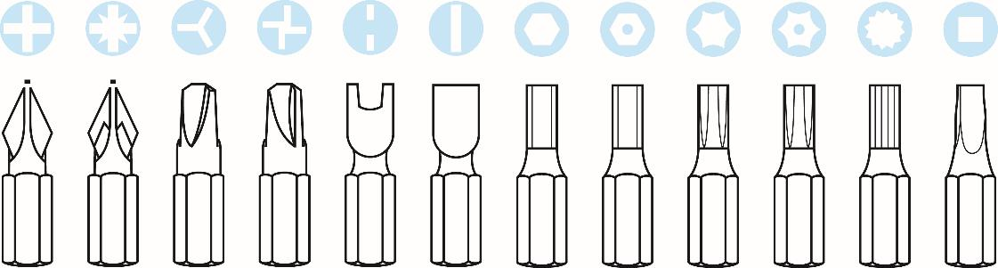

5. Swedish Case Study
The Swedish government is offering to halve VAT on repairs to encourage owners to make do and mend. They will also offset half the labour cost through income tax benefits.
  - This will significantly reduce the cost of repairs to clothes, shoes, bikes and large kitchen appliances such as washing machines and dishwashers.
  - Products will last longer and the consumption of materials will be reduced.

6. Ethics and environment
Companies are increasingly aware of the need for social responsibility.
  - This includes sustainably sourcing components and materials, ethical production methods, reducing waste, recycling and considerate end-of-life disposal.

7. End of life
Responsible end of life design should include:
  - As few materials as possible.
  - Recycled and recyclable materials where possible.
  - Easy-to-separate materials avoiding permanent bonding methods.
  - Built-in reusability where possible.

Tasks
1-7 Learn/cover/write and self-check the each section of the Informing Design Decisions Knowledge organiser.

