1. Material selection
Materials are usually selected for two purposes:  This can create a huge number of choices. | - Aesthetics  How a product looks.  Is it pleasing to the eyes? | - Function  How a product works?  What is its purpose?
Considering functionality  Investigate the functionality of a material to ensure it is appropriate for your prototype. | Consider:  - Strength.  - Movement.  - Conductivity (electrical & thermal).
Design Stage  Computer Aided Design (CAD) software enables designers to create a precision drawing of product | - CAD can produce either a 2D drawing or 3D render.  - Colours and finishes can be trialed.  - Stress loadings and weight  distribution can be tested.  - Market research can be conducted to receive early customer feedback.
Prototypes  A prototype is a first or preliminary version of a product. | - There are several categories of prototype:  It could be a working, visual or  functional prototype.  - This enables further testing of  functionality and aesthetic appeal.  - 3D printing can help create a precise  concept model.

2. Components selection
Component selection  A component is a part used in a product that is often prefabricated. | Components may:  - Require specialist machinery to make.  - Be expensive to produce yourself.  - Be time consuming to produce.  - Be purchased in bulk to decrease costs.
Availability and cost  Your project may be affected if chosen components become unavailable. | Project management triangle  Balancing the cost of your design and managing a deadline will require compromise, as you can only achieve two attributes of the triangle.  Each side of the triangle represents a constraint.  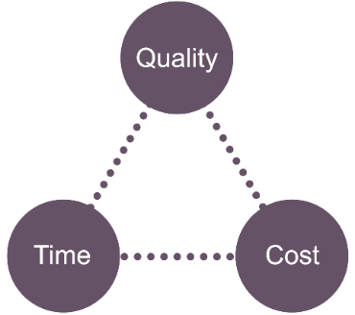
Questions you should ask of raw materials and components before commencing production include:
- Is the material available?
- Is it available in the correct size?
- Can it be delivered on time?
- Is there a plentiful supply?
- Is it cost effective to use?

Are there any environmental factors that may affect the availability or ethical use of the product?

Task: 1-2 Learn/cover/write and self-check material and component selection.
1. Tolerance and Allowances
What is Tolerance? | Tolerance is an acceptable margin of error for manufactured parts, publications, garments or electronic components for example. | This can be applied to measurements, weight, voltage, resistance or properties e.g. elasticity.  Tolerances are often given as (±) e.g. ±1mm.
The cost of precision | In industry, the narrower the degree of tolerance, the more the item is likely to cost to produce.
Why use Tolerances? | To ensure the accuracy when making a product.  A narrower tolerance generally means greater precision and a higher quality.
What is an Allowance? | An allowance is additional material that may aid cutting, forming of shaping to a higher quality.  Sometimes it may be difficult to cut accurately and allowances provide an acceptable margin of error.

2. Quality control and quality assurance
Quality assurance is the maintenance of a desired level of quality in a product. |  | Quality control is a system of checking standards through detailed inspection in manufactured or printed products by testing against given specifications to assure quality, accuracy and fitness for purpose.
3. Tolerance considerations For each of the products below a number of tolerances needs to be considered.
 | Flyer:  Registration / colour match / bleed / paper quality.
 | Shirt:  Seam allowance / colour / pattern match / positioning and joining of parts  seam strength / size of parts.
 | Flat pack:  Joint allowance / surface finish / overall dimensions / positioning of pre-drilled components / size of hardware such as screws and brackets etc.
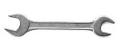 | Spanner:  Size of opening / length / weight / density /stress testing / brittleness / durability.

Task: 1-2 Learn/cover/write and self-check tolerances/ allowances, quality control/quality assurance and tolerance considerations.

1. Materials management
Material Management | Material management is an approach to planning and controlling material wastage within the manufacturing process.
Tessellation | Nesting shapes is a process that limits the amount of waste material by closely grouping them together.
Stock forms | Stock forms provide known quantities and sizes that can be easier to work with when measuring or marking out.  Stock forms are available at short notice and regularly kept in stock by suppliers. This allows a designer or manufacturer to plan cutting layouts and order materials.
SI units | Système international units are standard across the world.  These include Metres, Kilograms & Amps.  Millimeters is the preferred unit of length measurement, this allows a greater level without the use of decimal points

2. Marking out tools
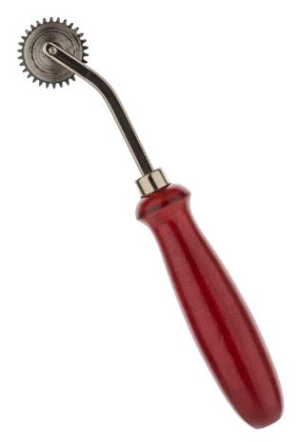 |  | Tracing Wheel
 |  | Engineers divider
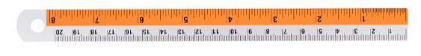 |  | Steel rule
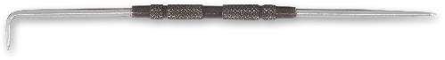 |  | Scriber
 |  | Marking gauge
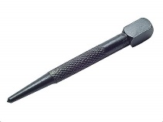 |  | Centre punch
 |  | Tailors chalk
3. Datum points
What is a Datum point?  A datum is a point from which all measurements  are taken. | - A datum symbol may be used to show the square face side and face edge of a piece of timber.  - Graphic illustrations may use a datum to show which point a measurement was taken from.
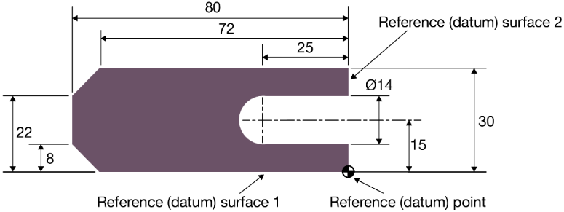

4. Marking out methods and Production tools
Marking out methods  In order to ensure accuracy, manufacturers use a range of marking techniques. |  | - Templates are used to accurately  mark out a product repeatedly for example a dress pattern.
Production tools  Repetitive accuracy can be ensured by using jigs or formers when manufacturing parts or products. | - A jig can be used to ensure certain parts fit together when producing batches, for example, a dowel joint.  - Patterns can be used as a former to ensure products are the same shape. E.g. a felt hat or a vacuum formed biscuit tray.
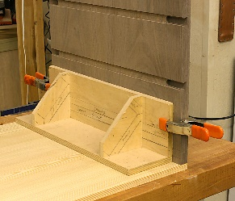 |  | 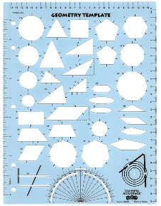

Task: 1-4 Learn/cover/write and self-check material Management, marking out tools, datum points and marking out/production methods.
1. Tools, techniques and processes.
What are the difference between:
- Tools and equipment
- Techniques
- Processes.
Tools and equipment | A tool is a device or implement used to carry out a particular function, for example scissors.
Techniques | A technique is a way of carrying out a particular task, for example sewing.
Processes | A process is a series of steps to work towards the completion of a final product, for example to overlock a seam.

2. Health and Safety Signs
In the workshop there are a variety of safety signs in order to reduce the risk of harm.
Triangular signs warn you of potential harm. | 
Red circular signs often indicate prohibited actions or access. | 
Blue signs offer mandatory safety instructions of what to wear e.g. safety glasses. | 
Green signs indicate safety, for example emergency exits or first aid. | 

3. Specialist tools
Many sources of guidance or advice can help with finding the correct tools, techniques and equipment.
These include:

Peers, Software, Companies, Books, Forums, Video links, Internet Research and Teachers

4. Health and Safety
PPE | Personal Protective Equipment includes anything that will protect users of equipment and products against health and safety risks.
Assessing Risk:
Risk assessments  These are performed to highlight dangers and limit the risk of accidents occurring. |  | - Schools complete risk assessments to ensure students are safe when using equipment or on trips for example.  - In industry, employers perform risk assessments to ensure their employees remain safe e.g. when welding.
There are five parts to a risk assessment, each defined in a separate column
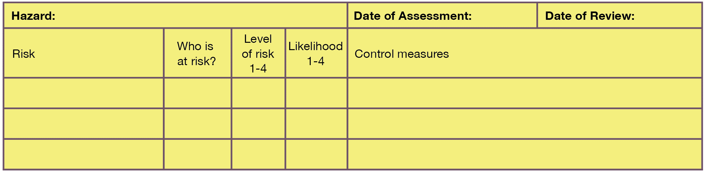

Data Sheets:
A data sheet is often provided by a material or equipment manufacturer highlighting any potential hazards with use.

Task: Learn/cover/write and self-check 1. Tools, techniques and processes. 2. Health and Safety Signs. 3. Specialist tools. 3. Health and Safety.

1. Treatments and finishes
Surface treatments and finishes are applied to materials for two main reasons:

- Functionality – (Protection)
- Aesthetics – (Appearance)

Some finishes will achieve both aesthetic and functional improvement.

Varnish | Natural grain enhancer that provides protection from water etc.
Paint | Colour and protection

2. The benefit of treatments and finishes
Improving Functionality | - Insulating electrical equipment.  - Insulating against adverse temperature changes.  - Making a product antibacterial, stain resistant or easy to iron.  - Protection against physical mistreatment or damage.  - Protection against attack from nature and the elements.
The benefits of treatments and finishes may improve functionality, as well to maintain it.

This may include:

Material protection | - Oxidisation and corrosion.  - Rot.  - Mould.  - UV degradation.  - Insect, creature and biological attack.
Attack from nature and the elements commonly includes weather protection.

This may include:
Aesthectic Qualities | - Printing, dyeing, staining.  - Embellishment.  - Applying
Finishes can be applied for purely aesthetic reasons: | - Printing, dyeing, staining.  - Embellishment.  - Applying
3. Surface treatments and finishes
Surface preparation:
Preparation is essential when looking to treat, protect or finish the surface of a material.
Application methods
A finish is likely to be applied to a product. The main methods of application include:
- Spraying / painting / rolling.
- Dipping / immersion.
- Heat / pressure bonding / blasting.
- Electroplating / electrostatics.
- Buffing / polishing.
- Printing.
- Adhesives.
Spray finishes
Spray finishes provide an even coating with good coverage of textured and hard to reach areas.

VOCs
Volatile Organic Compounds
Many finishes may contain high VOCs. Which often denoted by a coloured logo indicting the levels of VOCs.

4. Application of finishes
When applying finishes, consider the following:
- The work area is clear.
- The correct Personal Protective Equipment is available.
- The finishing product can be stored safely as you often have to apply multiple coats.
- Your prototype / product can be stored without risk of damage during drying time.
- Appropriate storage, e.g. lockable, flameproof cupboards for flammable products.

Task: Learn/cover/write and self-check 1. Treatments and finishes. 2. The benefit of treatments and finishes. 3. Surface treatments and finishes.
4. Application of finishes.

