1. Investigation and research - Sources of data and information fall into two categories – Primary and Secondary
Primary | Secondary
- Primary data is new data, gathered by the researcher.  - Sources include: interviews, focus  groups, questionnaires and case studies | - Secondary data is gathered as part of research or reporting on primary data.  - Sources include articles, books and magazines.

2. Market research - Research helps designers analyse and identify the market need for a product, the competition and the customer base.
  - Information can be gathered using interviews and questionnaires.
  - Non-specific, open-ended questions can help to gather general information.
  - Detailed questions help collect answers to very specific points.

3. Product analysis - As part of your research, it’s essential to know what else is on the market and how it’s made.
  - Consider the functionality of the product.
  - Observe the aesthetics and customer appeal.
  - Note the use of materials and the finish.
  - Analyse both the successful and weak areas of a design.
  - Qualitative feedback from focus groups is informative.

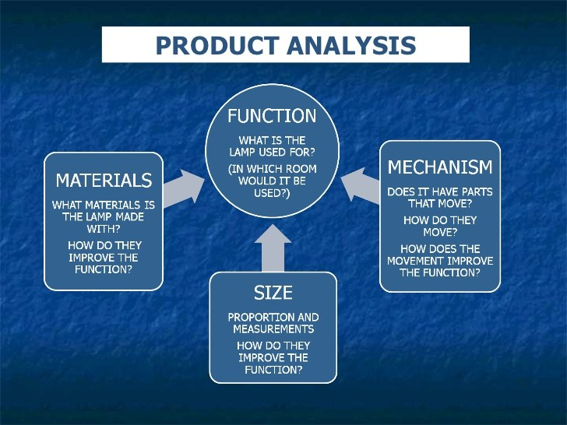

4. Functional performance
Product analysis can help your awareness of:
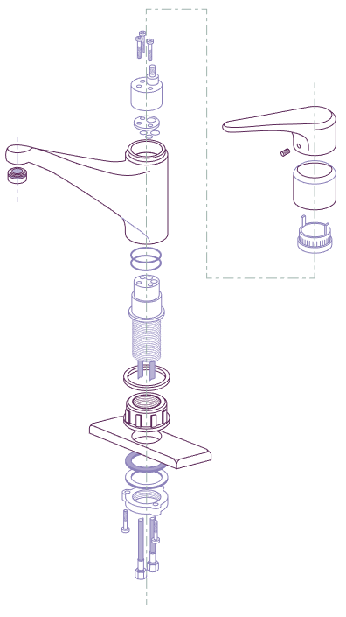
  - Production methods.
  - Which materials have been used and
types of finishes.
  - How materials perform, both functionally
and aesthetically.

5. Product analysis results -
Consider the following areas and their options:
  - Form – shape, size, weight, colour and texture.
  - Materials – mild steel, glass, cotton and oak.+
  - Manufacturing processes – injection moulded, drape formed.
  - Cost – production costs and retail price.
  - Function – what does it do?
  - Standard components – nuts, bolts, switches, rivets, zips.
  - Ergonomics – how easy it is to be used.
  - Environmental factors – use of sustainable materials and recyclable.

6. Response to a product - A focus group is made up of a diverse group of people who might trial an early version of a design.
  - Qualitative research will gather their reaction, perception and attitude toward a product.
  - Testing and questions will also give information on their experience of using or working with the product.

7. Focus group approach - Focus groups can enable a business to engage directly with their customers.
  - Listening to groups discussing their findings can help clarify feedback.
  - Watching body language and a response to an item can also
give a good insight to a customer’s reaction.


Task: 1-7 Learn/cover/write and self-check the various aspects of primary and secondary data/research.

1. Ergonomics and anthropometrics
Ergonomics | Anthropometrics
- The science of how humans interact with objects  - Design for efficiency and comfort in the  working environment. | - Measurement of the physical properties  of the human body.  - It derives from the Greek words  ‘Anthropos’ (human), and ‘metron’ (measure).

2. Ergonomic design - When designing a product, it should be both comfortable and functional.
  - Designers will study the way people interact and work with an object.
  - They will consider the physical and emotional connection to a product.
  - Touch and feel as well as sound and smell are all relevant.
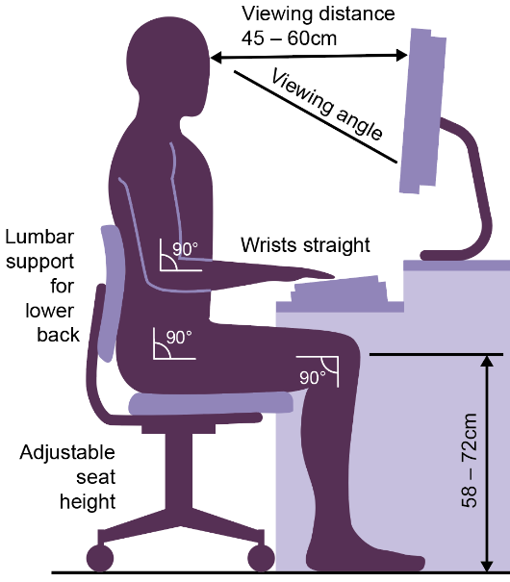

3. Anthropometrics - Designers gather the measurements of the
average individual human, looking at:
  - Height, weight and length.
  - Angle of reach.
  - Viewing distance and viewing angles.
  - A typical example of anthropometrics looks at the correct way to sit at a desk to maintain a comfortable position.

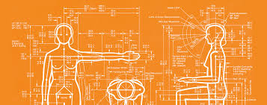

4. Graphs and charts - Most anthropometric data is presented as a bell graph.
  - It’s not easy to make products fit 100% of the target audience.
  - Often the top and bottom 5% of people will be excluded.
  - The 50th percentile is the average person or mean value.
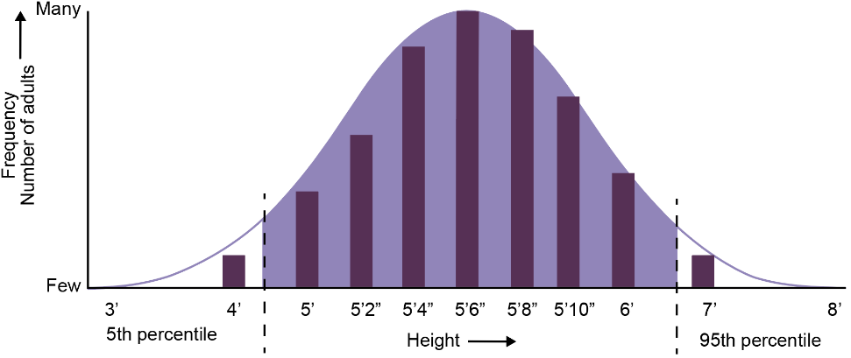

5. Present your data clearly - Once you have gathered your information, it needs to be presented in a relevant and meaningful way.
  - Summarise the findings of your market research.
  - Present a conclusion if this is evident from your data.
  - Clear presentations with the addition of photographs, audio or video recordings provide additional input.
  - Graphs will help summarise your statistics.
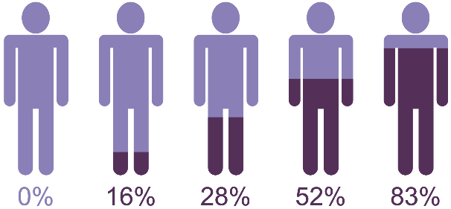

Task: 1-5 Learn/cover/write and self-check ergonomics/anthropometric data, graphs/charts and presenting data clearly.

1. Design brief - This is the conclusion of all your research and data.
A statement of intent will summarise your design plan:
  - What are you going to design?
  - Who is the target audience?
  - Where are they going to use the product?
  - What is the budget?
  - When does it need to be completed?
  - What size does it need to be?
  - Some of these are known as immovable constraints.

2. Design specification - A design specification is used to describe all of the client and technical requirements gathered throughout the research process.
It is a series of statements that outline:
  - The function and type of materials to be used in the product.
  - The client requirements including anthropometric data.
Before manufacture, the design specification is used to help create the final designs for the product. The final designs are then used to develop a detailed manufacturing specification.

3. Manufacturing specification - A manufacturing specification is used
to enable third party manufacture:
  - It can include drawings, CAD or 3D models.
  - It should be detailed and accurate, including dimensions, material choice, and a component list.
  - It will be used as a basis for testing and evaluation.
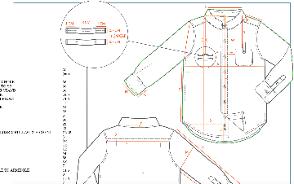

4. Test the design - The final product will need rigorous testing.
Strength and stress loadings may need testing.
  - Is it safe?
  - Does it function at the appropriate temperature?
  - Does it work?
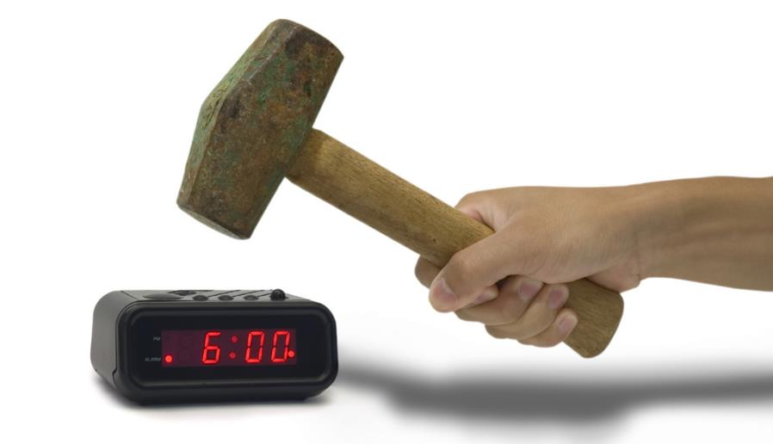

5. Modify your design - Following on from the testing, the design brief may need modifications:
  - Unforeseen changes may affect timescale, cost and material selection.
  - These may be minor and have low impact on the design.
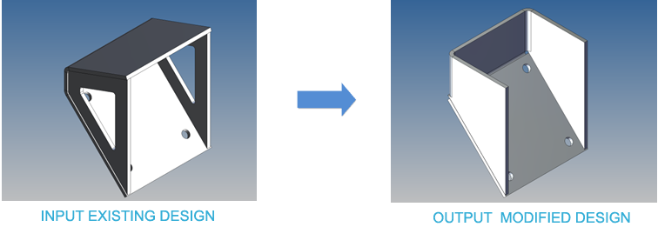

6. Environmental challenges - Responsible designers are sourcing alternative ways of manufacturing products.
To help reduce the effect human activity is having on the environment designers consider:
    - New and innovative methods of using waste materials and recycled material.
    - Reducing the use of scarce or limited resources.
    - Lowering energy consumption.
New, environmental friendly materials such as Bionic Yarn help change the stigma associated with recycled clothing.
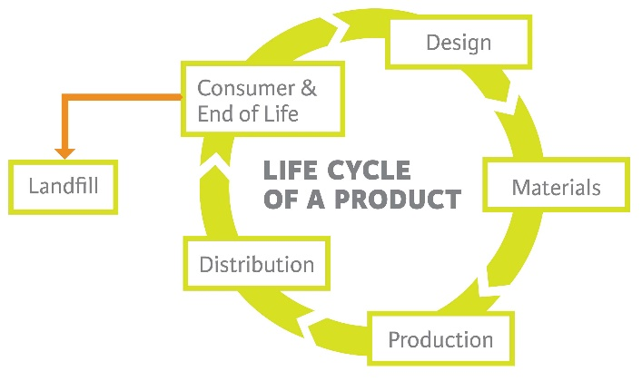

7. Social and economic solutions - Sustainable living aims to reduce our use of Earth’s natural resources. In manufacturing:
  - Disposal methods of waste materials have been refined.
  - Opportunities are being created in developing countries to enable producers and growers to receive better trading conditions and promote sustainable farming.

Task: 1-7 Learn/cover/write and self-check design process.

1. The work of others - Researching the work of others is
a key step in any design process.
  - As well as inspiring new ideas this will help you understand the materials and processes necessary in your focus area.
  - Investigate products both similar and dissimilar to your focus area to
discern the design process.
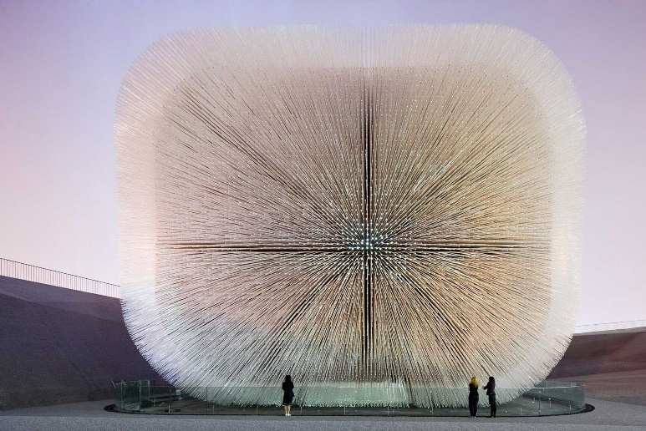

2. What to research? - All of the following contexts will provide a wealth of information and visual inspiration:
  - Artists.
  - Designers.
  - Design companies.
  - Design movements.
  - Trends and fashions.
  - The built environment.
  - Abstract patterns, nature and science.

3. Investigating the work of others - How can an investigation into the work of others be broken into different elements?
    - Materials.
    - Processes.
    - Aesthetics.
    - Design concepts.
    - Form and function.
    - Fitness for purpose.
    - Identify target market for product.
    - Manufacture / administration infrastructure.
    - Consistency with other products from the same designer.

4. Analysing the work of others - Look at similar products from different designers.
  - Compare and contrast different solutions to common problems.
  - Separate the underlying design concepts from the methods
of production.
  - Select those elements that most closely match your own design objectives.
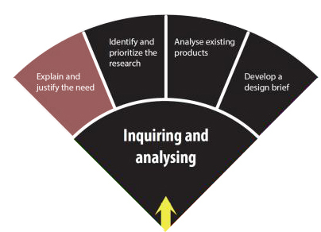

5. Evaluating the work of other - Evaluation should be as impartial and objective as possible.
  - What common features of their designs made the designer, or design company so successful?
  - What else was being produced at the time, and how did those products compare?
  - How could some of their most successful features and ideas, influence your own designs?

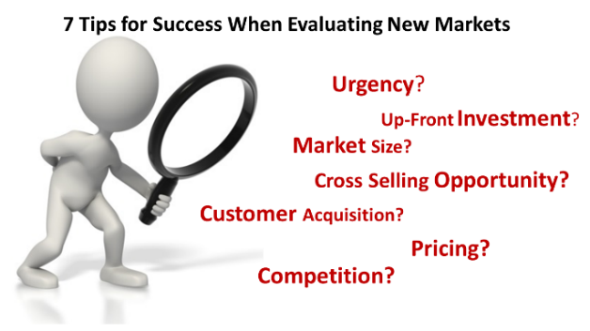

Task: 1-5 Learn/cover/write and self-check the work of others, research, investigating, analysis and evaluating.

1. Harry Beck 1902-1974 - A trained electrical draughtsman, Harry Beck drew inspiration from the simplistic style used for
electrical diagrams.
- His job was primarily to draw schematics for electrical systems of the London Underground.  - He created the colourful tube map that we know today. | 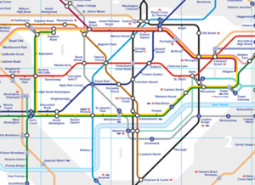

2. Coco Chanel 1883-1971 - French fashion designer and founder of the Chanel brand.
- Her simplicity and style revolutionised women’s clothing in the 1920’s.  - She liberated women from the corset and introduced casual elegance.  - Her Little Black Dress remains the most iconic fashion item that transcends age. | - Chanel expanded her successful brand into perfume and cosmetics. By 1929, Chanel No.5 was the best selling perfume in the World.  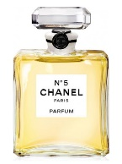

 | 3. Alexander McQueen 1969-2010 - The bad boy of British fashion, McQueen delivered collections that pushed the boundaries of design.
 | - He completed an apprenticeship at a Savile Row tailors before finishing an MA in fashion.  - Fashion houses of Paris, including Givenchy, hired McQueen which rocked the traditional world of fashion.  - His 2010 collection featured reptilian prints and alien inspired make-up.  - After winning a clutch of design awards he was awarded a CBE for services to fashion. | 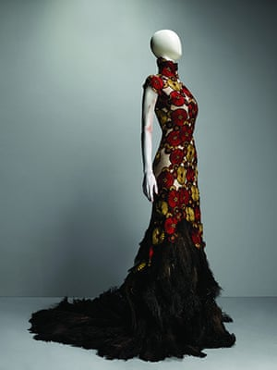
4. William Morris 1834-1896 - An outstanding figure of English textile design.
- Morris was associated with the Pre-Raphaelite Brotherhood and Arts and Craft Movement  - Celebrated for his block printed fabric and  textiles, he also produced elaborate  embroidery and tapestries  - Nature was his inspiration and he produced  stylised evocations of plants and flowers  He revived traditional art processes that  had been replaced by industrialisation. |  | 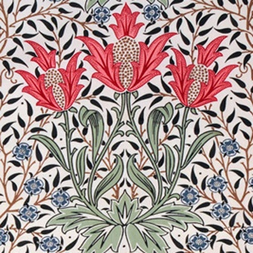

5. Mary Quant 1934 - British fashion designer who offered a refreshing alternative to fashion.
- Quant produced “relaxed clothes suited to the actions of normal life“ influenced by Mod style.  - She is often credited with creating the mini skirt. Whether or not she was the first, short skirts became synonymous with Quant style.  - Her daisy logo is recognised around the world. | 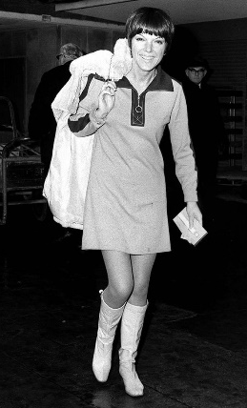

6. Vivienne Westwood 1941 - Famed for ripping up the fashion rule book with Malcolm McLaren.
- The media dubbed their provocative style ‘Punk’.  - In 1981, their first catwalk show created a template for the New Romantic look.  - Her designs often incorporate classic structured corsetry.  - Vivienne remains as challenging, innovative and anti-establishment as ever. | 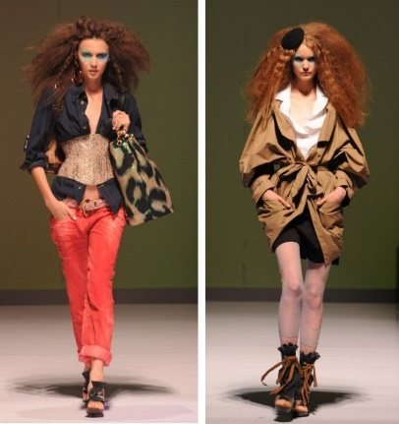

Task: 1-6 Learn/cover/write and self-check the various designers.

1. Marcel Breuer 1902-1981 - Influential Hungarian designer and architect.
- As a student of Bauhaus, Breuer  produced the first tubular steel furniture  - Breuer’s ground breaking design  of the Wassily Chair remains just  as fresh and modern today  - Cesca, a chair made of a single  curved piece of steel, became a  famous and much copied  cantilevered design  - His striking architecture often  showed a sculptural use of concrete | 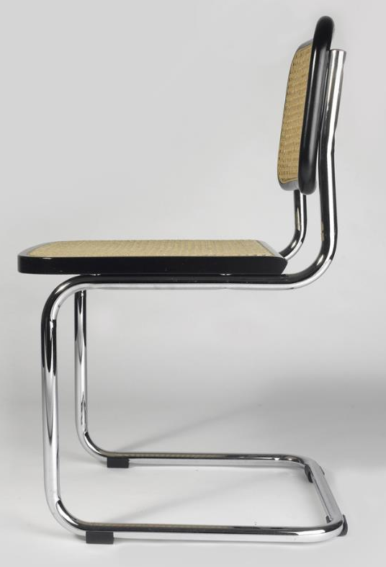

2. Norman Foster 1935 - British architect and founder of Foster + Partners.
- The partnership has created a wealth of outstanding buildings and structures around the World.  - Their designs are innovative, but practical and enhance our human experience with architecture.  - Creators of ambitious construction projects in challenging locations, they have realised iconic and landmark buildings. | 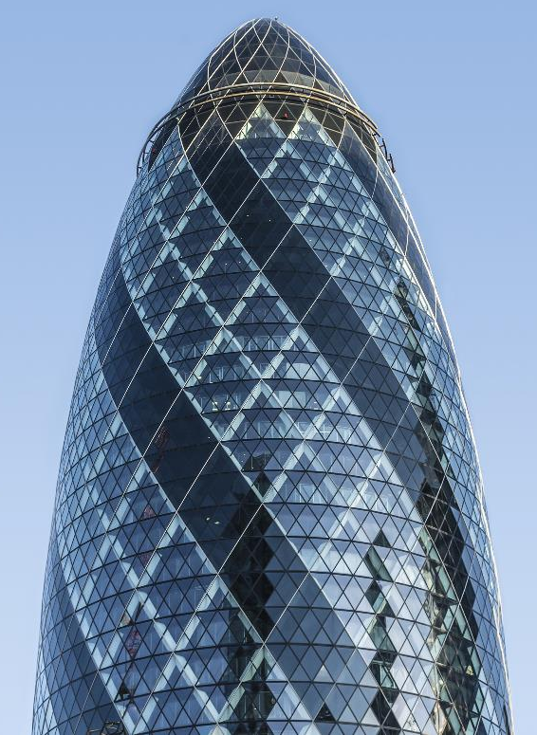

3. Charles Rennie Mackintosh - A Scottish designer, architect and artist 1868-1928.
- He was central to the success of Glasgow School of Art.  - His distinctive style of modernity with romanticism influenced building and furniture design of the early 20th century.  - He utilised geometric lines and natural forms with Asian and Japanese influence. | 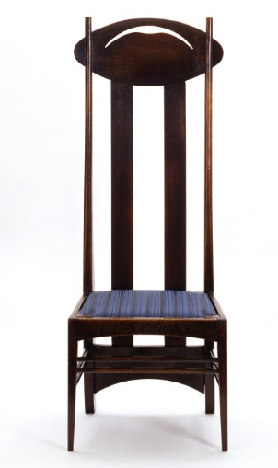

4. Aldo Rossi 1931-1997 - An Italian architect and product designer.
- Highly regarded for his original and geometric forms, he became an outstanding figure of post modern architecture.  - In the 1980s he worked with Alessi designing a series of iconic products including La Cupola coffee maker.  - He successfully expressed architectural and abstract form in his designs. | 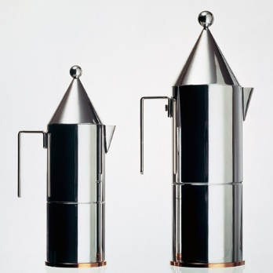

5. Gerrit Rietveld 1888-1964 - Dutch architect and furniture designer.
- In 1919 he joined forces with artists including Piet Mondrian and Theo van Doesburg as part of ‘De Stijl’.  - ‘De Stijl’ used a combination of monochromatic and primary colour pallets displayed in geometric arrangements.  - His most notable architectural project was the Van Gogh Museum in Amsterdam, completed after his death. | 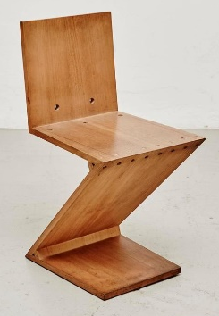

6. Ettore Sottsass 1917-2007 - A leading figure of Italian design and the Memphis design movement.
- Working as a design consultant for Olivetti, he revolutionised typewriter design with the Valentine typewriter.  - He worked extensively in architecture completing private houses and public buildings.  - He is among the many designers who have created housewares for Alessi. | 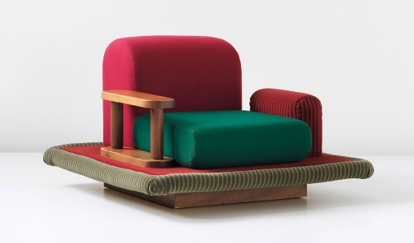

Task: 1-6 Learn/cover/write and self-check the various designers.

1. Philippe Starck 1949 - French product designer and architect.
- A prolific designer of kitchen appliances, furniture and lighting, through to motorbikes and yachts.  - Stark’s flamboyant personality is often reflected in his products as he adds an element of humour to everyday items  - Some say the Juicy Salif may be  celebrated more for its form over function.  - Stark is rumoured to have said  “It’s not meant to squeeze lemons,  it is meant to start conversations”. | 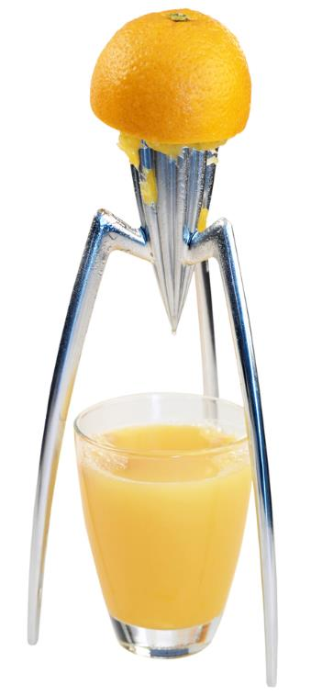

2. Raymond Templier 1891-1968 - An important figure in the world of Art Deco jewellery design.
- His work had a geometric style and was inspired by Cubism.  - He contrasted jewels with flat surfaces, matt with shiny materials.  - Templier jewellery is rare and highly sought after whenever items appear for public auction or sale. | 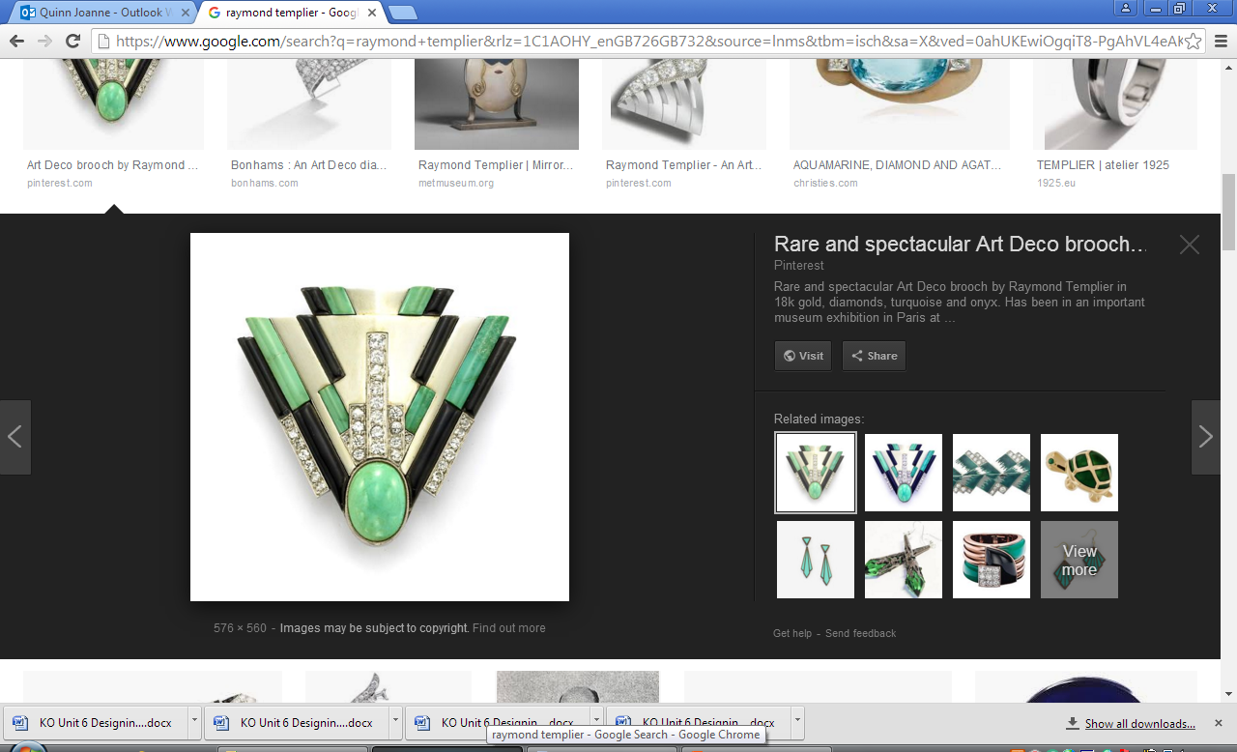

3. Louis Comfort Tiffany 1848-1933 - A prolific American designer whose life long goal was ‘the pursuit of beauty’.
- Rather than following his father in to the family business Tiffany & Co., he channelled his creativity into art and then stained glass.  - His stained glass designs echoed his love of naturalistic forms, flowers and insects.  - Tiffany expanded his range into furniture, frescoes, lampshades and small artefacts.  - By his death, he was an internationally acclaimed leader of American design. | 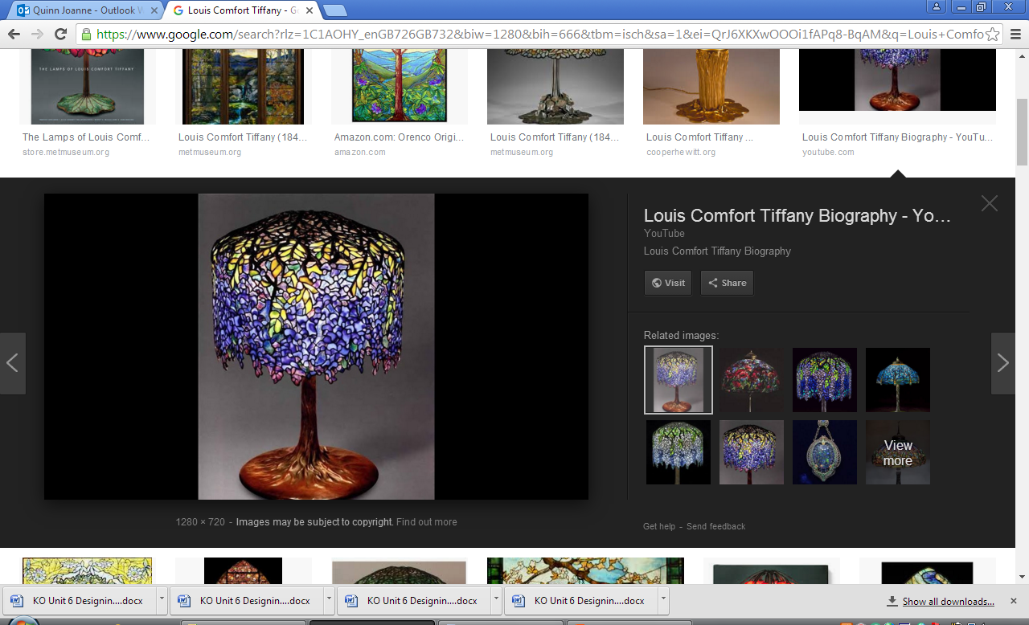

4. Sir Alec Issigonis 1906-1988 - Designer famed for the Morris Minor and Mini.
- His designs had more impact on Britain’s post war motor industry than any other designer.  - The Morris Minor was the first car to sell over a million units.  - His Mini designs broke the mould and revolutionised small car design.  - The iconic Mini continues to evolve today – a testament to its popularity. | 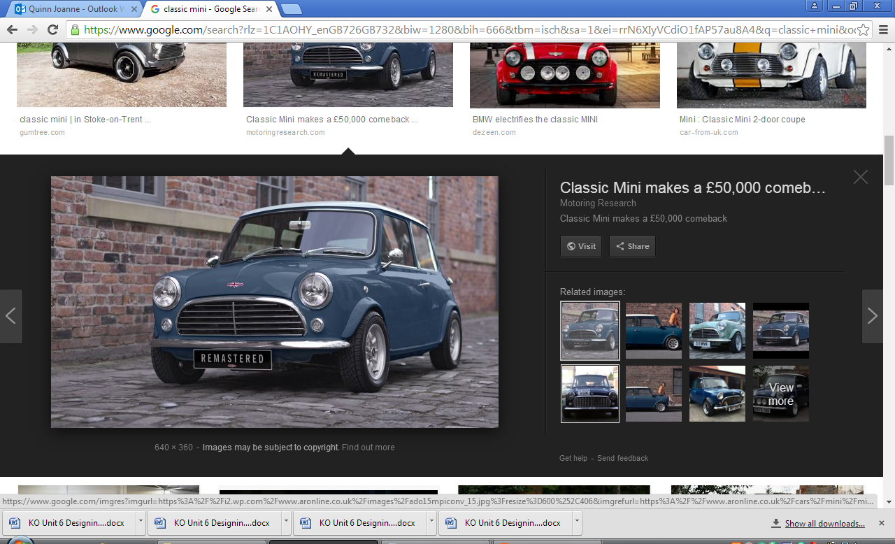

5. Design movements - Styles and fashions change.
Artists and designers take the lead in these changes and often form themselves into groups to promote their work.
  - Arts and Crafts Movement 1853 – 1907: Morris
  - Art Nouveau 1880 – 1910: Tiffany
  - Art Deco 1908 – 1935: Mackintosh
  - De Stijl 1917 – 1931: Rietveld
  - Bauhaus 1919 – 1933: Breuer
  - Post - Modernism 1970 – 1990: Rossi
  - Memphis 1981 – 1988: Sottsass

Task: 1-5 Learn/cover/write and self-check the various designers and design movements.

1. Influence on modern society - Designs, fashions and trends symbolise the spirit of the times.
  - Designers and design companies will be influenced by those who have gone before.
  - Companies aim to build upon and improve design, to create a product that’s more effective and also more desirable.
  - Material development and technological innovations will continue to aid in the advancement of design.
  - Culture and society also influence product design.

2. Alessi - Founded by skilled metalsmith, Giovanni Alessi in 1921, producing traditional items for the home.
- The company combined traditions with forward thinking ideas to create a series of finely crafted design wares.  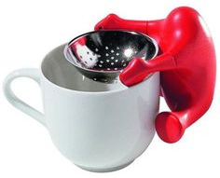 | Alessi work with creative partners rather than using in-house designers.  - These include Michael Graves, Aldo Rossi, Richard Sapper, Ettore Sottsass and Philippe Starck to name a few.  - Their attention grabbing style has made  Alessi one of the most recognised  brands in the world.  - Design is at the very heart of  everything they produce.

3. Apple - In 1976 Steve Jobs, Ronald Wayne and Steve Wozniak founded Apple.
- Their aim was to help make computing simpler and enjoyable.  - The combination of this ethos with pleasing aesthetics and elegant product design has made Apple a powerful brand.  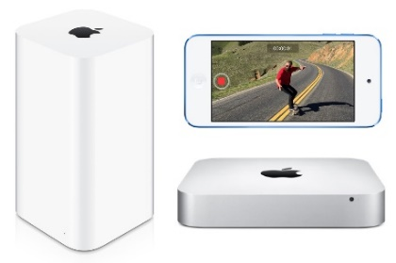 | Apple’s increased success has been helped by the launch of the iPhone in 2007.  - Apple met consumer demands by combining striking graphics with  multi-tasking capabilities.  - Their designs were described  as ‘game changers’ for the  phone industry.  - Apple’s Chief of Design, Jonathan Ive, is said to be influenced by Dieter Ram’s ‘ten principles of good design’.
4. Braun - Max Braun began in the 1920s with an engineering shop in Frankfurt, making radio components.
- Braun gained a reputation as one of Germany’s leading radio manufacturers.  - He expanded into audio equipment and in the 1950s produced the electric shaver.  - The core design principles are still used in the Braun shaver of today.  - Braun’s philosophy was for their products to be simple, functional, innovative and long lasting. |  | Dieter Rams became Head of Design at Braun and defined their elegant style.  - His objective was to design products  to be useful and easy to operate.  - During his 40 years at Braun, he  developed hundreds of products.  - His effortless design continues  to be influential and is an  enduring source of inspiration  for up and coming designers.
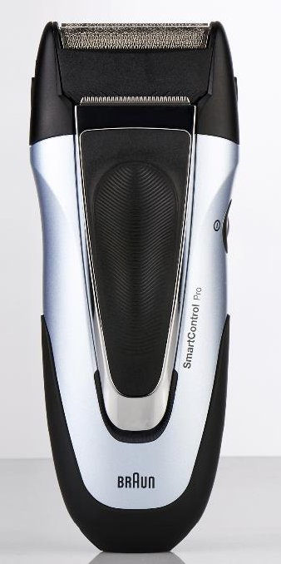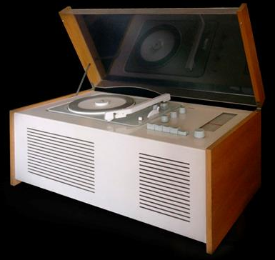

5. Dyson - James Dyson is a British inventor and founder of the Dyson company.
- He sees failure as a vital step to success.  - It took five years and over 5,000 prototypes before he launched the world’s first bagless vacuum cleaner.  - Dyson engineer their products to solve problems, with productivity and wellbeing in mind. | 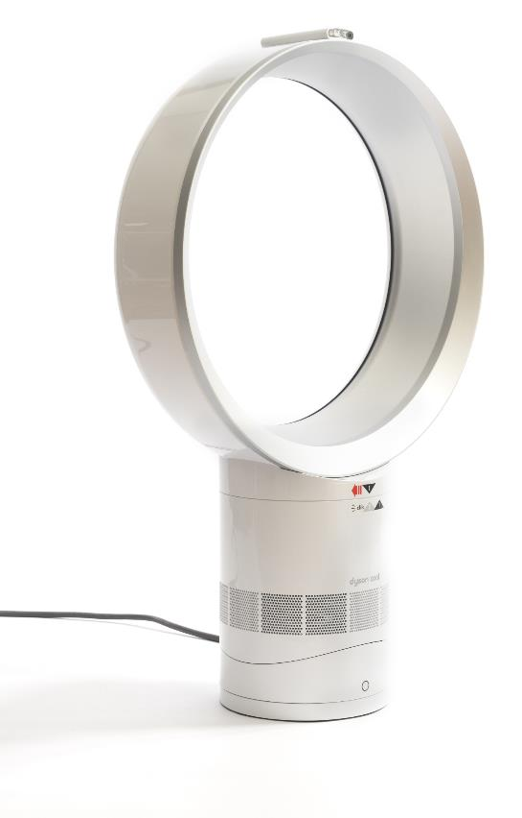
The company values the design process and the innovations that can come from a programme of continuous development.
  - Dyson analysed over 1,000 miles of different hair types to understand how it responds to the process of drying. Five years and 599 prototypes later the Dyson SupersonicTM dryer was released.
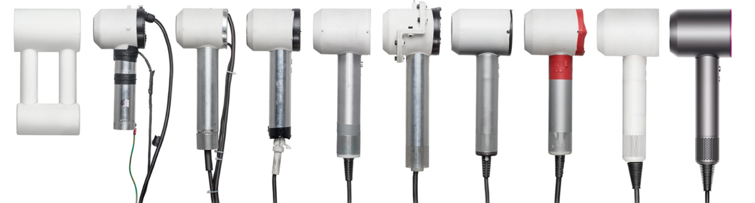

Task: 1-5 Learn/cover/write and self-check the influence on modern society, Alessi, Apple, Braun and Dyson.
1. GAP - Founded by Doris & Donald Fisher in 1969, originally selling Levi jeans and records in San Francisco.
- Their target market was a younger generation of shoppers.  - The stores only stocked a few lines, but in all sizes and colours.  - Their own Gap clothing soon replaced all the other brands and became the mainstay of the stores.  - Gap now have stores across the globe. |  | 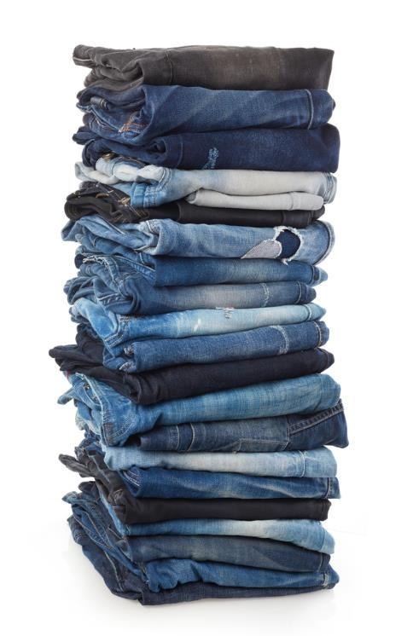
Gap “is defined by its people”.  - Gap has been built on a foundation of equality, and pay men and women equally.  - They continue to improve working conditions for their staff.  - Gap believe the future of fashion is sustainability and strive to reduce their emissions and energy use.  - They have set a goal to divert 80% of their waste from going to landfill and utilise recycled materials to make modern fibres. | 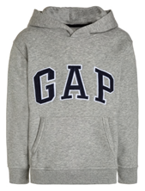

2. Primark - Primark produce high street clothing and accessories at
low prices.
- Shoppers’ appetite for fast fashion is fuelled by Primark’s ability to interpret the latest trends and produce high volumes of low cost items.  - Primark do not invest in advertising  and keep their price tags and hangers at basic quality.  - These savings are passed on to the consumer enabling Primark to keep down the cost of their items. | 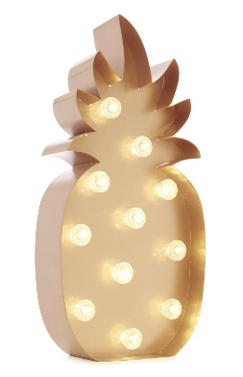
Primark began in Dublin in 1969.  - It’s now a global brand, regularly making the fashion news for its catwalk styles at bargain prices.  - They have also hit the headlines for their business ethics and working conditions.  - Primark have worked hard to change the way they work and are now award winning for their commitment to sustainability. | 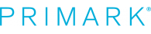

3. Under Armour - Founded in the USA, in 1996 by Kevin Plank, then a 23 year old football player.
- Frustrated by having to regularly change his sweat-soaked cotton T-shirts, he decided to find a more effective material.  - After researching the benefits of synthetic fibres, he engineered an effective moisture wicking fabric. | 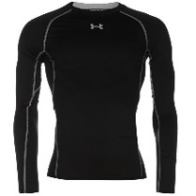
Under Armour’s now famous fabric is UA TECH™.  - They have gone on to develop more engineered textiles to keep athletes comfortable in all conditions.  - The technology has also been expanded into shoe design. | 

4. Zara - The first Zara store opened in 1975.
- It’s part of the Inditex group and a major force in the world of high street fashion.  - Zara aims to produce quality fashion that remains affordable.  - Zara is famed for swiftly interpreting catwalk styles and getting the look into their stores within weeks. | Zara continue to improve their design, manufacture and distribution methods.  - This has enabled them to expand into homewares and  online commerce.  - They have also developed an Environmental Strategic Plan to ensure responsibility and sustainability.
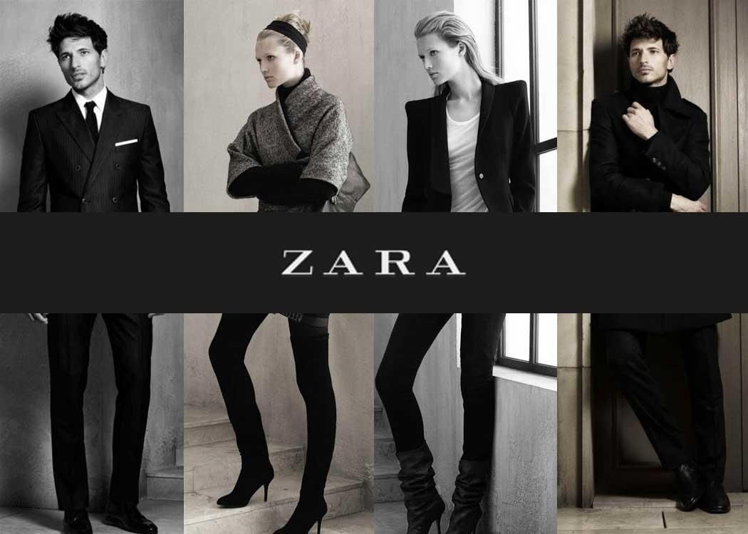

Task: 1-4 Learn/cover/write and self-check the information on GAP, Primark, Under Armour and Zara.
1. Design strategies - There is a variety of strategies that companies and individuals can employ to complete a design project:
  - Collaborative design.
  - User-centered design.
  - Systems approach.
  - Iterative design.
Each method has its own merits, and can also be used in conjunction with each other.

2. Collaboration - Working with others, especially at the development stage, can greatly increase creativity.
It also promotes:  - Motivation.  - Problem solving.  - Communication.  - Support. | In a team you will have a variety of people with different skills, e.g. graphics, design, technical, engineering and conceptual.

3. User centred design - The focus of user-centred design
is the client or user group.
  - Their requirements and limitations guide the design process.
  - A clear understanding of how the item will be used is the basis of any design.
  - Continuous consultation and testing ensures a project fulfils the brief.

4. Systems approach - The systems approach represents a sequence of actions, often based on an input-process-output model.
- The overall design process can also be broken down into sub-systems that are more manageable. | 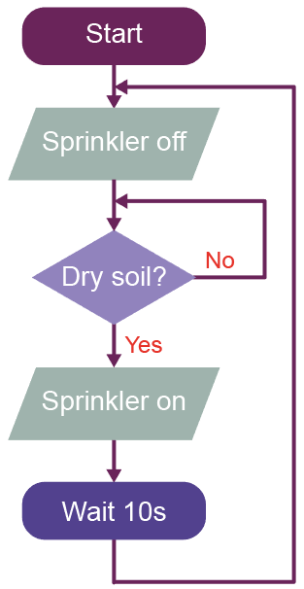
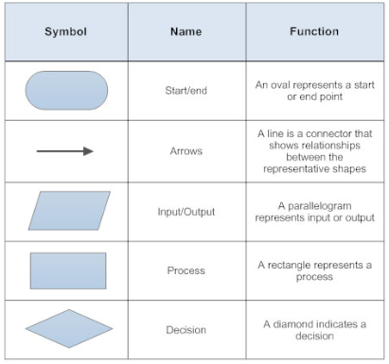

5. Iterative design - The iterative cycle enables the designer to refine their work in progress.
  - By actually making the item, designers begin to fully understand it and how successfully it works.
  - Many versions will fail to work as well as intended.
  - The outcomes, good or bad, dictate the next step.
Iterative process of designing - Using drawings, notes and models enables designers to work through a series of ideas.
  - These ideas are constantly revisited and reviewed at each stage of the design process to culminate in a finished product.
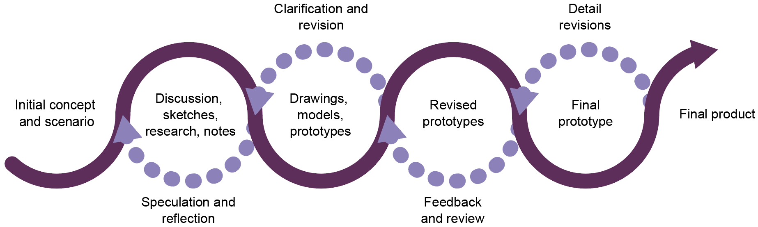

6. Design fixation - Design fixation can negatively impact design.
It can limit creativity and result in similar or ‘safe’ design ideas.
Designers can fall into common pitfalls of:
    - Not properly understanding a client’s needs.
    - Failing to consider alternative solutions.
    - Lack of research into new materials or technology.

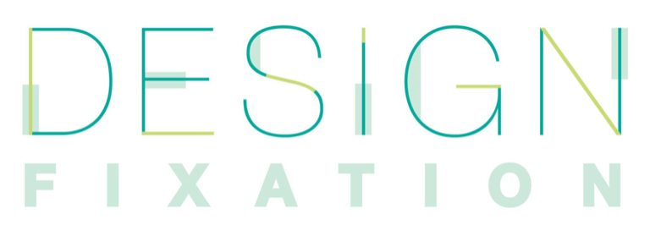

Task: 1-6 Learn/cover/write and self-check the design strategies.

1. Sketching - Sketches can be a first step in any design idea.
  - Sketches should be quick, enabling an abundance of ideas to be explored.
  - They can be produced anywhere and can record ideas and concepts as they arise.
  - Famously, Sir Alec Issigonis sketched his idea for the Mini on a napkin.
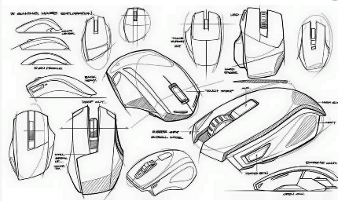

2. Modelling - Making a model can be the next step in the process.
  - However simple, it enables a designer to translate their idea into reality.
  - Everyday materials such as paper, card, tape, pipe cleaners, toile and fasteners can all be utilised to great effect.
  - Recording the steps (including the use of photography and video) is
also a valuable process, be it a success or failure.

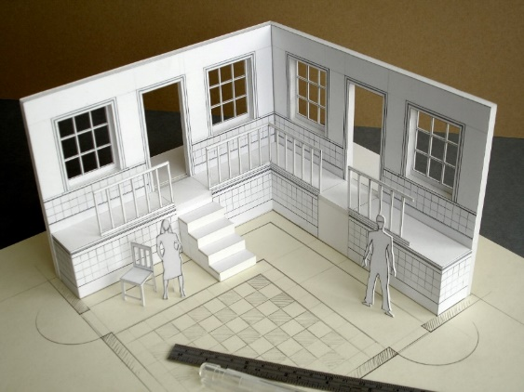 | 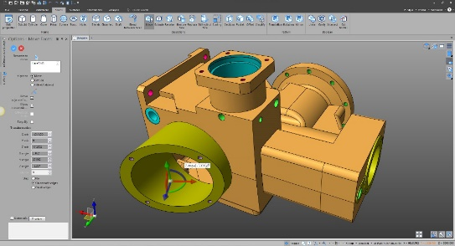

3. Testing - Testing could be as straightforward as checking
measurements or gathering opinions.
There are three different levels of testing:
  - Non-destructive testing.
  - Destructive testing.
  - Market testing - A group of people will try out a new product to see
if it is fit for purpose.
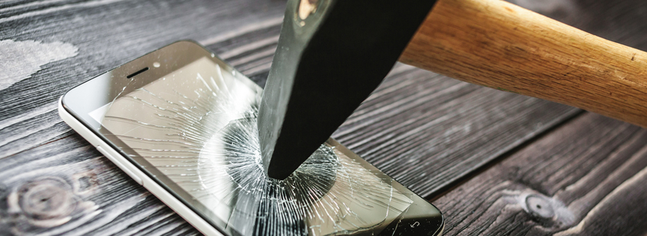

4. Why evaluate your design? Evaluating a piece of work enables a designer to see what can be improved.
  - Evaluation is a continual process of improvement.
  - Give one check that would be considered as part of an evaluation process.
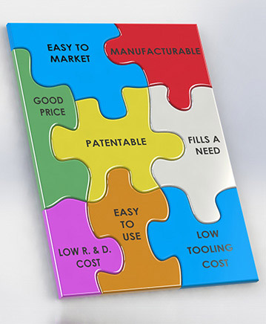

Task: 1-4 Learn/cover/write and self-check the various design strategies.

1. Methods of communication - Working on the presentation
of a design is a useful skill.
  - A portfolio is a good format for
communicating designs.
  - It should be accompanied by any working notes, sketches and mood boards that led to the final design.
  - Losing any stages of work can be frustrating and time consuming.

2. 2D and 3D sketching - 2D drawings are good for expressing ideas, dimensions, mechanical and electrical concepts.
- 3D drawings are better at representing the  look and feel of an object.  - A 3D room plan allows the viewer to imagine they are present in the room. | 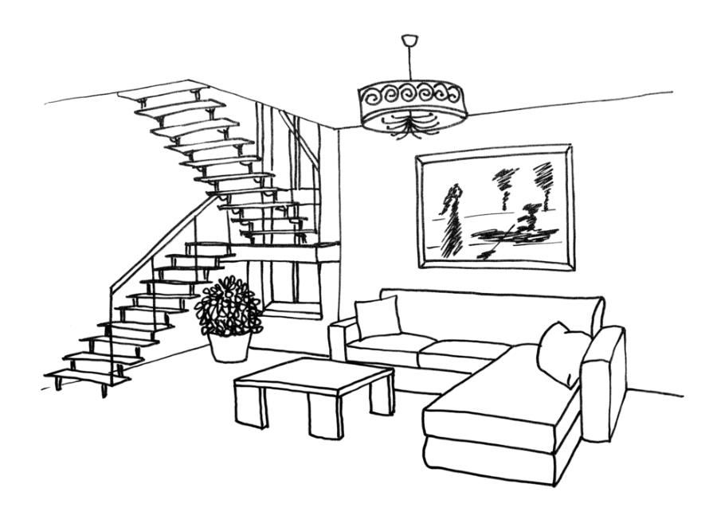

3. Oblique projection - Oblique projection is a simpler technique and useful in the early stages of design.
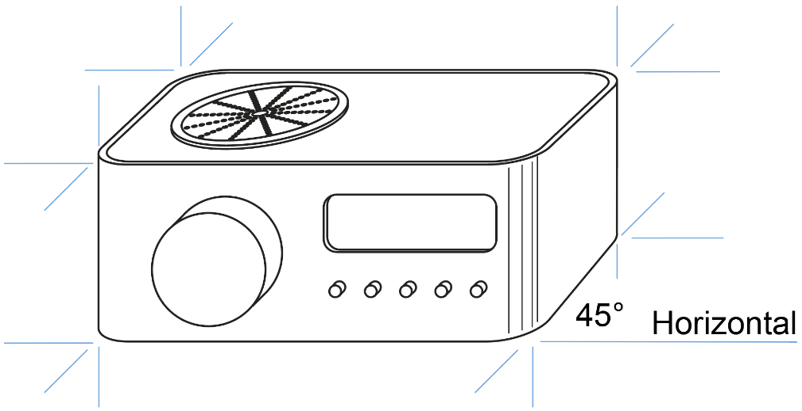

4. Isometric projection - Isometric drawings shows three faces of an object.
- Lines leading away are all parallel instead of narrowing, towards a vanishing point, which can create  slight distortion.  - Isometric grid paper can be a helpful guide when drawing in isometric projection. | 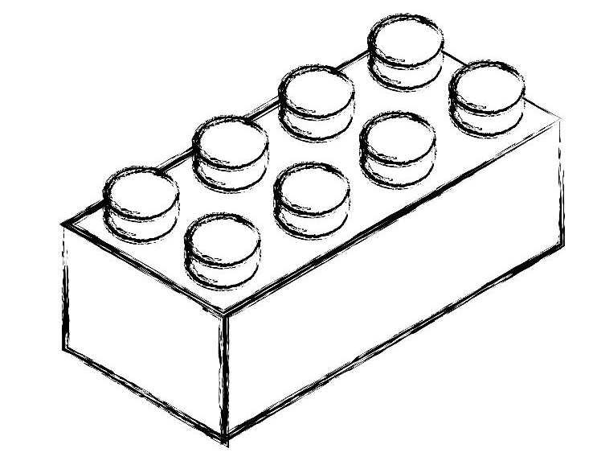


Isometric projection continued - Isometric projection enables designers to draw an object in three dimensions, which aids visualisation.
- All lines are drawn at a 30° angle away from the nearest corner of the object and accurate measurements can be added. | 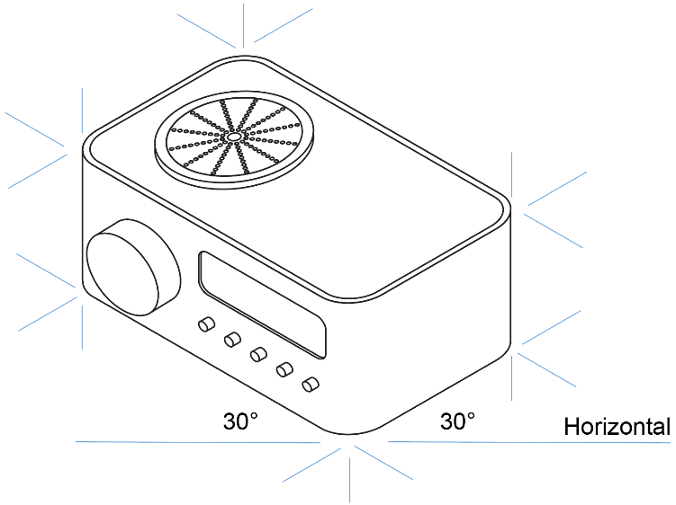

5. One point perspective sketch - This is one of the simplest styles, that you may sketch in a notebook, however its use is limited.
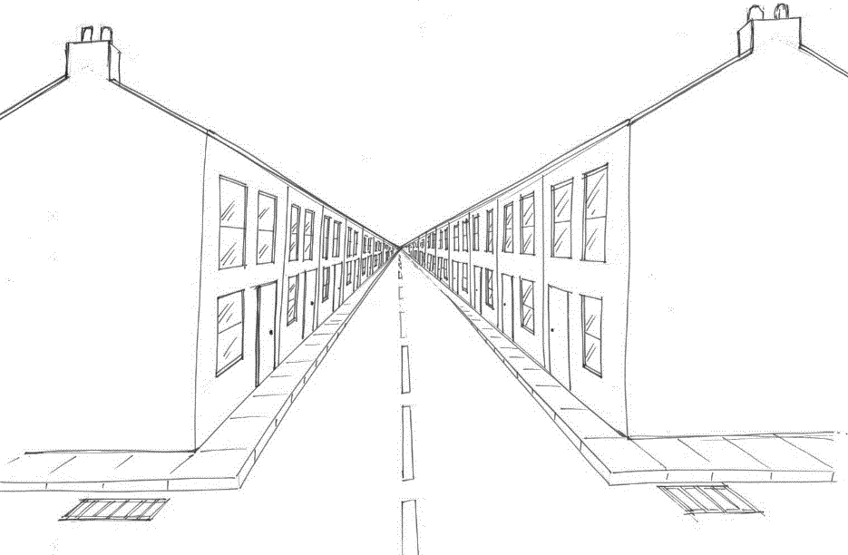

If you look square onto a item, you can’t see the sides.
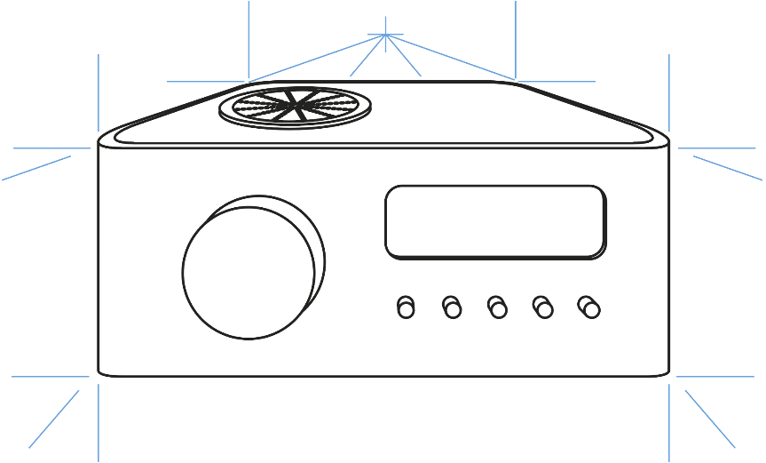

Task: 1-5 Learn/cover/write and self-check the various communication methods.
1. Two point perspective - Two point uses two vanishing points, so shapes that project towards them appear smaller.
  - This vanishing effect simulates the natural way we observe objects.
  - The following drawing used a rule for working out the structure, combined with freehand sketching for curved shapes.
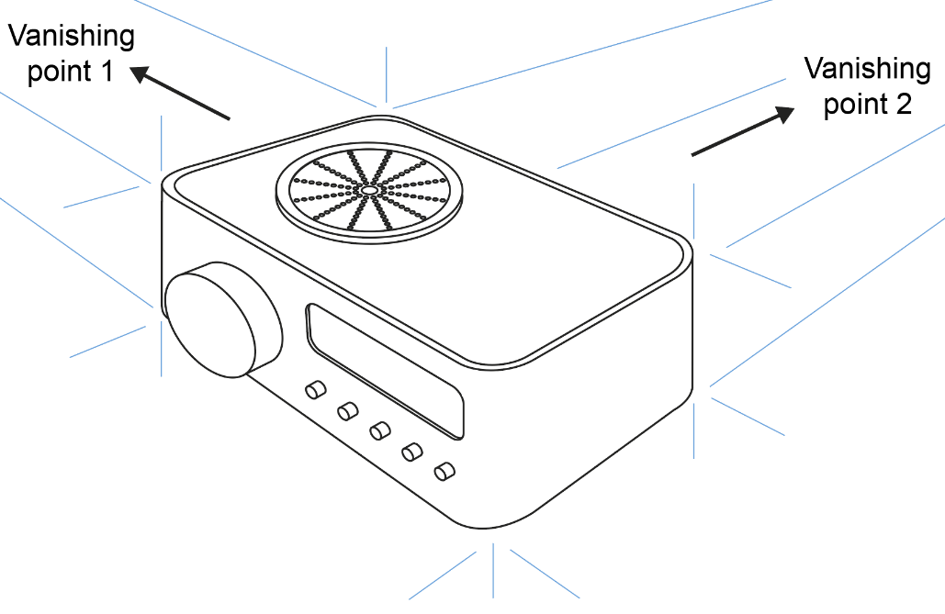 | 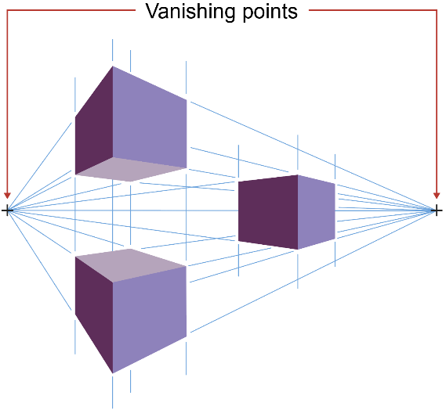

2. Three point perspective - This can bring a strong effect to a composition and make concepts more interesting.
  - All the vertical construction lines will end at the third vanishing point.
  - The nearer the third vanishing point to the centre of the drawing, the greater the distortion.
  - This can create an extreme point of view, which can make for a striking effect in architectural design.
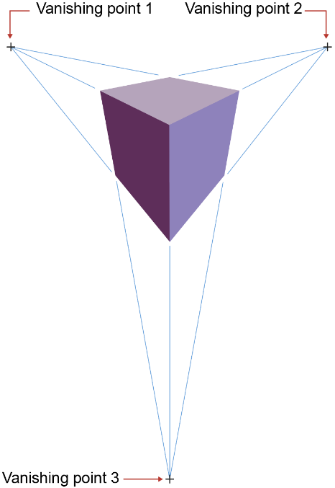 | 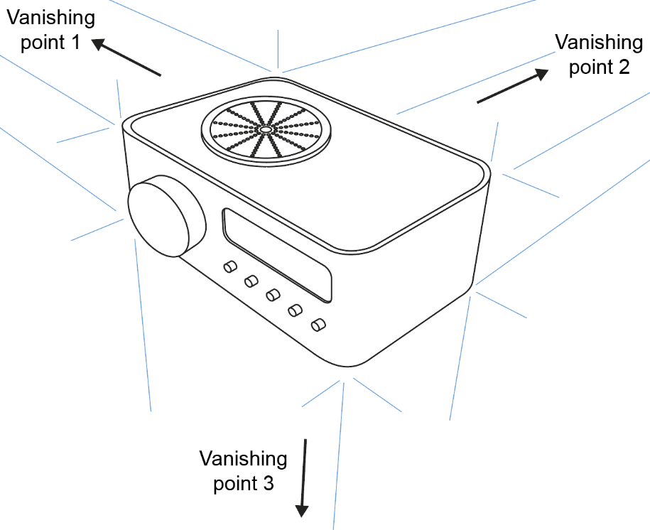

3. Systems diagrams - This is a graphical representation of a process.
  - Different elements such as input, output, decisions and processes can be modelled to create a logical system.
  - It may also communicate a circuit layout or assembly instructions.

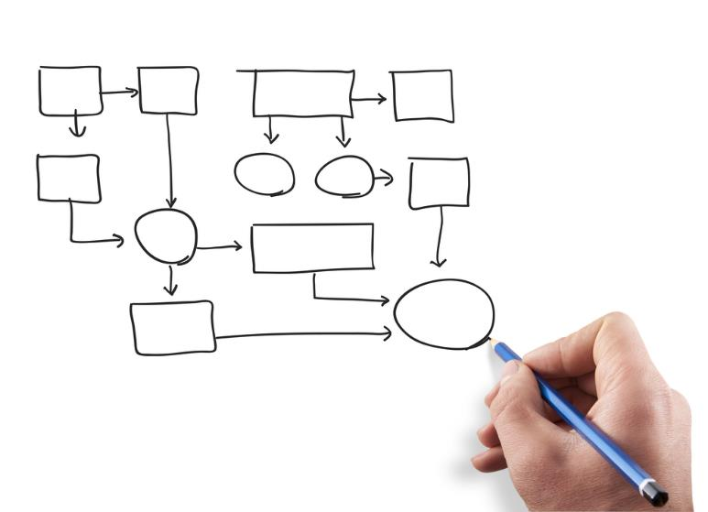

4. Annotations - Annotations are notes and labels, which provide information about the design or process.
- Annotated drawings show a work in progress.  - They provide a way of communicating a designer’s plan. | 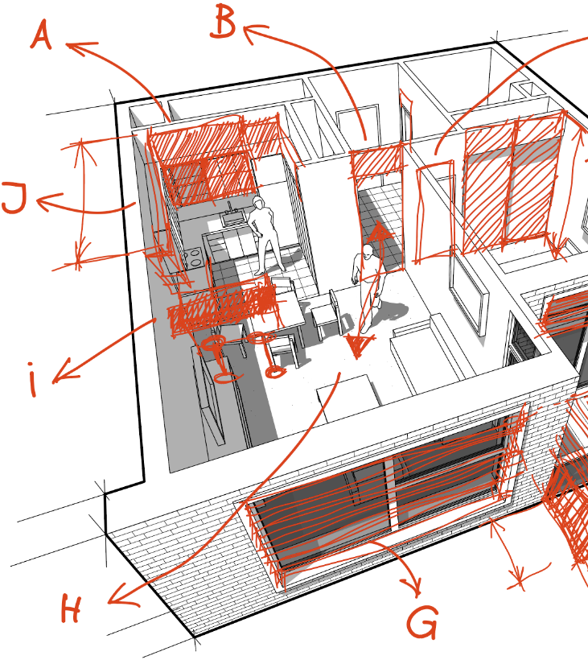
Annotations should clearly indicate information that the drawing may not convey.
These may include:
  - Materials.
  - Manufacturing processes.
  - Use of sustainable materials.
For the client, they will also be looking to see if it meets their specification points.

5. Human proportions - The realistic proportion for an adult is approximately a 1:8 ratio of head to body.
- Fashion designers tend to elongate this and commonly use a 1:9 ratio giving women a higher waist and longer legs. | 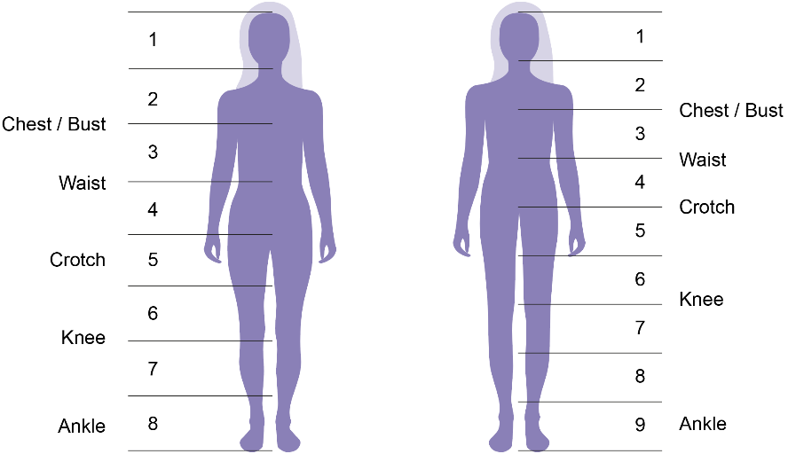

Task: 1-5 Learn/cover/write and self-check the various communication methods.

1. Exploded drawings - An exploded drawing shows how component parts of a product are assembled.
- Parts are aligned so you can clearly communicate where each part is from.  - Exploded diagrams are often supplied with kit models or flat packed furniture. | 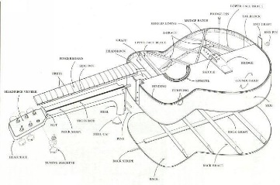

2. Isometric exploded drawing - Drawing styles can also be combined.
- This is an Isometric Exploded drawing. | 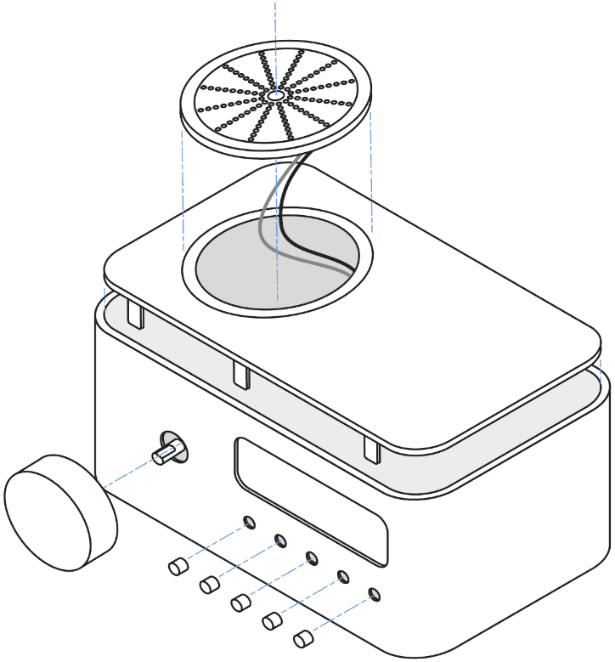

3. 3rd angle orthographic drawing - Orthographic drawings typically include the plan view, with front and side elevations.
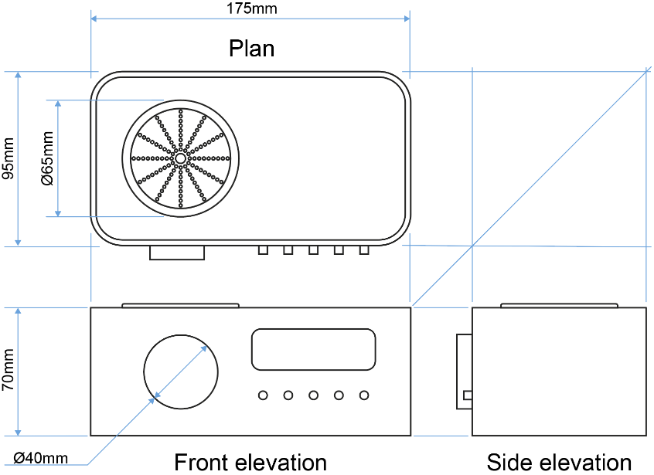

4. Working drawings - Working drawings give technical details to enable a product to be manufactured.
- For further accuracy, the drawings should be presented in orthographic projection.  - Textile drawings may simply be a front and rear view. | 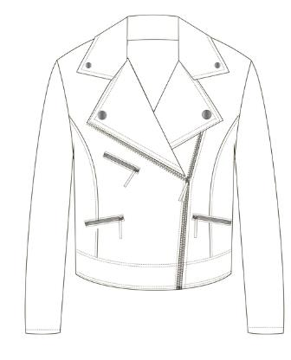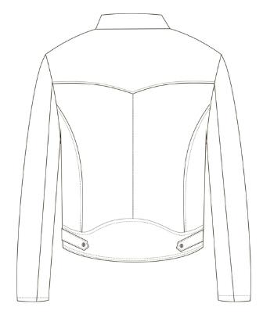

5. Mathematical modelling - The process of design often
entails using some maths.
  - Consider all the different aspects of design that will need careful calculation and list your findings.

The different aspects of design that will need careful calculation include:
    - How much material is required to make the item.
    - Economical use of materials to ensure minimal waste.
    - How much will the selected material weigh?
    - Is there a lighter option than works as well?
    - How strong is the material?
    - Check the upper and lower limits of component tolerances.
    - Scales of economy – will it be cheaper to buy in bulk?
    - Aesthetics.

6. Models for testing - Different elements of a design can be tested by making a model.
  - A breadboard can be used to test an electronic circuit.
  - A complete garment can be made from a cheap fabric known as a toile.
  - To help visualise shape and scale, something as simple as scrap materials can be utilised for modelling.

7. Developing prototypes - A prototype is a preliminary version
of a product and should be made to the highest achievable quality.
  - To ensure the prototype is successful it should satisfy the client’s brief.
  - The design should also be innovative, functional, aesthetically pleasing and marketable.

8. Prototype evaluation - Test, analyse and evaluate the product.
  - In industry, destructive and non-destructive testing are used see if products are safe and fit for purpose.
  - User groups and market research will also produce relevant user feedback.
  - Collate both audio and visual records of each stage of testing.
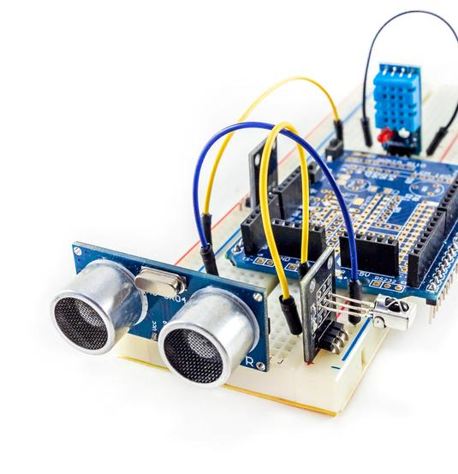

Task: 1-8 Learn/cover/write and self-check the various communication methods.

