1.Forces and stresses
All materials, structures and product have to withstand various stresses as forces are applied
Key forces | Definition
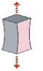 | Tension A pulling force applied to an object causing it to stretch.
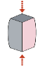 | Compression A pushing force applied to an object.
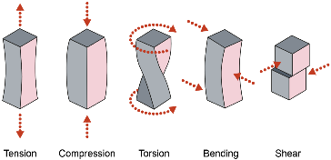 | Torsion A twisting force applied to an object as opposing rotating motions.
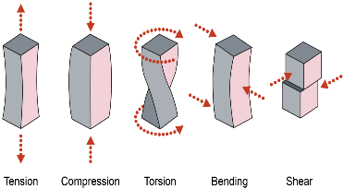 | Bending Both tension and compression are applied either side of a neutral axis or fulcrum.
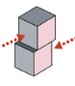 | Shear Opposing forces applied to an object in a direction that is perpendicular to its length.

2.Improving functionality
There are many ways a material can be enhanced to improve its working properties and functionality. They can be reinforced, stiffened or made more flexible.
Techniques include |  | Example
Webbing | Tightly woven strips are usually made from high- strength synthetic fibres such as nylon, polyester and Kevlar. | Seat belt  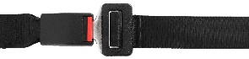
Folding and Bending | This involves changing or reshaping the structure of a material to reinforce it. | 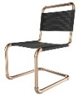  Metal chair
Lamination | Lamination involves bonding two or more layers of materials together to improve working properties. | 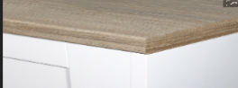  kitchen table top
Fabrication | Fabric interfacing is added to textile products to make rigid. |   Shirt

3.Ecological and social footprint - Key words
Key word | Meaning
Deforestation | Clearing a wide area of trees i.e. forests and rainforests.
Mining | Extracting raw materials, such as coal, sulphur and other minerals from the ground.
Drilling | Extracting raw materials, such as oil and natural gas from deep under the surface of the earth.
Atmospheric Pollution | Emissions released cause air pollution.
Farming | Growing crops and / or raising livestock to  meet consumer demand.
Product miles | The total distance a product travels from its place of growth or production to the place of consumption.
Oceanic Pollution | Poor waste management leads to pollutants and waste entering our waterways and seas.

4.The six R’s
The six R’s are a set of strategies used to help make more sustainable decisions as a consumer or designer.
Refuse | Ask yourself if a given process or product is necessary and avoid using it altogether.
Rethink | Revise the way a current product or system functions, either completely or partially. Solve the problem in a different way.
Reduce | Use less, buy less, throw away less. Create design with fewer materials.
Reuse | Use something again and again. Repurpose or modify designs or parts to avoid disposal.
Repair | Replace parts or design products to be fixed.
Recycle | Reprocess materials to be used again. Do not source materials from virgin resources.

Tasks: 1-4 Learn/cover/write and self-check the forces/ stresses, improving functionality, ecological/ social footprint and 6 R’s.

1. One-off production
A single product or unit is made.
One-off production is suitable for prototypes and when a product
is designed for a client with specific needs.
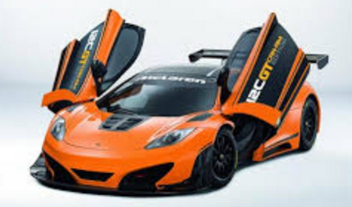
Prototypes and 3D printing
Prototypes are classified as one-off products and 3D printing is often used to manufacture prototypes.

2. Batch production
More than one unit is produced at a time in a set or batch e.g. confectionary, newspapers or furniture items.
- Patterns, templates or jigs are used to increase efficiency.
- Production lines are flexible and generally have shorter lead times.
Jigs, patterns and templates.
- Jigs and patterns can be made or bought in to expedite a certain process.
- Jigs can be used in one-off, and batch production.
CNC machines
- CNC stands for Computer Numerical Control.
- These are CAD/CAM machines like laser cutters and CNC routers.
- These machines are often used in batch production because they are accurate and efficient but also flexible.
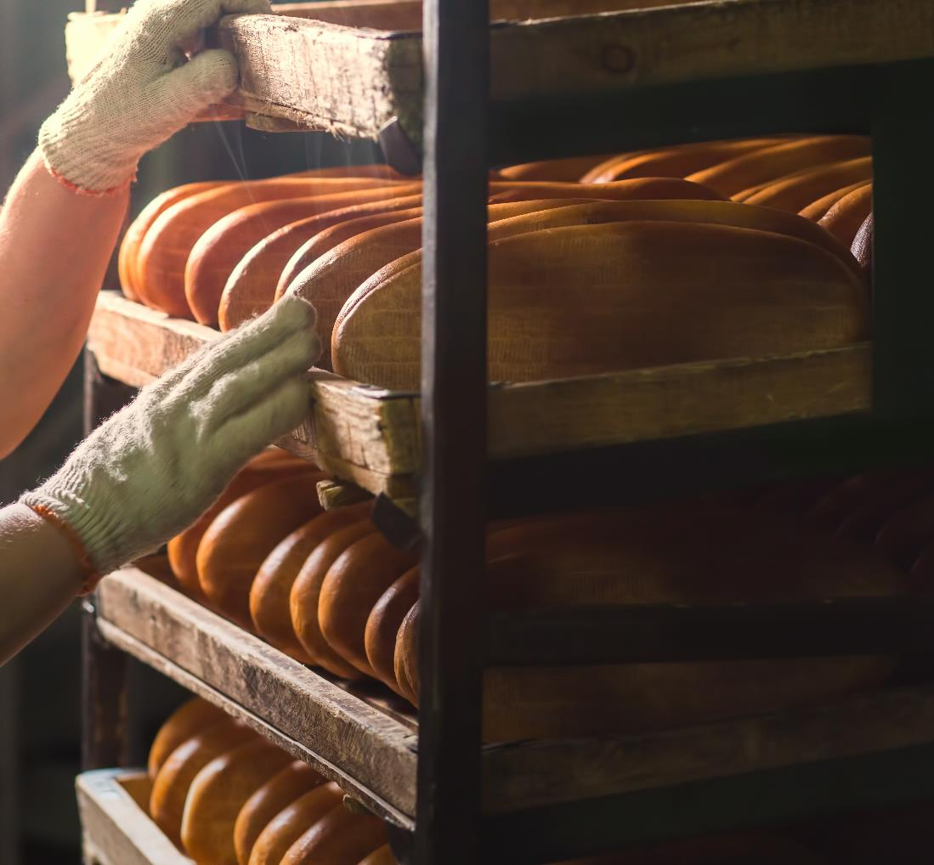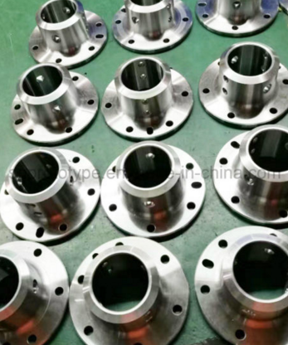

3. Mass production
- Mass produced products are made in large volumes, in factories with a high level of automation and very few, if any, processes completed by hand.
- High set-up costs and low unit costs characterise mass production.
Set-up costs
- The more automation in a production line, the higher the set-up costs will be.
- Products made using complex industrial machinery will be mass produced.

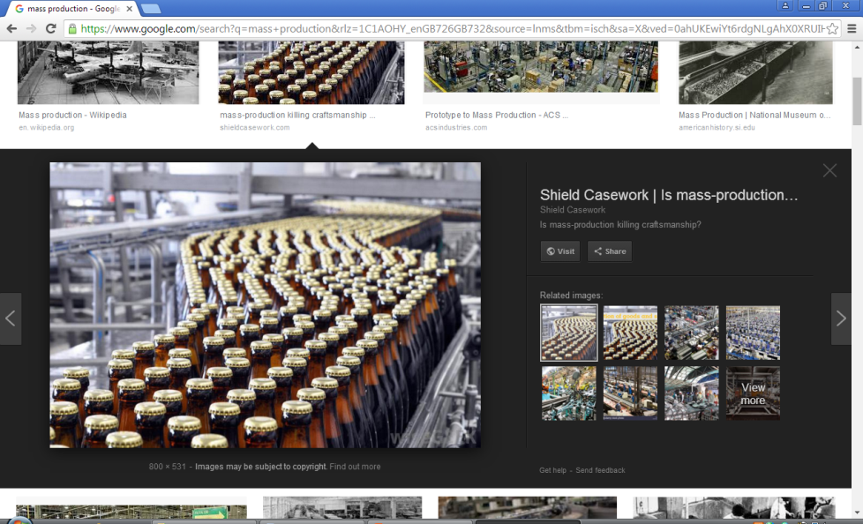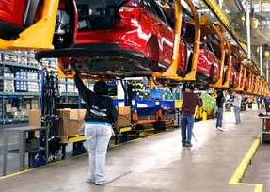

4. Continuous production
A continuous production line is run non-stop, 24 hours a day, 7 days a week, manufacturing products to meet a constant demand.

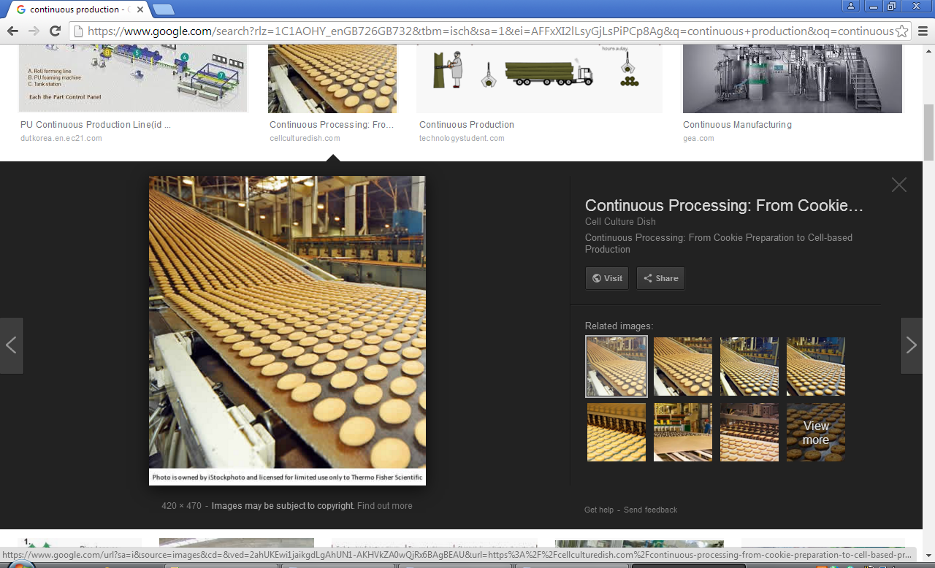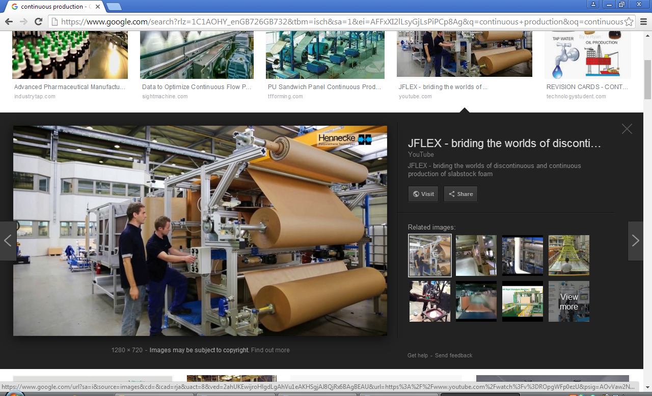

Tasks: 1-4 Learn/cover/write and self-check the types manufacturing.

