
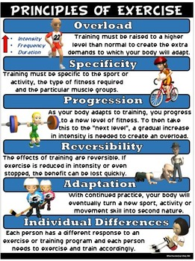
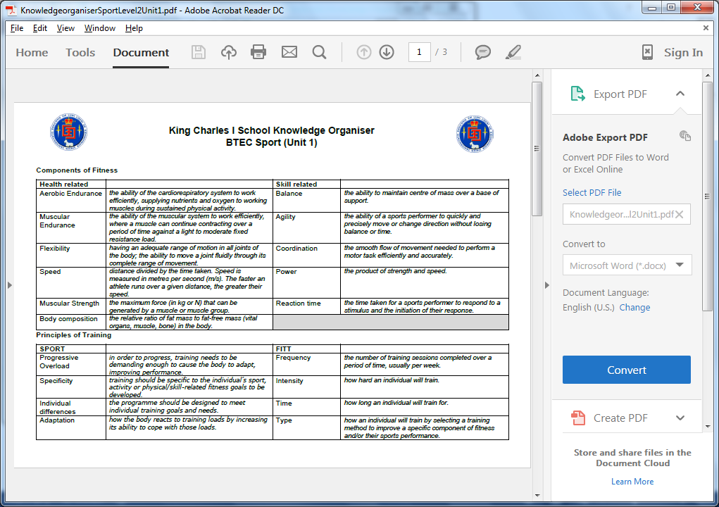
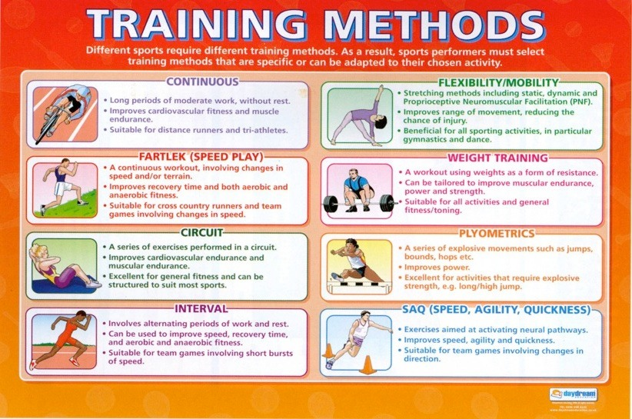
SPOR and principles of training
FITT Principles
Method of training
Pre Season training
PHYSICAL EDUCATION – The Principles and Methods of Training

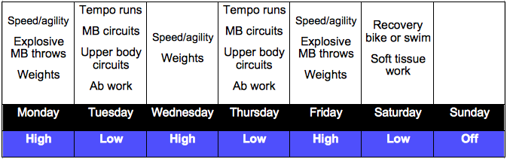
Homework 1- Remember the principles of training (SPOR)
Homework 2- Understand the FITT principles in regards to overloading fitness levels
Homework 3- Remember all the methods of training and describe their suitability to certain sports
Homework 4- Design a pre-season training programme for your sport

