Cardiovascular Fitness | Muscular Endurance | Muscular Strength | Flexibility | Power | Agility | Balance | Coordination | Speed | Reaction Time
12 Minute Cooper Run | 60 Second Sit-Ups | Hand Grip Dynamometer | Standing Stork Test | Sargent Jump | Illinois Agility Run | Standing Stork | Alternate Hand Wall Throw. | 30 Metre Sprint | Ruler Drop Test
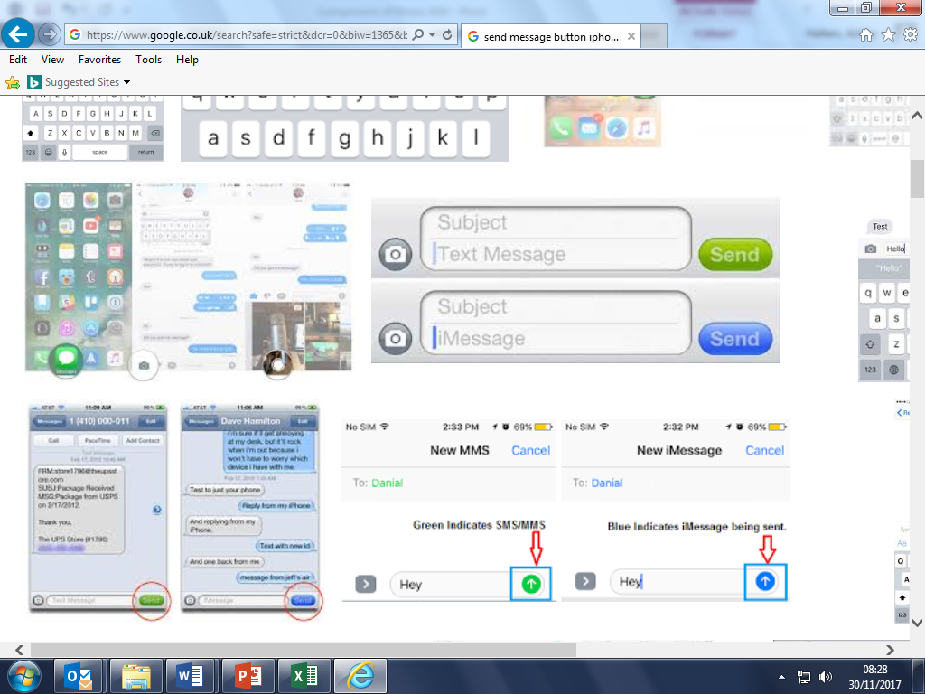

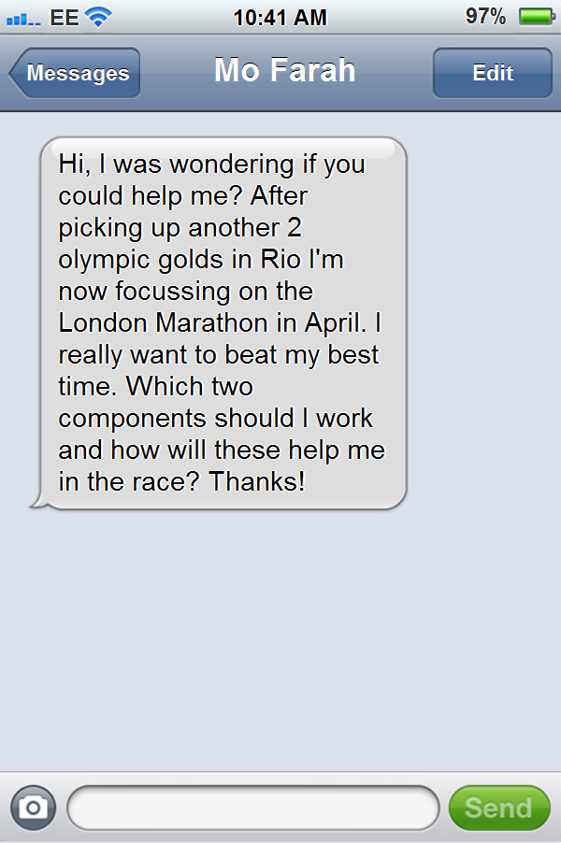


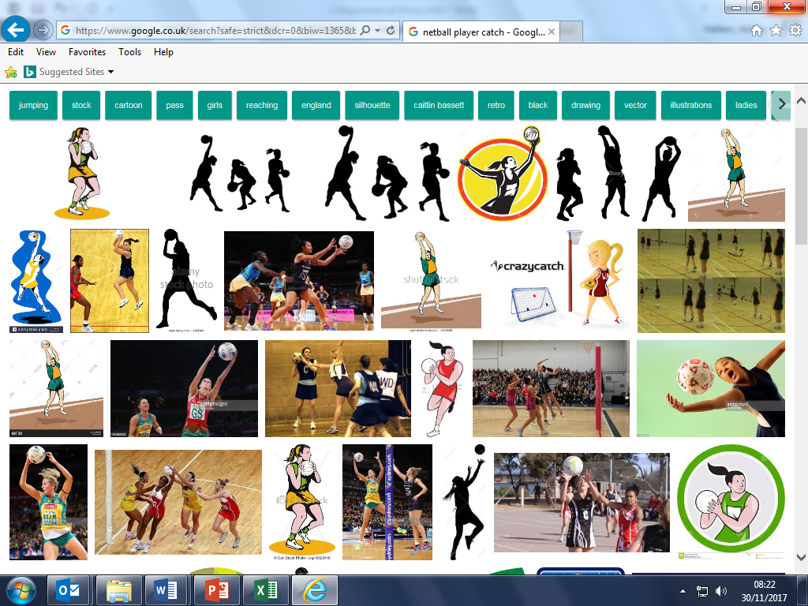

Homework 1: Know all the components of fitness and their definition
Homework 2: Know all the tests that test the components of fitness
Homework 3: Give a sporting example for each component of fitness e.g cardiovascular fitness will be used by a Marathon runner
Homework 4: Design a conversation between you and an athlete.

KO Quizzes will follow these, so make sure you revise.
Hi David, you should be focussing on Agility and Reaction time. Then Leicester might not beat you…
You should definitely work on Cardiovascular and Muscular Endurance, Mo.
Athletes concerns.
Test a component of fitness.
Component of Fitness and a sporting example
Coordination, Speed, Balance, Reaction Time.
Muscular Strength and Endurance and Power.
Agility, Coordination, Speed and Power
Components of fitness and their definitions.
PHYSICAL EDUCATION – Components of Fitness
Cardiovascular Fitness- The ability to work the entire body for long periods of time without tiring.
Muscular Endurance- To work the same muscle over and over without tiring.
Muscular Strength- The maximum amount of force a muscle can exert in one movement.
Flexibility- The range of movement at a joint.
Power- The combination of strength and speed.
Agility- The ability to change direction at speed.
Balance- The ability of the performer to retain their centre of mass over their base of support without falling.
Coordination- The ability to move two or more body parts at the same time.
Reaction Time- The time between the presentation of a stimulus and movement.
Speed- The ability to cover a distance in the shortest time possible.
Body Composition- The % of fat, muscle and bone.

