Component  Example | Carbohydrates  Bread, rice, pasta | Protein  Meat, eggs, nuts | Fats  Fish, butter, oils | Vitamins  A, B, C and D | Minerals  Calcium and Iron | Fibre  Cereals | Water  2-3 litres per day
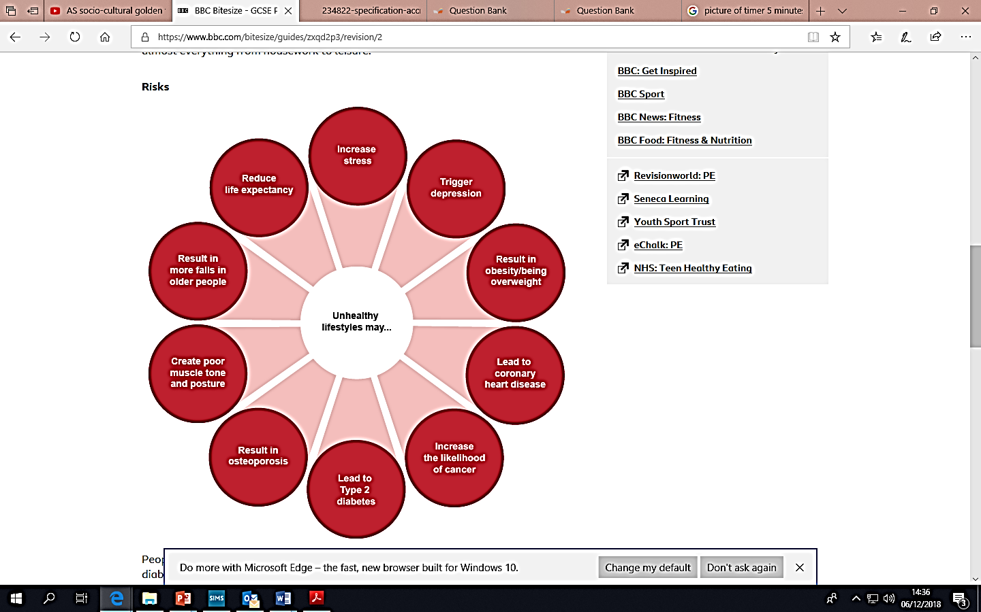
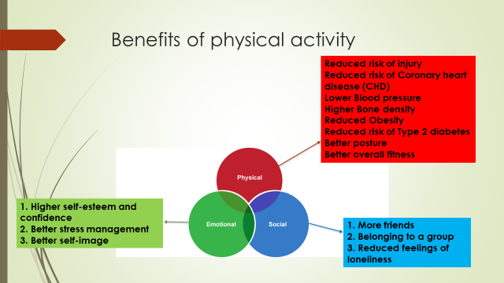

Homework 1: Name the componenents of a healthy and physical lifestyle
Homework 2: Name the components of a healthy diet
Homework 3: Define health, fitness and wellbeing
Homework 4: Name the benefits of physical activity
The benefits of physical activity for physical, social and emotional
Balanced Diet
Health is a state of complete physical, mental and social wellbeing and not merely the absence of disease or infirmity.
Fitness is the ability to meet the demands of the environment.
Wellbeing is the state of being comfortable, healthy and happy
A sedentary lifestyle is a type of lifestyle with little or no physical activity

Health, fitness and well-being
PHYSICAL EDUCATION – Health, fitness and wellbeing

