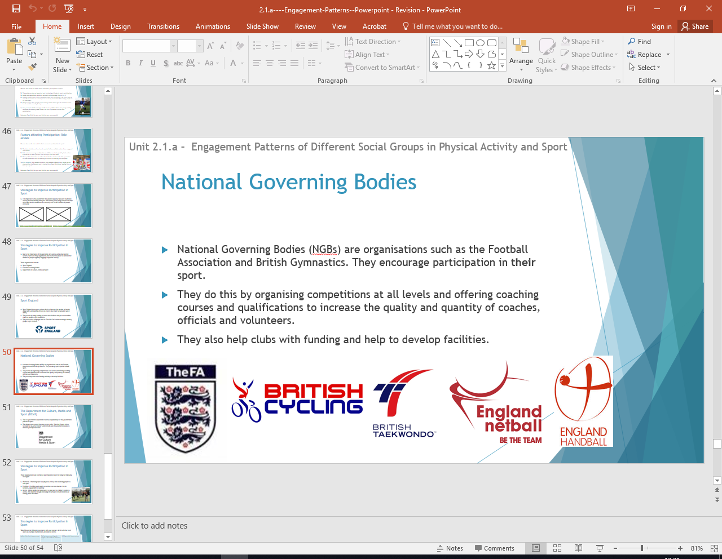



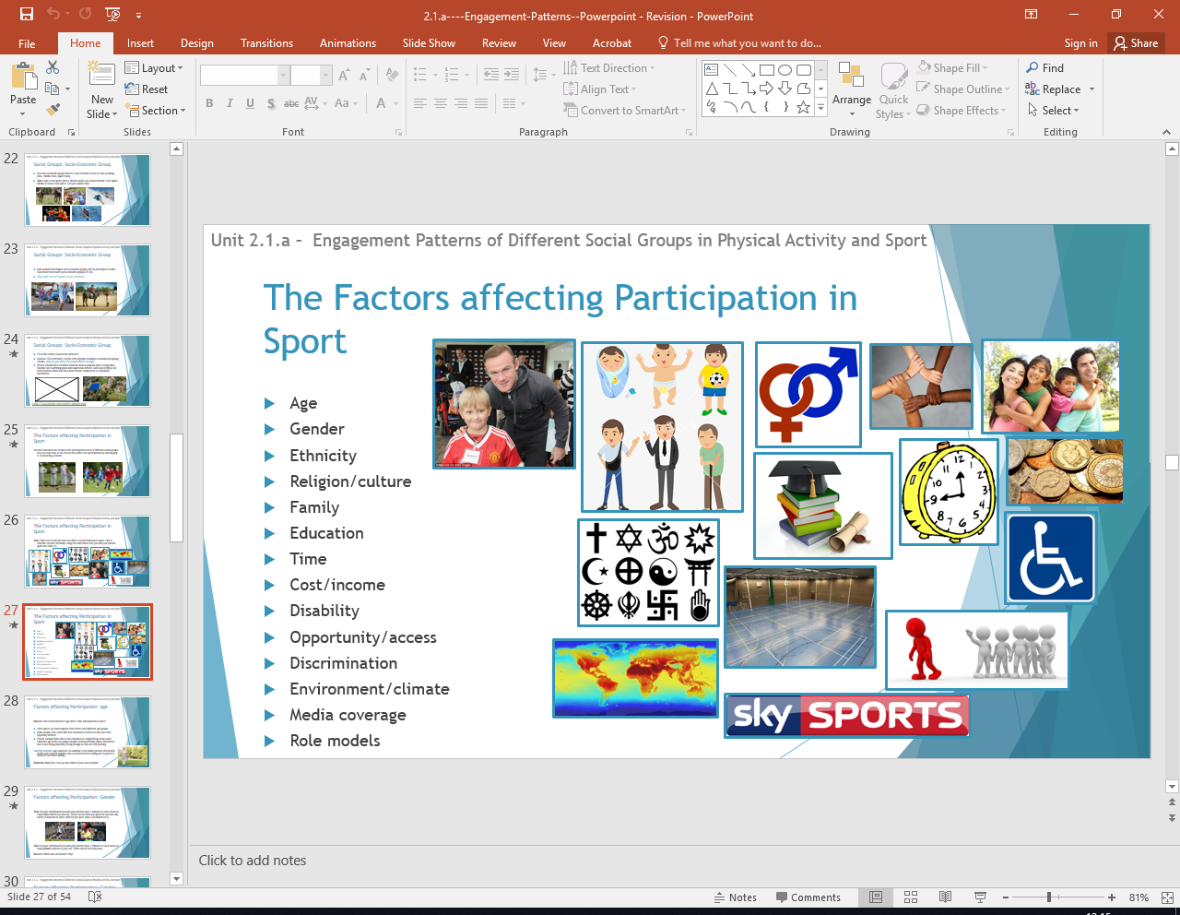
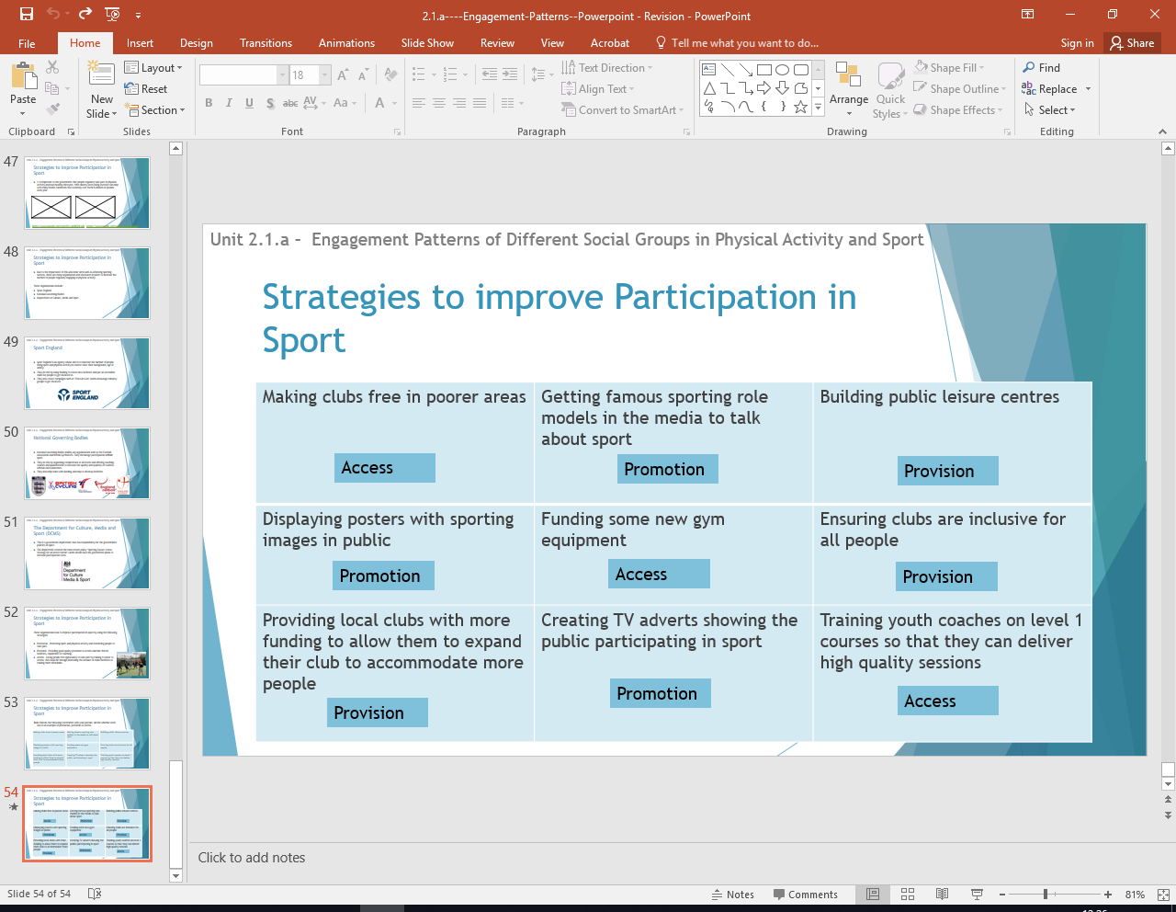

Homework 3: Name three governing bodies in sport
Homework 4: Name strategies to promote sport
Homework 1: Name all the factors affecting participation and give a sporting examples
Homework 2: Name the bodies that support sport
Bodies to increase sporting participation
Strategies to promote sport
Factors effecting engagement
PHYSICAL EDUCATION – Engagement patterns and current trends in sport

