Performance enhancing drug | Benefits | Sporting example
Anabolic Steroids | Rapid increase in strength  Increase muscle recovery  Allows performers to train harder | Weightlifter  Boxer  Sprinter
Beta Blockers | Controls heart rate  Reduces adrenaline  Relaxes performer | Golfer  Darts  Snooker
Stimulants | Increased alertness  Reduced tiredness  Increased endurance | Sprinter  Football  Boxing
Why performers take drugs?
A desire to win at all costs
They lack moral boundaries
Influenced by others
Under pressure to win
Violence in Sport
- Controlled aggression is a fundamental part of many sports.
Sometimes, however, this can spill over into an uncontrolled situation where serious physical injury can be caused.
Violence is ‘behaviour involving physical force intended to hurt, damage or kill someone’.
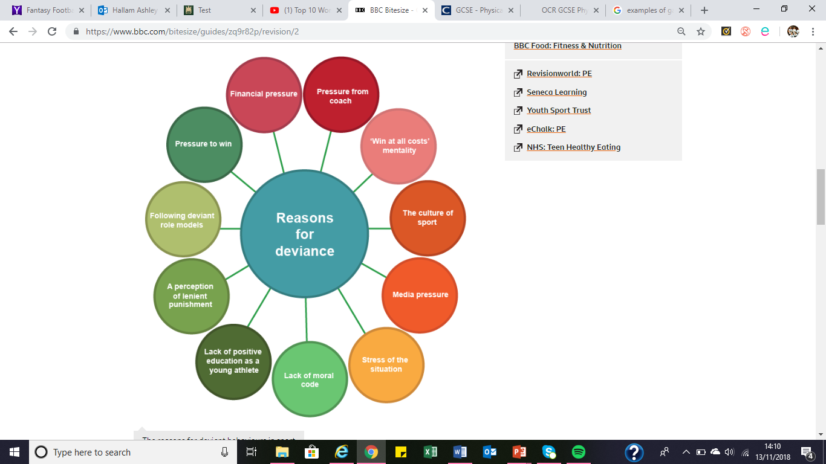
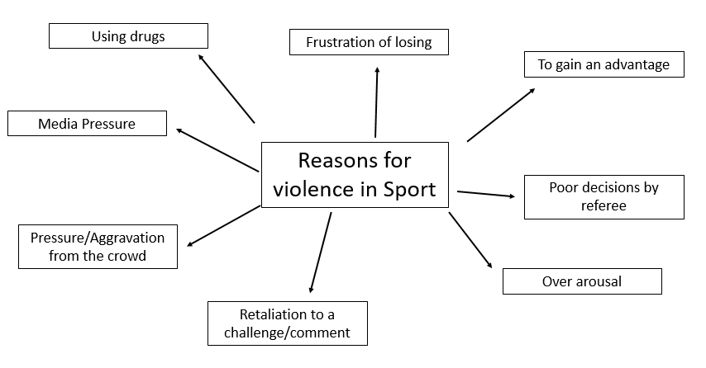




Homework 1: Be able to show excellent sportsmanship in a PE lesson
Homework 2: To be able to identify gamesmanship in a game of football
Homework 3: To be able to state the different PED
Homework 4: To be able to discuss why a performer would show violence in sport
PEDs and their advantages
Ethics
Sportsmanship means playing within the rules and understanding and using sports etiquette
Example- Shaking hands, walking in cricket, putting the ball out when someone is injured
Gamesmanship means deliberately bending the rules to gain an advantage
Example- Diving in football and faking injury
Deviance- Deliberately breaking the rules
Example- PEDs, bribery, fighting
Sportsmanship, gamesmanship and deviance
PHYSICAL EDUCATION – Ethics, PEDs and Violence

