
Sponsorship is a form of advertising where a company pays to be associated with an event, team or sports person.
Types of sponsorship include facilities, clothing, equipment and financial
Those affected | Positives | Negatives
Players/Athletes | Allows athletes in lower paid jobs to be paid  It can lead to further roles once they have finished | Favours men over women  Promoting brands they don’t believe in  Lesser athletes get less
The fans | Wider range of sports  More TV on sport  Can lead to higher funding | Can make sport more expensive  Increased adverts/breaks
Officials | Allows for better tech (VAR)  Officials earn more money | Bad decisions analysed and criticised
Sport | Raised overall profile of sport  Provides more funding  Better facilities/equipment  Improves overall standard | Less popular sports get less money  Match timing changed for TV  Changes to sports format

Sponsorship
Commercialisation is the act of making something available to be bought or sold for financial profit
Commercialisation
PHYSICAL EDUCATION – Commercialisation
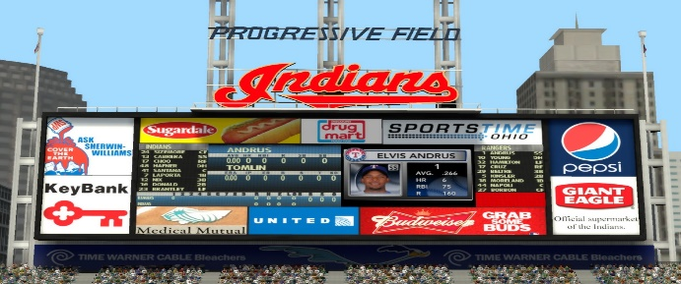

Media in sport
Type of media | Example | Sporting example
TV and Visual | Watching live  games | Sky football
Internet | Club website | LCFC website
Social media | Facebook, twitter and Insta | BBC Sport twitter
Newspaper / Magazines | National and local | The times or 4-4-2

Positives | Negatives
More media coverage of a sport will result in more companies wanting to sponsor them. | Less popular sports will not receive as much money from sponsorship deals as their brand will not get as much promotion.
This will increase the standard of the sport as the clubs will have more money to invest in better players and facilities. | This leads to less money, which can lead to less funds to invest in better players, coaches and facilities.
Increased coverage of the sport will result in more children participating, which will result in more sales of products such as boots. | Participation rates may go down in smaller, minority sports as a result of less coverage/popularity.
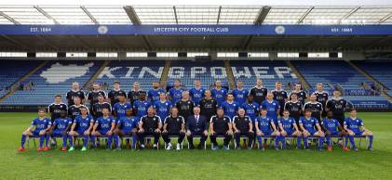
Golden Triangle
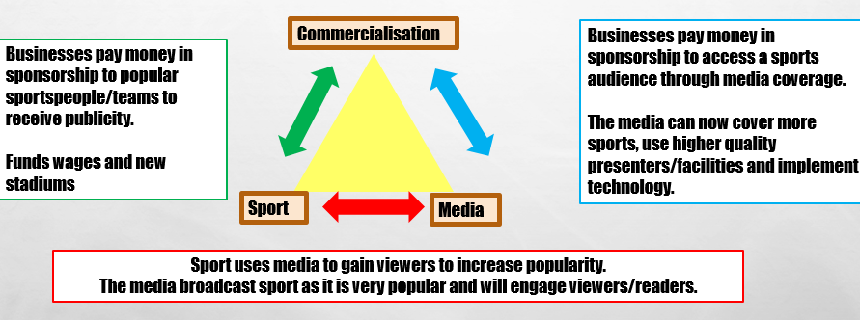
Homework 1: Apply different types of media to different sports
Homework 2: Show the effects of the golden triangle for your sport
Homework 3: Discuss the +/- of sponsorship in a practical lesson

