1. Properties
Wood | Classification | Properties
Oak | Deciduous | Heavy, hard, tough and polishes well.
Cedar | Coniferous | Lightweight, knot free, straight grained.
Beech | Deciduous | Very tough, hard, close grained.
Teak | Deciduous | Hard, durable, natural oils resist moisture & insects.
MDF | Man-made | No grain, smooth surface, saws well.
Scotts Pine | Coniferous | Straight grain, knotty, easy to work with.
Plywood | Man-made | Laminated layers at 90° to stop warping.

2. Manufacture Board
Image | Properties and uses
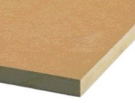 | MDF(Medium Density Fibreboard) – Made by compressing and gluing tiny particles of wood fibres, has a smooth surface can be painted of veneered. Used for indoor furniture
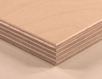 | Plywood – Made by laminating veneers at 90 degree angles so it doesn’t twist or warp. Used to make draw bottoms, doors and boats(marine ply).
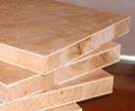 | Block board – Made by gluing strips of wood together and sandwiching them between to veneers. Used to make furniture such as table tops.
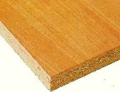 | Chipboard – Made by compressing and gluing chips of wood together. Used for flooring and veneered kitchen tops.
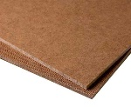 | Hardboard – Made by compressing and gluing small wood fibres together, one side of the board is smooth and the other has a rough texture. Used to line drawer bottoms backs of cabinets.

3. Forest Management stages
Stage | Explanations
Plantation | Planting the tree saplings.
Cultivation | Growing the tree, ensuring they are healthy.
Harvesting | Felling the trees into logs.
Transportation | Moving the trees to be process into timber.
Usage | Selling the wood to manufacture to make products.
Waste | Disposing of the products e.g. wood chip fuel.

 | 4. Surface treatments and finishes - Wood can be protected and visually enhanced using:
 | Preservative | Oil |  | Paint | Wax | Varnish | Stain
 | Finishes can be applied by brushing, rubbing or spraying.
5. Processes of timber
Processes |  |  | Description
Thinning |  |  | Forests need to be thinned so the trees do not need to compete for resources e.g. sun and water.
Felling |  |  | Trees are felled when they have reached maturity and turned into logs.
Timber conversion |  |  | 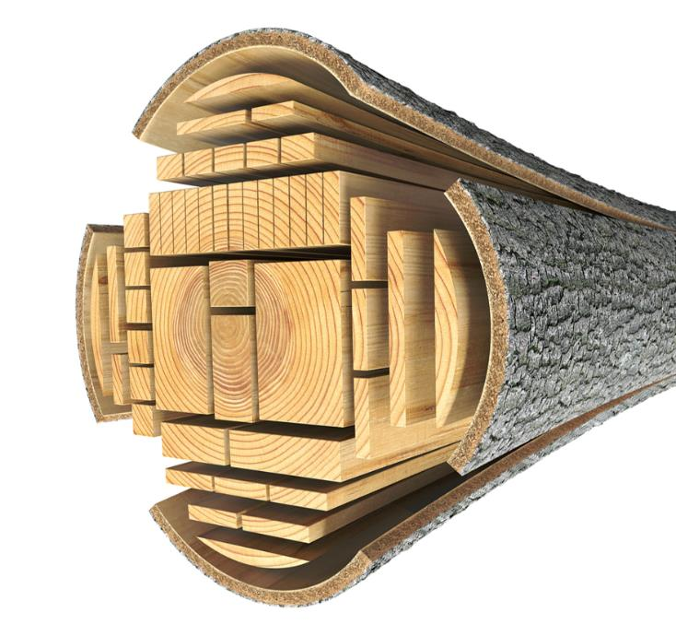  This is when a tree log is economically divided into a useful product e.g. planks of various sizes.
Green timber |  |  | Green timber is very wet, and difficult to work with. Timber for external use needs a moister content of 20% and 10% for internal use.
Seasoning |  |  | Seasoning timber reduces the moisture content, this is achieved by either air or kiln drying
Faults |  |  | Faults in wood include: bowing, splitting/cracking, crook/sprigging, cupping twisting.  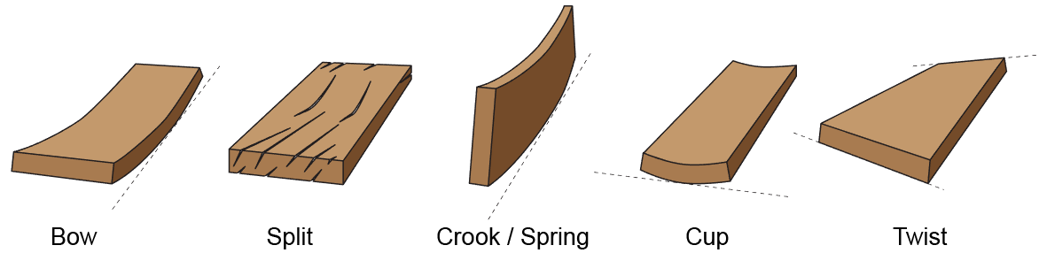

6. Timbers and components – Stock forms
Commercial | Description
Planks  Boards  Mouldings | Real wood is sold in planks of various lengths. Planks can only be the size width of the tree that they come from. Manufactured boards can come in large sheets and various thicknesses. These boards can then be cut down to the required size.
Length  Width  Diameter  Thickness | When purchasing wood, it will come in a variety of pre-manufactured sizes and shapes.
Wood screws  Hinges  Knock down fittings  Nails  Brackets | These are pre-manufactured components made to be used with wood. They come in various lengths, materials, sizes and thicknesses.

