Section 3 Sound
Live sound | Sounds generated by the performers on stage.
Recorded Sound | Sounds that have been pre-recorded and are then played through speakers
Live music | Live music is where performers or musicians generate the music on stage.
Sound effects | Can either be pre-recorded or played live. Can reflect what is happening on or off stage.
Diagetic sound | Sound from world of play that characters can hear
Non Diagetic sound | Sound not from world of play. The characters cannot hear this sound.

Year 8 Summer 1
Section 1 Vocal and Physical Skills
Vocal tone | How you say something to show meaning. Example: harsh tone of voice.
Vocal Pitch | How high or low your voice is.
Vocal Pace | How fast or slow you speak.
Gestures | Using your hands or body to indicate something.
Body language | Speaking with your body
Facial expression | Using the muscles in your face to indicate how you are feeling
Posture | How you sit or stand which can show status of a character.

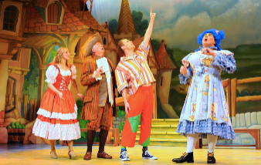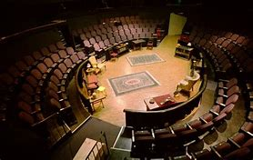
Section 5 Lighting angles
Side light | Where a scene is lit from the side. Can indicate location or give mystery feeling.
High front light | Where the performers are lit from above. Gives a natural effect.
Up light | There the lighting is angled upwards to create tension.
Back light | Where the actors are lit from behind. Can be used to create shadows.

All tested on SMHW test number 2
Homework:
- Section 4- Look/cover/write/check/self- mark the characters in DNA m- Test as Quiz on SMH
- Section 1- Look/cover/write/check/self- mark the lighting angles
Section 1- Look/cover/write/check/self- mark vocal and physical skills.
Section 2- Look/cover/write/check/self- mark lighting lanterns.
Section 3- Look/cover/write/check/self- mark sound.

Section 4. Characters in DNA
Phil | Quite psychotic and creates the cover up for Adam’s murder.
Leah | Phil’s girlfriend. She was not there when the murder happened. The smartest of the group. Member of the group that thinks about other things other than murder.
Mark | Mark was involved in the bullying of Adam. Feels guilty but thinks it was a joke.
Jan | Jan was involved in the bullying of Adam. Feels guilty but thinks it was a joke.
Lou | Smallest character. She is involved in the cover up.
John Tate | The leader of the group until he has a break down over the murder of Adam.
Danny | Does not want to be involved because he wants to be a dentist.
Richard | Member of the group that teachers at school trust.
Cathy | Dangerous character shows no remorse over the death of Adam. Actually finds it exciting.
Brian | Feels guilty and has a mental break down.
Adam | The boy who was bullied and murdered.

Section 2. Lighting Lanterns
Parcan | Lights a large area of the stage providing intense colour.  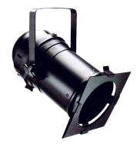
Profile spot | Highlights a particular performer or area. Sharp and clearly defined.  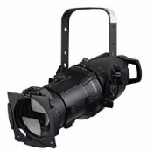
Fresnel | A soft edged spotlight which enables the lighting of precise areas.  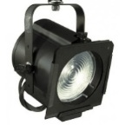
Birdie | A miniature light that is useful for highlighting parts of the set.  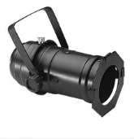
Flood light | Provides light to a large area.  

