Section 3- Characters of Commedia
Pantolone | Physicality: hunched over, very money orientated, bent knees and holds a bag full of money hanging from his belt  Voice: A high-pitched chicken Squawk
Dottoro | Physicality: Weight back on heels, belly forward, hands gesturing in front.  Voice: ‘Parps’ like a trombone. Pronounces ‘S’ as ‘Sh’.
Colombina | Physicality: Movement continues during speaking.  Voice: Sharp, gossipy, with frequent variations of pitch.
Harlequinn | Physicality: Crisp movements, or completely clumsy and sloppy. Quick and physically and slow mentally  Voice: No pauses or silences he either speaks (continuously) or doesn’t (silence).
Zanni | Physicality: Always urgent. He appears nervous, talks a lot, his head moves constantly.  Voice: Loud, open-mouthed.

Section 1 Key words
Commedia Dell’ Arte | A group of artists touring around Italy
Lazzi | Short improvised routines.
Improvisation | Made up theatre without a script.
Characterisation | The creation of a character.
Status | Social or professional standing in society.
Masks | A covering of part or all of the face to show a character, emotion or to entertain.

Year 8 Spring 2 Drama Commedia Dell Arte’

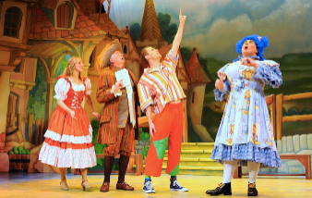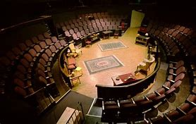

Homework -
- Read/Cover/Write and self-mark the key words and meanings in Section 1 and2
- Complete commedia quiz on SMH
- Read/Cover/Write and self-mark Characters of commedia in Section 3.
- Analyse and evaluate your Commedia Dell’ Arte performance on A4 lined paper using the guide above in Section 4

Section 4. Evaluation of your Commedia Dell’ Arte performance
Write an evaluation of your performance reflecting on your performance. (80-100 words)
- How did you demonstrate the character in your performance?
  - Did you think about the movements based on the information in Section 3?
  - Did you think about your vocal skills to make you sound like your character?
- What was the most successful moment when you were performing?
  - What did you do best? This could be movement, voice, using the stage space.
- When could you improve on in your performance?
  - Could you improve on your character?
  - Could you be bigger in your movements and gestures? How would you do this?

Section 2. Things to consider when devising
Genre | The type of drama chosen for the performance e.g. comedy, tragedy, docu-drama, etc
Style | The approach to performance chosen; this may link to practitioners  e.g. Brechtian, naturalist, minimalist, TIE etc
Practitioner | Someone who creates a type of theatre.
Form | The shape of each individual section or scene e.g. movement/ mime based ensemble scene.
Structure | The overall shape of the performance reflecting the order that scenes are put together  e.g. linear, narrative, circular, episodic, play within a play etc.
Language | The kind of language chosen e.g. contemporary, formal, colloquial, rap etc.

