Section 3- Type of genres
Horror | Setting | A haunted house. A grave yard. During the night or an abandoned building.
 | Narrative | Normally good ‘vs’ evil storyline and may include supernatural events.
 | Style | Normally sound is used to create suspense, pauses and sudden movements.
Comedy | Setting | House, School, workplace. In this genre the setting can be anywhere.
 | Narrative | Normally about a character’s journey through confusion or some unexpected event.
 | Style | Exaggerated body language and voice in unlikely situations.
Reality | Setting | House, school, workplace, a studio. It can be anywhere
 | Narrative | Normally follows the lives of individuals. It can also be a talent show.
 | Style | Not acting and real life.
Chat Show | Setting | A studio
 | Narrative | The presenter will interview a celebrity or someone who has achieved something
 | Style | Interview style natural everyday conversation.

Section 1 Key words
Genre | A style or category of film, theatre or a novel.
Stimuli | An object, poem, song or video that you use to create theatre from.
Vocal intonation | The way your voice rises and falls.
Vocal expression | How a performer uses his or her voice to convey character.
Vocal inflection | How you emphasise words to create meaning.
Vocal projection | Making your voice heard without shouting.
Character | The role an actor is playing.

Year 8- Spring 1 Drama Genres

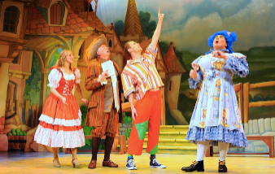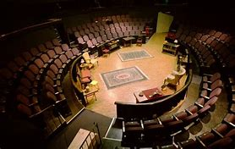

Homework -
- Read/Cover/Write and self-mark the key words and meanings in Section 1 and 2
- Complete Genres definitions quiz on SMH
- Read/Cover/Write and self-mark the different genres in Section 3.
- Storyboard or scene outline for your adaptation
- Written evaluation of how and why you adapted the story to your chosen genre

Section 4- Popular contemporary styles.
Naturalism | Imitates real, from the style of acting, to the set and costume.
Epic Theatre | Developed from Brecht; often has a moral or political message.
Physical Theatre | Immersive style of theatre, which mainly uses the body.
Expressionism | Non-naturalistic style, focusses on communicating and evoking strong emotional reactions.

Section 2. Set considerations.
Style | If the set is minimalistic or does it have a complex design. This is in terms of furniture and props.
Location | Where the play is set, this can be designed by backdrops and stage flats.
Backdrops | Fabric or screens at the back of the stage painted or projected to show location.
Stage flats | Canvas stretched and propped up with wood then painted to show location.
Atmosphere | This can create tension or show the genre through the painted set or through lights.
Time of day | This can set the location and the genre through the use of stage lights.
Staging | How the play is staged such as end on, thrust, in-the-round or traverse.

