
Section 3
Skills and important rules when applying them.
The slap. | Person A: Make sure head is moved quickly. Person B: Make the movement exaggerated so ~A knows when to move
The kick. | Person A: Exaggerate your fall in order to heighten the comedy. Person B: Do not kick hard and never the bottom of the back.
The hair pull. | Person A: Push your head hard against person B so your hair is not pulled. Person B: Ensure you push your hand on their head to make sure you do not hurt them.
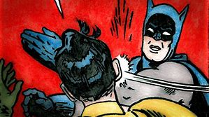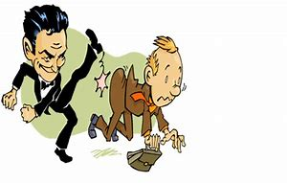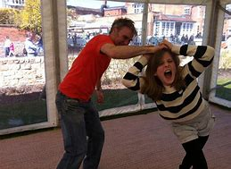

Year 8 Autumn 1 Drama Knowledge Organiser: Slapstick
Section 1
Key words
Slapstick | A form of comedy entertainment originating in the 16th-18th century
Physical Theatre | A style of theatre which is using all the body to it’s extreme to perform.
Comedy | Form of humorous entertainment key to the genre of Slapstick.
Mime | A dramatic form where the performer does not speak and uses gestures and movement to show the action.
Props | Items which are used in a performance on the person. Such as a pen, a watch, a book.
Costume | What someone wears which shows their character.

Section 4
Evaluation
A drama evaluation needs to include the following
- What have you done well in a performance? How do you know?
- How could you improve on what you performed?
- Did you include the skills you were supposed to include and did you apply them successfully?
Sentence starters
- A moment that I done particularly well was….
- I could improve on…..
- I used the skill of……… and this was applied well when I …

Homework -
- Read/Cover/Write and self-mark the key words and meanings in Section 1 and 2
- Slapstick quiz on SMH
- Learn/Cover/Write and self-mark the skills and safety information in Section 3 and make sure this is applied in class.
- Evaluate your Slapstick performance on A4 lined paper using the guide above in Section 4

Section 2.
People:
Charlie Chaplin. An actor who is famous for his Slapstick work one of the most famous people in Slapstick.
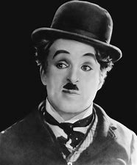
Mr Bean. A character created by the actor Rowen Atkinson. He is known for using traditional Slapstick skills in modern films.
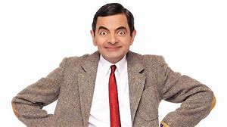
Films:
The Kid 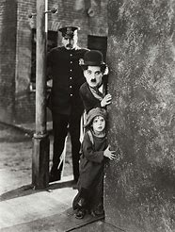 | The kid demonstrates the skills of Slapstick in a traditional way. The slap is applied many times in this.
Home Alone 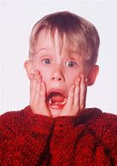 | A more familiar film which includes slapstick skills such as the trip.

