
PHYSICAL EDUCATION – Effects of Exercise
The four body systems
Long term effects of exercise
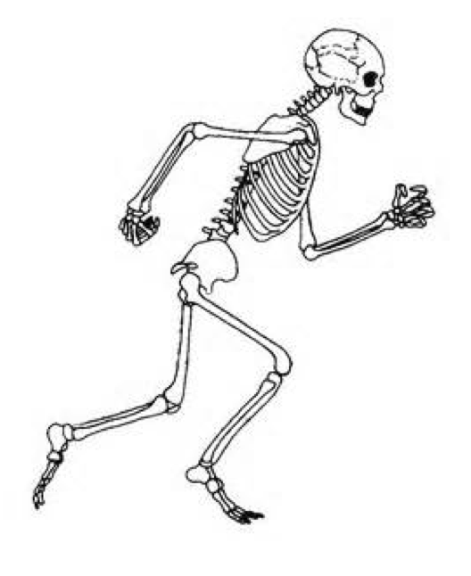 | SKELETAL SYSTEM:  - Bone density increases
 | MUSCULAR ENDURANCE:  - Muscle hypertrophy occurs.  - Muscular strength increases.  - Muscular endurance increases.  - Resistance to fatigue increases.
 | CARDIOVASCULAR ENDURANCE:  - Heart hypertrophy occurs.  - Resting heart rate decreases.  - Resting stroke volume increases.  - Cardiac output increases.  - Recovery rate increases.
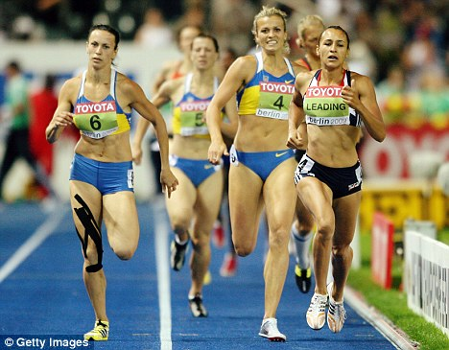 | RESPIRATORY SYSTEM:  - Aerobic capacity increases.  - Respiratory muscles become stronger.  - Tidal volume during exercise increases.  - Minute ventilation during exercise increases.

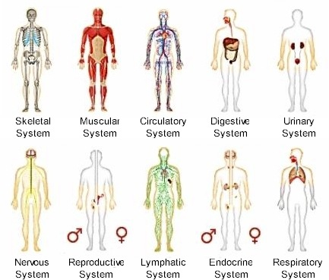
Short term effects of exercise.

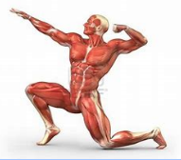 | MUSCULAR ENDURANCE:  When we exercise our muscle respond in a number of ways  - The temperature of our muscles increases.  - Build up of waste products like Lactic acid in the muscles.  Blood is redistributed to the working muscles, known as the vascular. So there is an increased supply of oxygen to the muscles.
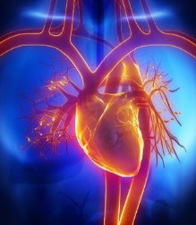 | CARDIOVASCULAR ENDURANCE:  - Heart rate increases. The heart beats faster to increase the flow of blood around the body especially to the working muscles.  - Stroke volume increases. More blood is pumped per beat as the heart expands to allow more blood in and out per beat.  - Cardiac Output increases (HR X SV = CO)  - Vascular Shunt occurs = Blood is redistributed to the working muscles.
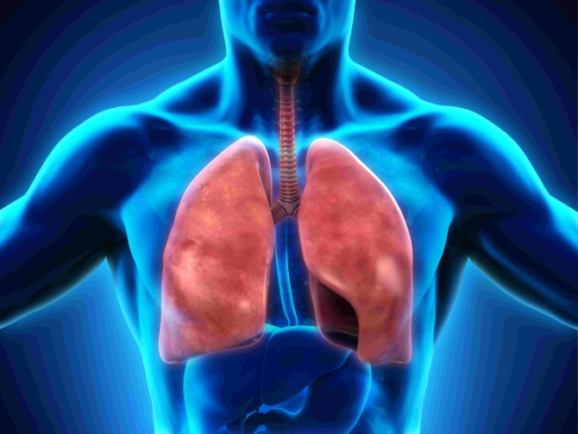  Homework 1: Remember all the skeletal effects of exercise  Homework 2: Remember muscular effects of exerice  Homework 3: Remember circulatory effects of exercise  Homework 4: Remember respiratory effects of exercise | RESPIRATORY SYSTEM:  - Respiratory rate increases.  - Minute ventilation increases.  - Tidal volume increases.
The benefits of long term exercise on the body compared to a sedentary lifestyle


