Plane of movement | Diagram | Sporting example
Saggital  Splits body left to right  Movement: Flexion & extension | 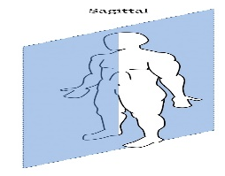 | 
Transverse  Splits body upper and lower  Movement: Rotation | 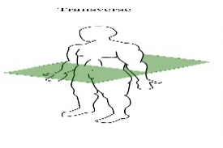 | 
Frontal  Splits body front to back  Movement: Abduction and Adduction | 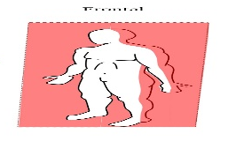 | 
Axes of the body
Longitudinal  Runs vertically from top to bottom | 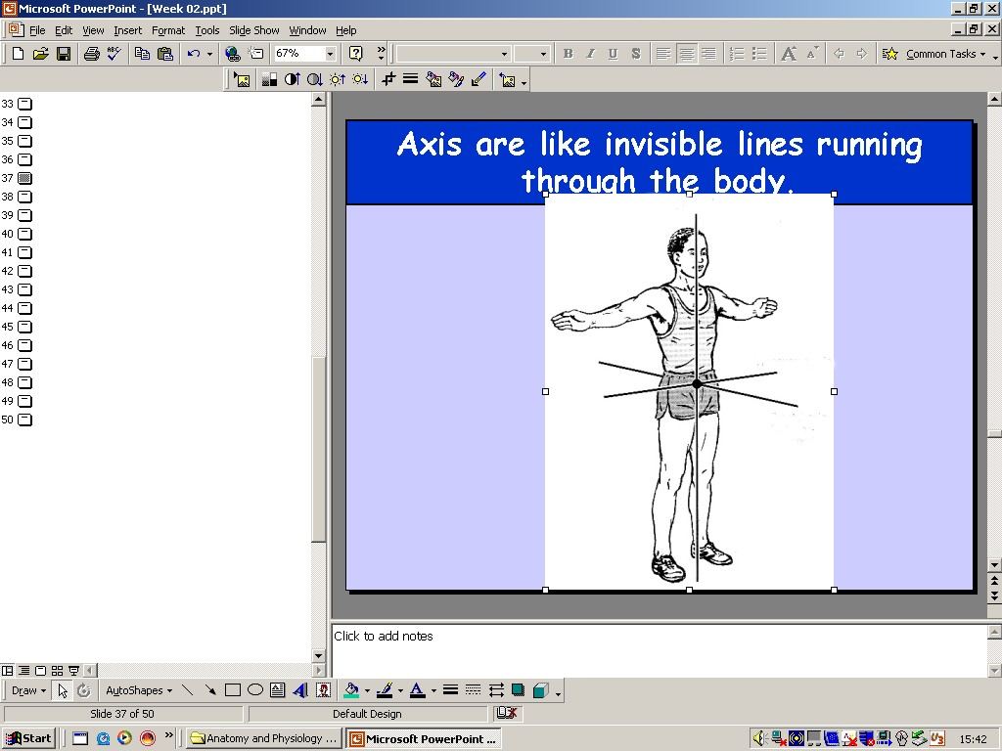 | 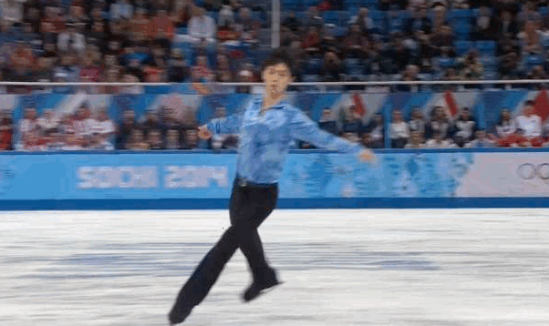
Transverse  Runs horizontally from left to right | 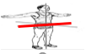 | 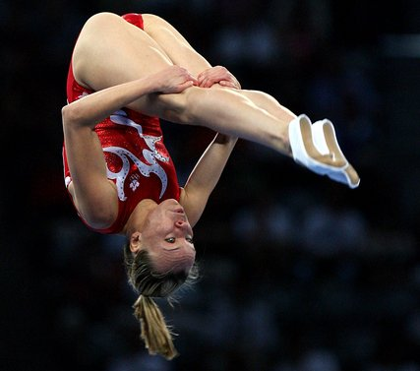
Frontal  Runs horizontally from back to front | 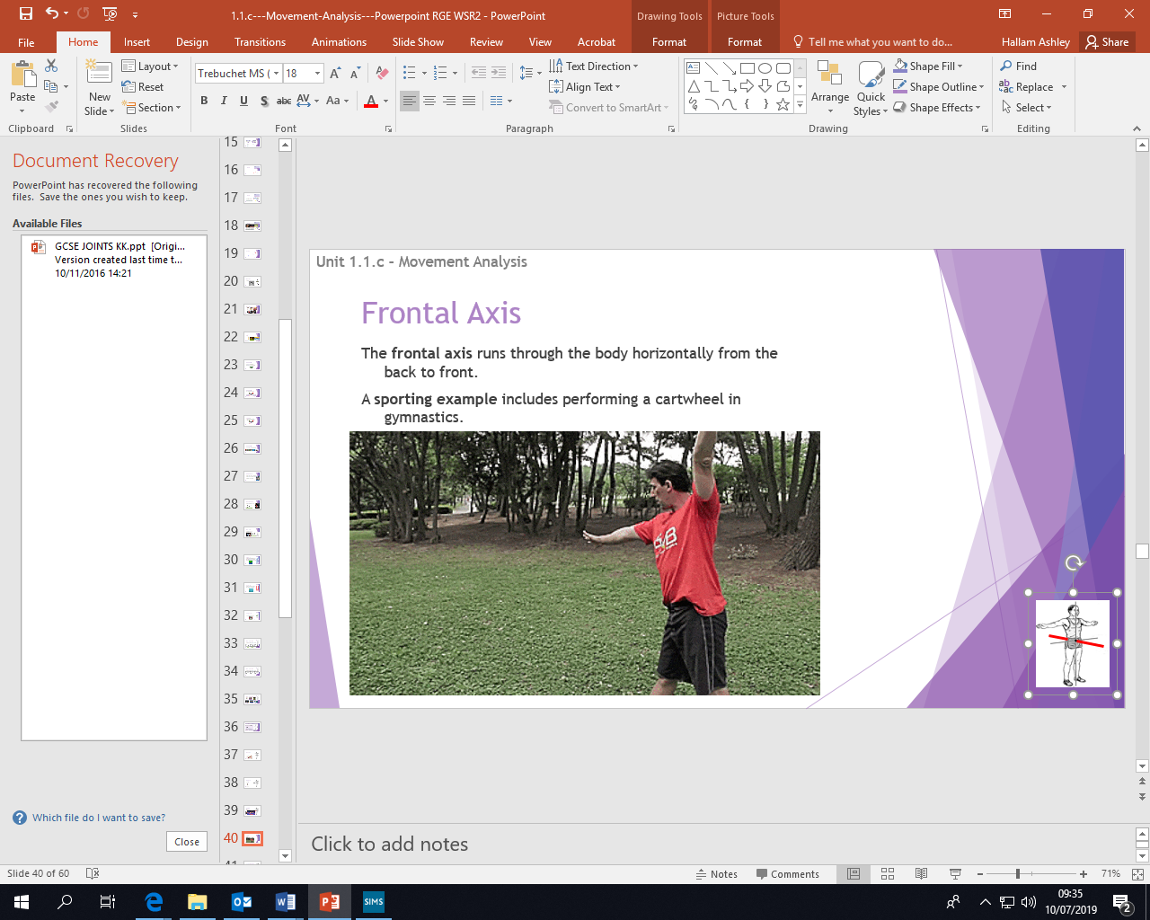 | 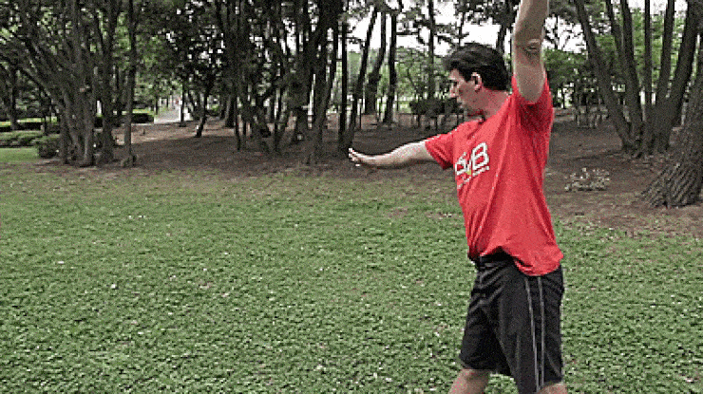

1 2 3
F L E
Levers of the body
Planes of the body and sporting examples
PHYSICAL EDUCATION – Movement analysis

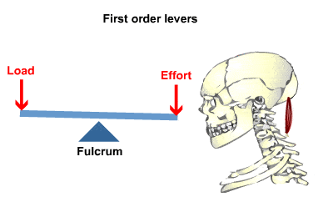
Sporting example


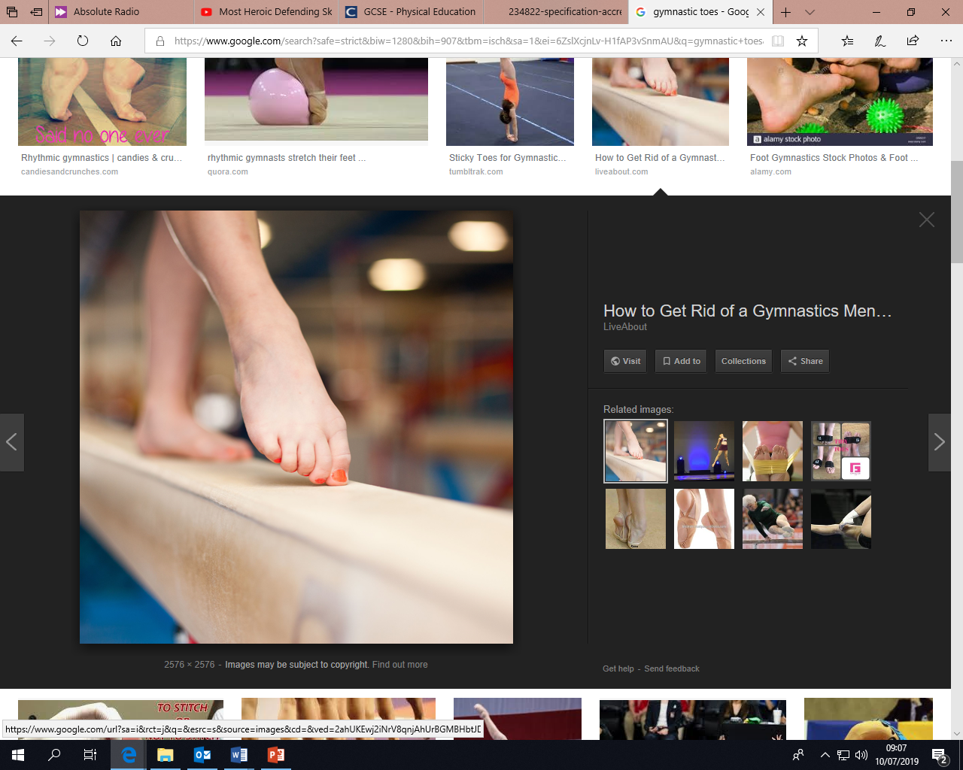
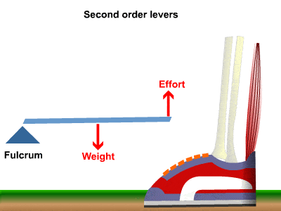

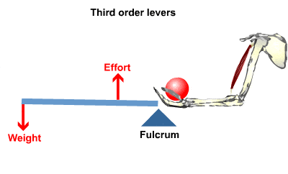



Levers are used to make a small amount of force into a bigger amount of force. This is known as gaining a mechanical advantage.
A mechanical advantage is when a lever allows you to move a large load with a smaller effort.

Mechanical Advantages
Homework 1: Be able to show sporting examples for Axis
Homework 2: Be able to show sporting examples for planes
Homework 3: Remember the acronym 123 FLE
Homework 4: Be able to show what mechanical advantage is in a PE lesson

