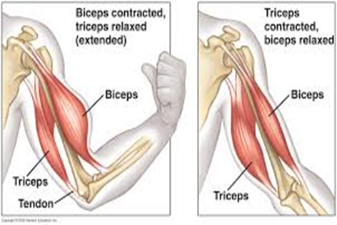
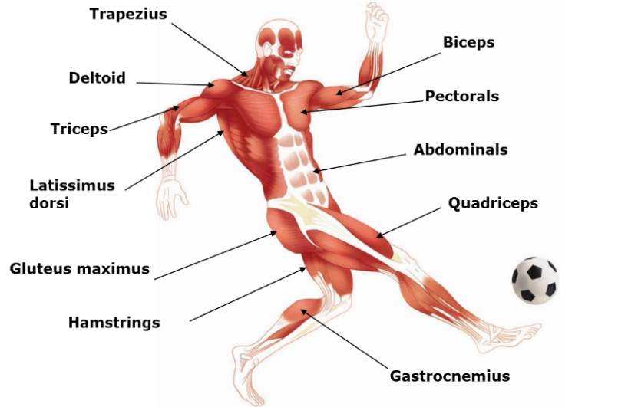

Understand antagonistic muscles pairs
Explain muscular contraction
Physical Education- The Muscular System
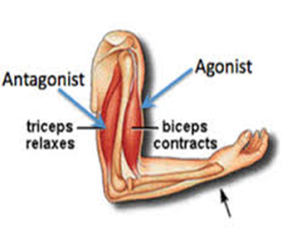
Agonist – the muscle that is working (contracting) and produces the desired joint movement
Antagonist – counters or opposes the action of the agonist (relaxes)

Label the major Muscles in the body
Antagonistic Muscle Pairs
Muscles that work in pairs; as one muscle contracts, the other relaxes to bring about movement
e.g. Biceps and Triceps; Quadriceps and Hamstrings
Types of Muscles:
Voluntary – skeletal muscles – we can consciously control these muscles – eg bicep
Involuntary – not controlled they work automatically – eg digestive system
Cardiac – found in the heart – never rests

Name the types of muscles in the body
Contracting muscle | Movement taking place
Trapezius | Extension at the neck
Deltoids | Abduction at the shoulder
Biceps | Flexion at the elbow
Triceps | Extension at the elbow
Pectorals | Adduction at the shoulder
Latissimus Dorsi | Adduction at the shoulder
Abdominals | Flexion at the hip
Gluteus Maximus | Extension at the hip
Quadriceps | Extension at the knee
Hamstrings | Flexion at the knee
Gastrocmenius | Extension at the elbow
Know the location of the muscles in the body and show in a lesson
Show how muscles allow for different movements in sport
Demonstrate how muscles work in pairs
Apply sporting examples

