Subject Content | What students need to learn?
1.3.2  Business revenues, costs  and profits | ● break even level of output  ● margin of safety.  Interpretation of break even diagrams:  ● the impact of changes in revenue and costs  ● break even level of output  ● margin of safety  ● profit and loss.
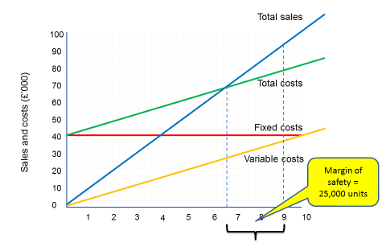
Calculating break even without using a graph.
Break even charts can be time consuming to make so often a formula is used instead:
BREAK EVEN = FIXED COSTS
(SELLING PRICE – VARIABLE COST PER UNIT)
BREAK EVEN =
The point at which sales revenue = total costs. At this point the business is nether making a profit nor a loss.

MARGIN OF SAFETY =
The difference between the break even level of output and actual level output.
MOS = CURRENT OUTPUT – BREAK EVEN OUTPUT
In this example = 90,000 – 65,000 = 25,000 units


