Subject Content | What students need to learn?
1.1.3  The role of business  enterprise | The role of business enterprise and the purpose of business activity:  ● to produce goods or services  ● to meet customer needs  ● to add value: convenience, branding, quality, design,  unique selling points.  The role of entrepreneurship:  ● an entrepreneur: organises resources, makes business  decisions, takes risks.

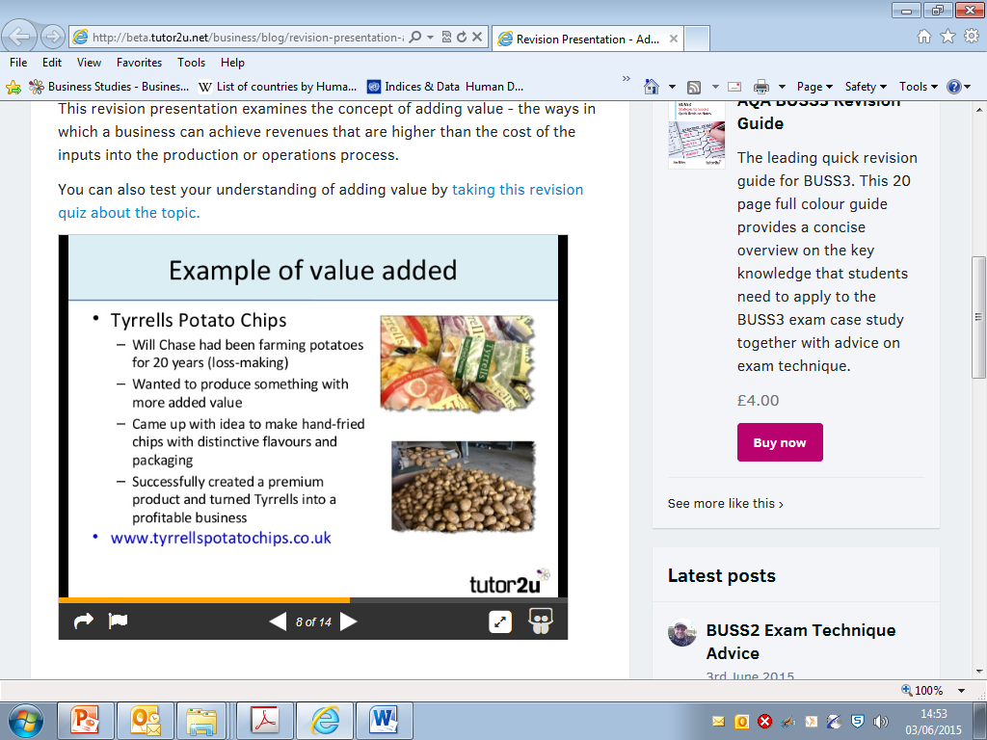
The role of a café entrepreneur:
- Organising resources:
- Physical resources e.g. premises, kitchen equipment
- Daily resources e.g. drinks, crockery
- Human resources e.g. good chef
- Making important decisions e.g closing a loss making café
- Taking risks e.g. opening a café in a new location

The role of business enterprise and the purpose of business activity:
- To produce goods and services
A business needs to make goods and services that satisfy consumers wants and needs. The profit made is reinvested by businesses, leading to further growth. Business enterprise has an important role to play in society by creating jobs and wealth.
- To meet customer needs
A business needs to meet customer needs by offering them products and services that they want. A business will not succeed if they are unable to do this.
- Adding Value
Adding value is the difference between the price of the finished product/service and the cost of the inputs involved in making it. There are a number of ways of adding value:
- Convenience and speed: in Britain most people will pay extra to save their own time e.g. takeaways are more expensive than cooking your own meal from scratch.
- Branding: A Nike tick adds tens of pounds to the ‘value’ of a pair of trainers. A Mercedes badge adds thousands of pounds to a new car.
- Quality and design: Good quality and well-designed products command higher prices as they are more desirable
- Unique selling point (USP): an original feature that competitors aren’t offering which customers are willing to pay more for.

Adding Value Example!

