Year 7 Autumn 1: 1 Storytelling through action (Darkwood Manor)
Section 4 Stage positioning and its meaning
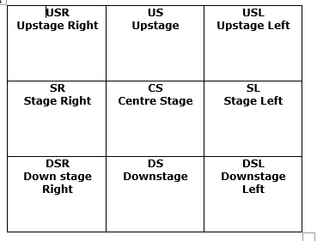

Section 1 Key words
Narrative | The collection of events that create the overall meaning of the story
Plot | The main events of the play.
Dialogue | A conversation between two or more people.
Set | The way the stage is designed to create the performance. It can include stage furniture.
Props | An object used on stage such as a cup, a newspaper etc.…
Lighting | Lights which are used to enhance the scene. These can be coloured or white and vary in focus.

You will notice that we describe the area furthest from the audience as ‘up’ and the area closest to the audience as ‘down’.
The important thing to note is that, when directing, we refer to the right hand side as ‘stage left’ and vice-versa

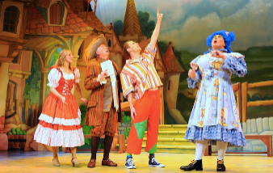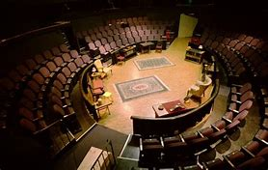
Example:
As a performer I would use a sharp, firm tone when trying to persuade the young people that they should listen to me. I would also use a whispering volume to ensure that they draw close to me. I would make certain my eyes were constantly scanning around as if looking for somebody I am afraid will overhear and correct what I am saying. My gestures would show that…
Section 3 Describing physical action
Gesture | The way in which a performer uses their hands and upper body to express emotions and reactions
Mime | The use of the precise actions and reactions to an object or situation that exists only in the imagination of the performer
Posture | The way in which the performer’s whole body communicates the mood and reactions of the character
Facial Expression | Specific reference to how a performer communicates the emotional state or reaction of a character

Section 2 Staging terminology
The fourth wall | The imaginary ‘see through’ wall through which the audience watch the action
Split staging | Using different areas of the stage to represent two events happening simultaneously
Tableaux | A still image which represents the narrative of a story or event
Action narration | Remaining in character whilst retelling a story with actions
Monologue | The performer speaking alone in character -usually directly to the audience

Homework -
- Read/Cover/Write and self-mark the key words and meanings in Section 1
- Read/Cover/Write and self-mark the staging information in Section 2
- Write 100 words that physically describe your character’s reactions to Darkwood.
- Draw a stage diagram justify the placement characters for the split-stage phone call
- Answer the question in your book – we will add your corrected version to your learning booklet in class.

Section 5. Extended writing
If you were going to play the character of an older person who is hiding a secret about ‘Darkwood manor’ how would you use vocal and physical skills to play this? (200 words)
Key words to help you
Vocal tone | How you say something
Vocal Pitch | How high or low you speak
Vocal Pace | How slow or fast you speak
Vocal inflection | How you emphasise certain words

